**Github link: (includes all the files of project iTube and Project NewsApp, demo videos of them)**

[SIT305_homeworks/Task5.1C/look at here at main · JudsonJia/SIT305_homeworks (github.com)](https://github.com/JudsonJia/SIT305_homeworks/tree/main/Task5.1C/look%20at%20here)

**The screenshot of the main app screen:**

**iTube:**

**mainpage:**

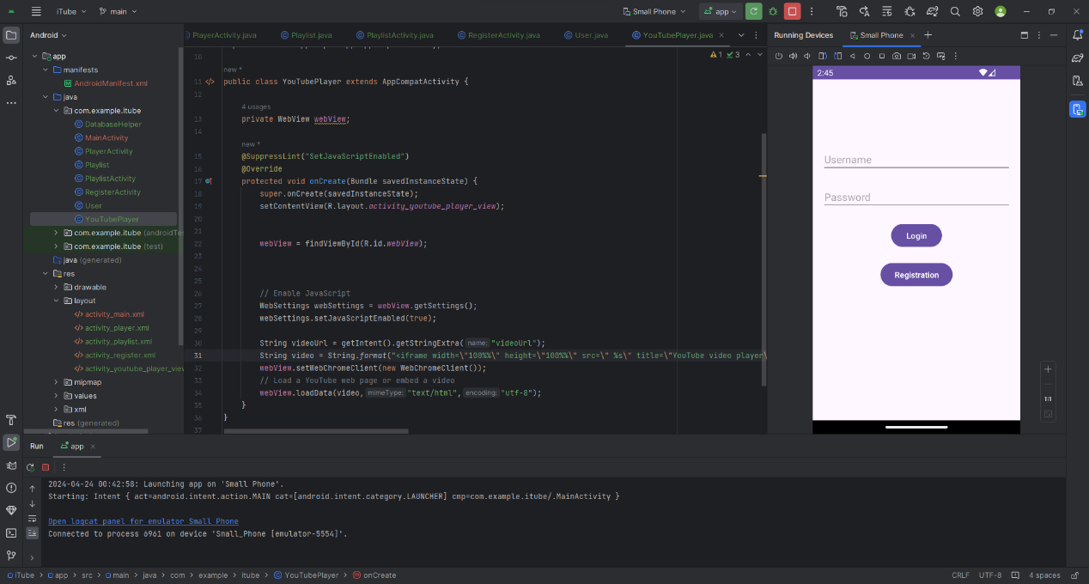

**Registration page:**

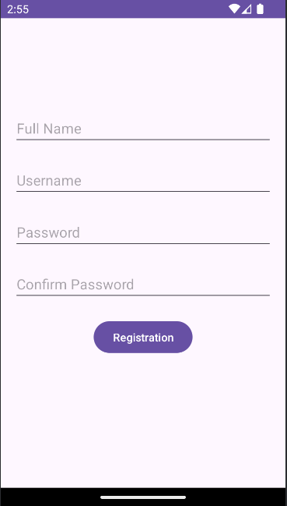

**Playerpage:**

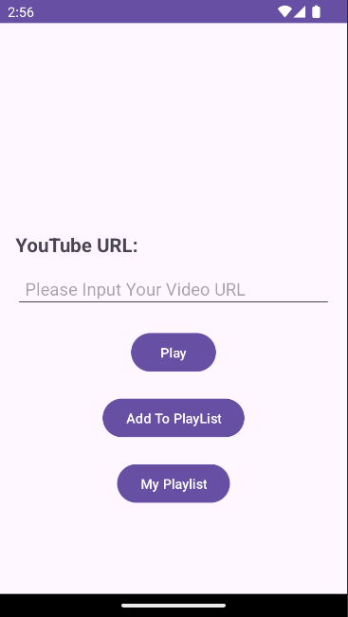

**My palylist page:**



**Vedio play page:**

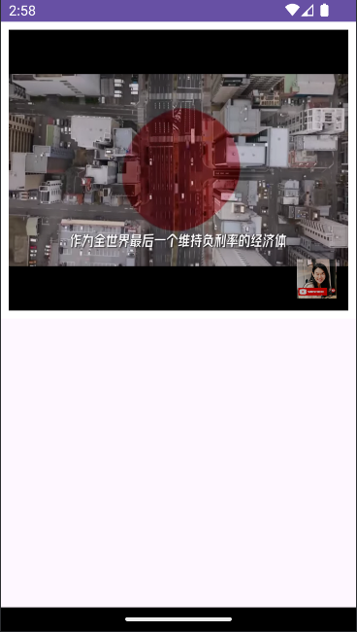

**NewsAPP:**

**Homepage:**

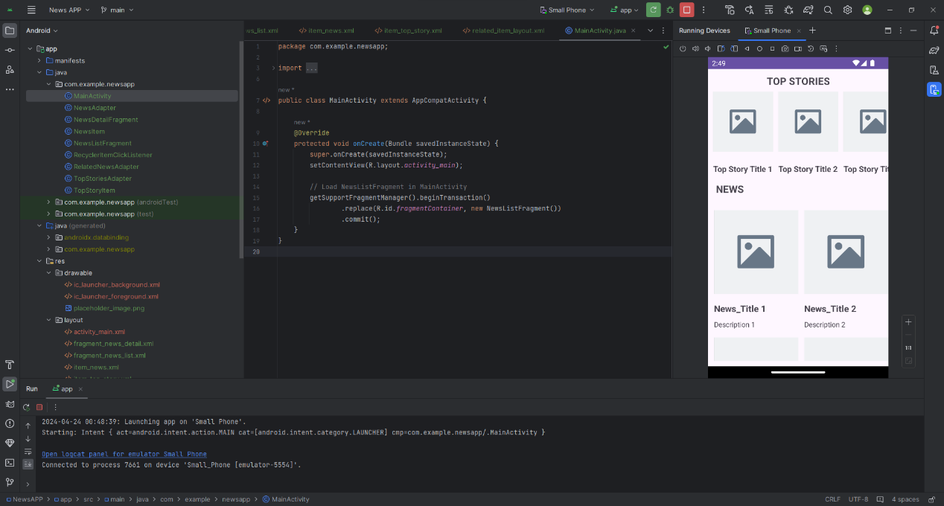

**News details page:**

