**GitHub link: (includes all the files of the project Personalized Learning Experience App, a demo video of it):**

[SIT305_homeworks/Task6.1D/look at here at main · JudsonJia/SIT305_homeworks (github.com)](https://github.com/JudsonJia/SIT305_homeworks/tree/main/Task6.1D/look%20at%20here)

**The screenshot of the main app screen:**

**Main page:**

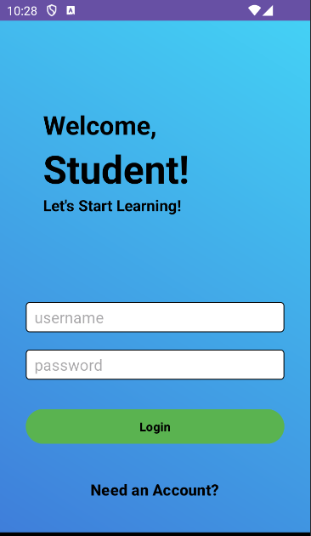

**Interest selecting screen:**

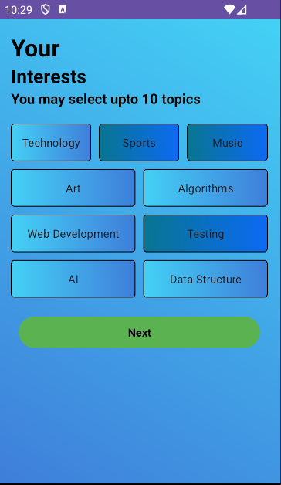

**Registration screen:**

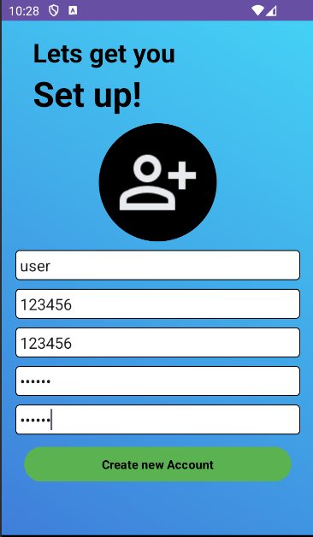

**Quiz initial screen:**

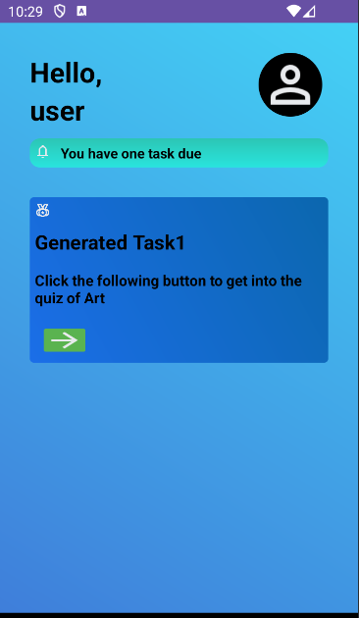

**Quiz screen:**

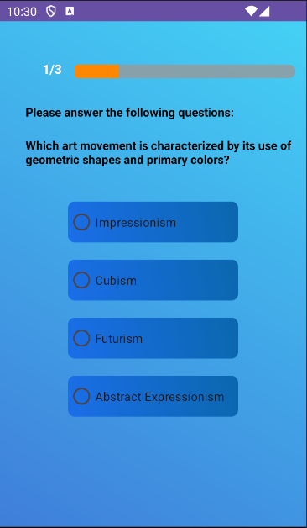

**Final screen:**

