education maintenance allowance erziehungsgeld

criminal justice system Strafjustiz

to resign from zurücktreten

to obey gehorchen

to violate verletzen

dweller einwohner

prosper wachsen

real estate immobilie

disparities ungleichheit

segregation aussonderung

indispensable unerlässich

unskilled labourer Arbeiter ohne qualifikationen

threat of deportation Abschiebungsgefahr

recruitment rekrutierung

trade union gewerkschaft

circumstances umstände

envied beneidet

commuting time pendelzeit

recession wirtschaftlicher rückgang

clogged verstopft

sprawl ausbreiten

social unrest soziale Unstabilität

American dream

American immigration policy:

65000 h1b visas per year (gets filled in 8 or 9 months)

5000 visas per year for unskilled labourers

Visas are mostly based on skill levels

European dream vs American dream

GDP of the EU will overshadow the GDP of USA in a few decades. EU is already world’ leading exporter.

More European companies among the 140 biggest companies in the world.

Higher average life span in Europe and more physicians.

In mathematical literacy America ranks behind 12 European nations and in scientific subjects behind 8 European countries.

Average European vacation is 5-6 weeks a year. America only 2

American emphasizes economic growth, personal wealth and independence. European dream focuses on sustainable development, quality of life and community

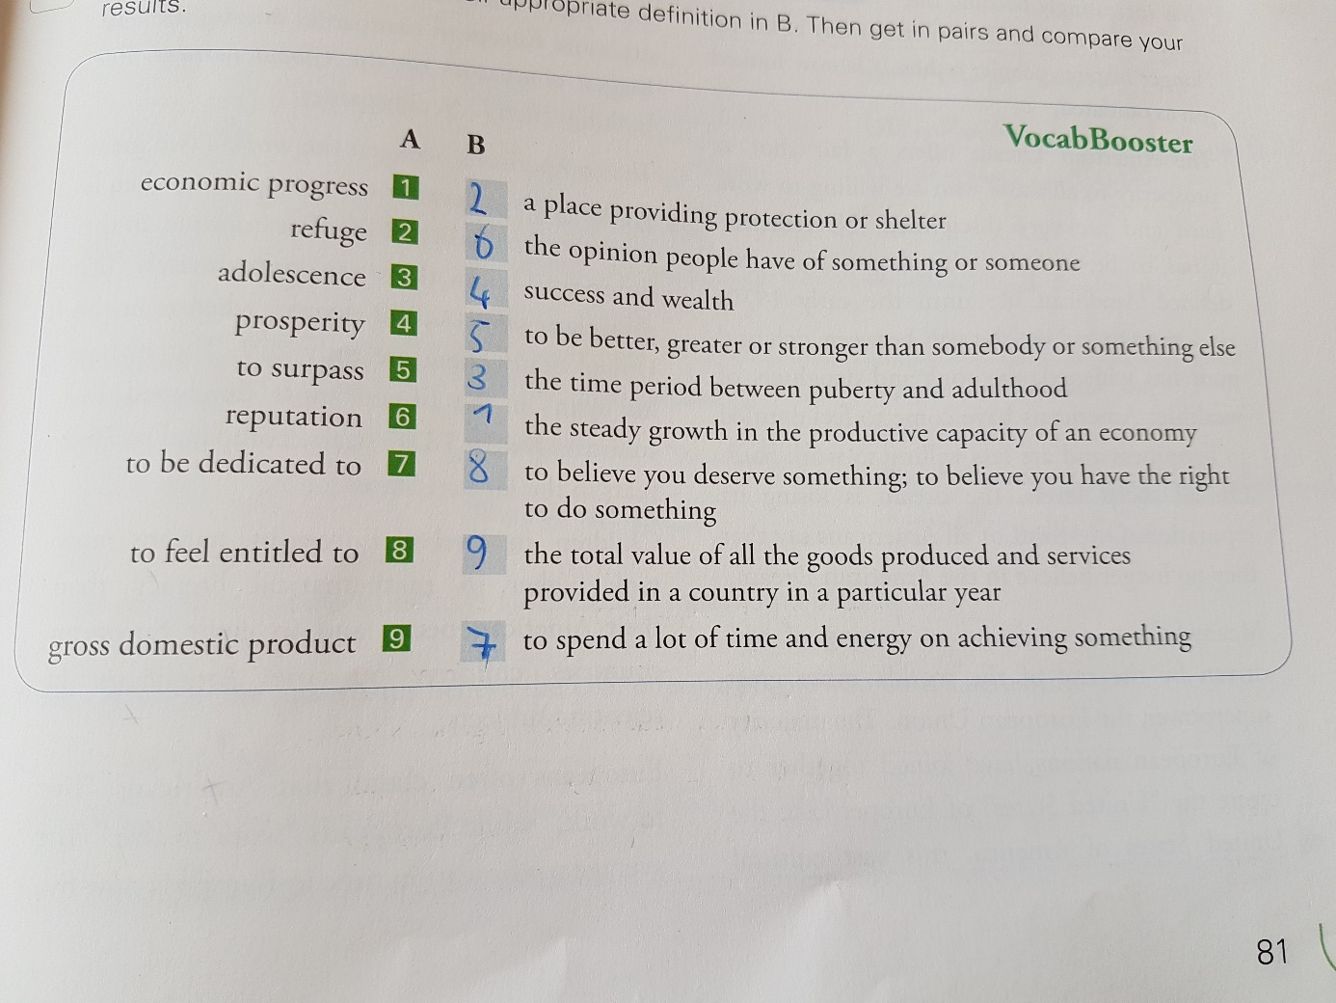

**Megaregions +**

Driving wealth

Huge economical activision

Technological and scientific innovation

Economic growth

**Megaregions –**

Unprecedented urban sprawl

New slums

Unbalanced development

Inequalities (income, wealth…)

Wasteful

Huge energy consumption

Requires much resources

Loss of prime farmland