Inhalt

Github 1

Create new repository on GitHub 1

initialize a local repository for your app with IDE 2

Commit the project in local repository 3

push local repository to global repository 3

clone global repository to another local repository (eg. different PC) 5

manage simple conflicts 7

# 

# **Github**

## Create new repository on GitHub

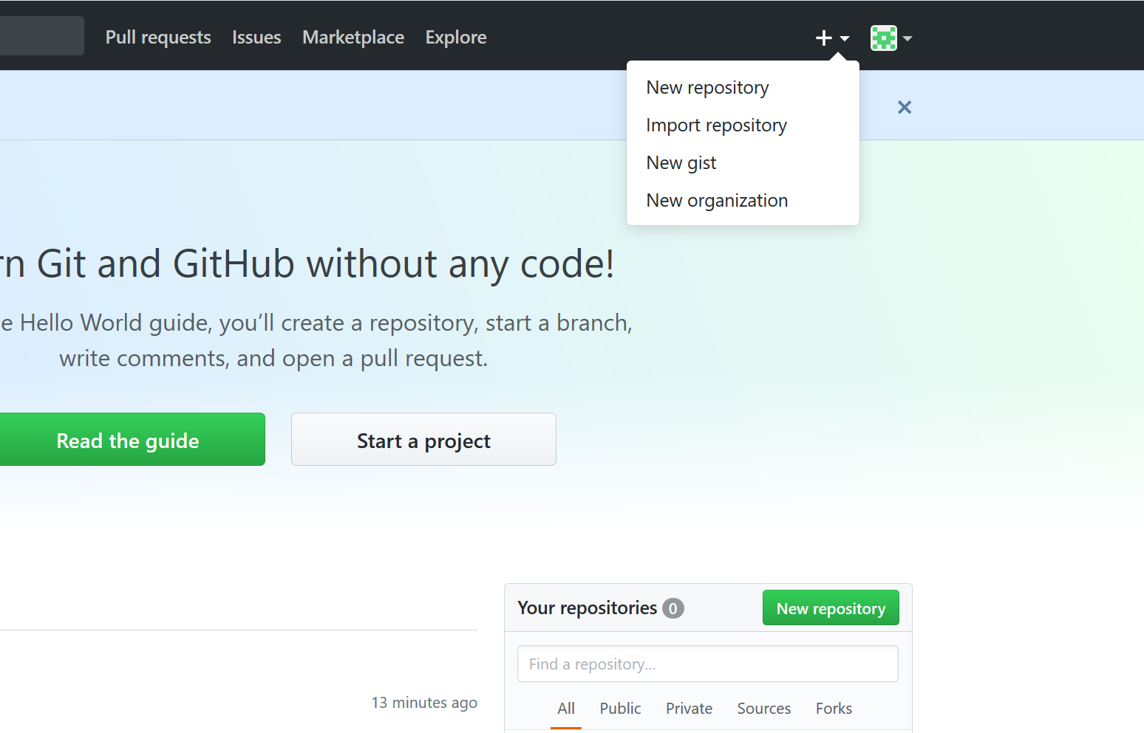

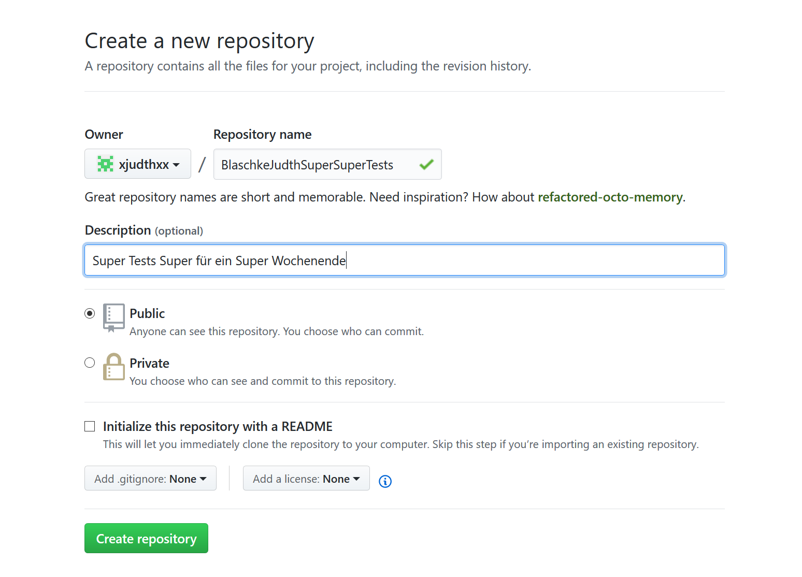initialize a local repository for your app with DIE

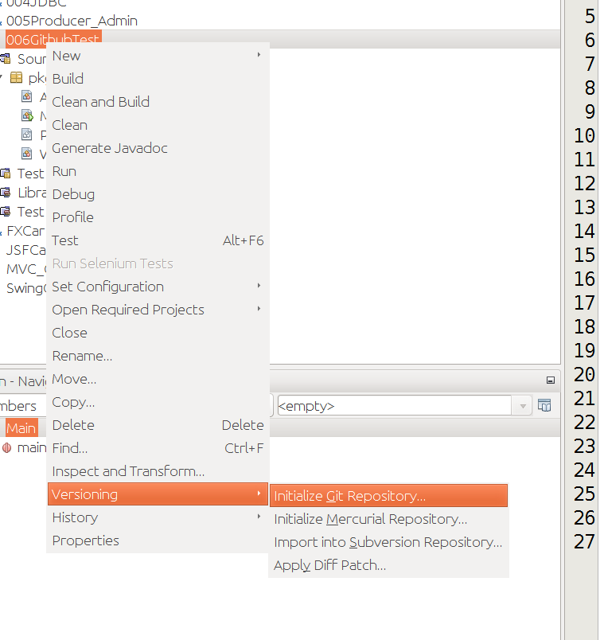

## Commit the project in local repository

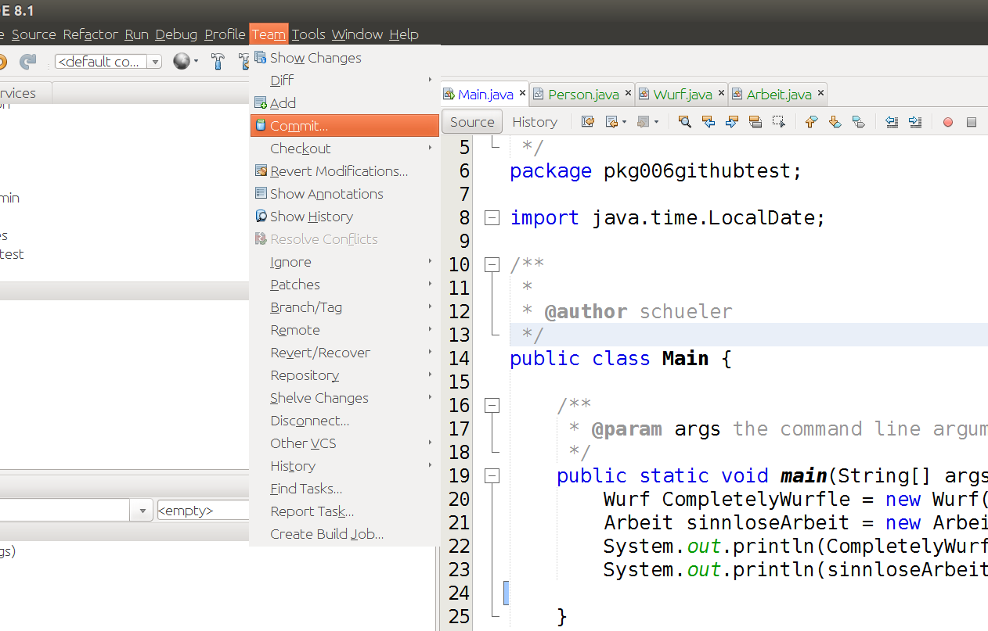

push local repository to global repository

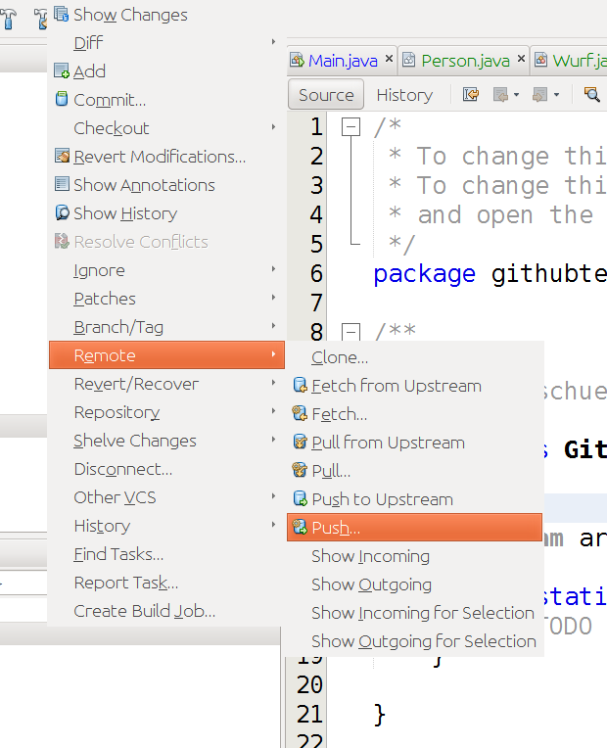

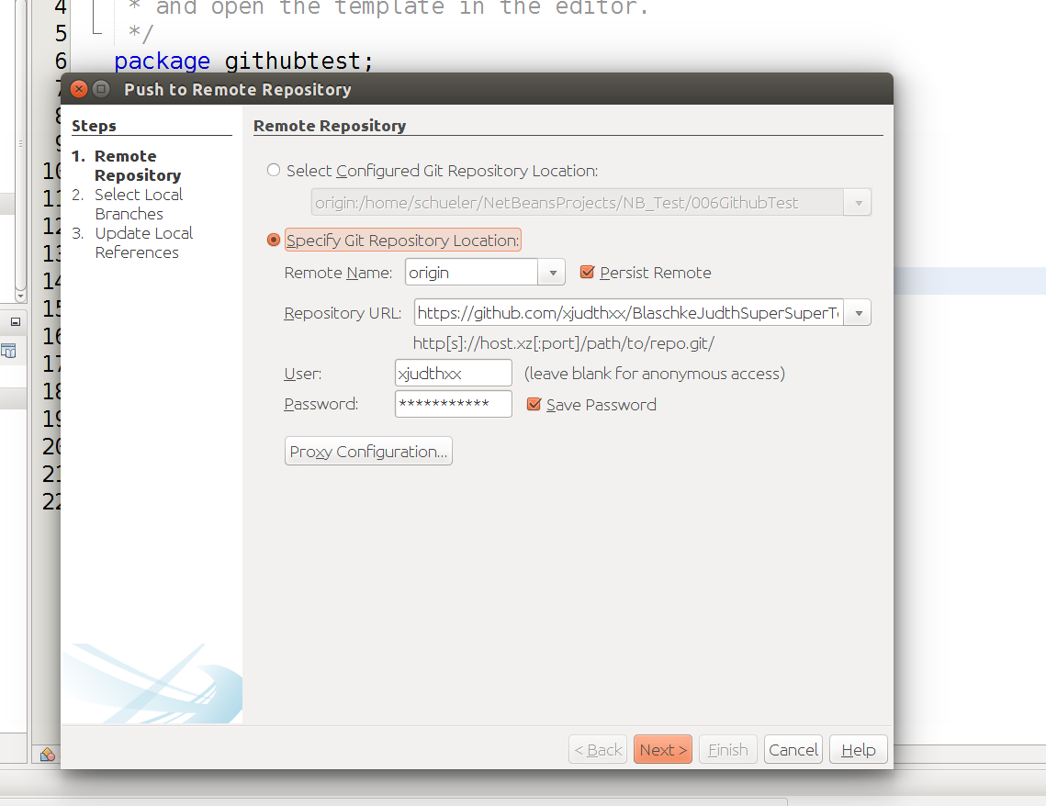

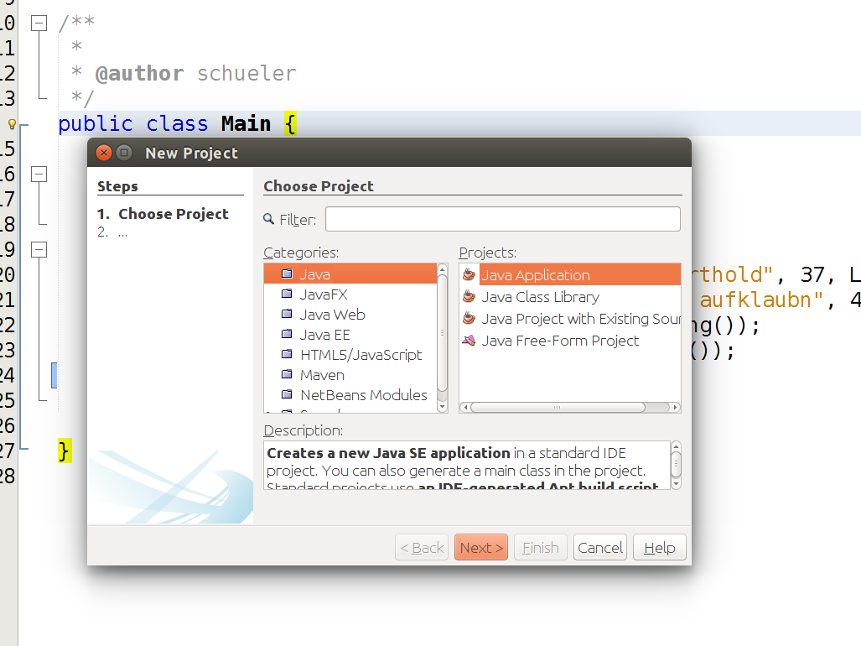

## clone global repository to another local repository (eg. different PC)

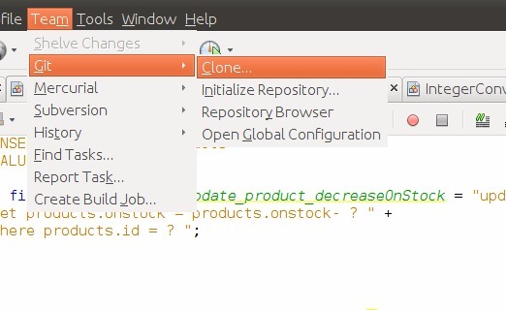

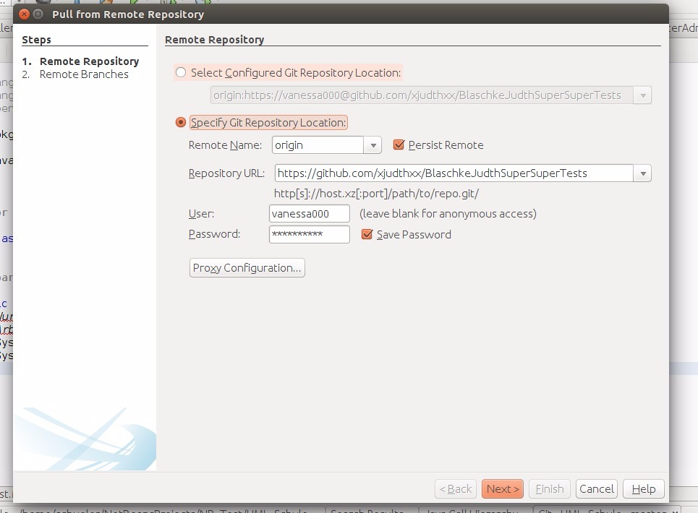



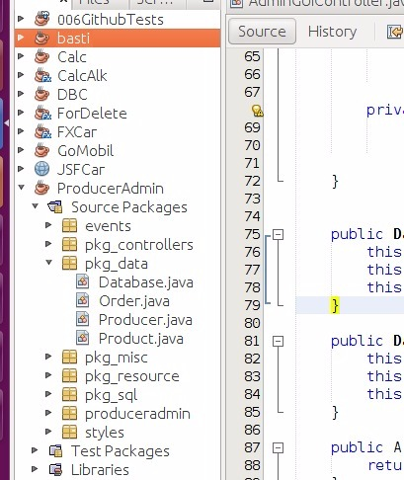

## manage simple conflicts

