GitHub repository：https://github.com/Judy060514/Lab3
Lab 3 Javascript Basics

- 实验目的
To practice the Javascript skills you have learned so far
- 实验内容
Exercise 1
Create a new HTML page. Add a script element to the body of the page. Use JavaScript ‘document.write’ statements to add a heading and a paragraph of text to the document.
Exercise 2
Using a web search, find the properties and methods of the ‘navigator’ object. Write a script that demonstrates one of these properties or methods.
Exercise 3
Create an external JavaScript file called ‘randominteger.js’. In this file, create a function called ‘randomInt’ that generates a random integer between 1 and 100. Call the function from a script element in an HTML page.
Exercise 4
Create a simple number guessing game. A random number between 1 and 100 should be generated from Exercise 3, then challenge the player to guess the number in 10 turns. After each turn, the player should be told if they are right or wrong, and if they are wrong, whether the guess was too low or too high. It should also tell the player what numbers they previously guessed. The game will end once the player guesses correctly, or once they run out of turns. When the game ends, the player should be given an option to start playing again.
三、实验结果
核心代码
Exercise 1 :
<!DOCTYPE html>
<html lang="en">
<head>
<meta charset="UTF-8">
<title>Exercise 1 - document.write</title>
</head>
<body>
<script>
document.write("<h1>Welcome to Lab 3 - Exercise 1</h1>");
document.write("<p>This heading and this paragraph were both generated by JavaScript " +
"using the document.write() method. It shows how JavaScript can add " +
"content directly into an HTML document.</p>");
</script>
</body>
</html>

运行效果：

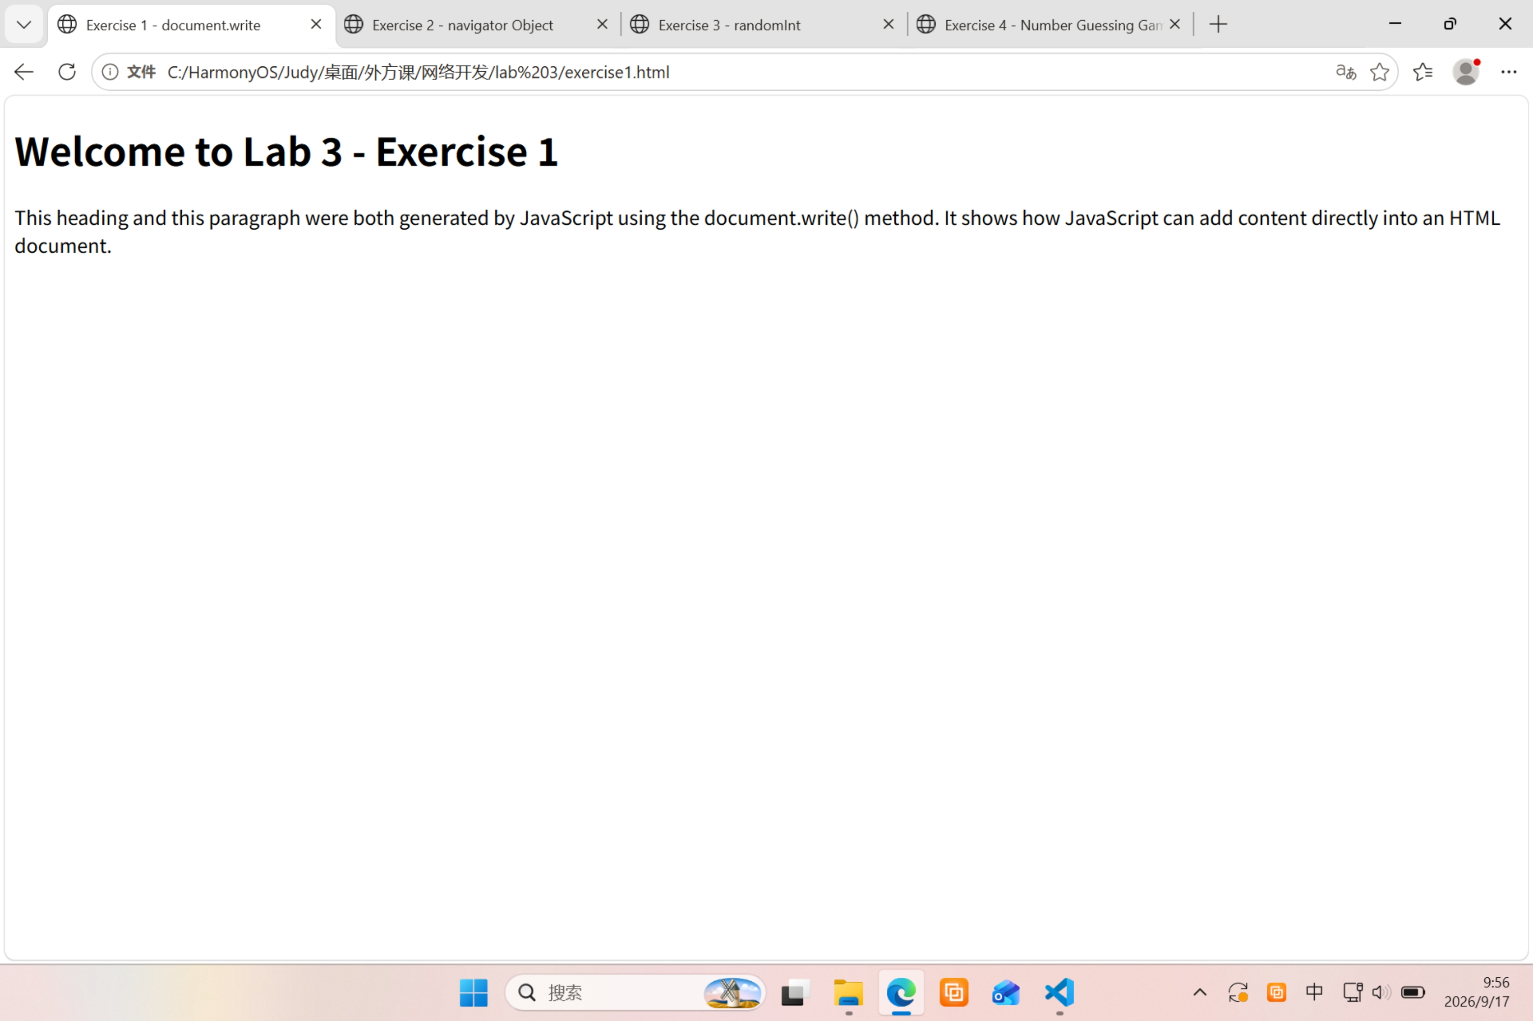
Exercise 2:
<!DOCTYPE html>
<html lang="en">
<head>
<meta charset="UTF-8">
<title>Exercise 2 - navigator Object</title>
</head>
<body>
<h1>Exercise 2 - Navigator Object Demo</h1>
<p>The <code>navigator</code> object contains information about the browser.</p>

<script>
// 属性 1：navigator.userAgent —— 浏览器身份信息
document.write("<h2>Property: navigator.userAgent</h2>");
document.write("<p>" + navigator.userAgent + "</p>");

// 属性 2：navigator.language —— 浏览器语言
document.write("<h2>Property: navigator.language</h2>");
document.write("<p>" + navigator.language + "</p>");

// 属性 3：navigator.platform —— 操作系统平台
document.write("<h2>Property: navigator.platform</h2>");
document.write("<p>" + navigator.platform + "</p>");

// 方法：navigator.javaEnabled() —— 检测 Java 是否启用
document.write("<h2>Method: navigator.javaEnabled()</h2>");
document.write("<p>Java enabled: " + navigator.javaEnabled() + "</p>");
</script>
</body>
</html>

运行效果：
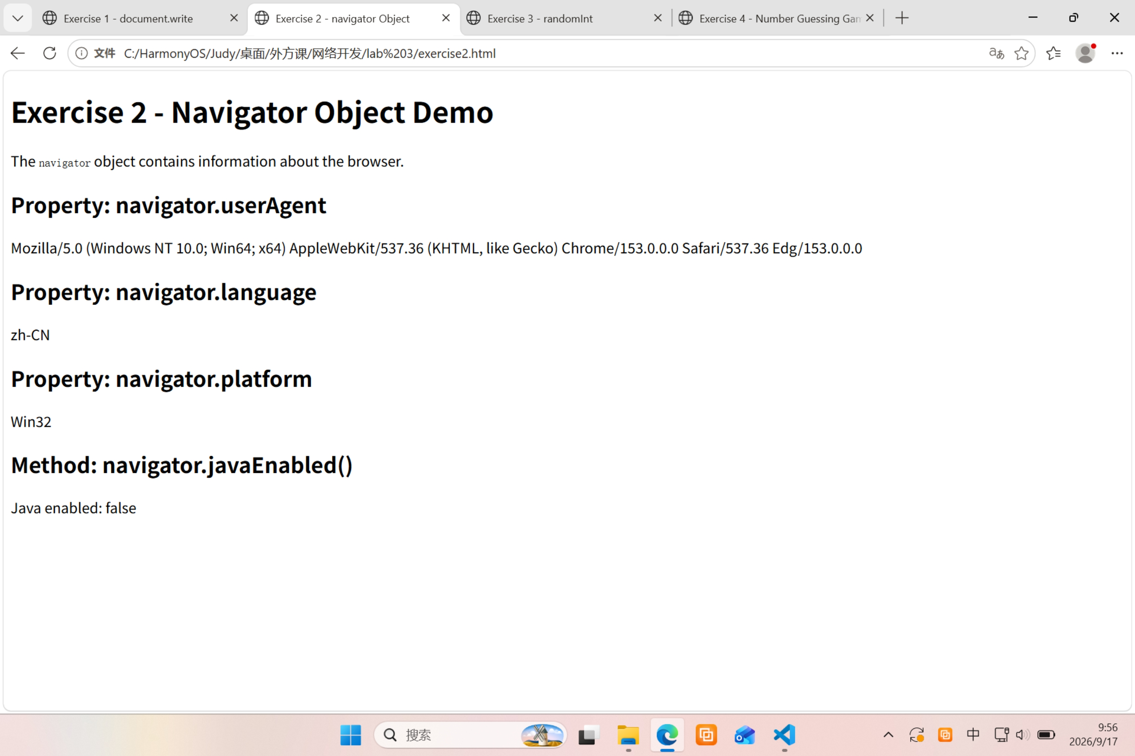

Exercise 3:
<!DOCTYPE html>
<html lang="en">
<head>
<meta charset="UTF-8">
<title>Exercise 3 - randomInt</title>
<script src="randominteger.js"></script>
</head>
<body>
<h1>Exercise 3 - randomInt() Demo</h1>
<p>Calling <code>randomInt()</code> five times to show random integers between 1 and 100:</p>

<script>
for (var i = 1; i <= 5; i++) {
document.write("<p>Call " + i + ": <strong>" + randomInt() + "</strong></p>");
}
</script>
</body>
</html>

randominteger.js:
/*
* randominteger.js
* Lab 3 - Exercise 3
* 生成 1 到 100 之间的随机整数
*/

function randomInt() {
// Math.random() 返回 [0, 1) 之间的小数
// * 100 → [0, 100)
// Math.floor() 向下取整 → 0~99
// + 1 → 1~100
return Math.floor(Math.random() * 100) + 1;
}

运行效果：
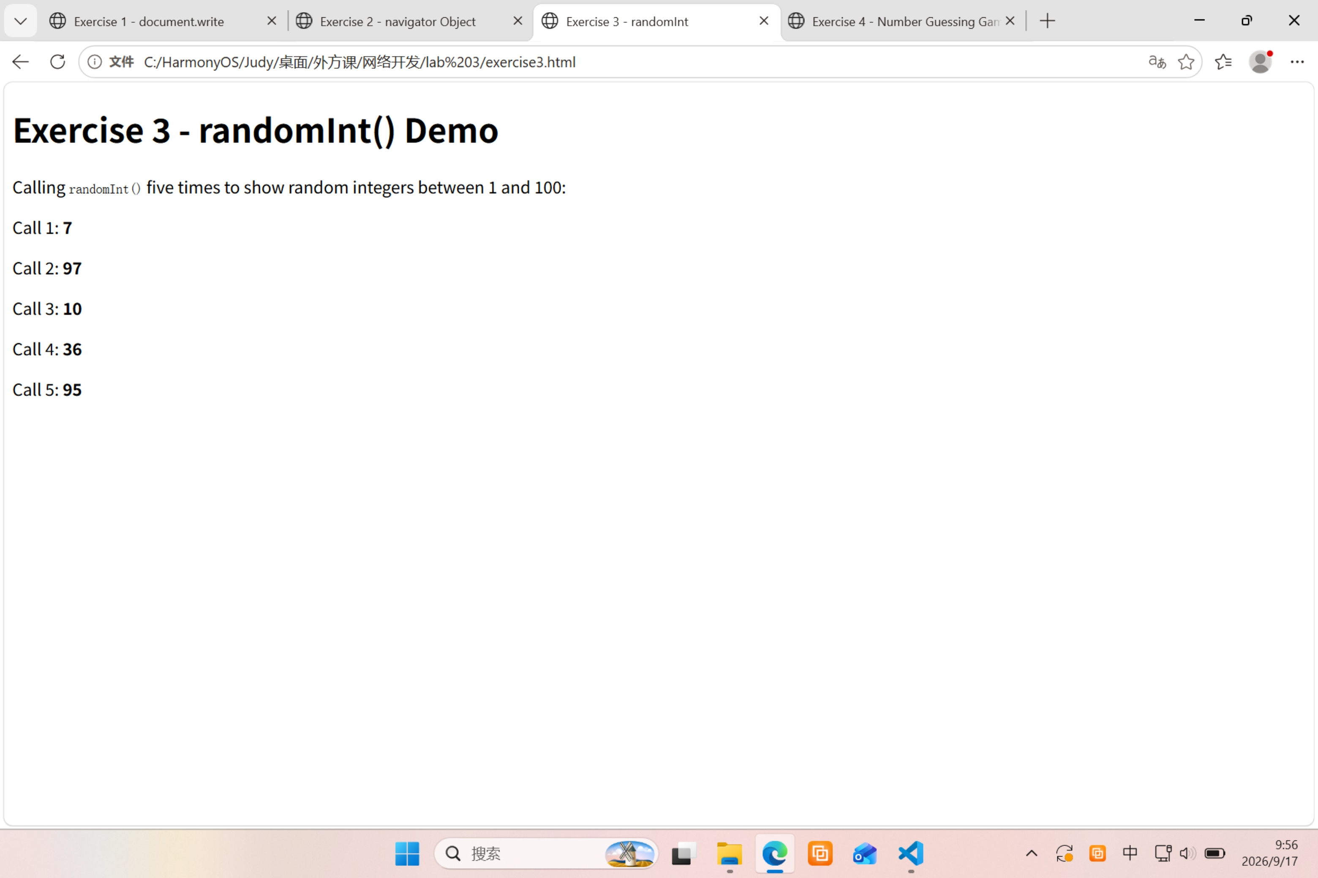
Exercise 4：
<!DOCTYPE html>
<html lang="en">
<head>
<meta charset="UTF-8">
<title>Exercise 4 - Number Guessing Game</title>
<script src="randominteger.js"></script>
</head>
<body>
<h1>Number Guessing Game</h1>
<p>I am thinking of a number between 1 and 100. You have 10 turns to guess it.</p>
<p>Open the browser console (F12) to see the game messages, or press the button below to start.</p>

<button onclick="startGame()">Start Game</button>

<script>
// ===== 游戏主逻辑 =====
function startGame() {
var target = randomInt(); // 用 Exercise 3 的函数生成 1~100
var guessed = []; // 记录玩家猜过的数字
var maxTurns = 10;
var turn = 0;
var correct = false;

// 最多 10 次
while (turn < maxTurns && !correct) {
turn++;
var input = prompt("Turn " + turn + " of " + maxTurns +
"\nGuess a number between 1 and 100:");

// 如果玩家点取消，直接结束
if (input === null) {
alert("Game cancelled. The number was " + target + ".");
return;
}

var guess = parseInt(input, 10);

// 检查是否为有效数字
if (isNaN(guess)) {
alert("Not a valid number: " + input);
turn--; // 无效输入不算一次机会
continue;
}

guessed.push(guess); // 记录这次猜测

// 判断结果
if (guess === target) {
correct = true;
alert("Correct! You guessed the number " + target +
" in " + turn + " turn(s).\n" +
"Previous guesses: " + guessed.join(", "));
} else if (guess < target) {
alert("Too low!\n" +
"Previous guesses: " + guessed.join(", "));
} else {
alert("Too high!\n" +
"Previous guesses: " + guessed.join(", "));
}
}

// 用完 10 次还没猜对
if (!correct) {
alert("Sorry, you ran out of turns.\n" +
"The number was " + target + ".\n" +
"Your guesses: " + guessed.join(", "));
}

// 问玩家是否再玩一次
if (confirm("Do you want to play again?")) {
startGame(); // 递归调用，重新开始
} else {
alert("Thanks for playing!");
}
}
</script>
</body>
</html>

运行效果：

