CS2111 Final Project Summary
INSTRUCTIONS: Type out your answer directly below each question. If a question does not apply to your project, type in N/A. When finished, save this file as a PDF and upload it to the Blackboard.

BASICS
Your group members?
Dana Mounayer and Jwdee Alamam

What is the topic of your final project?
Drive-Thrus guide website in Jeddah

Who is the intended audience?
Residents and visitors in Jeddah who are interested in quick and efficient dining options.

Provide a brief summary of the functionalities of your project.
Our project, ‘On the Go,’ is designed to provide an informative and user-friendly web application showcasing popular drive-thru options within Jeddah. The website includes a responsive navigation bar that is present on all pages for seamless navigation. It provides links to key sections such as Home, About Us, Categories, Reviews, and Contact Us. Users can view various drive-thru categories, which are listed with brief descriptions and visually engaging images. The section allows for easy filtering and selection of specific types of drive-thrus. The project ensures a fully responsive design across all devices, utilizing external stylesheets (MainStyles.CSS) as well as the Bootstrap framework for styling. Additionally, the website includes functionality that allows users to log in and contribute by adding their reviews on drive-thrus, enhancing interactivity and user engagement.

FRONT-END
What is the total page count?
6 webpages
List the names of any external stylesheet used in this project below.
MainStyles.CSS
List any CSS libraries/frameworks used in this project (e.g. Bootstrap) below.
Bootsrap and google fonts

List any JavaScript libraries/frameworks used in this project below.
Bootstrap (Javascript Bundle)

How does your project meet the Interactivity requirement?
We implemented a 'Read More / Read Less' button on the 'About Us' page using JavaScript. This feature allows users to expand or collapse additional content, enhancing user engagement by providing control over how much information they wish to view. When users click 'Read More,' hidden content becomes visible, and clicking 'Read Less' collapses it back. This functionality improves user experience and ensures a clean, organized page layout.

BACK-END
Attach a screenshot of the final database diagram (just the diagram, do not include any records) below.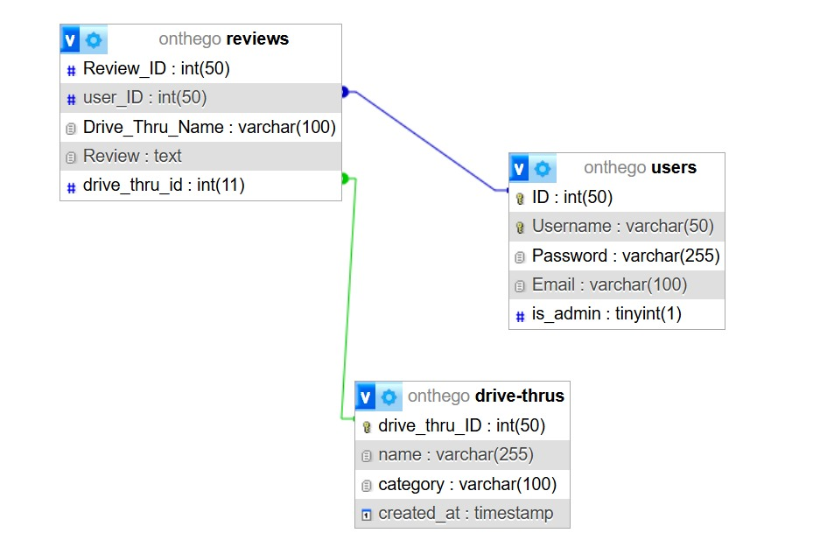

Where in your project do you insert a record to the database (the ‘C’ in CRUD)?
When a logged-in user submits the review form (submit_review POST request), the system inserts a new review into the reviews table using the INSERT INTO SQL query.
Where in your project do you search and display record(s) from the database (the ‘R’ in CRUD)?
Reviews are retrieved and displayed on the reviews page using a SELECT query. The results include the review text, drive-thru name, and user details.

Where in your project do you update and existing record(s) the database (the ‘U’ in CRUD)?
Users can update their reviews via the submit_update POST request, which executes an UPDATE query to modify the review text in the database. This is available only to logged-in users who own the review or admin users.

Where in your project do you delete existing record(s) from the database (the ‘D’ in CRUD)?
Users can delete reviews via the delete_review POST request, which executes a DELETE query. Admins can delete any review, while regular users can delete only their own reviews.

MISC
If your project requires any admin credentials (i.e. only admin users can access a certain page), list the credentials below.
Admin credentials are determined by the is_admin field in the users table. If this value is set to 1, the user is identified as an admin. Admin users can perform additional actions, such as deleting any review, while non-admin users are restricted to managing only their own reviews.

Provide any other information that you think the grader/instructor should know when grading your final project below.

Screenshots

Home page (it might look a bit off but tried screenshotting the whole page)

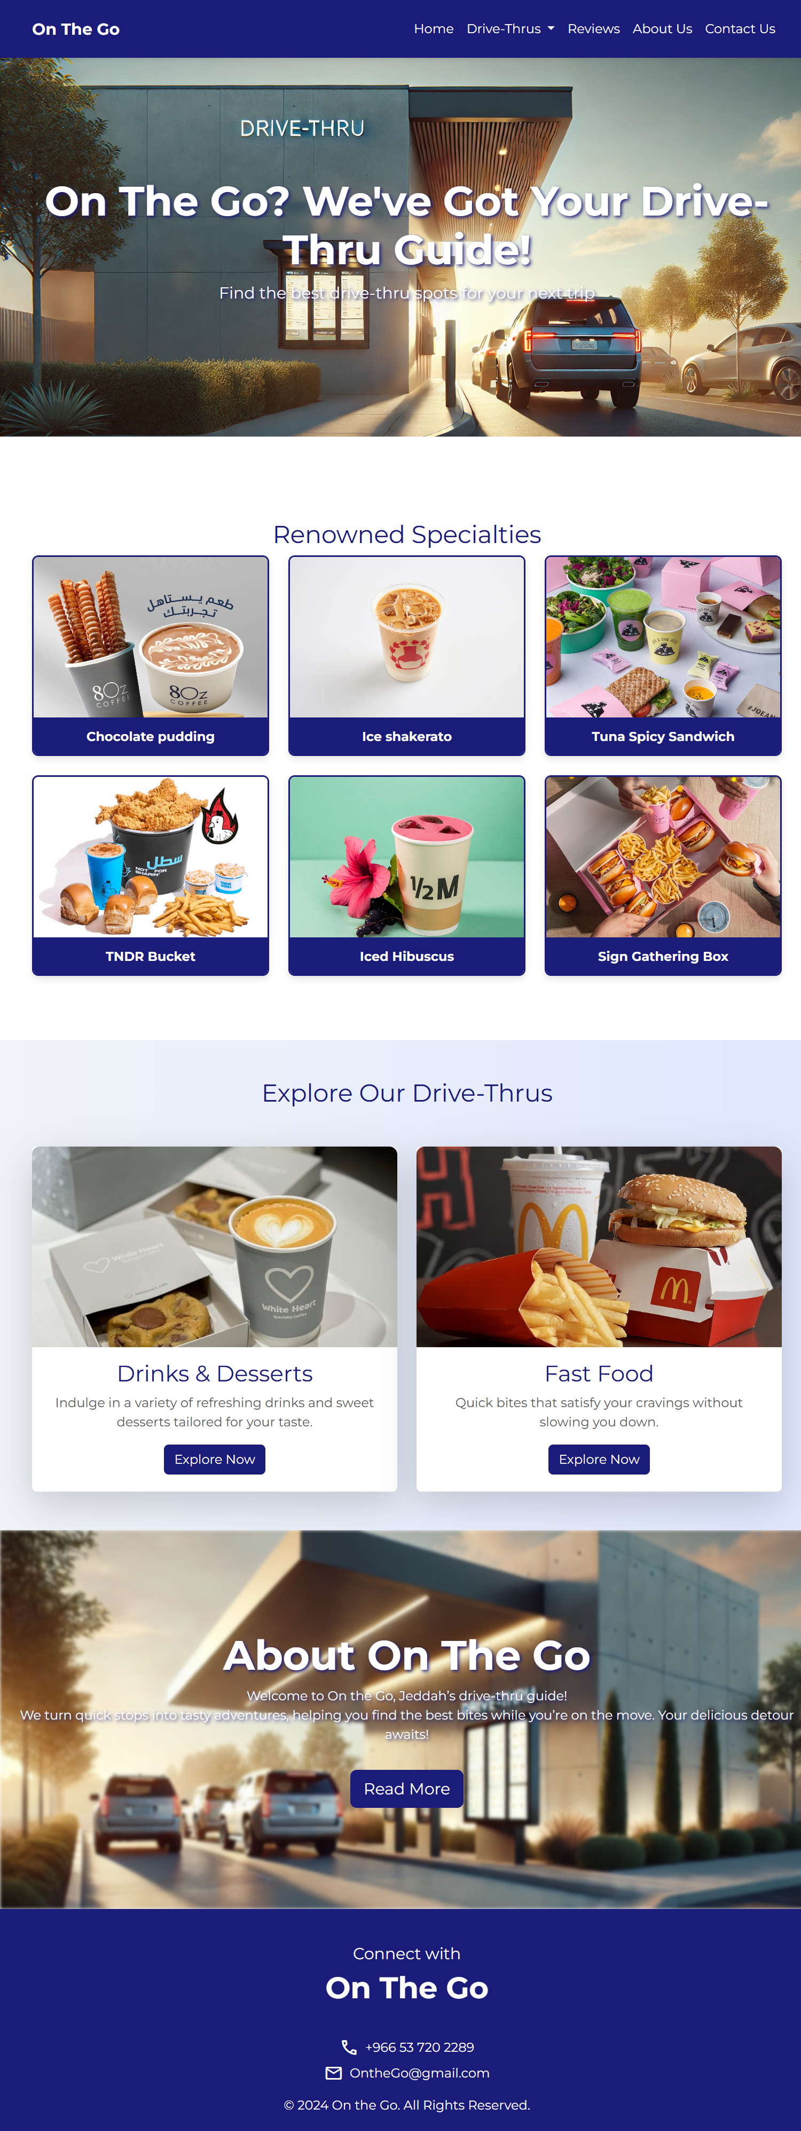
Drive-thrus (Drinks & Desserts webpage and Food webpage)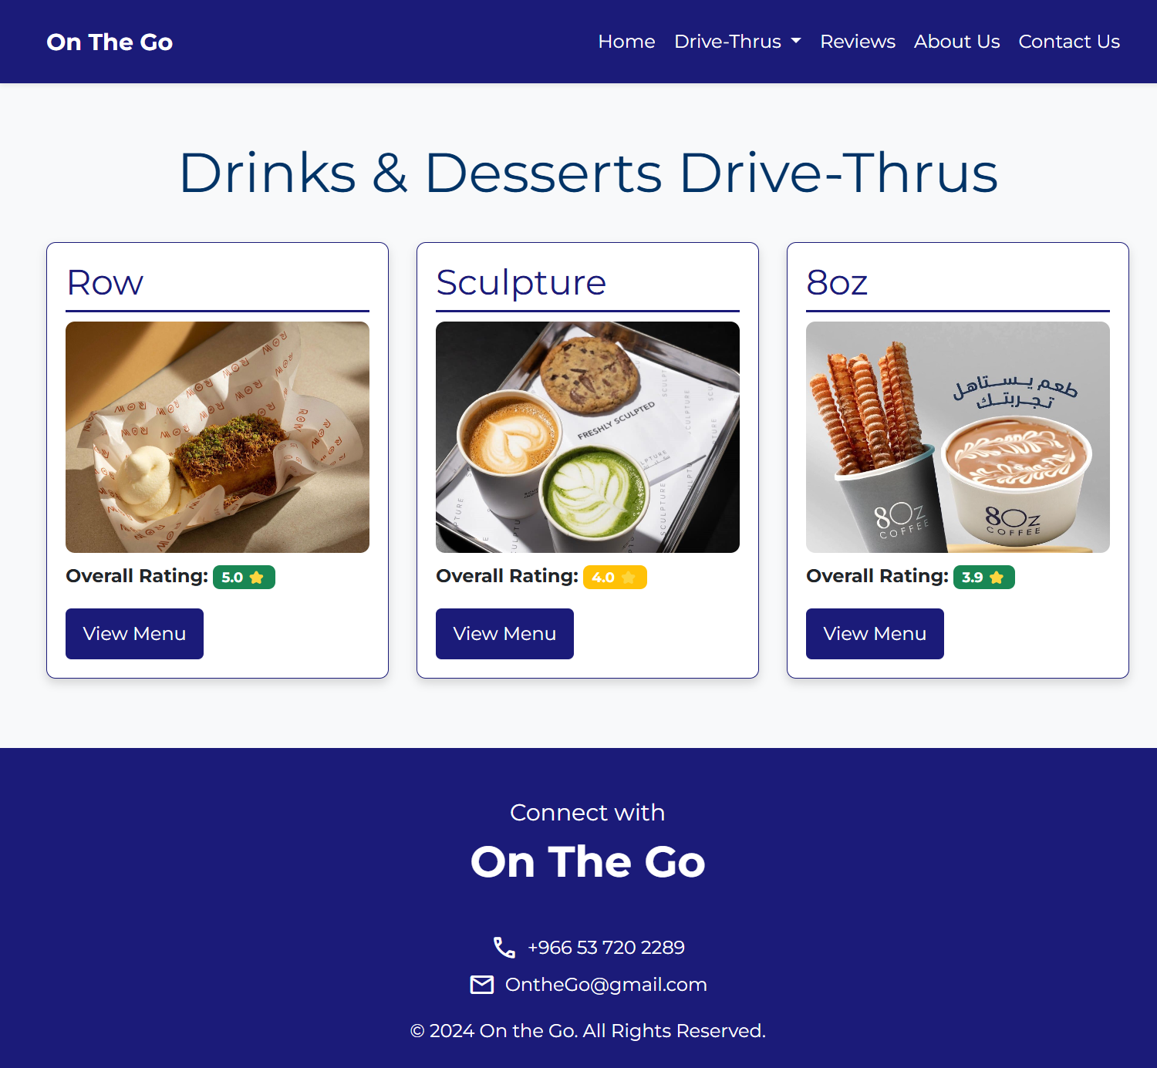 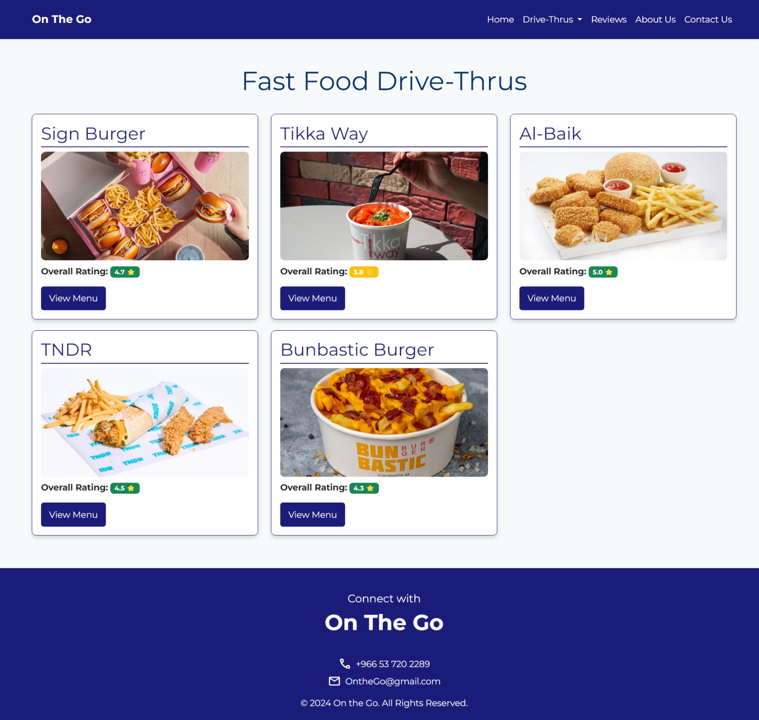

Reviews webpage
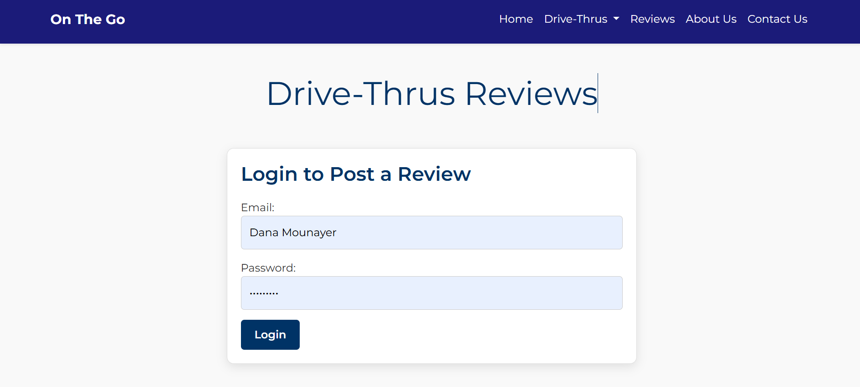
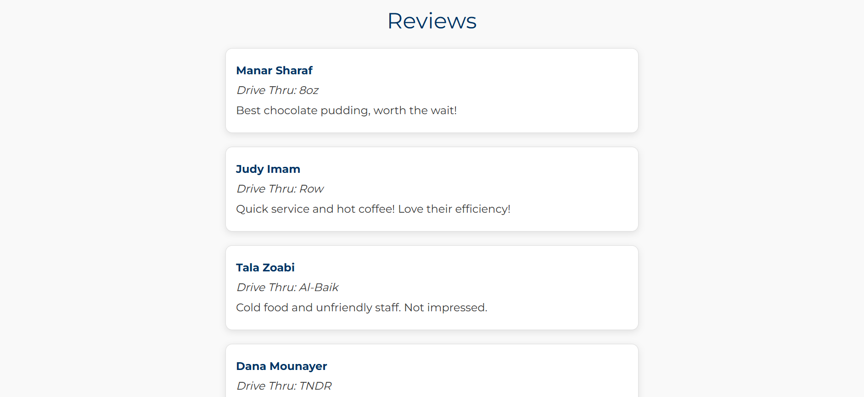
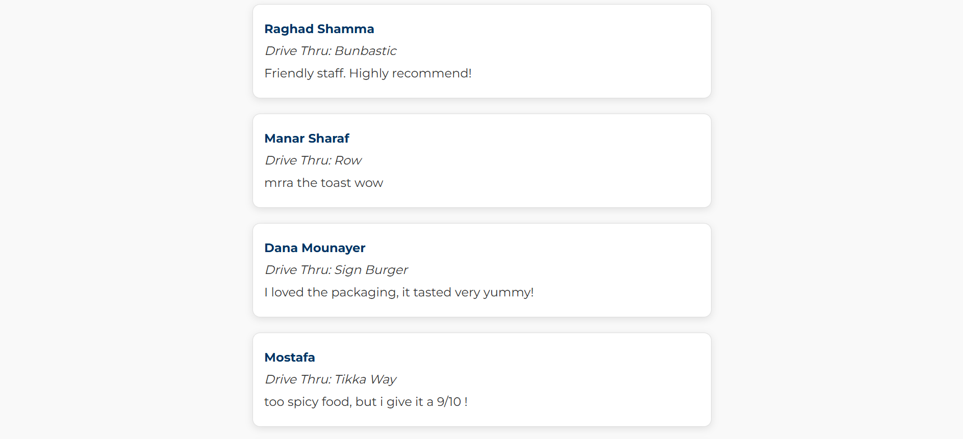
About webpage
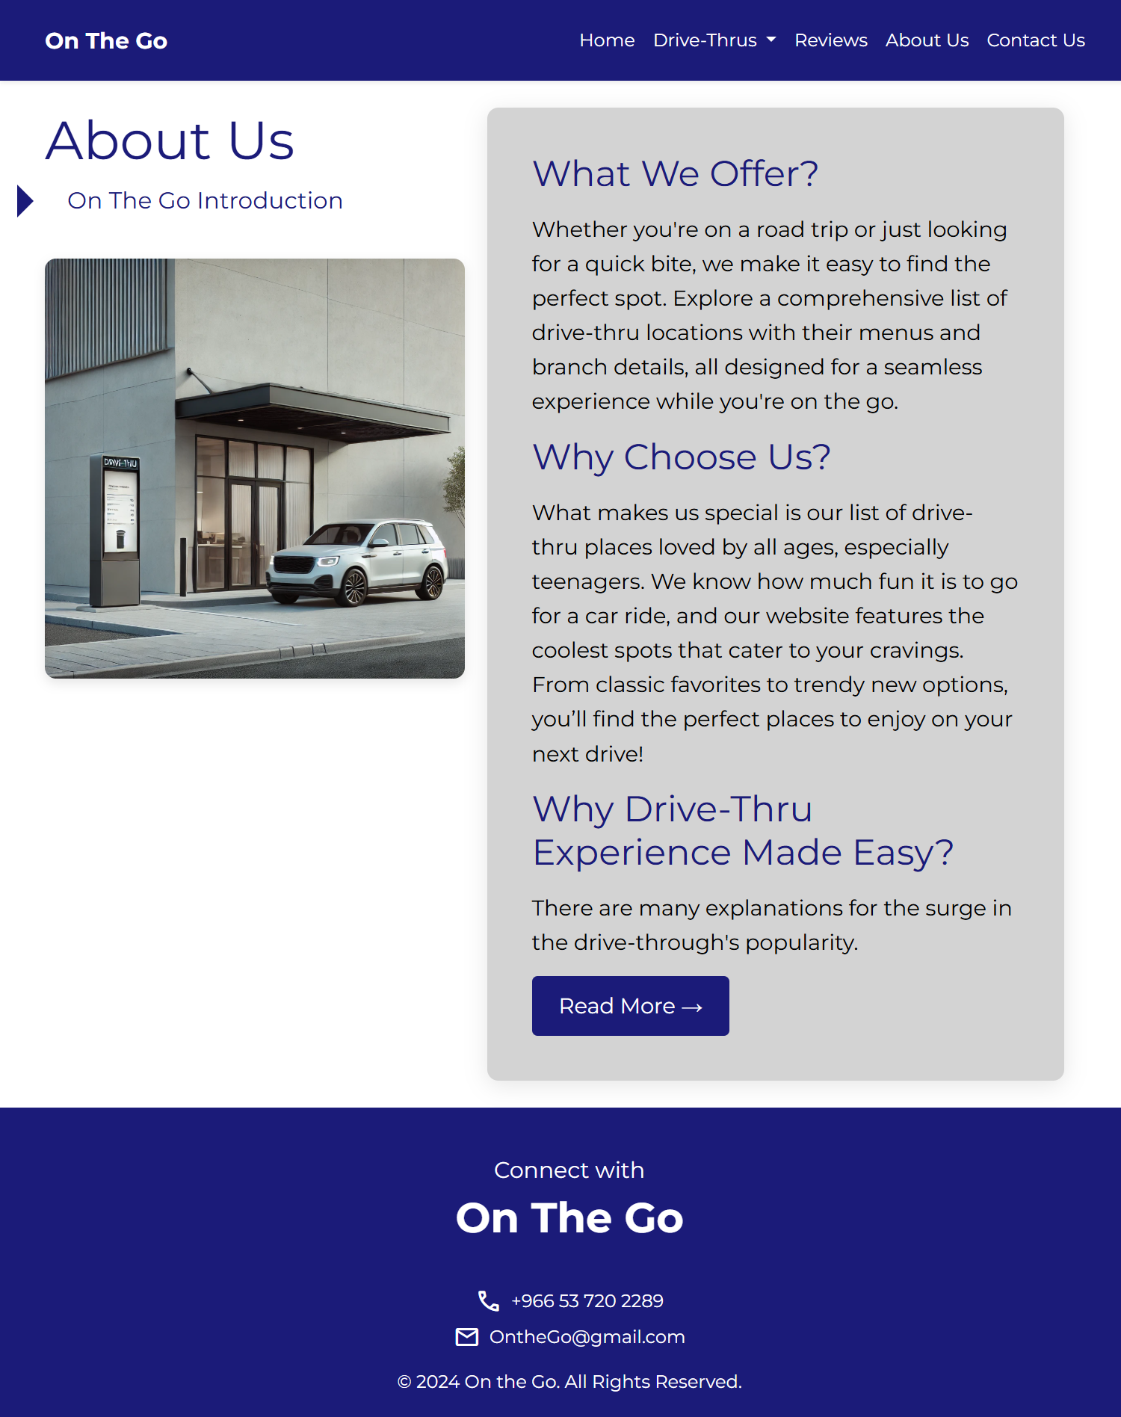

Contact webpage
