
ITS
(Intelligent Transportation System)
From CCTV to Grounded Incident Reports
Senior Project 2 prepared to obtain the degree of B.Sc. in the Department of Artificial Intelligence Engineering and Data Science
Authors:
Khawla Al-Shaikh
Judy Dukmak
Supervised By:
Dr. Assef Jafar
Eng. Wessam Alsohle
Damascus: 2026-2027

SUPERVISOR CERTIFICATION
I certify that the preparation of this project, entitled "ITS (Intelligent Transportation System): From CCTV to Grounded Incident Reports", prepared by Khawla Al-Shaikh and Judy Dukmak, was carried out under my supervision at the Faculty of Artificial Intelligence Engineering in partial fulfilment of the requirements for the degree of B.Sc. in the Department of Artificial Intelligence Engineering and Data Science.
Name:
Date:
Signature:

كلمة شكر وتقدير

إهداء

الملخص
تراقب مراكز إدارة المرور أعداداً كبيرة من كاميرات المراقبة المثبتة على الطرق، ولأن الحوادث المرورية أحداث نادرة فقد تفوت المشغّل أو يلاحظها بعد تأخير. ويتطلب فهم الحادث آلياً تحديد لحظة الاصطدام وموقعه في الصورة ونوع التصادم. وتواجه هذه المسألة ثلاثة تحديات رئيسية: أولها ندرة مقاطع الحوادث الحقيقية الموسومة وصعوبة استخدامها في التدريب، وثانيها الكلفة الحسابية العالية للنماذج الكبيرة التي تحقق أفضل النتائج المنشورة إذا شُغّلت على كل مقطع، وثالثها ضرورة أن تكون التقارير المقدَّمة للمشغّل قابلة للتحقق والتتبع إلى أدلتها.
يقترح هذا المشروع نظاماً من مرحلتين يُدرَّب على مقاطع مصطنعة فقط، مأخوذة من مجموعة بيانات معيارية حديثة تضم 2211 مقطعاً مولَّداً بالمحاكاة، إضافةً إلى 2027 مقطعاً حقيقياً من كاميرات المراقبة تُستخدم للاختبار. في المرحلة الأولى يعطي نموذج فيديو مدرَّب مسبقاً درجةً لكل نافذة زمنية مدتها نحو ثانيتين، ويُقدَّر زمن الاصطدام من قمة منحنى الدرجات مع قيمة تعبّر عن الثقة. وفي المرحلة الثانية يفحص نموذج أكبر وأعلى كلفة نافذة قصيرة حول الزمن المتوقع عندما تكون الثقة عالية، أو المقطع كاملاً عندما تكون منخفضة. بعد ذلك تُخزَّن النتائج على شكل أحداث موثّقة، ويكتب مساعد ذكي تقارير مستندة إليها. وتتمثل القيمة المضافة للمشروع في ثلاثة أمور: قياس قدرة النموذج على الانتقال من المحاكاة إلى الواقع وفق بروتوكول صارم لا يُضبط فيه أي إعداد على البيانات الحقيقية، وقياس مقدار الحساب الذي يوفّره النموذج المدرَّب، وتقييم مدى التزام التقارير بمصادرها. وقد أُنجز حتى الآن تدقيق البيانات، وتثبيت مجموعة اختبار حقيقية من 400 مقطع، وتقسيم البيانات المصطنعة تقسيماً يمنع تسرّب المعلومات، ووسم النوافذ الزمنية، وبناء أداة تقييم تطابق نتائجها القيم المنشورة.

كلمات مفتاحية: كشف الحوادث المرورية، كاميرات المراقبة، البيانات المصطنعة، الانتقال من المحاكاة إلى الواقع، التحديد الزمني للاصطدام.

Abstract
Traffic-operations centres monitor many roadside CCTV cameras, and accidents are rare events that an operator can miss or notice late. Understanding an accident automatically means finding when the impact happens, where it is in the image and what type of collision it is. Three challenges make this hard: labelled real accident video is scarce and usually cannot be used for training; the large vision-language models (VLMs) behind the best published results are too expensive to run on every clip; and reports given to an operator must be traceable to their evidence.
This project proposes a two-stage system trained only on the synthetic clips of the ACCIDENT benchmark (2,211 synthetic CARLA clips and 2,027 real CCTV clips). In the first stage, a VideoMAE-Base window classifier scores every 16-frame window of about 2 s, and the impact time is taken as the peak of the score curve together with a confidence. In the second stage, a VLM examines only a ±2 s window around the predicted time when the confidence is high, or the whole clip when it is low; detections are then stored as validated events, and an LLM assistant writes reports grounded in them. The added value is a clean measurement of synthetic-to-real transfer under a protocol that never tunes on real data, a measurement of the VLM computation saved by a trained first stage, and an evaluation of report faithfulness. Completed so far: a data audit, a frozen 400-clip real test subset, a leakage-safe grouped split, window labelling, and an ACCS scorer that reproduces the published baseline values.

Keywords: accident detection, CCTV, synthetic-to-real transfer, temporal localisation, VideoMAE, vision-language models, cascade.

Table of Contents

List of Tables

List of Figures

List of Equations
Equation (2.1): Scaled dot-product attention
Equation (2.2): Sigmoid score of a window
Equation (2.3): Weighted binary cross-entropy
Equation (2.4): Layer-wise learning-rate decay
Equation (2.5): Linear warmup
Equation (2.6): Cosine learning-rate decay
Equation (2.7): Linear scaling rule
Equation (4.1): Positive-class weight
Equation (4.2): Collision-type weight
Equation (4.3): Window start, end and centre times
Equation (4.4): Frame index of a sampled frame
Equation (4.5): Scheme C soft weight
Equation (4.6): Predicted impact time
Equation (4.7): Confidence of the peak
Equation (4.8): Cascade cost (VLM frames per clip)
Equation (5.1): Per-clip temporal score
Equation (5.2): Temporal score T
Equation (5.3): Per-clip spatial score
Equation (5.4): Collision-type accuracy C
Equation (5.5): Unified ACCS score
Equation (5.6): Mean absolute timing error

List of Terms and Abbreviations
Term | Meaning | Abbreviation / symbol
Accident score | Harmonic mean of the temporal, spatial and collision-type scores of the ACCIDENT benchmark | ACCS
Adam with decoupled weight decay | Optimiser used for fine-tuning | AdamW
Binary cross-entropy | Loss for two-class problems | BCE
Brain floating point 16 | 16-bit number format with the exponent range of fp32 | bf16
Car Learning to Act | Open driving simulator used to render the synthetic clips | CARLA
Closed-circuit television | Fixed roadside surveillance camera | CCTV
Checkpoint | Project milestone in the work plan | CP
Change-point detection | Finding the time at which a signal's statistics change | CPD
Frames per second | Video frame rate | fps
Large language model | Neural language model with billions of parameters | LLM
Low-rank adaptation | Parameter-efficient fine-tuning with low-rank updates | LoRA
Quantised LoRA | LoRA on a 4-bit quantised frozen model | QLoRA
Mean absolute error | Average absolute timing error | MAE
Optical flow | Per-pixel motion between consecutive frames | OF
Object-size dynamics | Heuristic based on the summed area of tracked boxes | OSD
Out-of-fold prediction | Prediction for a clip made by the model that did not train on its fold | OOF
Retrieval-augmented generation | Generation that cites retrieved documents | RAG
Research question | Question the project answers | RQ
Vision Transformer | Transformer applied to image patches | ViT
Vision-language model | Model that answers questions about images or video in text | VLM
Video masked autoencoder | Video transformer pretrained by masked reconstruction | VideoMAE
Ground-truth / predicted impact time | Annotated and predicted time of first contact (s) | t*, t̂
Temporal tolerance | Width of the Gaussian in the temporal score (s) | σ_{t}
Routing threshold | Confidence above which a clip takes the narrow VLM path | τ

Chapter 1: Introduction

1-1- Introduction
Road traffic accidents are rare events, but each one can block lanes, cause secondary collisions and delay emergency response. Traffic-operations centres therefore watch large numbers of roadside CCTV cameras. A single operator cannot look at every feed at the same time, so an accident can be missed or noticed late. Automatic video analysis can help by flagging the moment an accident happens, showing where it happened in the image and what kind of collision it was, and passing this information to the operator in a form that can be checked.
Recent progress makes this problem timely. Public benchmarks now provide real CCTV accident clips with labels for the time, the location and the type of the collision, together with synthetic clips rendered in a driving simulator that can be used for training [1]. At the same time, large vision-language models (VLMs) can describe and localise accidents without task-specific training, and the strongest entries of the 2026 ACCIDENT challenge are built on them [2], [3]. These models, however, are very large and expensive to run on every clip.
This project, presented under the name ITS (Intelligent Transportation System), builds a system that turns roadside CCTV footage into verified accident events and grounded incident reports for a traffic-operations operator. Its first part studies how well a video model trained only on synthetic accident clips transfers to real CCTV, and how such a model can reduce the amount of VLM computation when it is used as the first stage of a cascade. Its second part, an LLM assistant that writes incident reports from stored events and retrieved procedures, is planned for the later weeks of the project. Figure 1.1 shows the overall system.
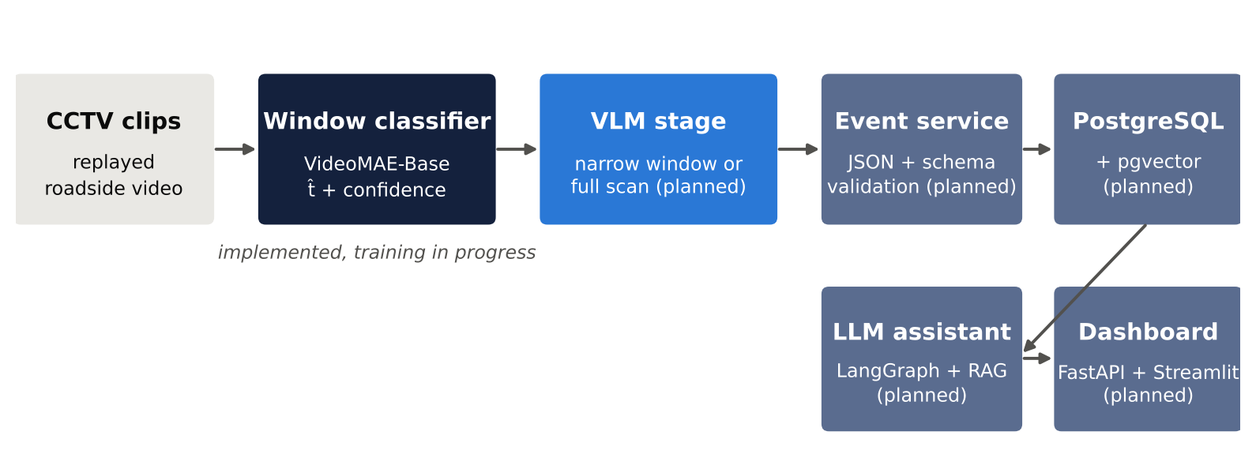
Figure 1.1: Overall architecture of the proposed system. The window classifier is implemented and in training; the other components are planned.

1-2- Research Problem
The project addresses three connected problems:
- Scarce labelled real data. Labelled real accident video is scarce and often cannot be used for training. The ACCIDENT benchmark reflects this: its real clips are meant for testing, while 2,211 synthetic clips rendered in the CARLA simulator are provided for training [1], [19]. A model trained on synthetic clips must cross a large synthetic-to-real gap: real CCTV clips differ in frame rate (4 to 50 fps), resolution (314p to 3840p) and quality, and about one third are recorded at night [1].
- Cost of large VLMs. The best published results on the benchmark use VLMs with 32 billion parameters or more on data-centre GPUs; the first-place pipeline needed about 13 hours on one RTX PRO 6000 GPU for its 32B leg alone [2]. Running such a model on every clip of every camera is not practical for a traffic centre, and not possible on the 8 GB laptop GPUs available to this project.
- Trustworthy reports. An operator needs more than a detection score. Reports must state facts that can be traced to stored events and to the procedures they cite, and must keep the status of an unconfirmed detection as unconfirmed.
Two research questions follow from these problems. RQ1 (core): How well does a video model fine-tuned only on synthetic clips localise accidents in real CCTV footage, compared with a zero-shot large VLM and a small VLM fine-tuned with QLoRA on the same synthetic data, and how much VLM computation does it save as the first stage of a cascade? RQ2 (applied): Are the assistant's reports faithful to the stored events and to the retrieved procedures, and does retrieval-augmented generation (RAG) do better than no retrieval or than placing the whole procedures corpus in the prompt?
Every clip in the benchmark contains an accident. The task is therefore not to decide whether an accident happens, but to find when it happens (impact time), where (impact point) and what type of collision it is, as defined by the benchmark's unified ACCS score [1].

1-3- Research Objectives
Main objective: to build and evaluate a CCTV accident-understanding system in which a video model trained only on synthetic data localises the impact time and routes each clip to a cheaper or a more expensive VLM path, and whose detections become validated events and grounded reports.
Sub-objectives and success thresholds. The thresholds below were fixed before any model was trained. They are measured on the frozen real test subset of 400 clips; published scores use all 2,027 real clips.
Table 1.1: Project objectives and success thresholds.
Component | Objective | Success threshold
Video classifier | Fine-tune a video model on synthetic clips and measure its transfer to real CCTV | Temporal score T above the best heuristic baseline on the same clips
Small VLM (QLoRA) | Fine-tune a 3–7B VLM on synthetic clips | ACCS ≥ 0.41 (stretch ≥ 0.50)
Cascade | Send only uncertain clips to the expensive VLM path | Fewer VLM frames per clip than a full scan at similar ACCS; τ chosen on synthetic data only
Event layer | Store each detection as a validated JSON event | ≥ 98% of outputs pass schema validation
Assistant reports | Write reports grounded in events and retrieved procedures | ≥ 95% of numeric claims correct; 100% of event statuses preserved

1-4- Research Contribution
The expected contributions are measurements and a working system. No claim of novelty or superiority is made before the experiments are complete.
- A measured synthetic-to-real transfer result for a fine-tuned impact-time localiser on ACCIDENT, obtained under a strict protocol: training and every selection step use synthetic data only, and the frozen real subset is used once per final configuration. Within the sources reviewed so far (Chapter 3), no published system trains a temporal localiser on the synthetic ACCIDENT split alone and reports its temporal score on real clips. This statement is limited to the sources that were searched.
- An accuracy-versus-cost curve for a cascade in which a trained classifier proposes the impact time and decides whether a VLM examines only a ±2 s window or the full clip.
- A faithfulness evaluation of LLM incident reports, with numeric claims checked by script against the event database (planned).
- Reusable data infrastructure: a leakage-safe grouped split of the synthetic data, window labels for three labelling schemes, and an ACCS scorer validated against the published baseline values.

1-5- Beneficiaries
- Traffic-operations centres and their operators, who would receive accident alerts with time, location, type and a traceable report, while keeping the final decision.
- Road authorities and emergency services, who depend on early and accurate incident information.
- Researchers in intelligent transportation, who can reuse the transfer measurements, the split and labelling rules, and the evaluation code.

1-6- Thesis Organisation
Chapter 2 presents the theoretical background: video transformers and VideoMAE, binary classification with weighted losses, the optimisation methods used for fine-tuning, the benchmark's evaluation metrics, and the VLM and retrieval methods used in the later stages. Chapter 3 reviews recent studies on CCTV accident understanding, compares existing systems and states the research gap. Chapter 4 describes the methodology: the traditional baselines, the proposed window classifier and its training, the cascade pipeline, and the data and its preparation. Chapter 5 presents the tools, the evaluation methods and the results obtained so far. Chapter 6 gives the conclusions and future work.

Chapter 2: Theoretical Background
This chapter introduces the theory the project relies on. It starts with how a video is represented for a neural network, then explains the Transformer and the VideoMAE model used as the window classifier, the loss and optimisation methods used to fine-tune it, the scoring of temporal localisation, and finally the VLM, QLoRA and retrieval methods planned for the later stages.

2-1- Video as Input to a Neural Network
A digital video is a sequence of images (frames) shown at a fixed rate, measured in frames per second (fps). A colour frame of height H and width W is a tensor of shape 3 × H × W. A short video segment of T frames is therefore a tensor of shape T × 3 × H × W. Video models do not process a whole clip at once; they take a fixed number of frames sampled at a fixed rate. In this project each model input is a window of 16 frames sampled at 8 fps, so it covers 15 × 0.125 = 1.875 s between its first and last frame, and each frame is resized to 224 × 224 pixels.
Recognising an accident requires motion information: two vehicles that approach, touch and change direction. A single frame shows the positions of vehicles but not their motion. Models that look at several frames together can learn how appearance changes over time, which is why a video model is used instead of an image model.

2-2- Transformers and the Vision Transformer
The Transformer [20] processes a set of tokens, vectors that each represent one piece of the input. Its central operation, self-attention, lets every token gather information from every other token. Each token is projected into a query, a key and a value; the attention weights are the similarity between queries and keys, normalised with a softmax:
$Attention(Q,K,V)=softmax\left(\frac{{QK}^{T}}{\sqrt{d_{k}}}\right)V$ (2.1)
where Q, K and V are the matrices of queries, keys and values and d_{k} is the key dimension. A Transformer block combines multi-head self-attention with a small feed-forward network, residual connections and layer normalisation. The Vision Transformer (ViT) [21] applies this to images by cutting an image into 16 × 16-pixel patches and embedding each patch as a token. ViT-Base has 12 blocks and a token width of 768.

2-3- VideoMAE
VideoMAE [10] extends ViT to video. Instead of 2D patches it uses cubes of 2 frames × 16 × 16 pixels, so a 16-frame 224 × 224 input becomes 8 × 14 × 14 = 1,568 tokens, and attention is computed jointly over space and time. VideoMAE is pretrained without labels by masked autoencoding: a very large share of the cubes (90%) is hidden and the model learns to reconstruct them from the rest. Because neighbouring frames are very similar, this high masking ratio forces the model to learn motion and structure rather than copying nearby pixels. The authors report that this pretraining is data-efficient, which matters when the labelled training set is small [10].
After pretraining, the model can be fine-tuned for a downstream task by adding a classification head on top of the pooled token features. The checkpoint used here was additionally fine-tuned on Kinetics-400 [22], a dataset of human-action clips, so its features already describe motion in natural video. Figure 2.1 shows how the model is adapted in this project: the Kinetics classification head is replaced by a new linear layer with a single output.
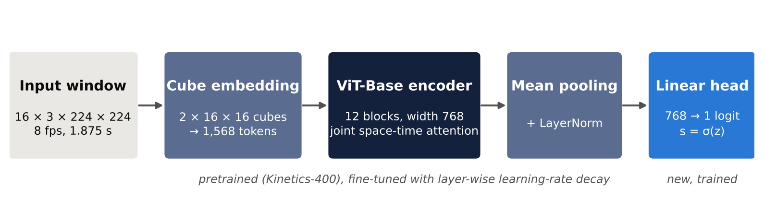
Figure 2.1: VideoMAE-Base as a window classifier: a 16-frame window is embedded as space-time cubes, encoded by a ViT-Base encoder, pooled, and mapped to one logit.

2-4- Binary Classification and Class Imbalance
The classifier answers one question per window: does this window contain the moment of impact? The linear head outputs a real number z (the logit), which the sigmoid function turns into a score between 0 and 1:
$s=σ(z)=\frac{1}{1+e^{−z}}$ (2.2)
The standard training loss for this setting is binary cross-entropy (BCE). It is small when the score is close to the label y ∈ {0, 1} and large when it is far from it. When positive windows are much rarer than negative ones, the model can reach a low loss by predicting "negative" almost everywhere. A common remedy is to weight the loss. With a positive-class weight p and a per-window weight w_{c(i)} that depends on the collision type of the clip, the loss over N labelled windows is:
$L=\frac{1}{N}\sum_{i=1}^{N}{w_{c(i)}\left[−p y_{i} log s_{i}−\left(1−y_{i}\right) log\left(1−s_{i}\right)\right]}$ (2.3)
Setting p to the ratio of negative to positive windows gives both classes the same total weight. The per-type weight raises the influence of rare collision types. Rebalancing by the square root of the inverse class frequency, rather than the full inverse frequency, is a milder correction that has been used for rare classes in large-scale training [17]. The values used in this project are given in Chapter 4.

2-5- Optimisation for Fine-Tuning
AdamW. Adam keeps running averages of the gradient and of its square and uses them to adapt the step size of each parameter. AdamW [12] applies weight decay directly to the weights instead of through the gradient, which separates regularisation from the adaptive step size. It is the optimiser used to fine-tune VideoMAE [10].
Layer-wise learning-rate decay. Lower layers of a pretrained network hold general features that should change little; upper layers and the new head must adapt more. Layer-wise decay [11] gives layer l of L layers the learning rate:
$η_{l}=η_{0}·γ^{L+1−l}$ (2.4)
where η₀ is the learning rate of the head and γ < 1 is the decay factor.
Warmup and cosine decay. A newly initialised head produces large gradients at the start of training. A linear warmup raises the learning rate gradually over the first u_{w} updates, and cosine decay [13] then lowers it smoothly to zero at the last update U:
$η(u)=η_{max}·\frac{u}{u_{w}}, u<u_{w}$ (2.5)
$η(u)=η_{max}·\frac{1}{2}\left(1+cos\left(π\frac{u−u_{w}}{U−u_{w}}\right)\right), u≥u_{w}$ (2.6)
Linear scaling rule. When the batch size B changes, the learning rate is scaled in proportion to it [14]. VideoMAE states its base learning rates for a reference batch of 256:
$η=η_{base}·\frac{B}{256}$ (2.7)
Early stopping [18] keeps the weights of the epoch with the best validation score and stops training when the score has not improved for a set number of checks (the patience). bf16 mixed precision stores activations in a 16-bit format that keeps the exponent range of 32-bit floats, which halves activation memory without the loss scaling needed for fp16 [15].

2-6- Temporal Localisation as Peak Prediction
The benchmark treats the accident time as a peak prediction problem: a method produces a confidence curve s(t) over the clip, and the predicted time is the position of its maximum, t̂ = argmax s(t) [1]. In this project the curve is built from the window classifier's scores, one per window. Each prediction is compared with the ground-truth impact time t* by a Gaussian similarity with tolerance σ_{t}, defined formally in Chapter 5. Figure 2.2 shows how strongly the tolerance changes the score of the same error: a prediction 1 s late scores 0.14 at σ_{t} = 0.5 s, 0.61 at 1 s and 0.88 at 2 s. A prediction made on the aftermath of a crash, several seconds after first contact, therefore scores almost nothing at the strict tolerances.
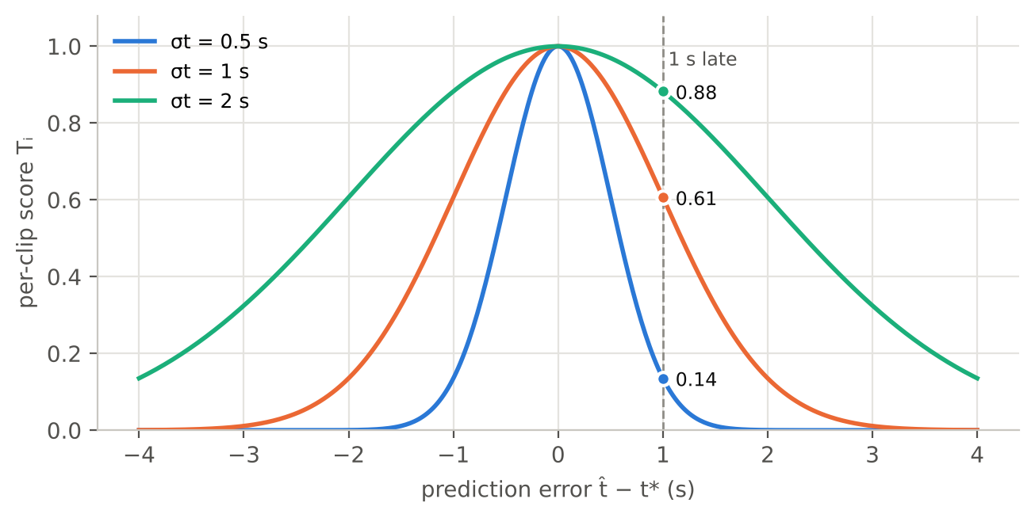
Figure 2.2: Per-clip temporal score as a function of the prediction error for the three tolerances used by the benchmark.

2-7- Vision-Language Models and Parameter-Efficient Fine-Tuning
A vision-language model combines an image or video encoder with a large language model, so it can answer questions about visual input in text. Open models such as Qwen2.5-VL and Molmo were used as zero-shot baselines on ACCIDENT [1], and Qwen3-VL models are the basis of the strongest challenge pipelines [2], [3]. Zero-shot means the model is used as it is, with only a prompt and no task-specific training.
Fine-tuning all weights of a multi-billion-parameter VLM does not fit on a laptop GPU. LoRA [23] freezes the pretrained weights and learns small low-rank update matrices added to selected layers. QLoRA [24] additionally stores the frozen weights in 4-bit precision, which lowers memory enough to fine-tune large models on a single GPU. QLoRA is planned for the small-VLM stage of this project.

2-8- Cascades and Retrieval-Augmented Generation
A cascade combines a cheap model with an expensive one: the cheap model handles the inputs it is confident about, and only the uncertain ones are passed on. The routing threshold τ trades accuracy against cost. In this project the cheap stage is the window classifier and the expensive stage is a VLM (Section 4-3-2).
Retrieval-augmented generation [25] gives a language model access to an external document collection: relevant passages are retrieved for each question and placed in the prompt, so the answer can cite them. RAG is planned for the incident-report assistant, where reports must cite stored events and retrieved procedures.

Chapter 3: Literature Review
This chapter reviews recent work that is closest to the project: the ACCIDENT benchmark and the methods submitted to its 2026 challenge, related accident datasets, and LLM agents for traffic incidents. Most of the accident-understanding works are 2026 preprints on arXiv; their publication status should be checked before the final submission. Numerical results are quoted from the papers themselves.

3-1- Previous Studies in Related Areas

3-1-1- ACCIDENT benchmark (Picek, Čermák, Hanzl and Čermák, 2026)
Contribution. Defines a benchmark for accident understanding in fixed-view traffic-surveillance video with three tasks: when the accident happens (temporal localisation), where (impact point) and what type it is (head-on, rear-end, sideswipe, single-vehicle, t-bone). It provides 2,027 curated real CCTV clips and 2,211 synthetic CARLA clips, together with in-distribution, geographic out-of-distribution, zero-shot and sim-to-real protocols [1]. Models. Naive priors (clip midpoint, image centre, majority class); training-free heuristics based on optical flow (OF) and object-size dynamics (OSD) of YOLO11x + ByteTrack tracklets [30] with kernel change-point detection [26]; zero-shot Qwen2.5-VL-7B and Molmo-7B; and linear probes on frozen DINOv2 and SigLIP2 features trained on synthetic data. Metrics. Gaussian temporal score T at σ_{t} = 0.5, 1, 2 s, anisotropic Gaussian spatial score S, top-1 type accuracy C, and their harmonic mean ACCS. Results. Best temporal score T = 0.343 (Molmo-7B, σ_{t} = 1 s); best end-to-end chain ACCS = 0.412 ("best from all", a modular upper bound); human agreement T = 0.979. Strengths: a unified task with uncertainty-aware metrics and synthetic training data. Weaknesses: all baselines are far below human level, and the paper does not state which σ_{t} enters ACCS (the end-to-end values match σ_{t} = 1 s).

3-1-2- Multi-stage VLM pipeline (Tatematsu and Takahashi, 2026)
Contribution. First-place solution of the ACCIDENT challenge at the CVPR 2026 AUTOPILOT workshop [2]. Model. Qwen3-VL-32B-FP8 in three stages: a full-clip scan at 4 fps (up to 128 frames, each stamped with its time), a constrained time refinement, and single-frame spatial grounding, followed by a 9:1 ensemble with Qwen3-VL-235B-A22B and a snap to detected vehicle boxes. No training. Results. ACCS 0.5669, T 0.5600, S 0.5441, C 0.5994. Strengths: decomposes a hard joint query into simpler stages. Weaknesses: about 13 GPU-hours for the 32B leg and about 10 hours on 8 GPUs for the 235B leg for 2,027 clips; several settings were checked on the public leaderboard, which is part of the test data; CARLA-trained models improved synthetic validation but lowered the leaderboard score, and no numbers were published for them.

3-1-3- Coarse-to-fine VLM-tracking pipeline (Saha et al., BUET, 2026)
Contribution. A training-free solution that adds detection and tracking to a frozen VLM [3]. Model. A sparse full-clip scan with Qwen3-VL-32B-Instruct for coarse time and type, then a ±2 s window at native frame rate with YOLO11x boxes and BoT-SORT identities drawn on 24 frames, and a second VLM call. Results. T 0.549, S 0.468, C 0.503, harmonic mean 0.504 on one H100 (80 GB), at about 40–90 s per clip. Strengths: the coarse-to-fine design avoids depending on a single frame. Weaknesses: night and compression cause missed detections; single-vehicle crashes are often predicted as t-bone; the authors deliberately avoid the CARLA labels and leave domain adaptation to future work.

3-1-4- Two-pass zero-shot grounding (Huang, 2026)
Contribution. A two-pass zero-shot method with a gate that keeps the first-pass time when the refined time is invalid or lies at the window boundary [4]. Results. The second pass raised T from 0.463 to 0.497 at σ_{t} = 1 s. The paper reports that VLMs tend to predict late (mean +1.55 s), choosing a frame of the wreckage instead of first contact, and that T was lowest for single-vehicle crashes (0.359 against 0.661 for t-bone). Strength: clear error analysis. Weakness: relies on large VLM calls.

3-1-5- Modular zero-shot pipeline (Thakur and Talele, 2026)
Contribution. A lightweight training-free pipeline with three independent modules [5]. Model. Frame differencing with smoothing and peak detection for time, Farneback optical flow for location, and CLIP ViT-B/32 with text prompts for type. Results. Public-leaderboard score 0.2523 (about 25% of the test data). Strength: cheap to run. Weaknesses: frame differences spike on vegetation or cloud motion, and CLIP is confused by overhead CCTV viewpoints (it predicted t-bone for all 10 head-on calibration clips).

3-1-6- SynCrash (Bagchi, Jangir and Raskar, IIT Jodhpur, 2026)
Contribution. The published design closest to this project [7]. Model. VideoMAEv2-giant trained on 16-frame 224 × 224 windows from the CARLA clips, with degradation augmentation; the predicted time is the centre of the highest-scoring window after smoothing. The backbone is initialised from dashcam weights, so the method is not trained on synthetic data alone. Results. Harmonic mean 0.38 (public) and 0.40 (private), 17th place. Weakness: no temporal score T is reported, so the effect of synthetic training on timing cannot be read from the paper.

3-1-7- TAD benchmark (Xu et al., IEEE Access)
Contribution. A surveillance accident benchmark with supervised image classification (ResNet50), video classification (SlowFast, VideoSwin) and object detection (Faster R-CNN, YOLOv5/8/9, RT-DETR) [8]. Results. VideoSwin outperformed SlowFast on every video-classification metric, and YOLOv8m gave the best overall detection results. Strength: supervised baselines on real surveillance data. Weaknesses: small and distant targets are detected with low confidence; the paper's video counts are internally inconsistent (344 vs. 404).

3-1-8- Virtual Traffic Police (Wei, Wang and Yang, 2026)
Contribution. An LLM agent that adapts an existing traffic-signal controller when an unforeseen incident occurs [9]. Model. DeepSeek-V3 or GPT-4o with a traffic-knowledge retrieval system (RAG), a verifier, and self-refinement, on top of Max-pressure or MPC controllers in SUMO. Results. For a car accident under oversaturated demand with Max-pressure, average delay fell from 305.51 s to 232.33 s. Strength: shows that retrieval and verification can make LLM decisions safer. Weaknesses: simulation only, one intersection, and the incident is assumed to be known rather than detected from video.

3-2- Modern Techniques and Frameworks
- Video transformers (VideoMAE [10], VideoMAEv2, VideoSwin) learn space-time features and are the standard backbones for clip and window classification.
- Vision-language models (Qwen2.5-VL, Qwen3-VL, Molmo) answer questions about images and video in text and dominate the ACCIDENT challenge [2], [3]; their temporal accuracy improves when frames carry explicit time stamps.
- Detection and tracking (YOLO11, ByteTrack [30], BoT-SORT) provide vehicle boxes and identities that feed heuristics or are drawn on frames for a VLM.
- Change-point detection (KernelCPD [26]) finds the time at which the statistics of a signal change; the benchmark heuristics apply it to motion and box-area signals.
- Parameter-efficient fine-tuning (LoRA [23], QLoRA [24]) adapts large models on a single GPU.
- LLM agents with retrieval (RAG [25], graph-based orchestration such as LangGraph) let a language model call fixed tools and cite retrieved sources.

3-3- Comparative Analysis of Systems
Table 3.1 compares four existing systems with the design of this project. Figure 3.1 summarises the published scores on the 2,027 real clips.
Table 3.1: Comparison of existing accident-understanding systems with the proposed design.
System | Approach | Training | Result (real clips) | Strengths | Weaknesses
ACCIDENT baselines [1] | Heuristics, zero-shot 7B VLMs, linear probes | Probes on synthetic (type only) | ACCS 0.412 (modular) | Reproducible; unified metric | Far below human level
Multi-stage VLM [2] | 3 VLM stages, 32B + 235B ensemble | None | ACCS 0.567, T 0.560 | Highest accuracy | Tens of GPU-hours; settings checked on public LB
Coarse-to-fine VLM [3] | 2-pass 32B VLM + YOLO11x + BoT-SORT | None | HM 0.504, T 0.549 | Grounded in tracked vehicles | 80 GB GPU; 40–90 s per clip
SynCrash [7] | VideoMAEv2-g on CARLA windows | CARLA + dashcam init. | HM 0.40 (17th) | Uses synthetic labels | No T reported
This project | Window classifier → VLM on ±2 s or full clip | Synthetic only | Pending | Measures transfer and cost | Small models; 8 GB GPU

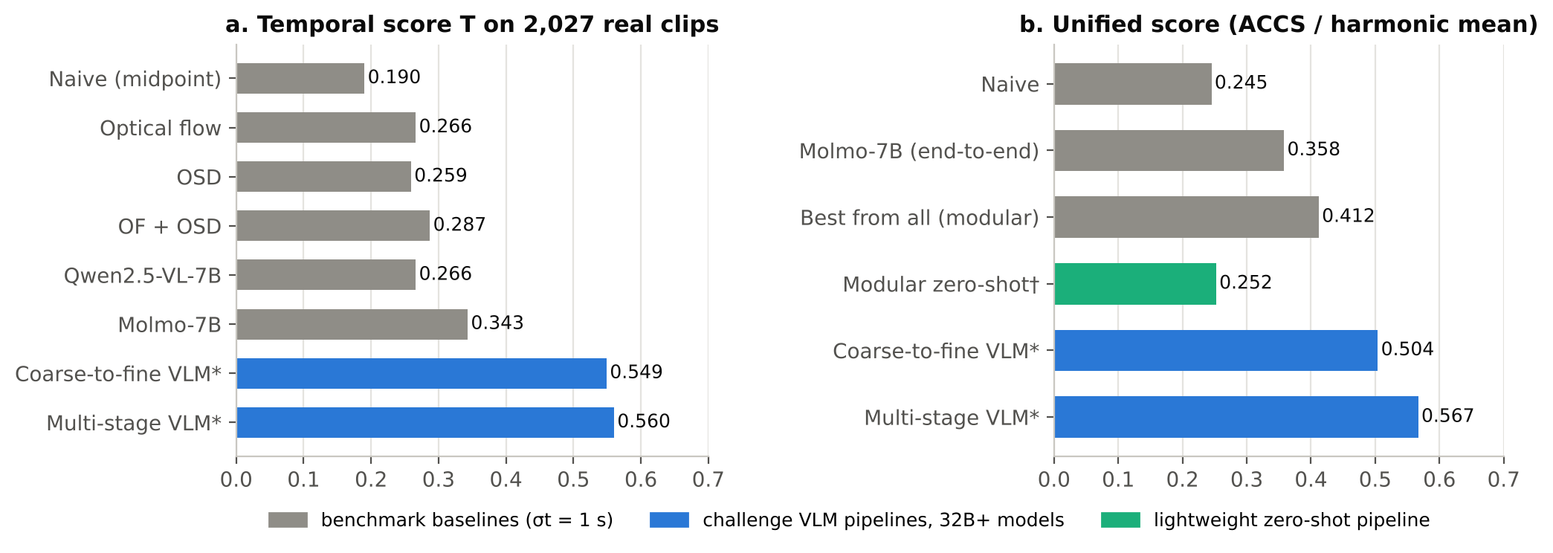
Figure 3.1: Published results on the 2,027 real ACCIDENT clips. *Challenge entries; the tolerance used in their T is not stated consistently across sources. †Public leaderboard (about 25% of the test data).
Two observations follow. First, the large gain of the challenge pipelines over the benchmark baselines comes from large VLMs; within one of these papers, the 4B, 8B and 32B versions of the same pipeline scored 0.285, 0.365 and 0.387 on a stage-level score at 512 px [2], so model size is a major factor. Second, the only published evidence on CARLA-trained temporal models for this benchmark is either negative without numbers [2] or positive without a temporal score [7].

3-4- Research Gap and Proposed Approach
Current ACCIDENT solutions are training-free and depend on 32B–235B VLMs that cost tens of GPU-hours, and they stop at predictions. Within the sources reviewed, no work (i) measures how a model trained only on the synthetic clips transfers to real CCTV under a protocol that never tunes on real data, (ii) measures how much VLM computation a trained first stage saves inside a cascade, or (iii) evaluates whether LLM reports built on the detections are faithful. This project addresses these three points with a window classifier trained on synthetic clips, a confidence-routed cascade, and a grounded reporting layer. A modest real temporal score would still be a valid answer to RQ1 if it is measured cleanly; the first-place team itself described the synthetic-to-real gap as the dominant source of error whenever synthetic signals were transferred [2].

Chapter 4: Research Methodology

4-1- Introduction
This chapter describes how the problem is solved. Section 4-2 presents the traditional methods that serve as reference baselines. Section 4-3 presents the proposed window classifier, its loss and training algorithm (4-3-1), the full pipeline from a clip to a predicted impact time and the cascade built on it (4-3-2), and the data used, with the audits and preprocessing carried out on it (4-3-3). Section 4-4 summarises the chapter and the current state of the work. Throughout, each setting is marked as taken from a cited paper, measured in our own tests, or a design choice of the project.
One rule governs every step: training and every selection step use synthetic data only. Model, checkpoint, threshold and prompt choices are made on synthetic validation folds. The frozen real test subset is used once per final configuration and is never edited.

4-2- Traditional Methods for the Problem

4-2-1- Signal-based (numerical) methods
The benchmark provides training-free baselines that reduce each clip to a one-dimensional signal and look for an abrupt change [1]:
- Naive prior: the clip midpoint for time, the image centre (0.5, 0.5) for location and the majority class for type. It ignores the video and gives a floor that any method must beat.
- Optical flow (OF): dense optical flow is computed between consecutive frames, and each frame is summarised by the mean flow magnitude. Impacts appear as sudden changes in the motion field.
- Object-size dynamics (OSD, called bbox dynamics in the code): vehicles are detected with YOLO11x and tracked with ByteTrack, and the summed box area per frame is used as the signal; boxes merge, split or change scale at contact.
- Ensemble: the average of the OF and OSD onset times.
Each signal is smoothed with a 5-frame median filter and standardised, and kernel change-point detection (KernelCPD) [26] returns the earliest change point as the predicted time [1]. These methods predict a single time per clip with no training. The project ran all four of them on the frozen real subset as reference results (Chapter 5).

4-2-2- Machine-learning methods
Two kinds of learned methods are used on the benchmark. Zero-shot VLMs are prompted every 0.5 s with "Is there a traffic accident or collision? Yes or No answer only." and the first "Yes" gives the predicted time [1]; the challenge pipelines (Chapter 3) replace this with multi-stage, time-stamped prompts to 32B-class models. Linear probes train a linear classifier on frozen image features (DINOv2, SigLIP2) using synthetic clips, and are used for collision type [1]. Neither of these trains a temporal model on the synthetic clips, which is the step this project adds.

4-3- Proposed Model, Loss Function and Training Algorithm
The first stage of the system is a window classifier: a video model that gives every 16-frame window of a clip a score for "this window contains the impact". The predicted impact time is the centre of the window with the highest smoothed score (Section 4-3-2). The design choices below were fixed in a training-configuration file before full training started.

4-3-1- Model, Loss Function and Training Algorithm
Model
The backbone is VideoMAE-Base, using the checkpoint MCG-NJU/videomae-base-finetuned-kinetics (pretrained by masked autoencoding and fine-tuned on Kinetics-400) [10]. It accepts 16 frames at 224 × 224 natively, is supported by the installed transformers library, and its licence (CC BY-NC 4.0) allows academic use; X3D-M is kept as a fallback. The 400-class Kinetics head is replaced by a new linear layer 768 → 1, and the whole network is fine-tuned (Figure 2.1).
Labels and loss function
Training uses label scheme B (Section 4-3-2): a window is positive (1) if its span contains the impact time t*, negative (0) if it ends more than 1 s before t*, and ignored (−1) otherwise. Ignored windows are excluded from the loss. The loss is the weighted binary cross-entropy of Equation (2.3) with two weights, both computed from the synthetic training windows of each fold only:
$p=\frac{N_{neg}}{N_{pos}}$ (4.1)
$w_{c}=clip\left(\sqrt{\frac{N}{5 n_{c}}}, 0.5, 5\right)$ (4.2)
where N_{neg} and N_{pos} are the numbers of negative and positive training windows, N is the number of labelled training windows and n_{c} the number of those windows from collision type c. The type weights are then normalised so that their mean over training windows equals 1. About 27% of labelled training windows are positive, which gives p = 2.63, 2.62 and 2.68 for folds 0, 1 and 2. The type weight follows a uniform prior over the five types, never the proportions of the real test set, which would be leakage. Single-vehicle crashes are only 3% of the synthetic clips, so they receive the largest weight (Figure 4.1); the square root and the cap of 5 keep 13 clips from one site from dominating training.
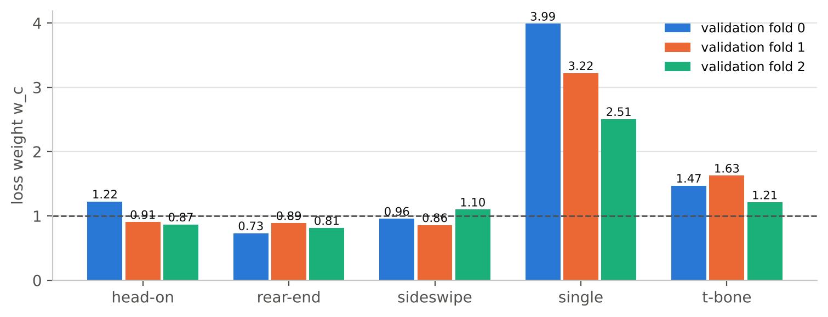
Figure 4.1: Collision-type loss weights per fold (mean over training windows = 1). Single-vehicle crashes receive the largest weight.
Training algorithm and hyperparameters
The optimiser is AdamW with layer-wise learning-rate decay, linear warmup and cosine decay (Section 2-5). The learning rate follows VideoMAE's recipe for its smallest dataset (UCF101, about 9.5k videos), the closest in size to our 1.4–1.5k training clips per fold: a base rate of 5 × 10⁻⁴ scaled by Equation (2.7) to the effective batch of 16 gives 3.125 × 10⁻⁵ [10], [14]. With decay 0.7 over 12 blocks, the top block receives 2.19 × 10⁻⁵ and the patch embedding 0.7¹³ ≈ 0.0097 of the head rate (Figure 4.2). Table 4.1 lists all settings with their sources.
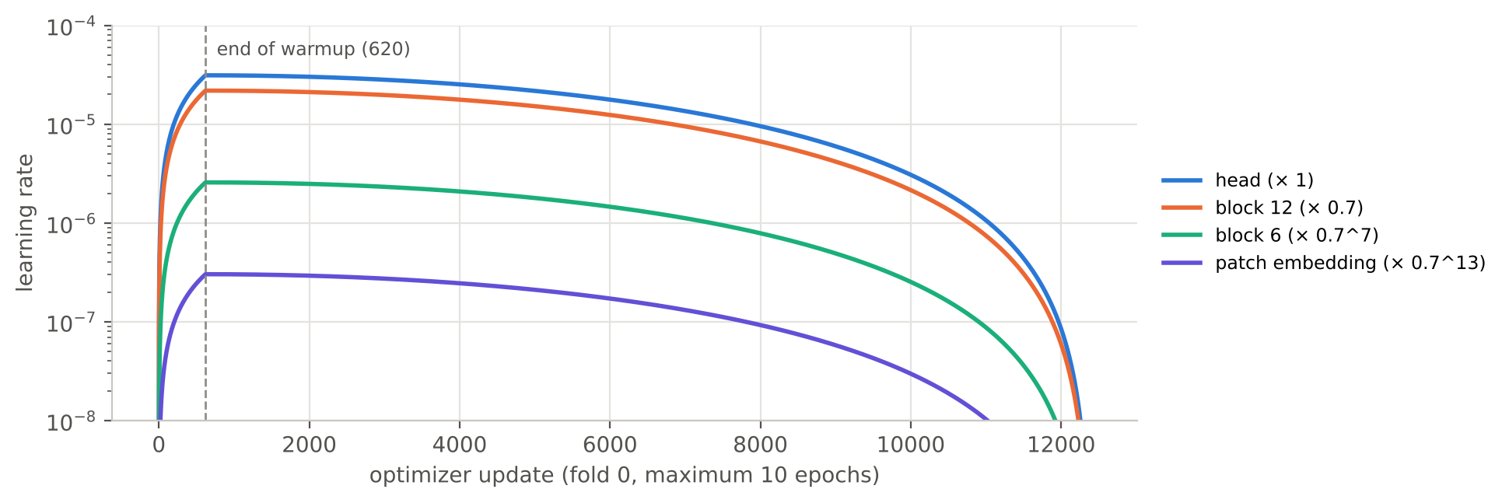
Figure 4.2: Learning-rate schedule for fold 0 (12,390 updates at most): linear warmup over 620 updates, cosine decay, and layer-wise decay of 0.7 per block.
Table 4.1: Hyperparameters of the window classifier, with their sources.
Setting | Value | Source / reason
Backbone | VideoMAE-Base, Kinetics-400 fine-tuned | Proposal; 16 × 224 × 224 native input
Head | Linear 768 → 1 | Design choice: one score per window
Labels | Scheme B; −1 ignored | Score should peak at first contact, not on the aftermath
Micro-batch / accumulation | 8 × 2 (effective batch 16) | Measured: peak 6.46 GB of 7.96 GB
Optimizer | AdamW, β₁ = 0.9, β₂ = 0.999 | VideoMAE fine-tuning [10], [12]
Weight decay | 0.05; none on biases and LayerNorm | VideoMAE fine-tuning [10]
Learning rate | 5e-4 × 16/256 = 3.125e-5 | VideoMAE UCF101 recipe; linear scaling [10], [14]
Layer-wise decay | 0.7 | VideoMAE UCF101; BEiT [11]
Schedule | 5% linear warmup (620/622/660 updates), cosine to 0 | VideoMAE: warmup + cosine [13]
Training length | Maximum 10 epochs (12,390–13,200 updates) | Same order as VideoMAE UCF101 (~7,400 updates); early stopping ends earlier
Early stopping | Validation T at σ_{t} = 1 s; patience 3 epochs; min. gain 0.002 | Primary metric; design choice [18]
Positive weight p | 2.63 / 2.62 / 2.68 | Equation (4.1), synthetic training windows
Type weight w_{c} | √(N / 5n_{c}), clipped to [0.5, 5], mean 1 | Equation (4.2) [17]
Gradient clipping | Max norm 1.0 | Design choice (safety in bf16)
Precision | bf16 autocast | No loss scaling needed [15]
Augmentation | Standard: horizontal flip p = 0.5; or CCTV-style (Table 4.3) | VideoMAE (flip); proposal ablation 1
Prediction | 3-window moving average; t̂ = centre of maximum | Section 4-3-2
Seeds | 0 (seeds 1 and 2 for the final configuration) | Proposal: mean ± std
Not used from the VideoMAE recipe: batch 128–512 (does not fit 8 GB), Mixup/CutMix (a mixed window has no single impact time), label smoothing, RandAugment, repeated augmentation, drop path (not available in transformers 5.20.2).
Table 4.2 gives the amount of training data per fold. One optimiser update uses 16 windows, so an epoch has about 1,240–1,320 updates. GPU memory depends on the size of one input and the micro-batch, not on the number of windows, so the full data set changes the run time but not the measured memory.
Table 4.2: Training and validation data per fold (synthetic data only).
Val. fold | Train clips | Train windows | Positives | Val. clips | Val. windows | Updates / epoch | p
0 | 1,441 | 19,817 | 5,453 (27.5%) | 770 | 25,988 | 1,239 | 2.63
1 | 1,456 | 19,903 | 5,494 (27.6%) | 755 | 25,041 | 1,244 | 2.62
2 | 1,525 | 21,114 | 5,741 (27.2%) | 686 | 19,701 | 1,320 | 2.68

Ablation: CCTV-style augmentation
Synthetic clips are clean 1080p video at 20 fps, while real CCTV clips are often of poor quality: the benchmark reports real frame rates from 4 to 50 fps, resolutions from 314p to 3840p, about two thirds of clips of poor or very poor quality and about one third at night [1]. The single ablation kept in the plan tests whether degrading synthetic training windows in a camera-like way narrows this gap (Table 4.3). One random draw is made per window and applied to all 16 frames, because all frames of a window come from one camera; in synthetic-to-real action recognition, video-level noise helped while per-frame noise hurt [16]. The ranges come from published dataset statistics, not from real clips.
Table 4.3: CCTV-style augmentation profile (one draw per window, same for all 16 frames).
Degradation | Prob. | Range | Basis
Frame-rate drop | 0.5 | Simulated source fps ∈ {4, 5, 6}; each frame replaced by the last frame such a camera would show | Real fps as low as 4 [1]
Blur | 0.5 | Gaussian σ ∈ [0.3, 1.5] px | Design choice
Low resolution | 0.5 | Downscale to 30–70% of 224 px, then upscale | Lowest real resolution 314p ≈ 0.29 × 1080p [1]
Colour shift | 0.5 | Brightness × [0.5, 1.3], contrast × [0.7, 1.3], saturation × [0.6, 1.3], hue ± 0.02; grayscale p = 0.1 | Design choice; covers night scenes
Compression | 0.5 | JPEG re-encode, quality ∈ [15, 40] | Design choice
Horizontal flip | 0.5 | As in the standard profile | Kept in both profiles

The two configurations (standard and CCTV-style) differ only in this setting. The one with the higher pooled out-of-fold T at σ_{t} = 1 s on synthetic validation becomes the final configuration; both are scored once on the real subset as the result of the ablation, and the real result never changes the choice. A second ablation in the original proposal (balanced vs. unbalanced training) was dropped to recover time, so every run uses the weighted loss.
Reliability of long runs on a laptop GPU
- Checkpoints and resume: last.pt at the end of every epoch and step_latest.pt every 500 updates, with model, optimiser, scheduler, early-stopping state and random states, written to a temporary file and then renamed; best.pt keeps the best epoch. Ctrl+C finishes the current update and saves first. A resume with a different configuration is refused by its hash.
- Out-of-memory protection: if a micro-batch fails with a CUDA out-of-memory error, the same 8 windows are recomputed in chunks of 4, then 2, with gradients accumulated, so the update is unchanged.
- Thermal protection: GPU temperature and clock are logged every 50 updates; training pauses at 85 °C and resumes at 70 °C (design choice).
- Integrity checks: training stops unless the SHA-256 hashes of the split, window and label files match the frozen split manifest and the frame cache is complete.

4-3-2- Detailed Pipeline
Figure 4.3 shows the two-stage pipeline. Stage 1 runs on every clip; the VLM path depends on the classifier's confidence. The steps are described in order below, with what each step produces.
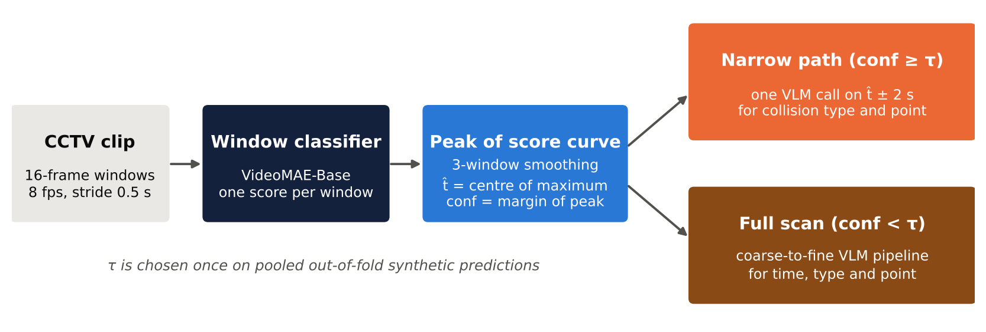
Figure 4.3: Two-stage cascade. The window classifier proposes the impact time t̂ and a confidence; the VLM examines only t̂ ± 2 s when the confidence is at least τ, and the full clip otherwise.
Step 1: cut the clip into windows. Each clip is cut into windows of 16 frames sampled at 8 fps with a stride of 0.5 s. Window j starts, ends and is timestamped at:
$t_{start}(j)=0.5 j, t_{end}(j)=t_{start}(j)+1.875, t_{c}(j)=t_{start}(j)+0.9375$ (4.3)
The window span is defined as the time of the last frame minus the time of the first frame (15 × 0.125 = 1.875 s), and the same definition is used in the labelling code and the window code. The centre t_{c}(j) is the single timestamp of a window everywhere: in the labels, in the prediction and for the VLM window. A frame at time t is taken from the source video at index:
$f(t)=⌊t·fps+0.5⌋, fps=\frac{no_frames}{duration}$ (4.4)
A window is kept only if its last frame exists. The 2,211 synthetic clips give 70,730 windows, between 8 and 61 per clip (Figure 4.8).
Step 2: label the windows (training only). Three labelling schemes were built. Scheme A, the first version, labelled every window after the impact as positive, so 62.6% of windows were positive and a classifier would learn "a crash has happened" and peak on the aftermath, seconds after first contact. Scheme B keeps as positive only the windows whose span contains t*. Scheme C gives a soft weight that is 1 for windows containing t*, follows a Gaussian of the distance d_{j} between t* and the nearer window edge, and is 0 for windows ending more than 1 s before t*:
$w_{C}(j)=exp\left(−\frac{{d_{j}}^{2}}{2·{0.5}^{2}}\right), d_{j}=min\left(|t*−t_{start}|, |t*−t_{end}|\right)$ (4.5)
Two versions of scheme C are stored, because the written rule and an alternative code form differ for windows ending more than 1 s before t* (0 in the text rule, up to 0.12 in the code, a total of 125.5 against 8,344 positive windows); the text rule is the one proposed for use. Figure 4.4 shows schemes B and C on one clip, and Figure 4.5 gives the totals: scheme B has 8,344 positive, 22,073 normal and 40,313 ignored windows, with 1 to 4 positives per clip.
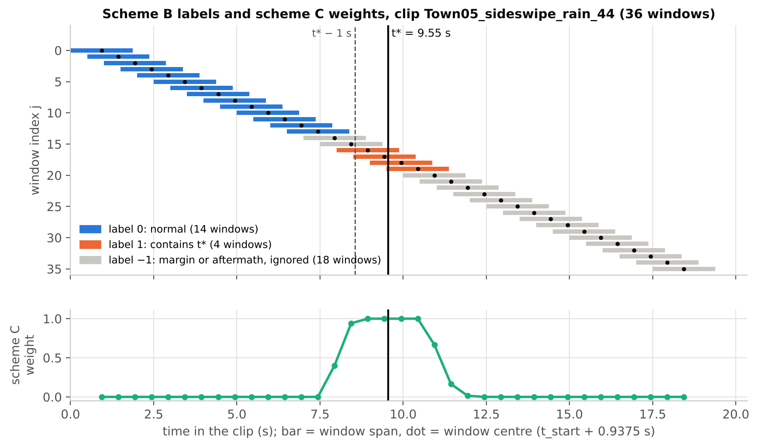
Figure 4.4: Window labels on one synthetic clip. Top: scheme B (bars are window spans, dots are window centres). Bottom: scheme C weight of each window.
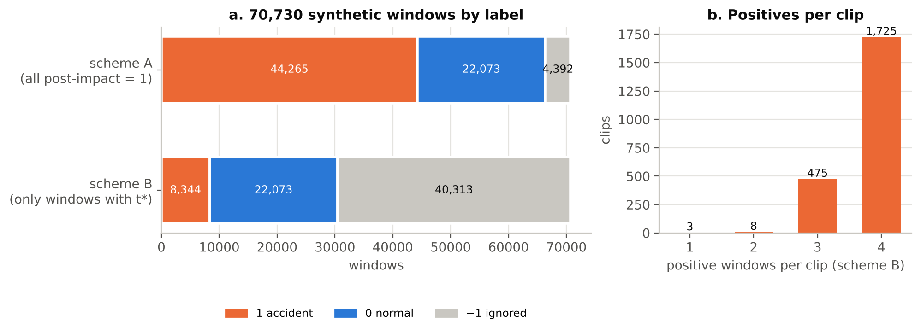
Figure 4.5: (a) The 70,730 synthetic windows under schemes A and B. (b) Number of positive windows per clip under scheme B.
Step 3: score every window. The trained model gives a score s_{j} ∈ [0, 1] to every window of the clip, which forms a score curve over time.
Step 4: predict the impact time and a confidence. The curve is smoothed with a moving average over 3 windows (s̄). The predicted time is the centre of the highest smoothed window, and the confidence is the height of the peak above the highest score more than 2 windows away from it:
$t̂=t_{c}\left(j^{*}\right), j^{*}=arg \max_{j} {s̄}_{j}$ (4.6)
$conf={s̄}_{j^{*}}−\max_{|j−j*|>2} {s̄}_{j}$ (4.7)
The time t̂ needs no threshold. For example, if the smoothed scores at window centres 3.0, 3.5, 4.0, 4.5, 5.0 and 5.5 s are 0.05, 0.10, 0.62, 0.91, 0.80 and 0.70, then t̂ = 4.5 s. A threshold rule such as "first window above 0.5" would give 4.0 s; the benchmark uses the peak [1]. In 24.5% of the frozen real clips the impact happens before 2.875 s, while the first window centre is at 0.94 s, so an impact at, for example, 0.5 s can never be predicted exactly. These early-impact clips are reported separately; padding the start of the clip is not planned.
Step 5: train one model per fold and pool the out-of-fold predictions. Three models are trained, each never seeing the scenarios of its validation fold. Their validation predictions together cover all 2,211 synthetic clips exactly once (out-of-fold predictions). The labelling scheme, the augmentation profile and the routing threshold τ are chosen once on these pooled predictions, never on a single fold, because the folds differ in their timing.
Step 6: score the real test set once. For each real clip, the window scores of the three fold models are averaged, t̂ and the confidence are computed, and the pooled τ is applied. The frozen 400-clip subset is scored once per final configuration. Because the real labels are public, the classifier alone is also scored on all 2,027 real clips for comparison with published numbers. For real clips, a predicted frame index f̂ is converted with t̂ = f̂ / (no_frames / duration), as in the official benchmark code [1].
Step 7: route to the VLM (cascade). Clips with confidence ≥ τ take the narrow path: one VLM call on t̂ ± 2 s, for collision type and impact point. Clips below τ take the full coarse-to-fine VLM scan for time, type and point. The main cost measure is the average number of frames sent to the VLM per clip, which does not depend on the hardware, together with GPU-seconds per clip (classifier plus VLM, with the GPU named):
$cost=\frac{1}{N}\sum_{i=1}^{N}{F_{i}}$ (4.8)
where F_{i} is the number of frames sent to the VLM for clip i. Sweeping τ gives a curve of cost against ACCS. The VLM stage, the small VLM fine-tuned with QLoRA, the event store and the assistant are planned for weeks 8–14.

4-3-3- Datasets Used
Choice of dataset. Five accident datasets were compared (Table 4.4). ACCIDENT was chosen because it uses fixed CCTV views, labels time, location and type, and provides synthetic training clips; TADS was kept as a fallback.
Table 4.4: Accident datasets considered for the project.
Dataset | View | Size | Labels | Decision
ACCIDENT (2026) [1] | Fixed CCTV | 2,027 real + 2,211 synthetic clips | Time, impact point, 5 collision types | Chosen
TADS (2024) | Fixed CCTV | 20 long videos, 966 accident segments | Segments, categories, eye-tracking | Fallback
TU-DAT (2025) | Roadside | About 280 videos (real + simulated) | Boxes, timestamps, collision types | Too small
DoTA (2020) | Dashcam | 4,677 videos | Start/end, tracklets, 18 categories | Wrong viewpoint
MIVIA-AID (2026) | Fixed CCTV | 2,556 videos (1,661 positive) | Incident start/end | Private test set

Real data. The real set has 2,027 clips from heterogeneous public CCTV sources, each labelled with accident_time, accident_frame, the impact centre (center_x, center_y), a bounding box, the collision type and the split. A check of all 2,027 rows found no missing values in the label columns. The licence shown on the download page is CC BY-NC-SA 4.0. The collision types are unbalanced: single-vehicle 680 (33.5%), t-bone 657, rear-end 328, sideswipe 245 and head-on 117 (5.8%) (Figure 4.6).
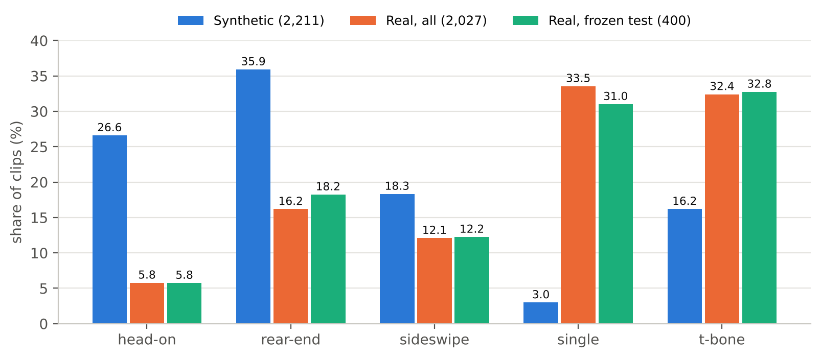
Figure 4.6: Collision-type distribution of the synthetic clips, all real clips and the frozen real test subset. Single-vehicle crashes are 3.0% of the synthetic data but about a third of the real data.
Synthetic data. The 2,211 synthetic clips were rendered with the benchmark's CARLA framework; all are 1920 × 1080 at 20 fps. The audit, checked against the official loading notebook, found that the clips come from only 14 scenarios, each a crash site on one CARLA map with one collision type, rendered from several camera positions and under 5 weather or lighting settings with randomised vehicles (Figure 4.7). The trailing number in a file name is the camera position, not an event identifier. The relation sim_tick = accident_frame + annotations_start_offset held in 104 of 104 sampled clips. Single-vehicle crashes come from only two scenarios (66 clips).
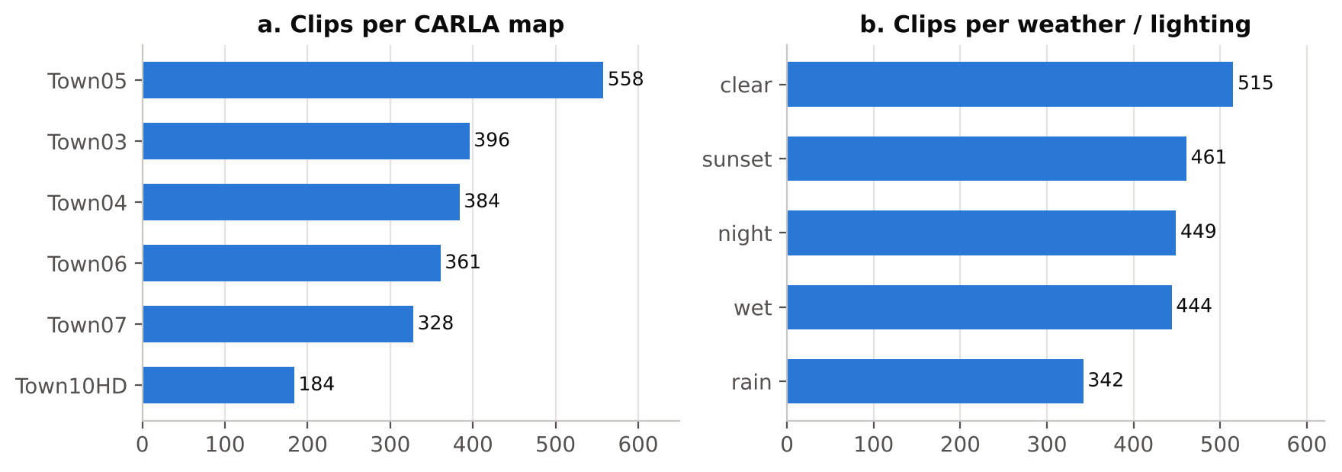
Figure 4.7: Synthetic clips per CARLA map and per weather or lighting condition.
The impact time in the synthetic clips has a median of 6.9 s (interquartile range 5.15–9.8 s, range 1.05–20.75 s); 62 clips have their impact before 2.875 s and therefore contain no normal window (Figure 4.8). Median impact times differ strongly between scenarios, from 3.65 s to 13.25 s (Figure 4.9 and Table 4.5), which matters for how the folds are formed.
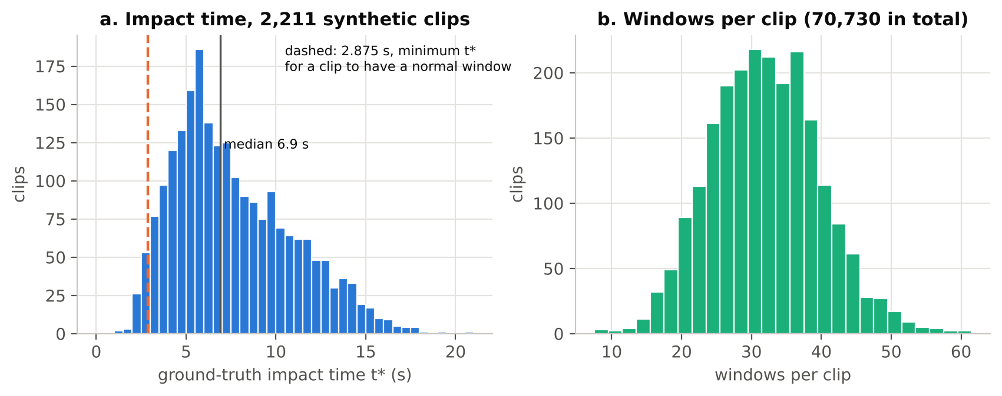
Figure 4.8: (a) Histogram of the ground-truth impact time of the 2,211 synthetic clips. (b) Number of windows per clip.
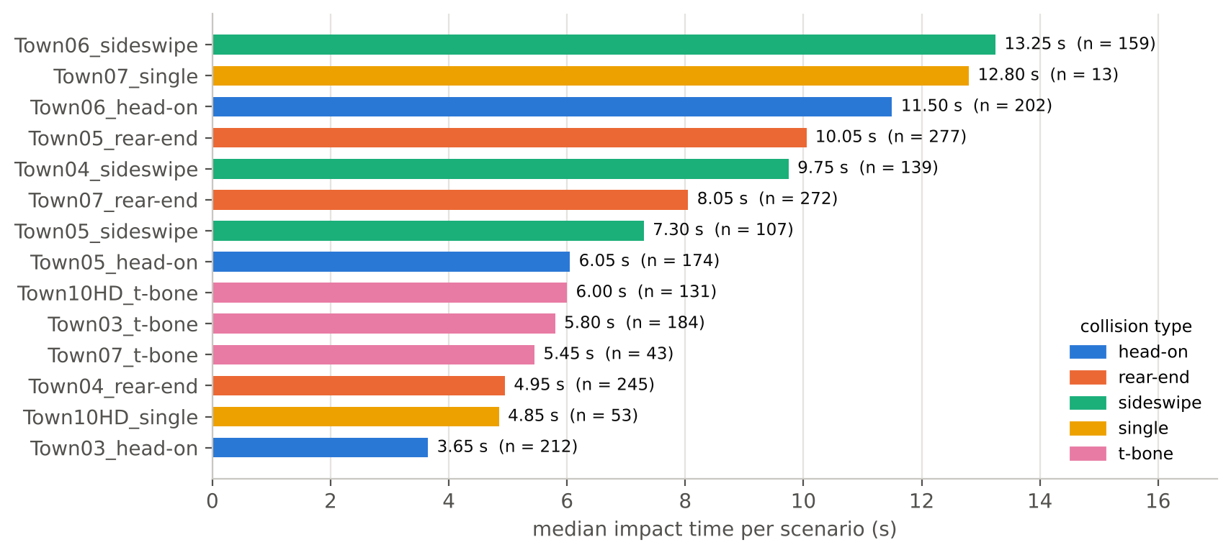
Figure 4.9: Median impact time of each of the 14 synthetic scenarios, coloured by collision type (n = number of clips).
Table 4.5: The 14 synthetic scenarios and their validation fold in the frozen split (v2).
Scenario | Type | Clips | Camera positions | Median t* (s) | Val. fold
Town03_head-on | head-on | 212 | 52 | 3.65 | 2
Town05_head-on | head-on | 174 | 52 | 6.05 | 1
Town06_head-on | head-on | 202 | 55 | 11.50 | 0
Town04_rear-end | rear-end | 245 | 54 | 4.95 | 0
Town05_rear-end | rear-end | 277 | 87 | 10.05 | 1
Town07_rear-end | rear-end | 272 | 60 | 8.05 | 2
Town04_sideswipe | sideswipe | 139 | 45 | 9.75 | 0
Town05_sideswipe | sideswipe | 107 | 46 | 7.30 | 1
Town06_sideswipe | sideswipe | 159 | 48 | 13.25 | 2
Town03_t-bone | t-bone | 184 | 48 | 5.80 | 1
Town07_t-bone | t-bone | 43 | 43 | 5.45 | 2
Town10HD_t-bone | t-bone | 131 | 49 | 6.00 | 0
Town07_single | single | 13 | 11 | 12.80 | 1
Town10HD_single | single | 53 | 31 | 4.85 | 0

Frozen real test subset. Running VLMs on all real clips is expensive, so a fixed subset was frozen on 7 October 2026 by a script: one random clip per source video, then 400 random sources, with seed 42 (1,944 distinct sources were available). The output file and the source metadata are recorded with their SHA-256 hashes in a manifest, and the subset is never edited or used for tuning. Its composition is 131 t-bone, 124 single-vehicle, 73 rear-end, 49 sideswipe and 23 head-on clips, close to the full real set (Figure 4.6); 268 clips are in daylight and 132 at night, and 98 clips (24.5%) have their impact before 2.875 s (Figure 4.10b). The pre-impact footage totals 0.66 h with a median accident time of 4.8 s.
Frame-rate audit of the real clips. Real clips have mixed frame rates (median file fps about 15). For each clip, the labelled accident time and frame were compared with the frame rate stored in the file and with no_frames / duration. In 1,693 clips both agree; in 304 the labelled time and frame disagree with the file fps; in 17 both disagree; and in 13 the duration disagrees with the file (Figure 4.10a). The 321 clips with inconsistent frame and time labels (64 of them in the frozen subset) are reported, not modified. The conversion t̂ = f̂ / (no_frames / duration) of the official code is used.
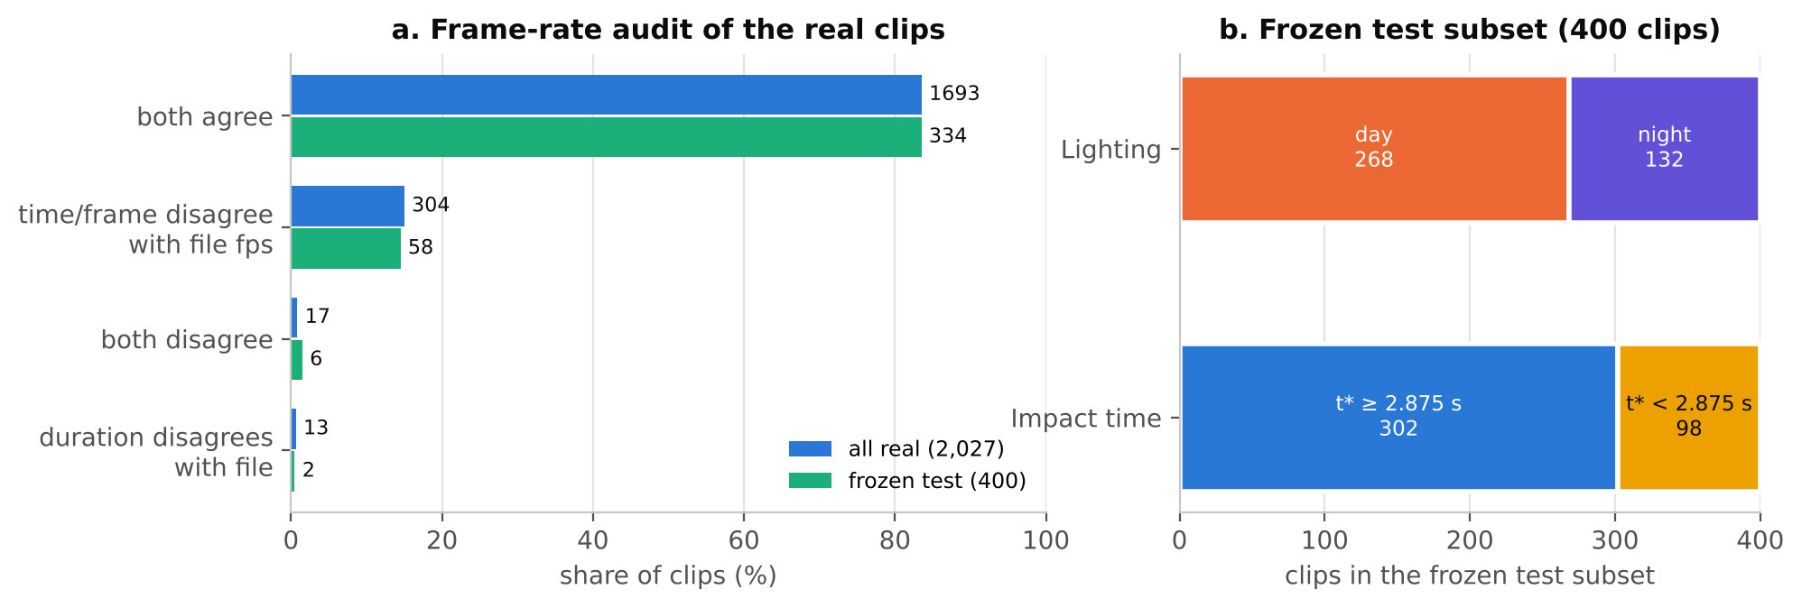
Figure 4.10: (a) Frame-rate audit of all real clips and of the frozen subset (numbers are clip counts). (b) Lighting and early-impact composition of the frozen subset.
Label timing and input resolution. Because every label depends on accident_time, it was checked visually before training: in 6 synthetic clips covering all 5 collision types, the first visible contact was within about 2 frames (0.1 s) of accident_frame. A box-size audit showed that a square centre crop would cut the crash centre out of the frame in 3.4% of clips (19% in Town03_t-bone), so frames are resized whole to 224 × 224 (squashed, not cropped).
Frame cache. To make training fast enough, the 16-frame grids of all windows were decoded once and stored: 309,452 frames of 2,211 clips at 224 × 224 (JPEG quality 95, 6.7 GB) with 0 errors. Every window was checked to equal its 16-frame grid slice, and cached frames were compared with an independent re-decode.
Leakage-safe grouped split. Clips of the same scenario share the crash site, the vehicles' paths and often the camera, so a random split would put near-copies of the same crash in training and validation. The synthetic clips are therefore split by scenario into 3 folds, so that every clip is validated exactly once and the same crash never appears on both sides; the grouping principle is that of group-wise cross-validation [27]. Plain group k-fold balances only clip counts and can leave a fold without a collision type, so the fold assignment was searched explicitly. A first hand-made split (v1) put the late-crash scenarios together: its share of accident windows (scheme A) was 75.5%, 68.3% and 41.0% per fold. A random search over 200,000 assignments (seed 0) minimised a cost that balances clip counts, median impact time and the number of collision types per fold, reducing the cost from 13.06 to 7.40 and the spread of accident-window share from 34.5 to 5.3 points (Figure 4.11). Scenarios on the same map are separate crash sites 76–758 m apart, and the best of all 540 map-level splits costs 12.71, so the scenario-level split was kept and map sharing is stated as a limitation. The v2 split is frozen with SHA-256 hashes of the split, window and label files; v1 is archived. With 14 scenarios, 3 folds × 5 types cannot all be covered: single-vehicle crashes appear in only 2 of the 3 validation folds.
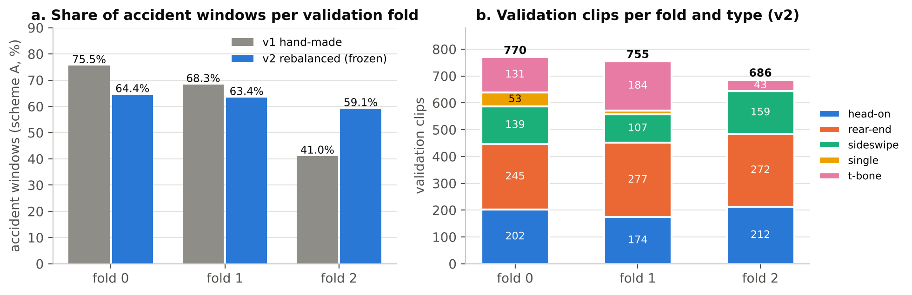
Figure 4.11: (a) Share of accident windows per validation fold before (v1) and after (v2) rebalancing. (b) Validation clips per fold and collision type in the frozen v2 split.
Tools. Data work used Python with pandas and NumPy, scikit-learn, and the scripts of the benchmark repository; training uses PyTorch 2.10.0 (CUDA 12.8) and transformers 5.20.2 in a separate Python 3.12.2 environment. The code is kept in a shared GitHub repository, and large data files are not committed.

4-4- Chapter Conclusion and Research Contribution
This chapter defined the method: a VideoMAE-Base window classifier trained only on synthetic clips, with impact-centred labels and a weighted loss, a peak-based predictor of the impact time, and a cascade that uses the classifier's confidence to decide how much VLM computation each clip receives. The data work established the conditions for a clean transfer measurement: a frozen real test subset, a scenario-grouped and rebalanced synthetic split, verified label timing, and audited real frame rates. Figure 4.12 shows the state of the work.
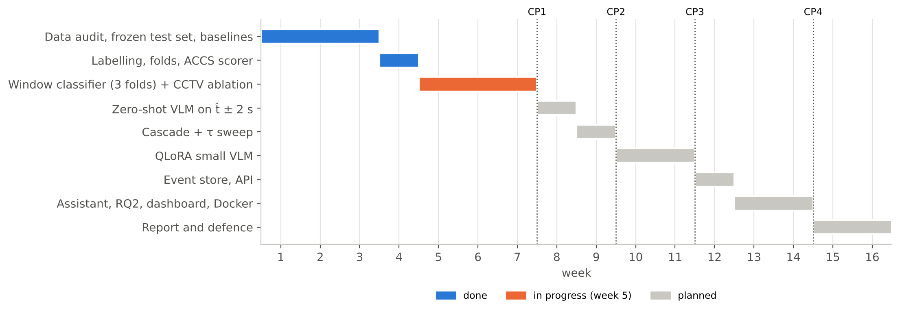
Figure 4.12: Project timeline (weeks 1–16) with the four checkpoints (CP). Status as of week 5.

Chapter 5: Results
This chapter presents the tools and evaluation methods (5-1) and the results obtained so far (5-2). Training of the window classifier is in progress, so only the first fold-0 run and the reference baselines are reported.

5-1- Tools and Evaluation Methods
Tools
Table 5.1: Hardware and software used.
Item | Details
Training GPU | NVIDIA RTX 5060 Laptop GPU, 8 GB (7.96 GB usable)
Second machine | Laptop with NVIDIA RTX 4050 GPU (data work, scripts)
Operating system and editor | Windows, PowerShell, VS Code
Training environment | Python 3.12.2, PyTorch 2.10.0 + CUDA 12.8, transformers 5.20.2, bf16 autocast
Data and evaluation | pandas, NumPy, scikit-learn; benchmark repository baselines (YOLO11x, ByteTrack, OpenCV optical flow, KernelCPD)
Version control | Git and a shared GitHub repository; SHA-256 manifests for frozen files
Planned | Open VLM with QLoRA, PostgreSQL + pgvector, LangGraph, FastAPI, Streamlit, Docker Compose

Evaluation metrics
The primary metrics are those of the ACCIDENT benchmark [1]. Temporal score T. For clip i with ground-truth impact time t*_{i} and prediction t̂_{i}, and the mean over N clips:
$T_{i}=exp\left(−\frac{{\left({t̂}_{i}−{t*}_{i}\right)}^{2}}{2{σ_{t}}^{2}}\right)$ (5.1)
$T=\frac{1}{N}\sum_{i=1}^{N}{T_{i}}$ (5.2)
T is reported at σ_{t} = 0.5, 1 and 2 s; T at 1 s selects models. Spatial score S compares the predicted point (x̂, ŷ) in normalised image coordinates with the centre of the accident box (x*, y*):
$S_{i}=exp\left(−\left[\frac{{\left({x̂}_{i}−{x*}_{i}\right)}^{2}}{2{σ_{x}}^{2}}+\frac{{\left(ŷ_{i}−{y*}_{i}\right)}^{2}}{2{σ_{y}}^{2}}\right]\right)$ (5.3)
with σ_{x} = 0.127 and σ_{y} = 0.119, the dataset mean of the normalised accident-box width and height; S is the mean of S_{i}. Collision-type score C is the top-1 accuracy over the five types; per-class and macro accuracy are also reported, because always predicting the majority class already gives 0.335 on the real set:
$C=\frac{1}{N}\sum_{i=1}^{N}{𝟙[ŷ_{i}=y_{i}]}$ (5.4)
Unified score ACCS is the harmonic mean of the three, with T at σ_{t} = 1 s (the paper's end-to-end values match that column):
$ACCS=\frac{3}{\frac{1}{T}+\frac{1}{S}+\frac{1}{C}}$ (5.5)
A harmonic mean is pulled down by the weakest component: T = 0.9, S = 0.9 and C = 0.05 give ACCS = 0.135. These metrics suit the problem because they are continuous, tolerate small timing errors in a controlled way, and match the task as the benchmark defines it. As a diagnostic, the mean absolute error of the predicted time is also reported:
$MAE=\frac{1}{N}\sum_{i=1}^{N}{|{t̂}_{i}−{t*}_{i}|}$ (5.6)
Rules. Every clip is scored: a failed prediction uses a fixed fallback (clip midpoint, frame centre, majority class), and the number of fallbacks is reported. Per-fold results are given as mean ± std over the 3 folds and repeated seeds as mean ± std over seeds 0, 1 and 2, with n stated. Cascade cost is measured as VLM frames per clip and GPU-seconds per clip (Equation (4.8)). An alarm-metrics module (miss rate, detection delay, timely-detection rate at d, false alarms per hour on pre-impact footage, following the definitions of [31] and the rule of three [29]) is kept unchanged and reported only as a short secondary deployment view; its self-test passes 27 of 27 checks.
Validation of the scorer
The benchmark repository does not include a scoring script, so the implementation was validated by reproducing the paper's naive baseline on all 2,027 real clips (Figure 5.1). Every component matches the published value within 0.0005, and the scorer's own self-test passes 33 of 33 checks. Since the same code computes all later results, this also validates the evaluation harness.
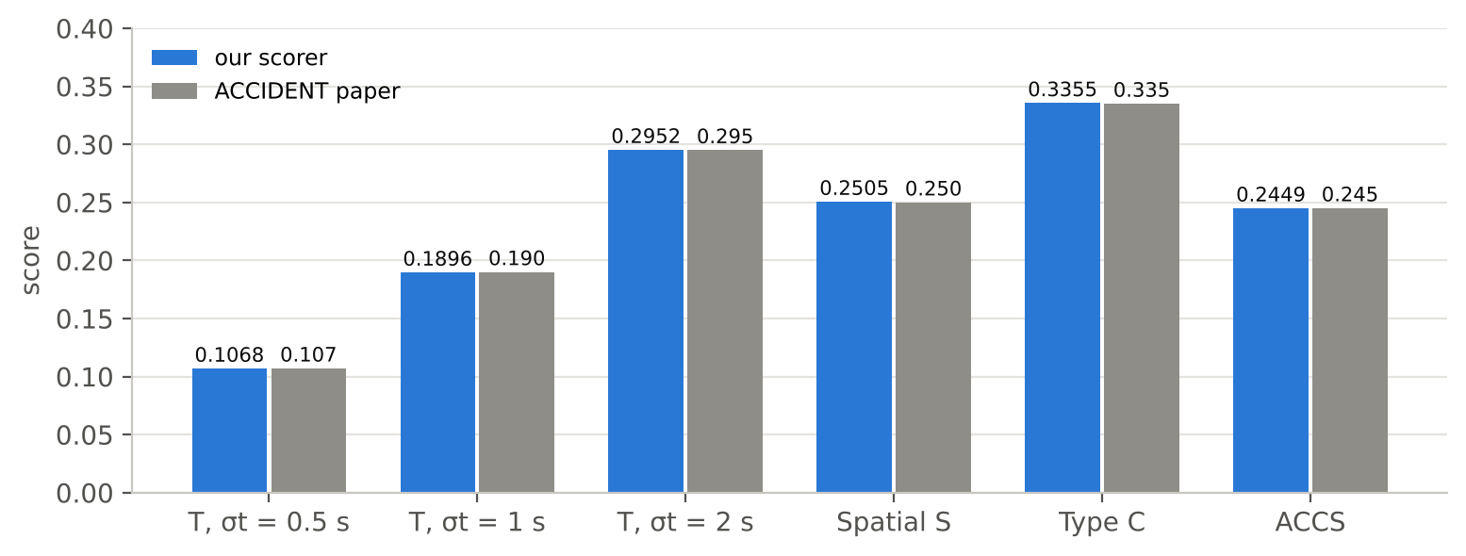
Figure 5.1: Naive baseline on all 2,027 real clips: our scorer against the values published in the ACCIDENT paper.

5-2- Results of the Proposed Model

5-2-1- Reference baselines on the frozen subset
The four heuristic baselines of the benchmark repository were run on the 400 frozen real clips; all four produced a prediction for every clip. Table 5.2 and Figure 5.2 give the results. On the subset, the naive and ensemble baselines are close to the published values on the full set (0.193 vs. 0.190 and 0.287 vs. 0.287 at σ_{t} = 1 s), which suggests that the subset represents the full set well. These are the reference scores the classifier must exceed (Table 1.1).
Table 5.2: Heuristic baselines on the frozen real subset (400 clips) and published values on all 2,027 clips.
Method | T, σt = 1 s (400) | T, σt = 2 s (400) | MAE (s, 400) | Paper T, σt = 1 s (2,027) | Paper T, σt = 2 s (2,027)
Naive (midpoint) | 0.193 | 0.296 | 6.13 | 0.190 | 0.295
Optical flow | 0.293 | 0.491 | 3.82 | 0.266 | 0.466
BBox dynamics (OSD) | 0.247 | 0.432 | 4.28 | 0.259 | 0.452
Ensemble (OF + OSD) | 0.287 | 0.487 | 3.62 | 0.287 | 0.496

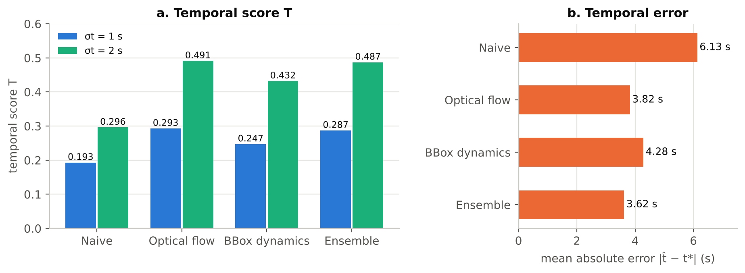
Figure 5.2: Heuristic baselines on the frozen real subset: (a) temporal score at two tolerances; (b) mean absolute timing error.

5-2-2- Verification of the training pipeline
Before full training, every part of the training pipeline was tested on small runs (Table 5.3).
Table 5.3: Tests completed before full training.
Test | What it checks | Result
GPU memory and speed | VideoMAE-Base fits at micro-batch 8 | Peak 6.46 GB training, 2.28 GB validation; 14.4 windows/s training, 51.6 windows/s scoring
Overfit (2 clips) | Frames, labels and training loop are connected | Loss 0.714 → 0.0001 in 100 updates: pass
Resume at epoch end and mid-epoch | Optimiser, scheduler and early-stopping state restored | Same step count and metrics as an uninterrupted run; skips exactly the applied batches
Session limit (--max-hours) | Clean stop after a time limit, then resume | Pass
GPU pause (forced) | Training pauses when hot and continues when cool | Pass: resumed after 0.5–1.5 min each time
OOM fallback (forced) | Out-of-memory error handled without stopping | Pass: 7 fallbacks per epoch; train loss 0.5036 vs. 0.5035
Layer-wise learning rate | 28 parameter groups | Head 3.125e-5, top block 2.19e-5, embeddings 3.0e-7
CCTV augmentation preview | Degradations visible; data loading keeps up | Pass; data wait 8–21% (standard 13–18%)
Run aggregation | Pooled out-of-fold T and mean ± std | Pass; refuses missing or duplicated clips

5-2-3- First training run (fold 0)
Run 0 trained the classifier with scheme B, seed 0, on folds 1–2 and validated on fold 0 (770 clips), with validation once per epoch. The best validation T at σ_{t} = 1 s was 0.441 after the first epoch, against 0.192 for the naive midpoint on the same clips. Validation T then fell while the training loss kept falling, and early stopping ended the run after epoch 3 (Figure 5.3).
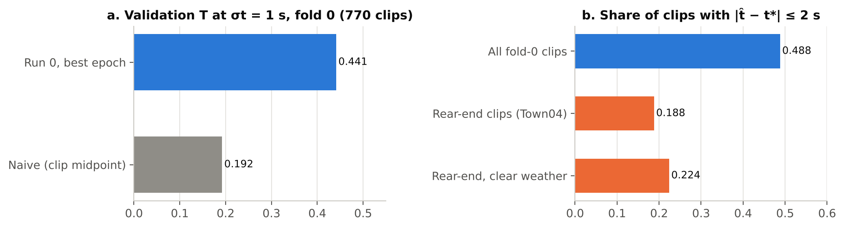
Figure 5.3: Run 0 (scheme B, seed 0, validation fold 0): (a) validation temporal score against the naive baseline; (b) share of clips whose predicted time is within 2 s of the impact.
Two error patterns were found. First, the score curves stay high after the impact (mean score 0.252 more than 5 s after t*), because scheme B gives no training signal on the aftermath. Second, rear-end clips of Town04 dominate the errors: queues of stopped vehicles behind the crash look like a rear-end collision, so the peak moves late, and night makes this worse. Estimated from per-group errors (not from experiments), these account for about 0.13 (rear-end) and 0.03 (night) of fold-0 T at 1 s. This is a single run on one fold, on synthetic validation data only; it says nothing yet about transfer to real CCTV.
The next runs change one setting at a time: Run 1 validates every 620 updates with a patience of 6 checks (in progress), Run 2 uses label scheme C, Run 3 adds CCTV-style augmentation to the better scheme, and Run 4 repeats the final configuration with seeds 1 and 2.

5-2-4- Remaining results

5-3- Comparison of Results

5-3-1- Comparison of the Proposed Models

5-3-2- Comparison with Previous Works

Chapter 6: Conclusion

6-1- Conclusions

6-2- Challenges and Future Work

References
[1] L. Picek, M. Čermák, M. Hanzl and V. Čermák, "ACCIDENT: A Benchmark Dataset for Vehicle Accident Detection from Traffic Surveillance Videos," CVPR Workshops, 2026. arXiv:2604.09819. https://arxiv.org/abs/2604.09819
[2] F. Tatematsu and F. Takahashi, "Multi-Stage VLM Pipeline for Zero-Shot Traffic Accident Understanding," arXiv:2605.29325, 2026. https://arxiv.org/abs/2605.29325
[3] D. Saha, S. M. A. Mannan, M. R. Rashid, R. Naswan and A. Tahmid, "Zero-Shot Traffic Accident Detection via a Coarse-to-Fine VLM-Tracking Pipeline," arXiv:2608.08867, 2026. https://arxiv.org/abs/2608.08867
[4] J. Huang, "Two-Pass Zero-Shot Temporal-Spatial Grounding of Rare Traffic Events in Surveillance Video," arXiv:2605.01512, 2026. https://arxiv.org/abs/2605.01512
[5] A. Thakur and S. Talele, "A Modular Zero-Shot Pipeline for Accident Detection, Localization, and Classification in Traffic Surveillance Video," arXiv:2604.09685, 2026. https://arxiv.org/abs/2604.09685
[6] T. Singh et al., "Metadata-Aware Multi-Prompt Reasoning for Zero-Shot Accident Understanding," arXiv:2606.12047, 2026. https://arxiv.org/abs/2606.12047
[7] A. J. Bagchi, R. Jangir and V. Raskar, "SynCrash: A Multi-Stage Pipeline for Zero-Shot Accident Detection and Localization in Traffic Surveillance Video," arXiv:2608.29759, 2026. https://arxiv.org/abs/2608.29759
[8] Y. Xu, H. Hu, C. Huang, Y. Nan, Y. Liu, K. Wang, Z. Liu and S. Lian, "TAD: A Large-Scale Benchmark for Traffic Accidents Detection From Video Surveillance," IEEE Access. doi:10.1109/ACCESS.2024.3522384
[9] S. Wei, Q. Wang and K. Yang, "Virtual Traffic Police: Large Language Model-Augmented Traffic Signal Control for Unforeseen Incidents," arXiv:2601.15816, 2026. https://arxiv.org/abs/2601.15816
[10] Z. Tong, Y. Song, J. Wang and L. Wang, "VideoMAE: Masked Autoencoders are Data-Efficient Learners for Self-Supervised Video Pre-Training," NeurIPS, 2022. arXiv:2203.12602
[11] H. Bao, L. Dong, S. Piao and F. Wei, "BEiT: BERT Pre-Training of Image Transformers," ICLR, 2022. arXiv:2106.08254
[12] I. Loshchilov and F. Hutter, "Decoupled Weight Decay Regularization," ICLR, 2019. arXiv:1711.05101
[13] I. Loshchilov and F. Hutter, "SGDR: Stochastic Gradient Descent with Warm Restarts," ICLR, 2017. arXiv:1608.03983
[14] P. Goyal et al., "Accurate, Large Minibatch SGD: Training ImageNet in 1 Hour," arXiv:1706.02677, 2017
[15] D. Kalamkar et al., "A Study of BFLOAT16 for Deep Learning Training," arXiv:1905.12322, 2019
[16] G. Varol, I. Laptev, C. Schmid and A. Zisserman, "Synthetic Humans for Action Recognition from Unseen Viewpoints," International Journal of Computer Vision, 2021. arXiv:1912.04070
[17] D. Mahajan et al., "Exploring the Limits of Weakly Supervised Pretraining," ECCV, 2018. arXiv:1805.00932
[18] L. Prechelt, "Early Stopping – But When?," in Neural Networks: Tricks of the Trade, Springer, 1998
[19] A. Dosovitskiy, G. Ros, F. Codevilla, A. López and V. Koltun, "CARLA: An Open Urban Driving Simulator," Conference on Robot Learning (CoRL), 2017. arXiv:1711.03938
[20] A. Vaswani et al., "Attention Is All You Need," NeurIPS, 2017. arXiv:1706.03762
[21] A. Dosovitskiy et al., "An Image is Worth 16x16 Words: Transformers for Image Recognition at Scale," ICLR, 2021. arXiv:2010.11929
[22] W. Kay et al., "The Kinetics Human Action Video Dataset," arXiv:1705.06950, 2017
[23] E. J. Hu et al., "LoRA: Low-Rank Adaptation of Large Language Models," ICLR, 2022. arXiv:2106.09685
[24] T. Dettmers, A. Pagnoni, A. Holtzman and L. Zettlemoyer, "QLoRA: Efficient Finetuning of Quantized LLMs," NeurIPS, 2023. arXiv:2305.14314
[25] P. Lewis et al., "Retrieval-Augmented Generation for Knowledge-Intensive NLP Tasks," NeurIPS, 2020. arXiv:2005.11401
[26] C. Truong, L. Oudre and N. Vayatis, "Selective Review of Offline Change Point Detection Methods," Signal Processing, vol. 167, 2020. arXiv:1801.00826
[27] scikit-learn developers, "GroupKFold," scikit-learn documentation. https://scikit-learn.org/stable/modules/generated/sklearn.model_selection.GroupKFold.html (visited October 2026)
[28] ACCIDENT benchmark code repository. https://github.com/accidentbench/ACCIDENT (visited October 2026)
[29] J. A. Hanley and A. Lippman-Hand, "If Nothing Goes Wrong, Is Everything All Right?," JAMA, vol. 249, no. 13, pp. 1743–1745, 1983. doi:10.1001/jama.1983.03330370053031
[30] Y. Zhang et al., "ByteTrack: Multi-Object Tracking by Associating Every Detection Box," ECCV, 2022. arXiv:2110.06864
[31] Y. Zhao, W. Wu, Y. He, Y. Li, X. Tan and S. Chen, "Good Practices and A Strong Baseline for Traffic Anomaly Detection," AI City Challenge, CVPR Workshops, 2021. arXiv:2105.03827

