1. Git Repo View

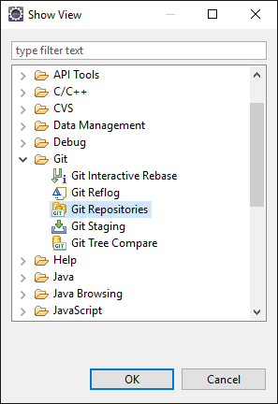

1. Clone button

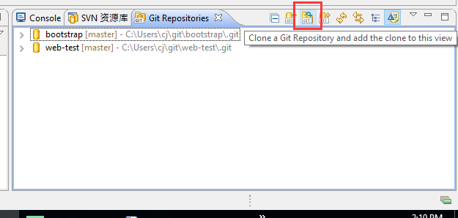

1. URI: <https://github.com/wcj3570/web-test.git> , and your user/pass

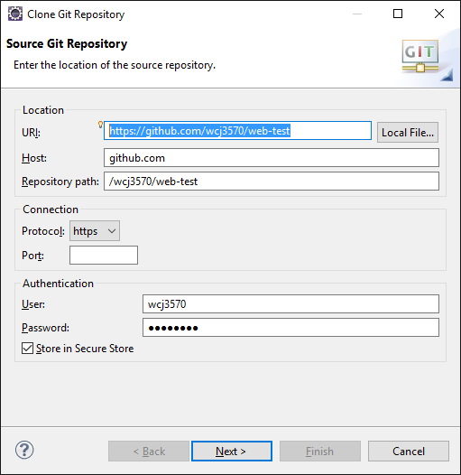

1. Import project

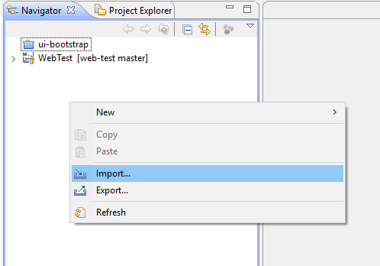

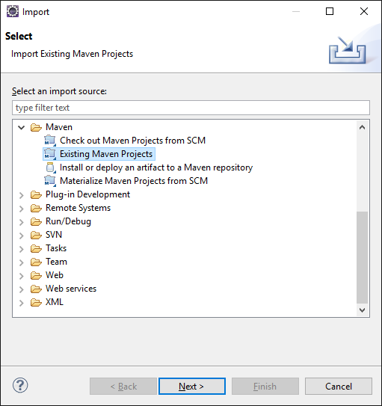

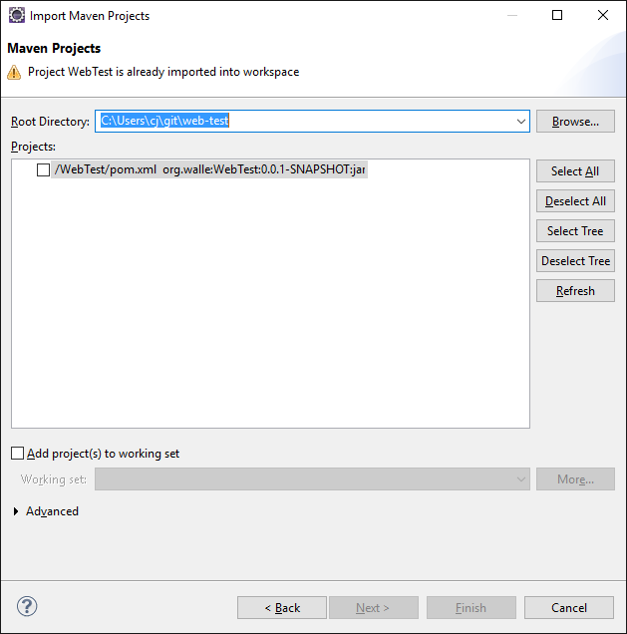

1. Install walle jars, goto UserFolder/git/web-test/dependencies, run install.bat
2. Build project. Run as -> Maven build, Goals: clean package -DskipTests

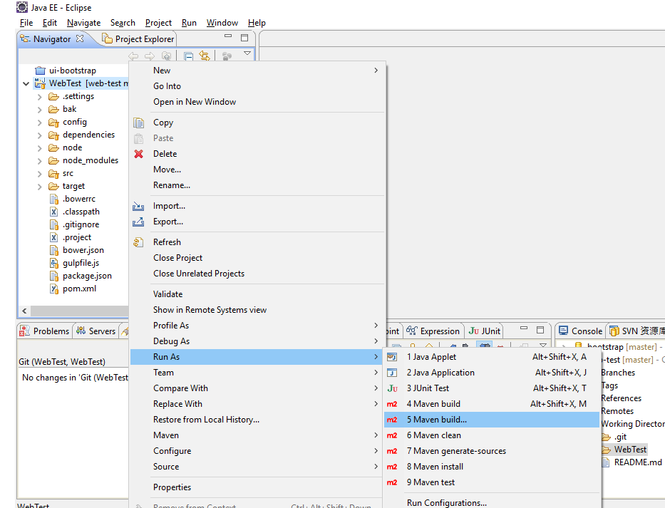

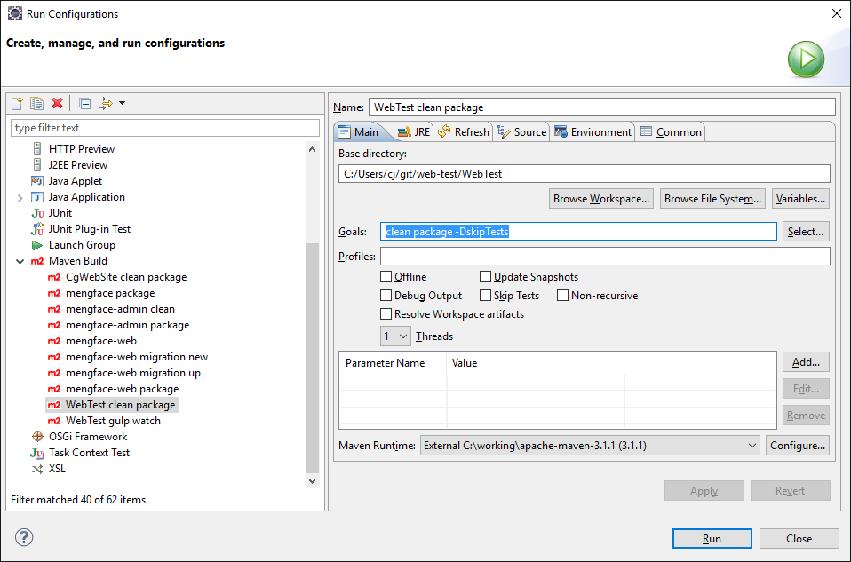

1. Run gulp watch when developing. Run as -> Maven build, Goals: com.github.eirslett:frontend-maven-plugin:gulp, with a Parameter frontend.gulp.arguments = watch

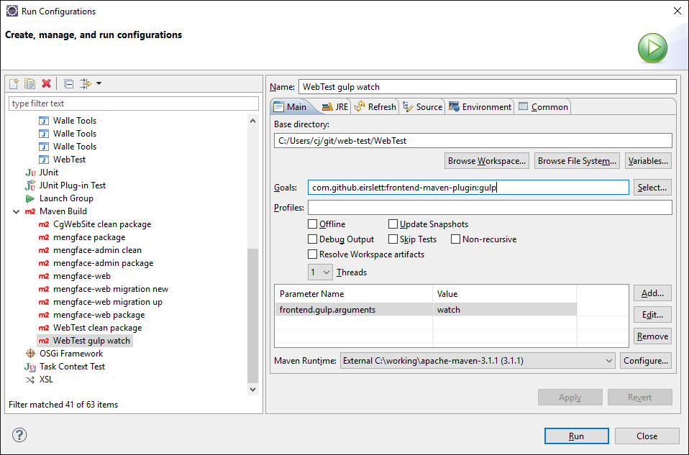

1. Run as Java Application, Main class org.walle.webtest.Application

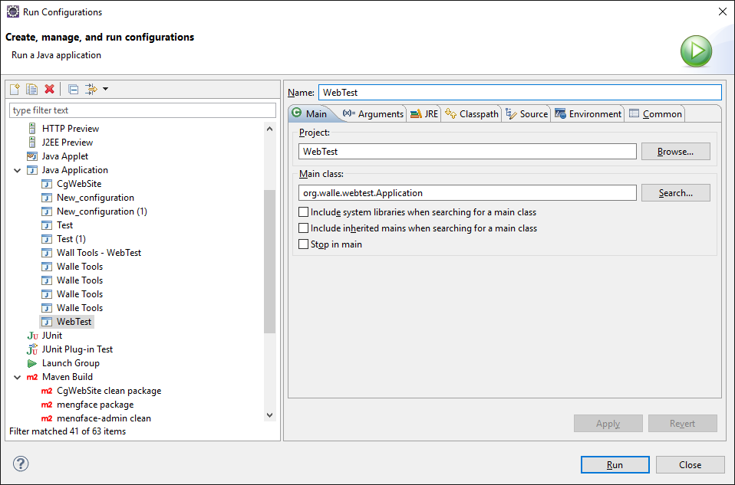

1. Visit <http://localhost:8080>