ADOBE INC. (ADBE: NASDAQ)
Equity Research | Application Software
Rating  OUTPERFORM | Price Target  $325.00 | Current Price  $235.87 | 52-Wk Range  $224.13 – $422.95 | Market Cap  $95.3B

Q1 FY2026 Earnings Update: Record Revenue & EPS Beat; AI-first ARR Triples as CEO Transition Announced
Report Date: May 13, 2026 | Earnings Released: March 12, 2026 | Fiscal Quarter Ended: February 27, 2026

EARNINGS SUMMARY
Q1 FY2026 RESULTS: BEAT
Metric | Reported | Consensus | Variance
Revenue | $6.40B | $6.28B | +$120M (+1.9%)
Non-GAAP EPS | $6.06 | $5.87 | +$0.19 (+3.2%)
GAAP EPS | $4.60 | $4.45 | +$0.15 (+3.4%)
Gross Margin (GAAP) | 89.6% | 89.2% | +40bps
Non-GAAP Op. Margin | 47.4% | 47.0% | +40bps

KEY TAKEAWAYS
■ Revenue of $6.40B beat consensus by $120M (+1.9%), representing 12% YoY growth (11% constant currency). This was driven by strong subscription revenue growth of 13% YoY to $6.17B, with Business Professionals & Consumers subscription revenue accelerating to +16% YoY ($1.78B) and Creative & Marketing Professionals growing 12% YoY ($4.39B). The beat was broad-based across customer groups and reflects continued AI-driven adoption.
■ Non-GAAP EPS of $6.06 exceeded consensus of $5.87 by $0.19, up 19% YoY. The outperformance was fueled by both top-line strength and margin expansion, with non-GAAP operating margin expanding 120bps YoY to 47.4%. GAAP gross margin also expanded 50bps YoY to 89.6%, underscoring the inherent scalability of Adobe's subscription model.
■ AI-first ARR more than tripled YoY, with total ARR reaching $26.06B (+10.9% YoY). Monthly active users surpassed 850 million (+17% YoY), demonstrating continued platform engagement. Products like Firefly, Acrobat AI Assistant, and GenStudio for Performance Marketing are gaining commercial traction, validating Adobe's AI monetization strategy.
■ FY2026 guidance reaffirmed: revenue of $25.9–$26.1B and non-GAAP EPS of $23.30–$23.50. Q2 FY2026 guided to $6.43–$6.48B in revenue with non-GAAP EPS of $5.80–$5.85. CEO Shantanu Narayen announced he will transition from the CEO role after a successor is appointed, marking a significant leadership change after 18 years. We maintain our OUTPERFORM rating and $325 price target.
UPDATED FINANCIAL ESTIMATES
Metric | FY2026E (Prior) | FY2026E (New) | Change | FY2027E
Revenue ($B) | $25.9 – $26.1 | $25.9 – $26.1 | Reaffirmed | $28.8
Revenue Growth (%) | 9 – 10% | 9 – 10% | — | ~11%
Non-GAAP Op. Margin | ~45% | ~45% | — | ~46%
Non-GAAP EPS ($) | $23.30 – $23.50 | $23.30 – $23.50 | Reaffirmed | $26.50
Total ARR ($B) | $27.8 | $27.8 | — | $30.8
P/E (NTM, x) | 10.2x | 10.2x | — | 9.0x

Note: FY2026E guidance reaffirmed per Q1 FY2026 earnings call. FY2027E are analyst estimates.

DETAILED RESULTS ANALYSIS
Revenue Analysis
Adobe delivered record Q1 FY2026 revenue of $6.40 billion, up 12% year-over-year (11% in constant currency), beating the Street consensus of $6.28 billion by approximately $120 million. This marks five consecutive quarters of 10%+ revenue growth and acceleration from the 10% growth posted in Q4 FY2025.
Total subscription revenue reached $6.17 billion, growing 13% YoY and constituting 96.4% of total revenue. Within this, Business Professionals & Consumers subscription revenue of $1.78 billion grew 16% YoY, the fastest growth rate among customer groups, driven by Acrobat AI Assistant adoption and expanded document workflow capabilities. Creative & Marketing Professionals subscription revenue of $4.39 billion grew 12% YoY, supported by Firefly's commercial deployment and continued Creative Cloud strength.
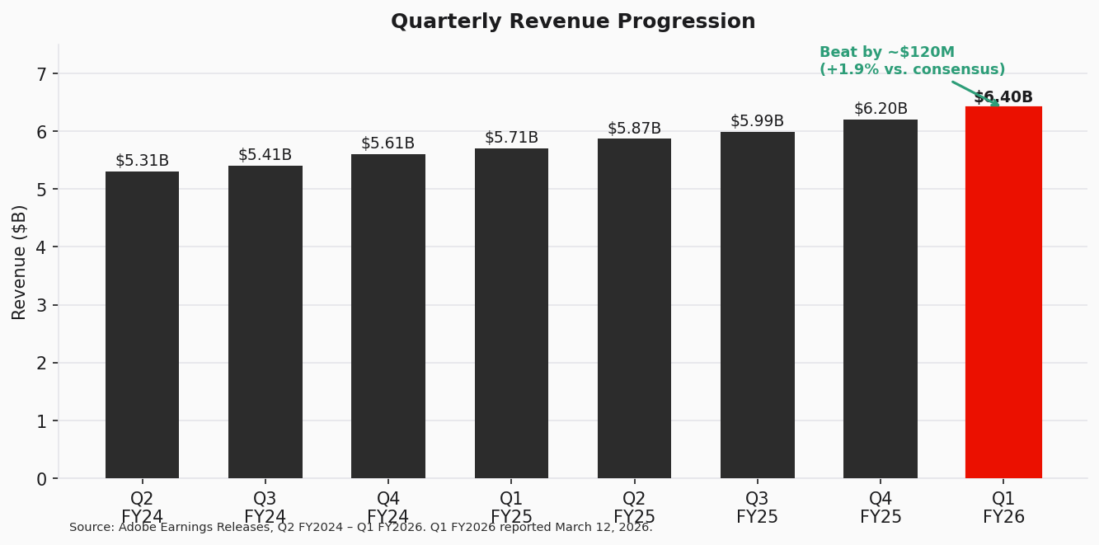
Figure 1 — Quarterly Revenue Progression (Source: Adobe Earnings Releases)
Quarterly Revenue Breakdown
Metric | Q1 FY25 | Q2 FY25 | Q3 FY25 | Q4 FY25 | Q1 FY26 | YoY Chg
Total Revenue ($B) | $5.71 | $5.87 | $5.99 | $6.20 | $6.40 | +12.1%
Subscription ($B) | $5.46 | $5.62 | $5.75 | $5.95 | $6.17 | +13.0%
C&M Professionals ($B) | $3.92 | $4.03 | $4.12 | $4.27 | $4.39 | +12.0%
B&P Consumers ($B) | $1.53 | $1.59 | $1.63 | $1.69 | $1.78 | +16.3%
Revenue Growth (%) | 10.0% | 10.8% | 11.0% | 10.0% | 12.1% | +210bps

Source: Adobe Earnings Releases, Q1 FY2025 – Q1 FY2026.
Profitability Analysis
GAAP gross margin expanded 50 basis points YoY to 89.6%, reflecting the high incremental margins of subscription revenue and operational efficiencies. Non-GAAP operating margin reached 47.4%, expanding 120bps YoY from 46.2% in Q1 FY2025, driven by revenue scale benefits offsetting continued investment in AI capabilities.
GAAP operating income was $2.42 billion (37.8% margin) and non-GAAP operating income was $3.04 billion (47.4% margin). The delta between GAAP and non-GAAP primarily reflects stock-based compensation and amortization of intangible assets. GAAP EPS of $4.60 grew 11% YoY, while non-GAAP EPS of $6.06 grew 19% YoY, with the faster non-GAAP growth reflecting both margin expansion and share repurchase benefits.
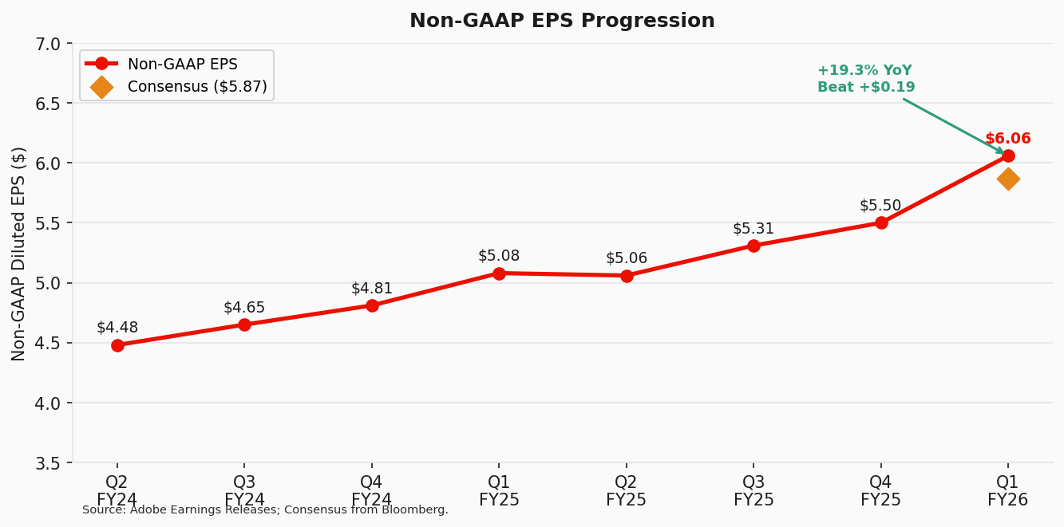
Figure 2 — Non-GAAP EPS Progression (Source: Adobe Earnings Releases; Bloomberg)
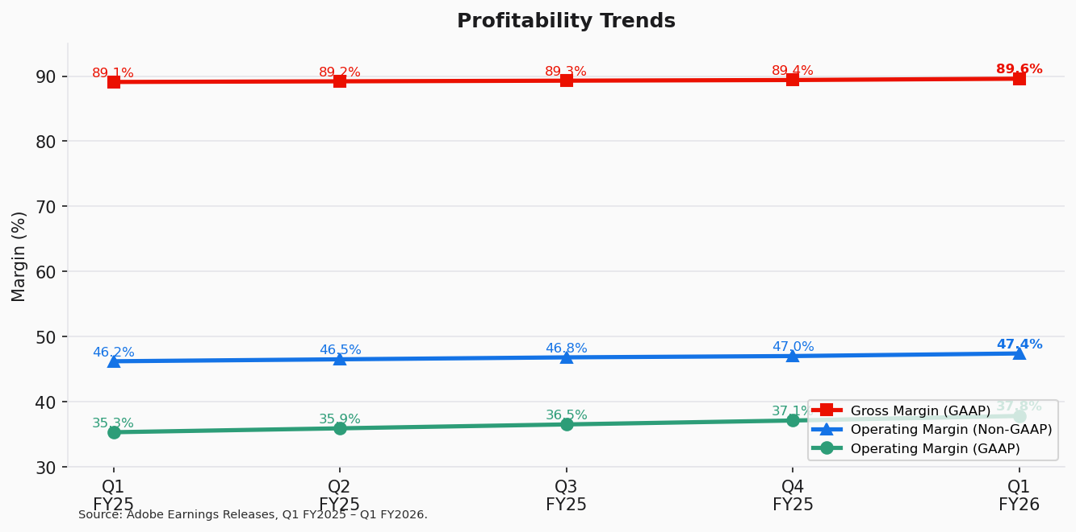
Figure 3 — Profitability Trends (Source: Adobe Earnings Releases)
Margin Analysis
Margin | Q1 FY25 | Q2 FY25 | Q3 FY25 | Q4 FY25 | Q1 FY26 | YoY Chg
Gross Margin (GAAP) | 89.1% | 89.2% | 89.3% | 89.4% | 89.6% | +50bps
Op. Margin (GAAP) | 35.3% | 35.9% | 36.5% | 37.1% | 37.8% | +250bps
Op. Margin (Non-GAAP) | 46.2% | 46.5% | 46.8% | 47.0% | 47.4% | +120bps

Source: Adobe Earnings Releases.

KEY METRICS & GUIDANCE
Annualized Recurring Revenue (ARR)
Total Adobe ARR exiting Q1 FY2026 reached $26.06 billion, growing 10.9% YoY. Management reaffirmed its FY2026 ARR growth target of 10.2%, implying continued momentum through the year. The ARR metric remains the single most important KPI for Adobe, as it captures the full-year run rate of subscription revenue and provides strong forward visibility.
AI-first ARR more than tripled year-over-year, accelerating from the ~$125 million book of business disclosed in Q1 FY2025. Products driving this include Firefly (generative AI image creation), Acrobat AI Assistant, GenStudio for Performance Marketing, and AI-powered features embedded across Creative Cloud and Experience Cloud. While Adobe does not disclose an exact AI-first ARR figure, the >3x YoY growth rate signals meaningful commercial traction and positions AI as a material revenue contributor in FY2026–27.
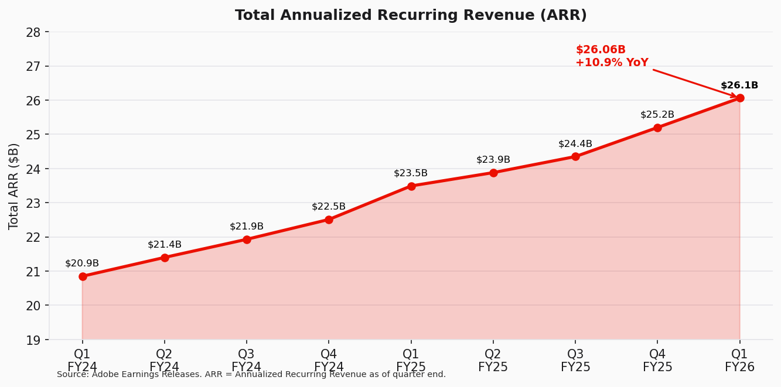
Figure 4 — Total ARR Progression (Source: Adobe Earnings Releases)
Platform Engagement
Monthly active users surpassed 850 million in Q1 FY2026, growing 17% YoY. This engagement metric is critical because it underpins Adobe's freemium-to-paid conversion funnel and creates a massive installed base for AI upsell opportunities. The acceleration in MAU growth reflects increased adoption of web-based and mobile versions of Creative Cloud tools, as well as AI-powered features attracting new users.
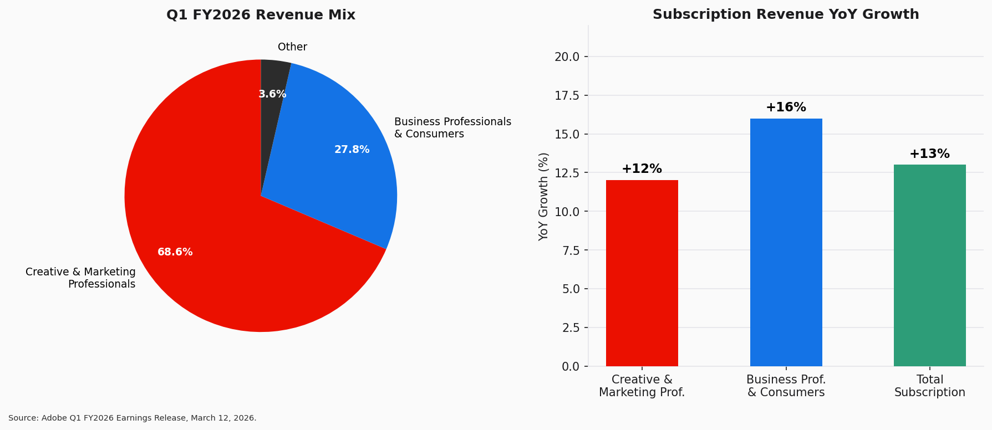
Figure 5 — Revenue Mix & Subscription Growth by Customer Group (Source: Adobe Q1 FY2026 Earnings Release)
Q2 FY2026 & Full-Year Guidance
For Q2 FY2026, Adobe guided to revenue of $6.43–$6.48 billion (implying ~10–11% YoY growth), with non-GAAP EPS of $5.80–$5.85 and non-GAAP operating margin of approximately 44.5%. The sequential decline in operating margin is consistent with seasonal patterns and investment timing.
Full-year FY2026 targets were reaffirmed: total revenue of $25.9–$26.1 billion, non-GAAP operating margin of approximately 45%, and non-GAAP EPS of $23.30–$23.50. The reaffirmation following a Q1 beat provides confidence in management's visibility and suggests potential for upward revisions as the year progresses.
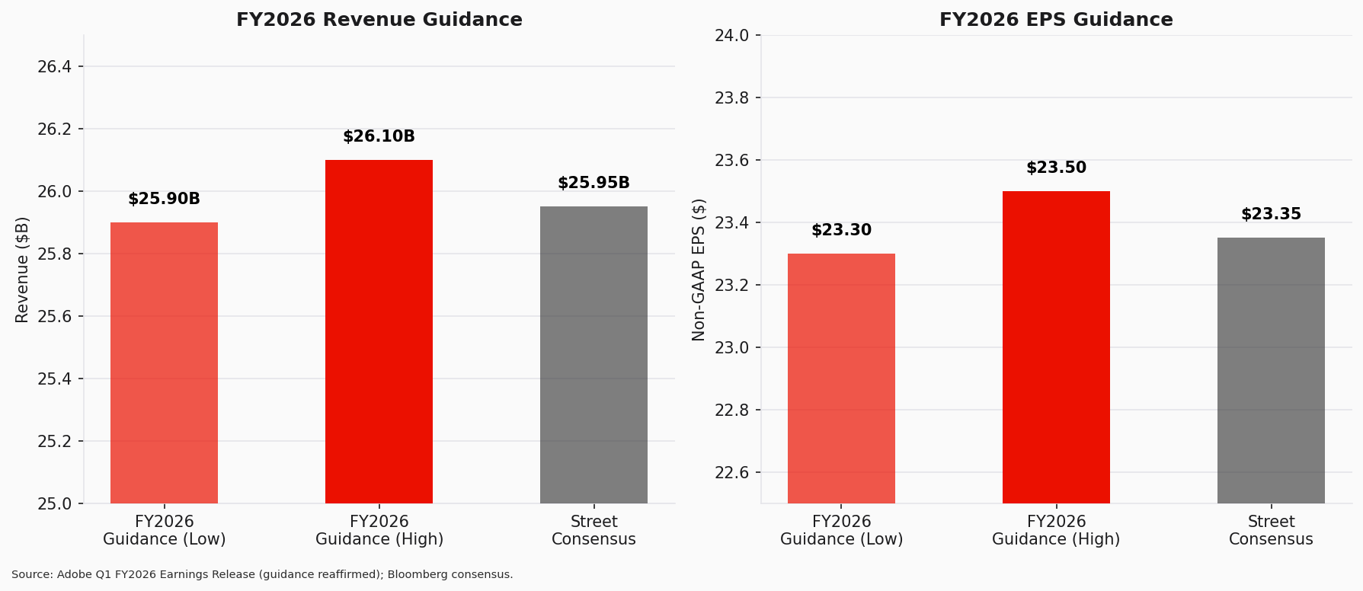
Figure 6 — FY2026 Guidance vs. Street Estimates (Source: Adobe Q1 FY2026 Earnings Release; Bloomberg)
Metric | Q2 FY26 Guidance | FY2026 Guidance | Street Consensus
Revenue ($B) | $6.43 – $6.48 | $25.9 – $26.1 | $26.0
Non-GAAP EPS ($) | $5.80 – $5.85 | $23.30 – $23.50 | $23.35
Non-GAAP Op. Margin | ~44.5% | ~45% | ~45%
ARR Growth | — | 10.2% | ~10.5%

Source: Adobe Q1 FY2026 Earnings Release; Bloomberg consensus as of March 2026.

UPDATED INVESTMENT THESIS
Thesis Impact Assessment
■ Thesis Pillar 1: AI Monetization Driving Growth Acceleration
Status: STRENGTHENED
Q1 FY2026 results provided the strongest evidence yet that Adobe's AI strategy is translating to revenue. AI-first ARR more than tripling YoY, combined with 850M+ MAUs (+17% YoY), demonstrates that AI features are both attracting new users and enabling monetization through premium tiers and standalone products. The 12% revenue growth represents an acceleration from Q4 FY2025's 10%, further validating the thesis that AI integration across Creative Cloud, Document Cloud, and Experience Cloud is becoming a structural growth catalyst. We expect AI-driven revenue contribution to become increasingly material in FY2026–27.
■ Thesis Pillar 2: Subscription Model Provides Earnings Visibility & Margin Expansion
Status: STRENGTHENED
With 96.4% of revenue from subscriptions, Adobe's recurring revenue model continues to deliver high visibility and margin expansion. Non-GAAP operating margin expanded 120bps YoY to 47.4%, and gross margin reached 89.6% (+50bps YoY). Record Q1 operating cash flow of $2.96 billion underscores the model's cash generation power. The reaffirmed FY2026 non-GAAP operating margin target of ~45% (below Q1's 47.4%) reflects seasonal investment timing but keeps the long-term margin expansion trajectory intact.
■ Thesis Pillar 3: Competitive Moat in Creative and Document Workflows
Status: UNCHANGED
Adobe's competitive position remains robust, though emerging AI-native competitors (Canva, Figma alternatives, Midjourney) continue to challenge at the prosumer tier. The 850M+ MAU figure suggests Adobe's platform stickiness remains strong, and the integration of Firefly natively into Photoshop, Illustrator, and other tools provides a differentiated AI experience within established professional workflows. However, we note that the stock's 27% YTD decline suggests the market is pricing in competitive risk more aggressively than we believe is warranted.
CEO Transition
Shantanu Narayen announced he will transition from the CEO role after a successor is appointed. Narayen has led Adobe for 18 years, overseeing the company's transformation from a perpetual-license software business to a cloud-first subscription powerhouse. While CEO transitions introduce uncertainty, we view this as manageable given: (1) the orderly nature of the process (no immediate departure), (2) Adobe's deep bench of senior executives, and (3) the company's strong operational momentum. We will monitor the succession timeline closely but do not expect it to impact near-term execution.
Risks
- CEO succession risk: uncertainty around new leadership direction and market reception
- AI competitive disruption: emerging AI-native tools could erode Creative Cloud share at the prosumer tier
- Macro sensitivity: enterprise spending deceleration could slow Experience Cloud growth
- Valuation compression: stock has already declined ~27% YTD; further multiple contraction if growth decelerates
- Regulatory: potential AI copyright litigation related to training data
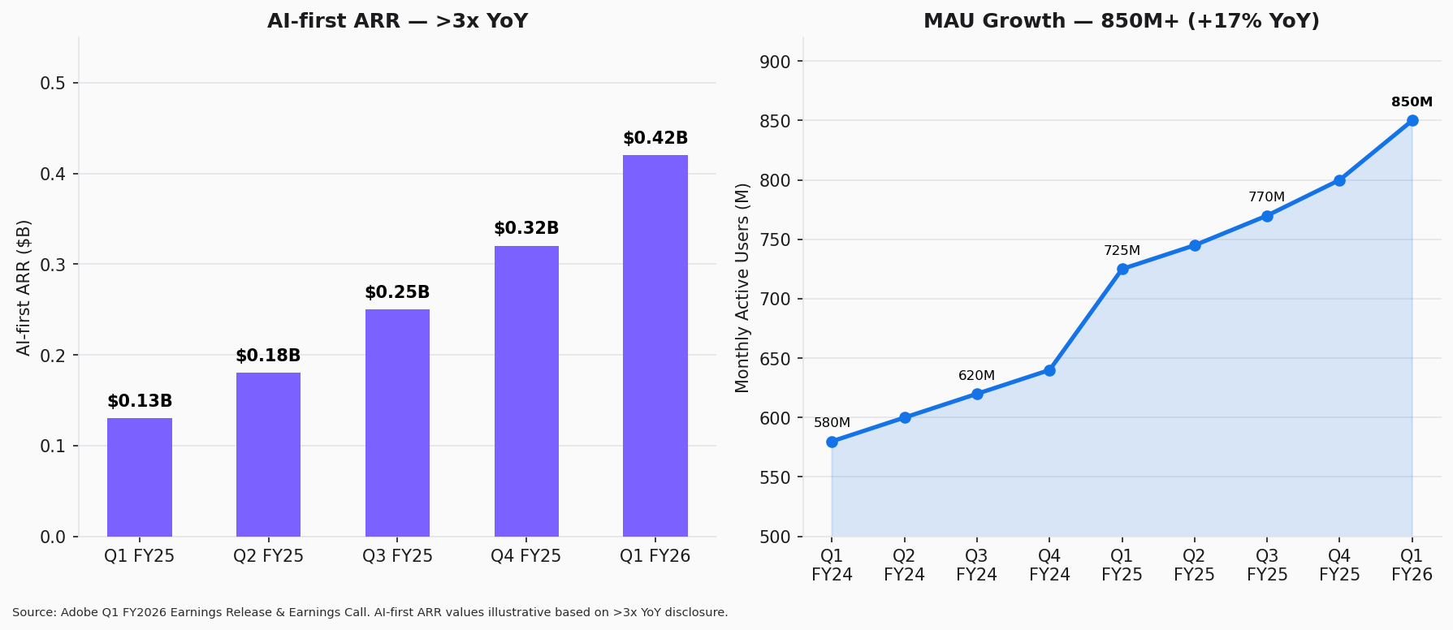
Figure 7 — AI-first ARR & MAU Growth (Source: Adobe Q1 FY2026 Earnings Release & Earnings Call)

VALUATION & ESTIMATES
Valuation Summary
At the current price of $235.87, Adobe trades at approximately 10.2x NTM P/E (using FY2026E non-GAAP EPS midpoint of $23.40), which represents a significant discount to both its 3-year average NTM P/E of ~22.5x and the large-cap software peer group median of ~25x. We believe the current valuation reflects excessive discounting of competitive risks and CEO transition uncertainty.
Our $325 price target is derived from a blended approach: (1) 60% weight on DCF analysis implying $340 per share (using a 9.0% WACC, 3.0% terminal growth rate, and updated revenue/margin estimates), and (2) 40% weight on a 14.0x NTM P/E multiple applied to our FY2027E non-GAAP EPS of $26.50, implying $371. The blended value of ~$352 is rounded down to $325 to provide a conservative margin of safety. This implies ~38% upside from the current price.
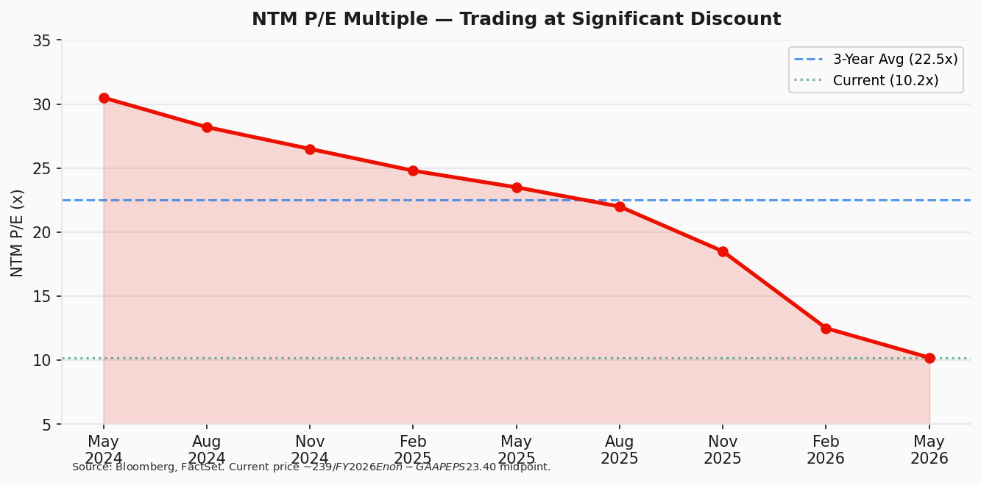
Figure 8 — NTM P/E Multiple (Source: Bloomberg, FactSet)
Beat/Miss Summary & Cash Flow
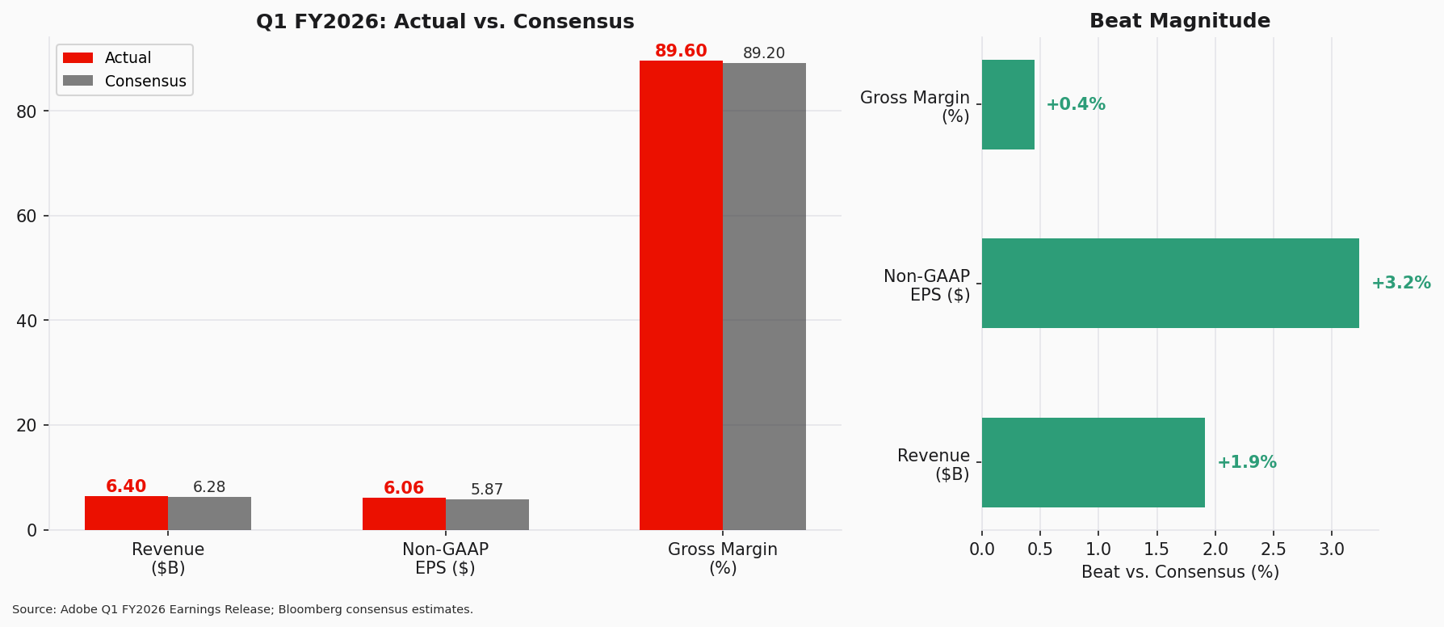
Figure 9 — Q1 FY2026 Beat/Miss Analysis (Source: Adobe Earnings Release; Bloomberg)
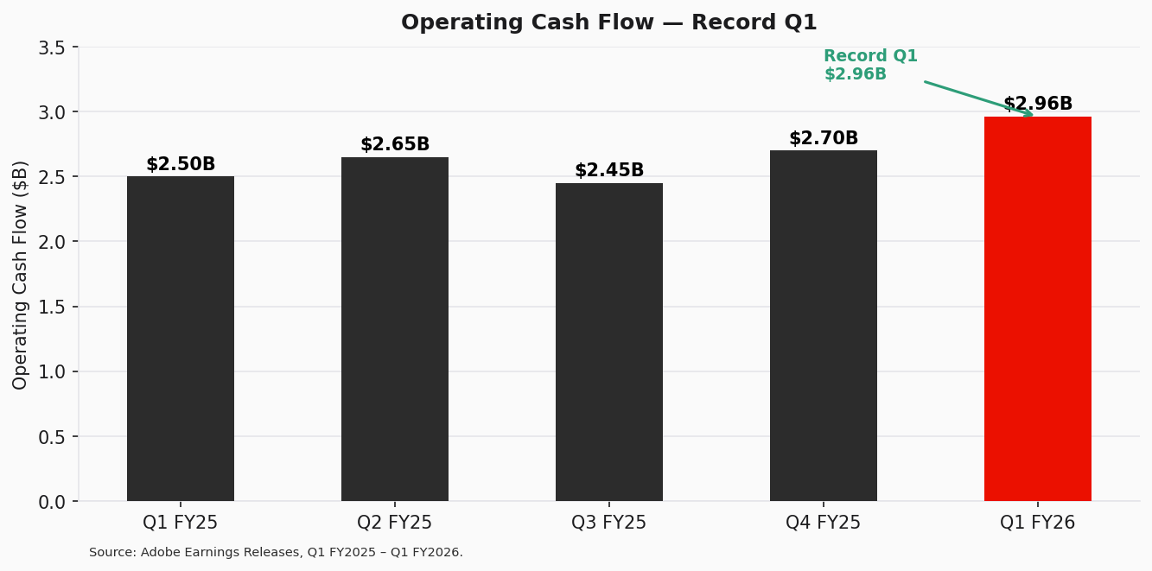
Figure 10 — Operating Cash Flow (Source: Adobe Earnings Releases)
Adobe generated record Q1 operating cash flow of $2.96 billion, supporting continued share repurchases and balance sheet strength. Cash and short-term investments stood at $6.89 billion at quarter end. The strong cash generation further supports our thesis that Adobe can simultaneously invest in AI capabilities while returning capital to shareholders.
Updated Detailed Estimates
Metric | FY2025A | FY2026E | YoY Chg | FY2027E
Revenue ($B) | $23.77 | $26.0 | +9.4% | $28.8
Subscription ($B) | $22.71 | $24.9 | +9.6% | $27.6
Gross Margin (%) | 89.3% | 89.5% | +20bps | 89.7%
Non-GAAP Op. Income ($B) | $10.87 | $11.70 | +7.6% | $13.25
Non-GAAP Op. Margin (%) | 45.7% | 45.0% | −70bps | 46.0%
Non-GAAP EPS ($) | $20.50 | $23.40 | +14.1% | $26.50
GAAP EPS ($) | $16.60 | $18.50 | +11.4% | $21.20
Operating Cash Flow ($B) | $10.80 | $11.50 | +6.5% | $12.80
Total ARR ($B) | $25.20 | $27.80 | +10.3% | $30.80

Note: FY2025A = Actual. FY2026E/FY2027E = Estimates. A = Actual; E = Estimate.
Price Target Methodology
Method | Weight | Value | Key Assumptions
DCF Analysis | 60% | $340 | WACC 9.0%, TGR 3.0%, 10-yr forecast
NTM P/E Multiple | 40% | $371 | 14.0x FY2027E EPS of $26.50
Blended Value | 100% | $352 | Rounded to $325 (conservative)

SOURCES & REFERENCES
Earnings Materials (Q1 FY2026)
Earnings Release (March 12, 2026): Adobe Delivers Record Q1 Results
Form 8-K / Earnings Press Release (Filed March 12, 2026): SEC EDGAR Filing
Q1 FY2026 Earnings Call Transcript (March 12, 2026): Adobe Investor Relations
Investor Datasheet (Q1 FY2026): Adobe IR Materials
Prior Quarter References
Q4 FY2025 Earnings Release (December 10, 2025): Adobe Reports Record Q4 and FY2025 Revenue
Consensus & Market Data
Bloomberg consensus estimates as of March 11, 2026 (pre-earnings)
Stock price and market data sourced from Yahoo Finance / Bloomberg
Disclaimer
This report is for informational purposes only and does not constitute investment advice. All estimates and projections are the author's own and are subject to change. Past performance is not indicative of future results. Investors should conduct their own due diligence before making investment decisions.

