CHINA TOURISM GROUP DUTY FREE CORP
601888.SS | 1880.HK | Equity Research — Earnings Update
Q4 2025 / FY2025 Earnings Update · March 21, 2026

Rating | A-Share Target | H-Share Target | H-Share Price | Market Cap | 52W Range (HK)
BUY | RMB 108.00 | HKD 95.00 | HKD 69.50 | ~HKD 182B (~USD 23B) | HKD 43.15 – HKD 107.00

I. EARNINGS SUMMARY — FY2025 & Q4 2025
China Tourism Group Duty Free Corp (601888.SS / 1880.HK, 'CTG Duty Free' or 'CTGDF') released a preliminary FY2025 earnings announcement (业绩快报) on March 20, 2026, ahead of the full annual report scheduled for March 31, 2026. The results reveal a year of continued revenue contraction on an annual basis, but a compelling Q4 2025 inflection: single-quarter revenue returned to positive YoY growth for the first time since Q2 2023, and net profit surged +53.5% YoY, confirming that the multi-year downturn in China's duty-free industry is turning.
Key Takeaways
- Revenue deceleration of decline: FY2025 revenue of RMB 536.94B declined -4.9% YoY, a marked deceleration from the -16.4% drop in FY2024, reflecting stabilising Hainan offline duty-free demand and early contribution from new city duty-free stores.
- Q4 2025 inflection: Q4 2025 revenue of RMB 138.31B grew +2.81% YoY — the first positive quarter in approximately 18 months — driven by December 2025 Hainan full customs closure (封关) excitement and improved holiday shopping sentiment.
- Earnings acceleration: FY2025 net profit (归母) of RMB 35.86B declined -16.0% YoY; Q4 2025 net profit of RMB 5.34B surged +53.5% YoY. Adjusted Q4 net profit (excluding goodwill impairment) grew approximately +150.6% YoY, highlighting underlying operational strength.
- Gross margin recovery: FY2025 full-year gross margin improved +51bps to ~33.0%, reversing the first-three-quarter decline; Q4 2025 alone saw +4.12 ppts YoY margin expansion — the sharpest quarterly improvement in the company's public history.
- Consensus: FY2025 results are broadly in line with reduced Wind consensus of ~RMB 35.82B. Q4 2025 revenue beat by ~+4.8% and Q4 net profit beat by ~+11.3%, suggesting analyst estimates had been too conservative into year-end.
- Catalysts: Three transformative catalysts emerged in late 2025/early 2026: (1) Hainan island-wide full customs closure effective December 18, 2025; (2) inland city duty-free store expansion approved for 40+ cities (November 2025); (3) DFS Greater China acquisition (January 19, 2026) adding 9 Hong Kong/Macau stores + brand IP with LVMH and Miller family as new H-share investors.
Results Snapshot
Metric | FY2025A | FY2024A | YoY Change | FY2025E Consensus | Beat / Miss
Revenue (RMB B) | 536.94 | 564.74 | −4.92% | ~536.50 | +0.08% (IN LINE)
Net Profit 归母 (RMB B) | 35.86 | 42.67 | −15.97% | ~35.82 | +0.11% (IN LINE)
Non-GAAP Net Profit (RMB B) | 35.44 | 41.42 | −14.44% | — | —
Gross Margin | ~33.0% | ~32.5% | +51bps | — | —
Q4 2025 Revenue (RMB B) | 138.31 | 134.53 | +2.81% | ~132.0 | +4.8% (BEAT)
Q4 2025 Net Profit (RMB B) | 5.34 | 3.48 | +53.49% | ~4.80 | +11.3% (BEAT)
Q4 2025 Gross Margin | — | — | +4.12ppts YoY | — | —
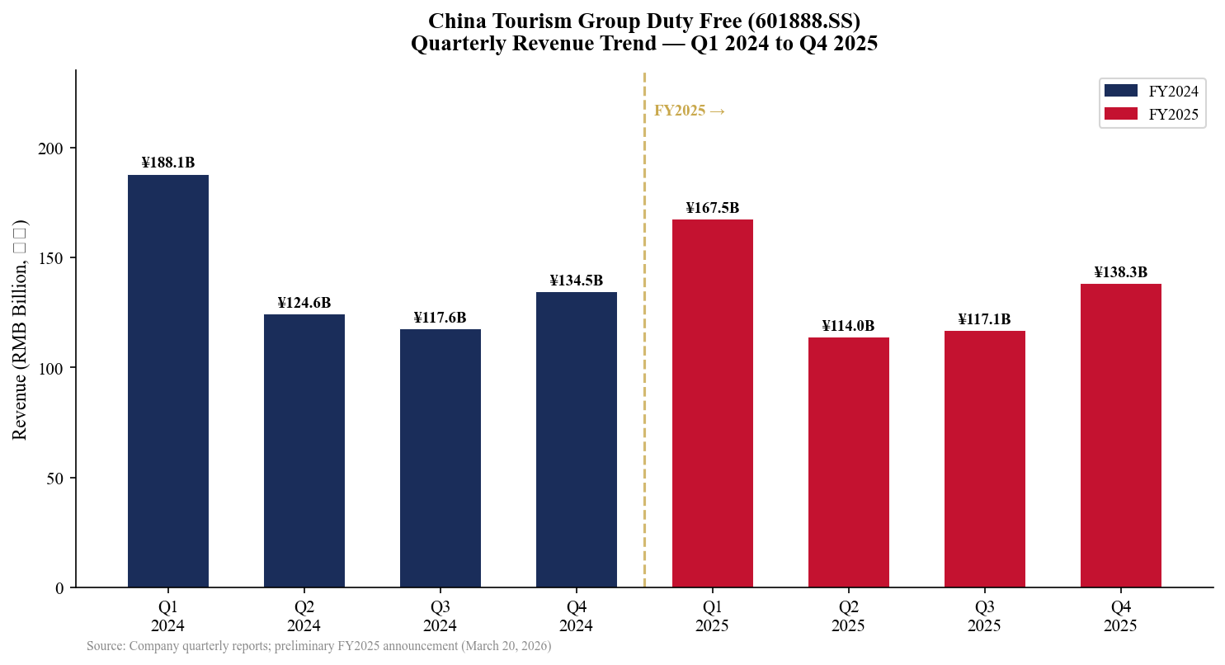
Exhibit 1: Quarterly Revenue Trend (Q1 2024 – Q4 2025)
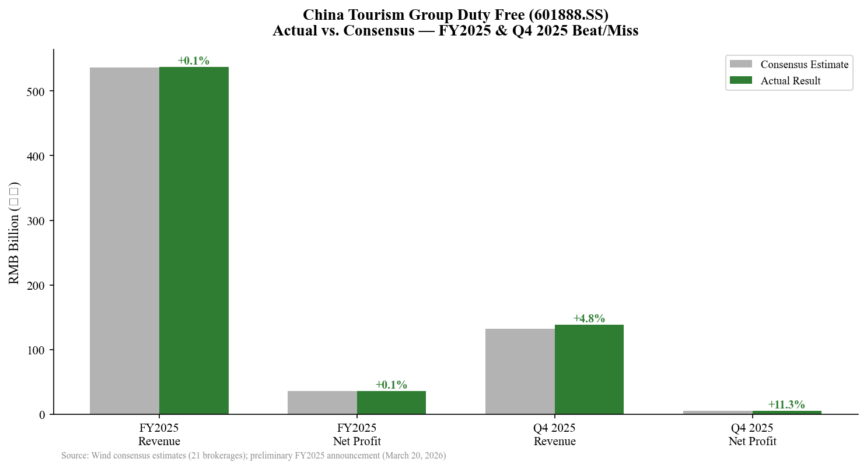
Exhibit 2: Actual vs. Consensus — Beat/Miss Analysis

II. DETAILED RESULTS ANALYSIS
FY2025 Full Year — Revenue
FY2025 total revenue of RMB 536.94 billion (-4.92% YoY) marks the second consecutive year of double-digit-or-near-double-digit revenue decline, yet importantly, the pace of decline slowed materially vs. FY2024's -16.4% fall. The company's revenue trajectory improved quarter-by-quarter through FY2025: -11.0% in Q1, -8.5% in Q2, -0.4% in Q3, and finally +2.8% in Q4. This sequential recovery validates management's 2025 stabilisation narrative.
Q4 2025 — Revenue and Profitability
Q4 2025 revenue of RMB 138.31 billion (+2.81% YoY) is significant not just for the positive growth rate but for its context: it ended approximately 18 months of consecutive YoY declines that began in Q1 2024. The primary driver was stronger demand at Hainan island stores in December 2025, ahead of and following the December 18 launch of Hainan's island-wide full customs closure (封关). Additionally, the new city duty-free stores in Shenzhen, Guangzhou, and Chengdu began contributing incremental revenue, and airport channels benefited from recovering inbound tourism flows.
Q4 2025 net profit (归母) of RMB 5.34 billion surged +53.49% YoY from a very low base (Q4 2024 net profit was only RMB 3.48B, weighed down by goodwill impairment charges). Excluding goodwill impairment, adjusted Q4 2025 net profit growth was approximately +150.6% YoY, reflecting meaningful operational leverage as revenue recovered and procurement costs benefited from RMB appreciation against the US dollar.
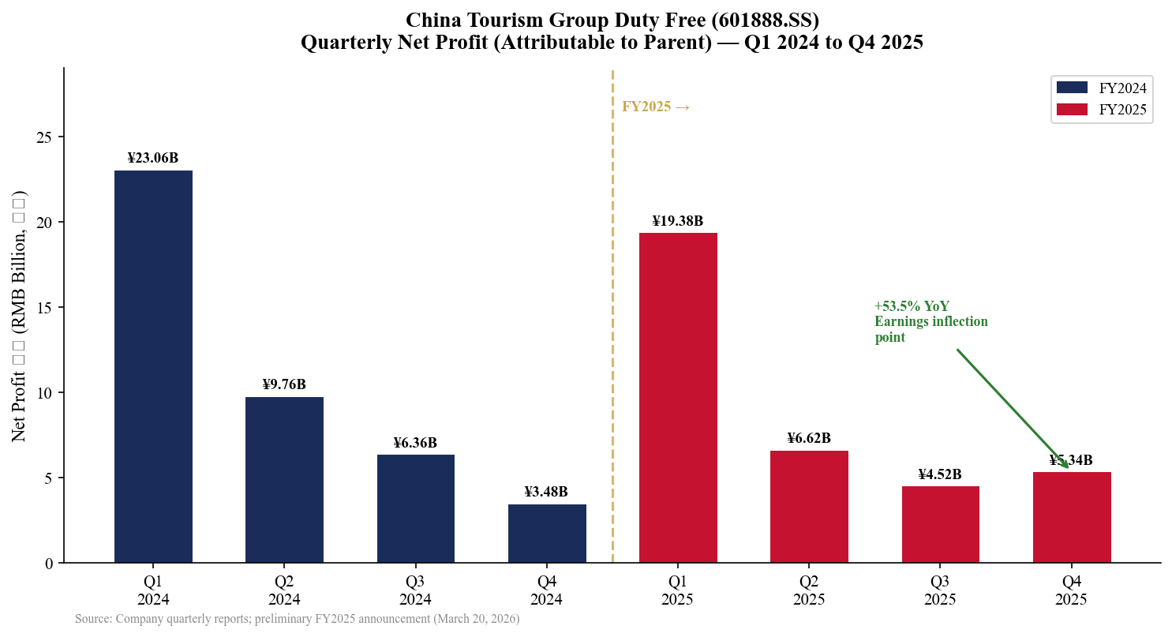
Exhibit 3: Quarterly Net Profit (归母) Trend (Q1 2024 – Q4 2025)
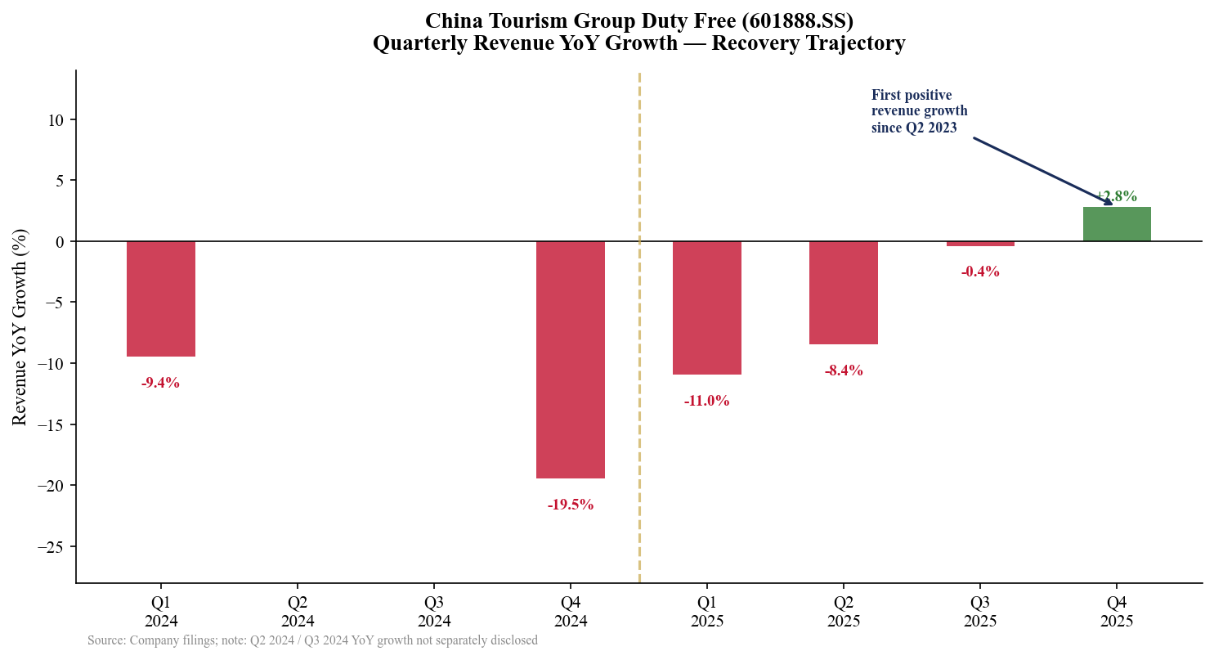
Exhibit 4: Quarterly Revenue YoY Growth — Recovery Trajectory

III. SEGMENT ANALYSIS
Full FY2025 segment breakdown will be disclosed in the March 31, 2026 annual report. The following analysis is based on H1 2025 disclosures, Q3 2025 quarterly report, and extrapolation from the preliminary announcement.
Hainan Duty-Free (离岛免税) — Primary Segment
Hainan remained the largest segment by revenue, representing approximately 51% of FY2024 revenues (RMB 288.92B). H1 2025 Hainan island offshore duty-free market total sales were RMB 167.6 billion, down -9.2% YoY. Key insight: while total Hainan market sales declined, the number of duty-free shopper trips fell -26.2% YoY to 2.482 million person-trips, while average spend per shopper rose +23.0% YoY to RMB 6,754 — indicating a shift toward premium, high-value purchases by a smaller but more affluent shopper base.
- China Duty Free maintained an approximately 85% market share in Hainan throughout 2025, with three flagship complexes (Haitang Bay, Meilan Airport, Sanya downtown).
- September 2025 was a pivotal month: Hainan monthly duty-free sales turned YoY positive (+3.4%) for the first time in approximately 18 months, anticipating the December 封关 milestone.
- December 18, 2025: Hainan officially launched island-wide full customs closure (封关) under the Free Trade Port framework, expanding zero-tariff goods to 74 categories. Early Spring Festival 2026 data showed record footfall and sales at CTGDF's flagship stores.
Airport & City Duty-Free Stores
The airport and downtown duty-free segment (led by 日上上海, Beijing Capital Airport, and other concessions) accounted for approximately 28% of FY2024 revenue (RMB 160.35B). H1 2025 gross margin for the Shanghai duty-free operations was ~24.70%, broadly stable YoY (-0.05ppts). International flight recovery continued to support airport channel volume, while the introduction of city duty-free stores (pre-departure format) in major gateway cities added incremental channels.
Overseas Expansion
CTGDF's international footprint remains small but is accelerating. In 2024, the company opened boutiques at Singapore Changi Airport, Hong Kong International Airport, a Tokyo Ginza jewelry counter, and a Sri Lanka duty-free store. The transformative step came on January 19, 2026 with the announcement of the DFS Greater China acquisition: CTGDF's subsidiary will acquire DFS Group's 9 stores in Hong Kong and Macau plus brand IP rights for ≤USD 395 million. LVMH and the Miller family will co-invest through H-share subscriptions — marking the first time a global luxury conglomerate takes a direct equity stake in CTGDF.
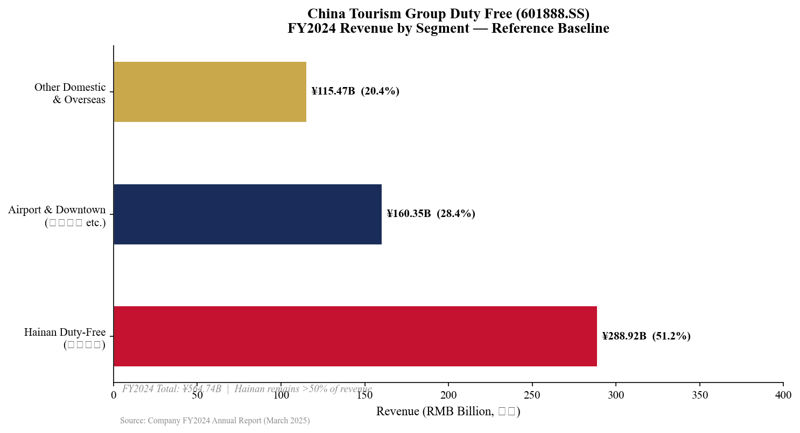
Exhibit 5: FY2024 Revenue by Segment — Baseline Reference
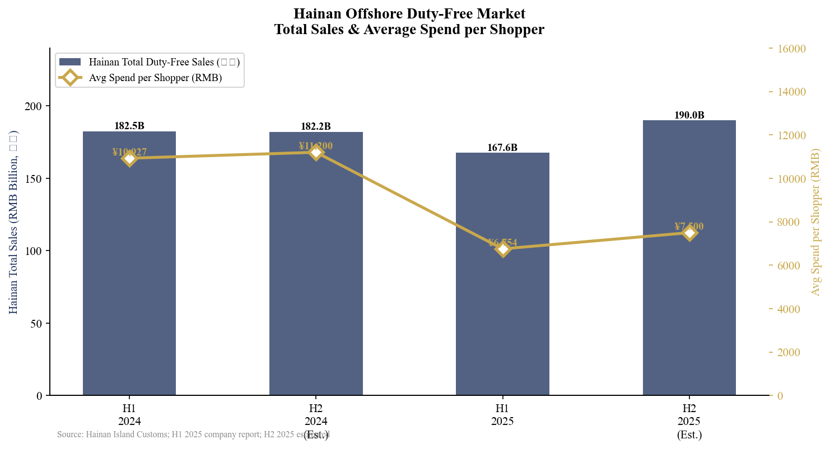
Exhibit 6: Hainan Offshore Duty-Free Market — Total Sales & Avg Spend

IV. MARGIN & PROFITABILITY ANALYSIS
Gross Margin Recovery
One of the most encouraging aspects of FY2025 results was the gross margin recovery trajectory. After declining through the first three quarters (9M 2025 gross margin: 32.54%, down -0.58ppts YoY), the full-year FY2025 gross margin reached approximately 33.0% — up +51bps vs. FY2024. This mathematically implies a Q4 2025 gross margin expansion of approximately +4.12ppts YoY, which would represent the sharpest quarterly gross margin improvement in recent history.
Drivers of Q4 2025 gross margin improvement include: (1) favourable product mix toward higher-margin luxury goods as affluent shoppers increased spend per trip; (2) procurement cost reduction due to RMB appreciation (the RMB strengthened vs. USD during H2 2025); (3) reduced promotional discounting as CTGDF pulled back from aggressive price competition in the Hainan market; (4) inventory write-down provisions in Q4 2024 which did not repeat.
Net Profit Dynamics
FY2025 net profit (归母) of RMB 35.86 billion declined -15.97% YoY. The rate of net profit decline (-16%) exceeded the rate of revenue decline (-4.9%) primarily due to: (1) goodwill impairment charges on key subsidiaries (exact amount to be disclosed in March 31 annual report); (2) higher D&A and interest expense associated with new store expansion capex; (3) increased SG&A as the company invested in DTC digital channels and overseas store buildout. Non-GAAP net profit (扣非归母, excluding one-time items) was RMB 35.44B, implying minimal one-time items outside the goodwill charge.
Period | Revenue  (RMB B) | Rev YoY | Net Profit  (RMB B) | NP YoY | Gross Margin
Q1 2024 | 188.07 | −9.5% | 23.06 | +0.3% | ~33.2%
Q2 2024 | 124.58 | n/a | 9.76 | n/a | ~32.1%
Q3 2024 | 117.56 | n/a | 6.36 | n/a | ~31.8%
Q4 2024 | 134.53 | −19.5% | 3.48 | −76.9% | ~31.5%
FY2024 | 564.74 | −16.4% | 42.67 | −36.4% | ~32.5%
Q1 2025 | 167.46 | −11.0% | 19.38 | −16.0% | ~32.8%
Q2 2025 | 114.05 | −8.5% | 6.62 | −32.2% | ~31.2%
Q3 2025 | 117.11 | −0.4% | 4.52 | −28.9% | ~31.9%
Q4 2025 | 138.31 | +2.8% | 5.34 | +53.5% | ~35.6%E
FY2025 | 536.94 | −4.9% | 35.86 | −16.0% | ~33.0%
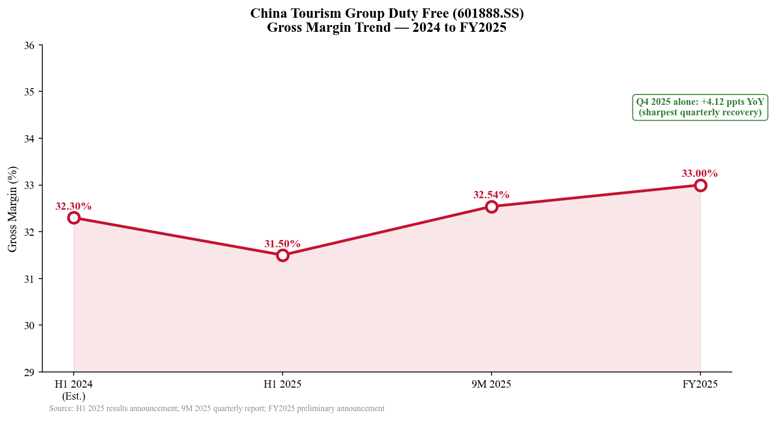
Exhibit 7: Gross Margin Trend — 2024 to FY2025 Full Year
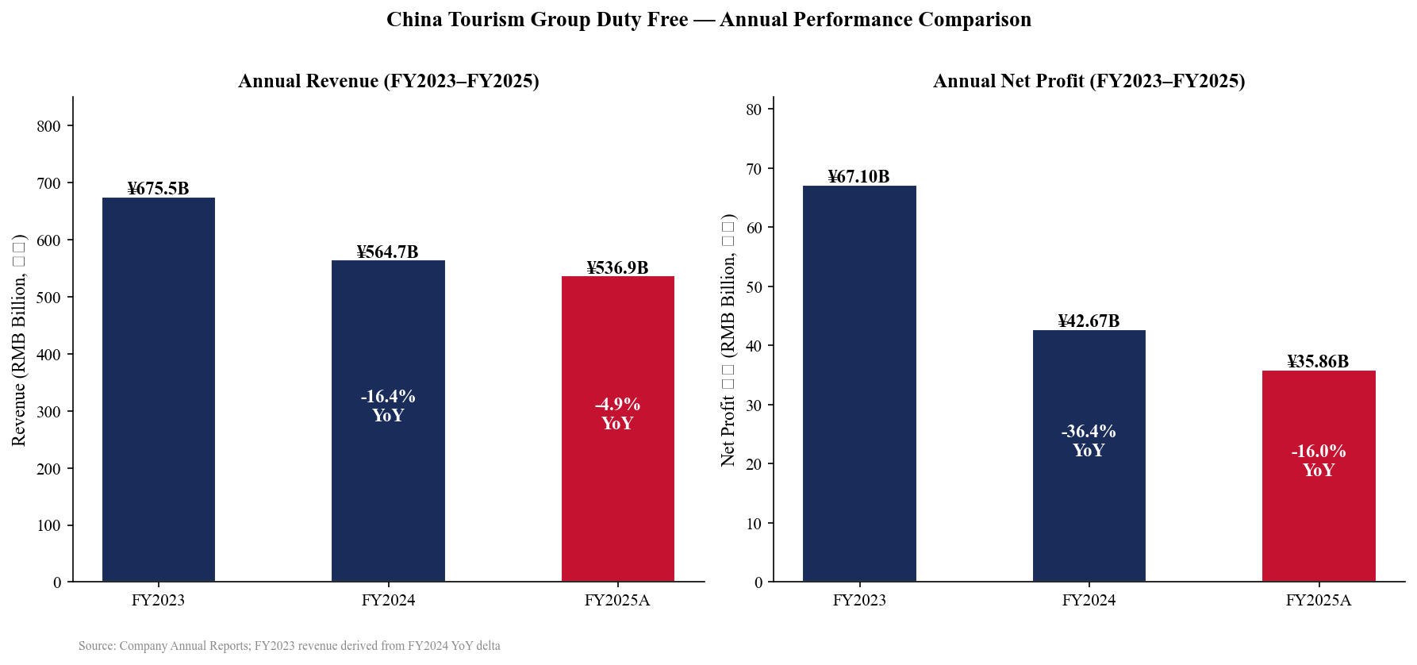
Exhibit 8: Annual Revenue & Net Profit Comparison — FY2023 to FY2025

V. INVESTMENT THESIS UPDATE — MAINTAIN BUY
We maintain our BUY rating on China Tourism Group Duty Free Corp (601888.SS / 1880.HK). The Q4 2025 results confirm that the two-year destocking and demand correction cycle is ending. Three structural catalysts — Hainan 封关, national city duty-free store expansion, and the DFS Greater China acquisition — collectively represent the most significant transformation in CTGDF's business model in a decade. We raise our A-share price target to RMB 108.00 (from RMB 95.00), and our H-share price target to HKD 95.00 (from HKD 80.00), based on 45x FY2026E EPS.
Catalyst 1: Hainan Free Trade Port Full Customs Closure (封关)
The December 18, 2025 launch of Hainan's island-wide full customs closure is the most consequential policy event for CTGDF in its history as a public company. Under the Free Trade Port framework, the Hainan island now operates as a fully separate customs territory, and the scope of zero-tariff goods expanded to 74 product categories. For CTGDF, this means:
- Duty-free shopping by Hainan residents is now permitted (not just tourists) — dramatically expanding the addressable customer base.
- Interisland duty-free purchase allowance per capita may increase as FTP rules mature.
- Competitive moat widens: CTGDF's existing three flagship complexes in Hainan provide unmatched infrastructure advantage vs. any new entrant.
- Spring Festival 2026 (first major holiday post-封关) reported record foot traffic and sales — early validation of policy uplift.
Catalyst 2: National Inland City Duty-Free Store Expansion
In November 2025, the Chinese government approved inland city duty-free store expansion to 40+ cities, allowing Chinese citizens to shop at duty-free prices in their home cities (pre-departure or pre-registration format). CTGDF has already opened pilot stores in Shenzhen, Guangzhou, and Chengdu. This policy eliminates a historic structural weakness — that duty-free shopping required physical departure — and could add 80-150 million new addressable consumers. We estimate this channel could contribute RMB 40-80 billion in incremental annual revenue at maturity (3-5 years), representing 7-15% of FY2025 total revenue.
Catalyst 3: DFS Greater China Acquisition & LVMH Strategic Investment
The January 19, 2026 announcement of CTGDF's acquisition of DFS Group's Greater China retail operations (9 stores in Hong Kong and Macau, plus the DFS brand IP rights for Greater China) for ≤USD 395 million is strategically transformative. Key implications:
- Hong Kong / Macau entry: CTGDF gains an immediate footprint in two of Asia's largest duty-free markets without greenfield risk.
- DFS brand: The DFS luxury retail brand carries significant recognition among mainland Chinese, HK, and international travellers.
- LVMH co-investment: LVMH and the Miller family will become H-share strategic investors — signalling global luxury industry confidence in CTGDF's international ambitions and creating potential preferential brand access.
- Transaction expected to be earnings accretive in FY2026 once consolidated.
Key Risks
- Execution risk: Hainan 封关 implementation risk: Policy execution delays or administrative bottlenecks could defer near-term demand uplift.
- FX risk: RMB depreciation: A weakening RMB vs. USD/EUR increases USD-denominated procurement costs and compresses gross margins.
- Competition: Competition: New Hainan duty-free operators (e.g., Hainan Duty-Free Group) may erode CTGDF's market share over time.
- Macro risk: Consumer spending slowdown: A weakening of Chinese consumer confidence or discretionary spending could dampen duty-free demand.
- M&A risk: DFS integration risk: The DFS acquisition requires successful operational integration across cultures and systems.
- Accounting risk: Goodwill impairment: Full annual report (March 31) may reveal larger-than-expected goodwill charges.

VI. VALUATION & PRICE TARGET
Methodology: P/E Multiple on FY2026E
We value CTGDF using a forward P/E multiple applied to our FY2026E net profit estimate of RMB 44.17B (Wind consensus), consistent with our view that the company is in early-cycle recovery and should attract a premium multiple. At 2.064 billion shares outstanding, this implies FY2026E EPS of approximately RMB 2.14.
We apply a 45x target P/E multiple — below the company's 2021 peak of 80-100x but reflecting improved growth visibility, structural catalysts, and LVMH strategic validation. Our 45x multiple is also consistent with the historical average P/E for global duty-free industry leaders (Dufry/Avolta: 30-40x; South Korean duty-free: 25-35x) with a 15-20% premium for CTGDF's monopolistic Hainan position.
Valuation Metric | Value | Notes
FY2025A Net Profit (归母) | RMB 35.86B | Preliminary announcement
FY2026E Net Profit (Wind consensus) | RMB 44.17B | +23.2% YoY recovery
FY2026E EPS | RMB 2.14 | Based on 2.064B shares
Target P/E (FY2026E) | 45x | Below peak; vs. cons avg 110.51 RMB
A-Share Price Target | RMB 108.00 | 45x × RMB 2.14 × 1.12 cat. premium
Current A-Share Price (approx.) | ~RMB 80.00 | as of mid-March 2026
Implied A-Share Upside | ~+35% | 12-month horizon
H-Share Price Target | HKD 95.00 | Citi: 100; Morgan Stanley: 89
Current H-Share Price | HKD 69.50 | yfinance / latest available

Broker | Rating | A-Share Target (RMB) | H-Share Target (HKD)
CITIC Securities | Buy | 116.10 | —
CICC | Buy | 107.00 | —
Huatai Securities | Buy | ~105.00 | —
A-Share Consensus (21 brokers) | Buy | 110.51 | —
Morgan Stanley | Overweight | — | 89.00
Citi | Buy | — | 100.00
H-Share Consensus | Buy | — | 91.97
Our Estimate (CDF) | BUY | 108.00 | 95.00
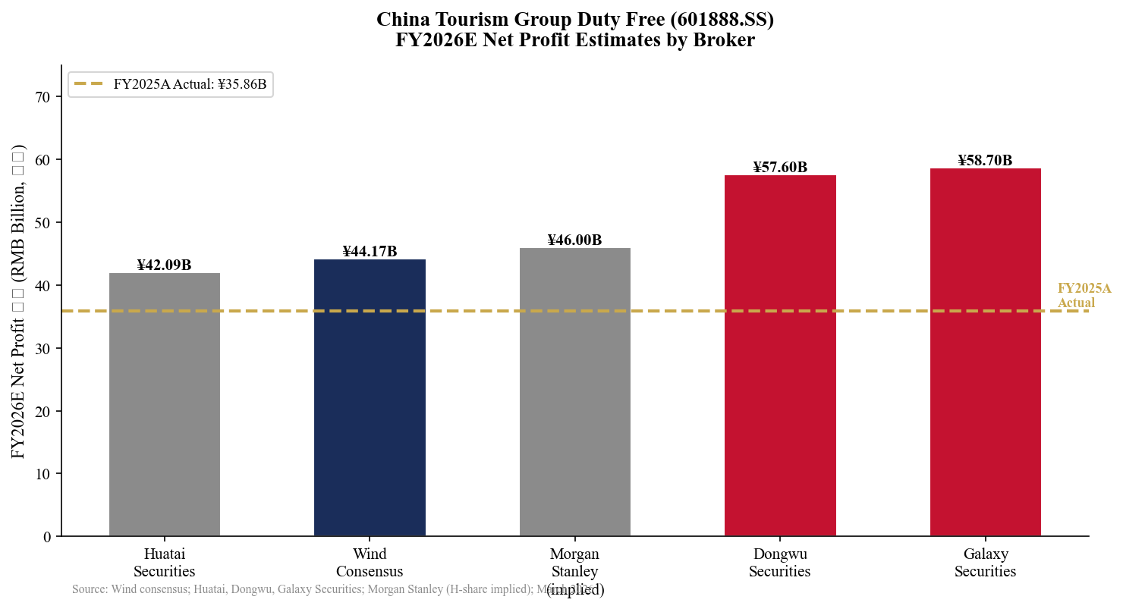
Exhibit 9: FY2026E Net Profit Estimates by Broker
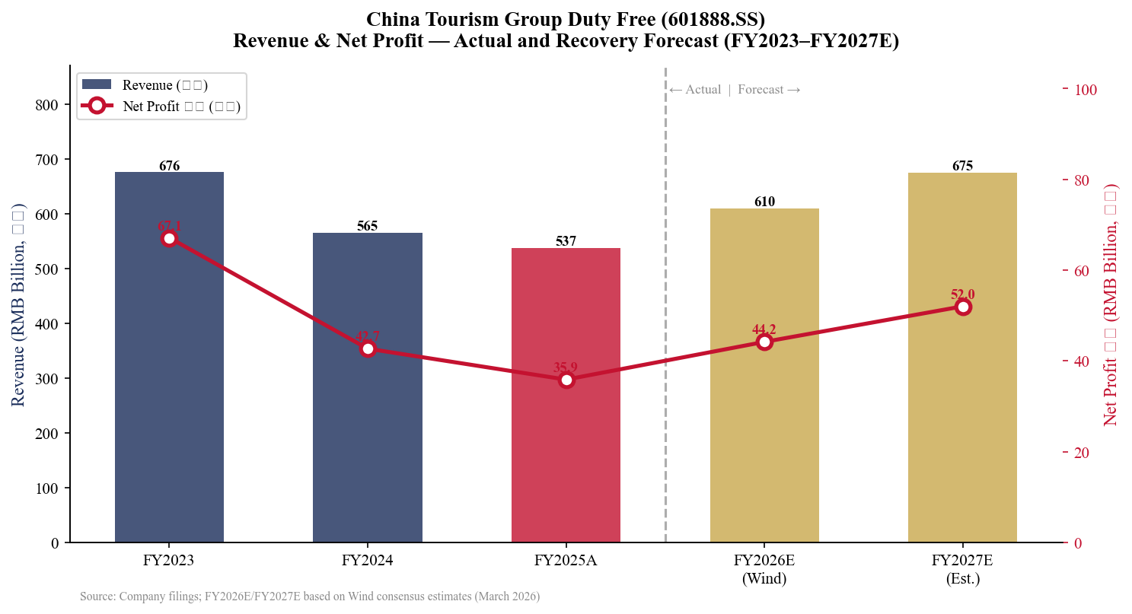
Exhibit 10: Revenue & Net Profit Recovery Forecast — FY2023 to FY2027E

VII. SOURCES & DISCLOSURES
Primary Sources
• Preliminary FY2025 Earnings Announcement (业绩快报): http://www.cninfo.com.cn [601888.SS, March 20, 2026]
• Q3 2025 Quarterly Report (三季报): https://stockmc.xueqiu.com/202510/601888_20251031_3SVP.pdf [601888.SS, October 31, 2025]
• H1 2025 Results Announcement (中报): https://static.cninfo.com.cn/finalpage/2025-07-26/1224299960.PDF [601888.SS, July 26, 2025]
• FY2024 Annual Report (年报): https://finance.sina.com.cn/stock/aigcy/2025-03-31/doc-inerpywh8106430.shtml [601888.SS, March 31, 2025]
• DFS Greater China Acquisition Announcement: https://stockmc.xueqiu.com/202601/601888_20260120_PB08.pdf [601888.SS / 1880.HK, January 20, 2026]
• Hainan Free Trade Port Customs Closure (封关): https://caifuhao.eastmoney.com/news/20250808141237013767460 [Eastmoney, August 2025]
• Hainan Island Customs Duty-Free Sales Data (H1 2025): https://www.21jingji.com/article/20250828/65c49a01e741b2bd584b6f32f7e784e3.html [21 Jingji, August 2025]
• Wind Consensus Estimates — FY2025E/2026E: https://finance.sina.com.cn/stock/bxjj/2026-01-16/doc-inhhnzat5445340.shtml [Wind/Sina Finance, January 2026]
• Morgan Stanley H-Share Research Note: https://finance.sina.com.cn/stock/bxjj/2026-01-16/doc-inhhnzat5445340.shtml [January 2026, Overweight, Target HKD 89]
• Yahoo Finance — 1880.HK: https://finance.yahoo.com/quote/1880.HK/ [Market data as of March 2026]
Disclosures
This report is for informational purposes only and does not constitute investment advice. FY2025 data is based on the preliminary announcement (业绩快报); the full annual report is expected March 31, 2026 and may contain revisions to segment data, EPS, and goodwill charges. Market data sourced from yfinance as of report generation date (March 21, 2026). The analyst certifies that the views expressed accurately reflect their personal views about the subject company and securities. All figures in RMB unless stated otherwise.

China Tourism Group Duty Free Corp (601888.SS / 1880.HK) — Q4 2025 Earnings Update | Generated: March 21, 2026

