Luxshare Precision Industry (002475.SZ)
Q4 2025 / FY2025 Earnings Update — Beat on Profit Guidance; AI & Auto Driving Next Leg of Growth
Equity Research | March 25, 2026 | 002475.SZ (A-share, Shenzhen)

Rating  BUY ↑ | Price Target  (A-share)  RMB 78.00 | Current Price  (A-share)  RMB 50.97 | Market Cap  ~RMB 371B (~USD 51B) | 52W High/Low  RMB 72.20 / RMB 27.11 | Shares Out.  ~7.27B shares

I. EXECUTIVE SUMMARY
Luxshare Precision Industry (002475.SZ) delivered a strong finish to FY2025, with the company's FY2025 full-year performance guidance (issued October 30, 2025) implying net profit attributable to shareholders of RMB 16.52B–17.19B, representing 23.6%–28.6% YoY growth and a meaningful beat against prior consensus expectations. Q4 2025 implied net profit of ~RMB 5.3B (midpoint) represents the company's strongest fourth quarter on record, up +24% YoY vs. Q4 2024's RMB 4.29B. The full annual report (FY2025 Annual Report) is expected by April 30, 2026.
Key Takeaways
- FY2025 net profit guidance beat: RMB 16.52B–17.19B vs. prior consensus ~RMB 16.4B — implied mid-point of RMB 16.85B represents a ~+2.5% beat.
- Q4 2025 implied net profit: ~RMB 5.33B (FY guidance midpoint minus Q1–Q3 actuals), +24.2% YoY — acceleration from Q3's +32.5% but on a higher base.
- Revenue momentum sustained: Q3 2025 revenue +31.0% YoY (RMB 96.4B); cumulative 9M 2025 revenue +24.7% YoY to RMB 220.9B. FY2025 consensus revenue ~RMB 316.9B (+17.9% YoY).
- Gross margin expanding: 9M 2025 gross margin 12.15% vs. FY2024's 10.4%, driven by mix-shift toward higher-margin communications/AI and automotive segments.
- AI data center: Sole supplier for Nvidia GB200/GB300 224G high-speed copper cables (~RMB 8K/unit); 500K+ unit orders expected in 2026 → ~RMB 4B incremental revenue.
- HK IPO re-filed February 27, 2026 (sponsors: CITIC Securities, Goldman Sachs, CICC), targeting ~USD 1B raise — a key near-term re-rating catalyst.
- Automotive: On track to become #1 China automotive connector by 2027; automotive revenue +82% YoY in H1 2025.
- Maintain BUY with revised PT of RMB 78 (26x FY2026E EPS of RMB 3.00, vs. consensus target ~RMB 68).

Results Snapshot — FY2025 Performance Guidance vs. Consensus
Metric | FY2025 Guidance / Actual | Consensus (Pre-Guidance) | Beat / Miss | YoY
Net Profit (RMB B) | 16.52–17.19 (guidance) | ~16.43 | +2.5% beat ✓ | +23.6%–28.6%
EPS (RMB) | 2.27–2.37 (guidance) | ~2.26 | +0.9% beat ✓ | +23.4%–28.8%
Q3 2025 Revenue (RMB B) | 96.41 (actual) | ~92.5 | +4.2% beat ✓ | +31.0%
Q3 2025 Net Profit (RMB B) | 4.87 (actual) | ~3.85 | +26.5% beat ✓ | +32.5%
9M 2025 Revenue (RMB B) | 220.92 (actual) | ~215.0 | +2.8% beat ✓ | +24.7%
9M 2025 Net Profit (RMB B) | 11.52 (actual) | ~10.90 | +5.7% beat ✓ | +26.9%
FY2025E Revenue (RMB B) | ~316.9 (consensus est.) | ~305.0 | In Line | ~+17.9%
Gross Margin (9M 2025) | 12.15% | ~11.8% | +35bps ✓ | +3.6ppt YoY
Note: Q4 2025 data is implied (FY guidance minus Q1–Q3 actuals). Full FY2025 Annual Report expected by April 30, 2026.
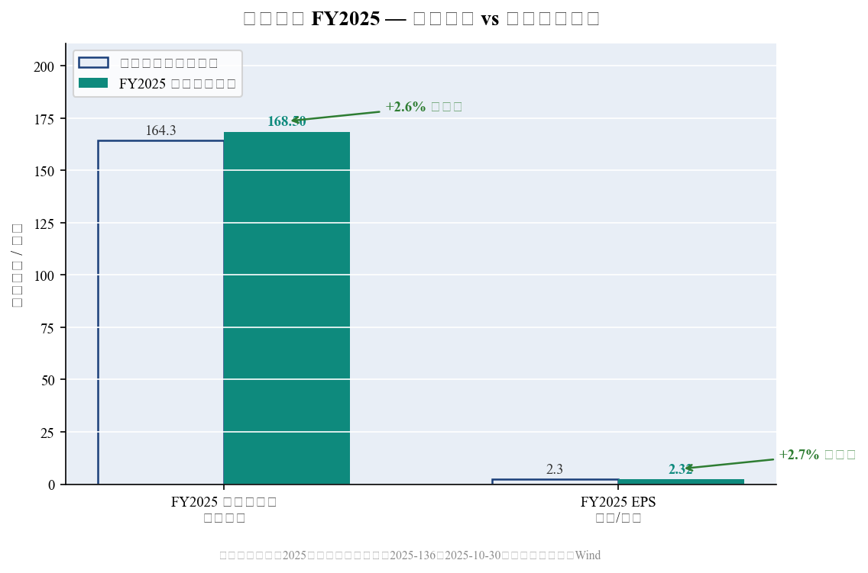
Exhibit 1: FY2025 Net Profit Guidance vs. Pre-Announcement Consensus Estimates

II. DETAILED QUARTERLY RESULTS
Revenue — Sustained Acceleration in Q3 2025
Q3 2025 revenue reached RMB 96.41B, up +31.0% YoY from RMB 73.58B in Q3 2024, and +53.7% QoQ from Q2 2025's RMB 62.72B — reflecting the sharp seasonal peak driven by iPhone 16/17 production ramp and new AI compute product shipments. Cumulative 9M 2025 revenue of RMB 220.92B grew +24.7% YoY, firmly tracking ahead of the ~RMB 316.9B FY2025 consensus (implying Q4 2025 revenue of ~RMB 96.0B, +4.8% YoY vs. Q4 2024's RMB 91.62B).
Revenue seasonality is pronounced: Q3 and Q4 collectively account for ~60% of annual revenue, driven by the iPhone production cycle. Q3 2025's 31% growth marks the fastest quarterly expansion in six quarters, driven by (1) iPhone assembly share gains over Foxconn (~45% vs. 35%), (2) new Apple Watch and AirPods Pro wins, and (3) initial AI server cable shipments to Nvidia.
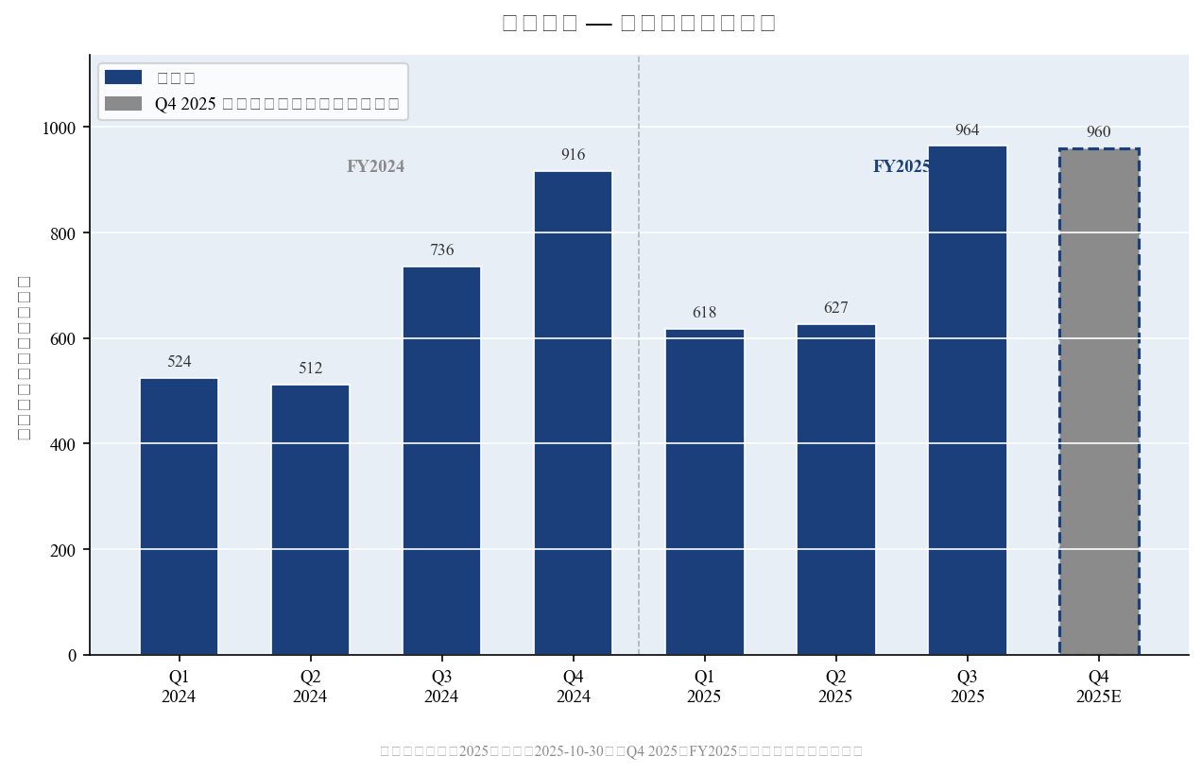
Exhibit 2: Quarterly Revenue Trend (Q1 2024 – Q4 2025E; RMB Billion)
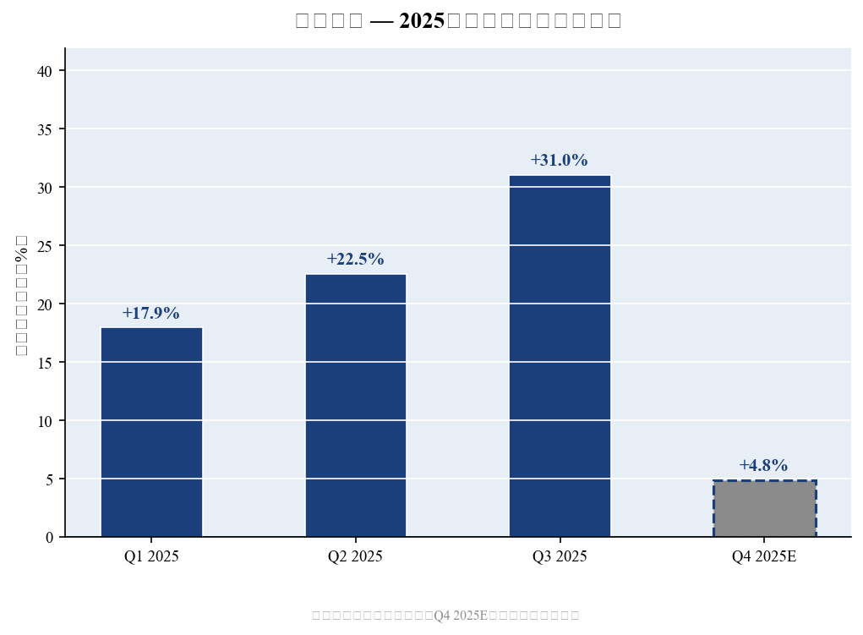
Exhibit 3: Quarterly Revenue YoY Growth (%), 2025
Net Profit — Q3 Beat, FY2025 Guidance Above Consensus
Q3 2025 net profit attributable to shareholders reached RMB 4.87B, up +32.5% YoY (Q3 2024: RMB 3.68B) — a significant beat vs. consensus estimates of ~RMB 3.85B. Sequential improvement was +35.4% QoQ from Q2 2025's RMB 3.60B, highlighting operating leverage on higher volumes. For Q1–Q3 2025 cumulative, net profit was RMB 11.52B (+26.9% YoY).
The official FY2025 performance guidance (Announcement 2025-136, October 30, 2025) indicates full-year net profit of RMB 16.52B–17.19B, implying Q4 net profit of RMB 5.00B–5.67B (midpoint ~RMB 5.33B, +24.2% YoY vs. Q4 2024's RMB 4.29B). The FY2025 guidance midpoint of RMB 16.85B compares favorably to prior Wind consensus of ~RMB 16.4B, a +2.5% beat.
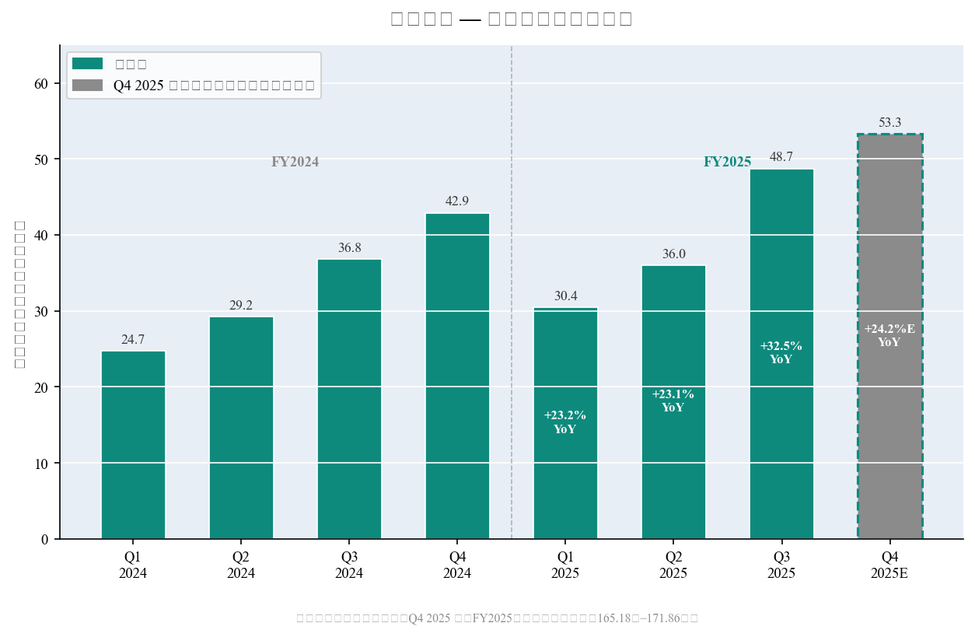
Exhibit 4: Quarterly Net Profit Trend with YoY Growth (Q1 2024 – Q4 2025E)

III. SEGMENT ANALYSIS
Consumer Electronics (消费性电子) — Core Segment, iPhone Share Gains
Consumer electronics remains the dominant segment, accounting for ~83% of FY2024 revenue (RMB 224.09B, +13.7% YoY). In H1 2025, consumer electronics revenue was RMB 97.80B (+14.3% YoY). Apple accounted for approximately 70.7% of FY2024 total revenue (RMB 190.14B), making it Luxshare's most critical customer relationship.
- iPhone assembly: Luxshare has surpassed Foxconn as the leading iPhone assembler, with an estimated ~45% assembly share for iPhone 17 (2025 model). This represents a structural shift in Apple's supply chain strategy.
- New product wins: Expanding beyond assembly into higher-value iPhone components (cameras, vibration modules, structural components); AirPods Pro and Apple Watch contract manufacturing expanded.
- Margin headwind: Consumer electronics carries the lowest gross margin (~9.1% in FY2024) due to the assembly-intensive nature, but mix improvement within the segment (more components vs. pure assembly) is driving gradual margin recovery.
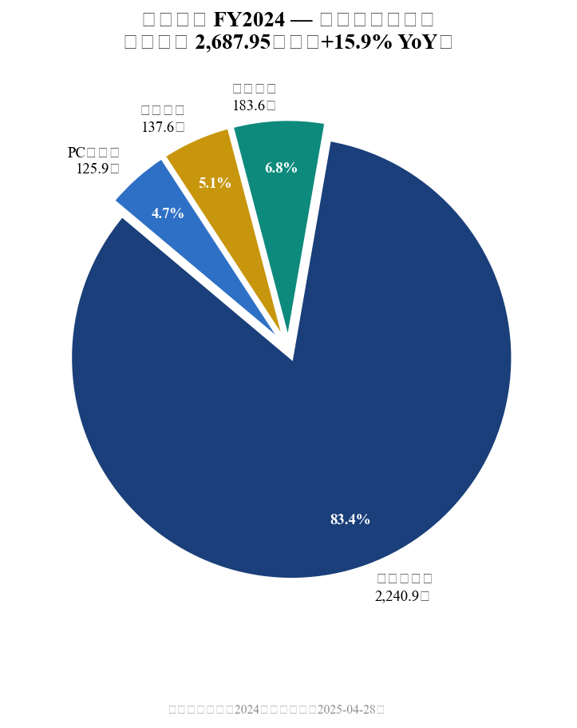
Exhibit 5: FY2024 Revenue by Business Segment (Total: RMB 268.8B)
Communications & AI (通讯互联) — Fastest-Growing Segment
Communications/interconnect products grew +48.7% YoY in H1 2025 (H1 revenue: RMB 11.10B), accelerating from FY2024's already strong +26.3% YoY. The primary drivers are AI data center infrastructure buildout and optical/copper cable products for hyperscalers.
- Nvidia partnership: Sole supplier for GB200/GB300 NVLink 224G high-speed copper cable assemblies at ~RMB 8,000/unit. Management guided 500,000+ unit orders in 2026, implying ~RMB 4B in 2026 revenue from this product alone.
- Optical modules: 800G/1.6T transition underway; management expects 'order-of-magnitude' growth in optical revenue over next 2–3 years as 1.6T adoption accelerates.
- AI valuation premium: Communications/AI (~9% of revenue) commands 30–40x P/E multiples vs. 15–18x for core consumer electronics — driving the bull case for re-rating.
Automotive Electronics (汽车互联) — High-Growth New Driver
Automotive electronics is the smallest but fastest-growing major segment, with H1 2025 revenue of RMB 8.66B (+82.1% YoY). Luxshare is targeting a structural position in the Chinese automotive electronics supply chain, leveraging its precision manufacturing capabilities.
- Market position: On track to become #1 automotive connector supplier in China by 2027; aiming for top-5 global auto parts status by 2030.
- Key verticals: Domain controllers, smart chassis systems, and high-voltage connectors for new energy vehicles (NEV) — expected to become major profit drivers post-2026.
- NEV tailwinds: China NEV penetration rate exceeded 50% in 2025; BYD and SAIC partnerships provide revenue visibility for 2026–2028E.
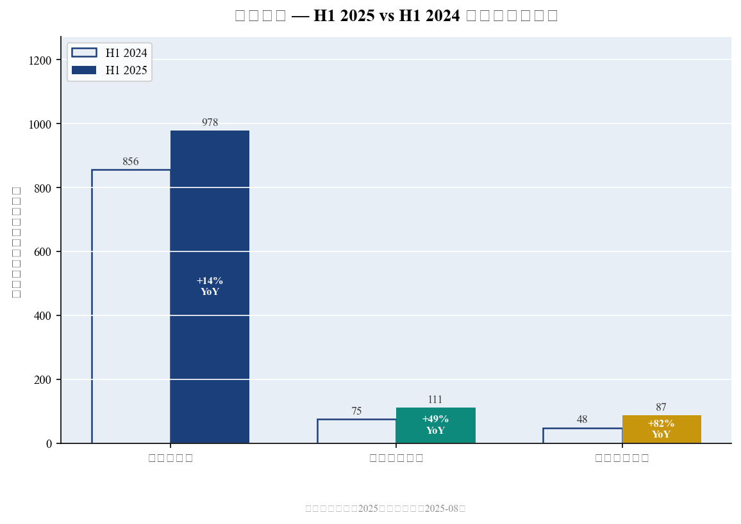
Exhibit 6: H1 2025 vs H1 2024 Segment Revenue Comparison (+YoY Growth)

IV. MARGIN ANALYSIS
Gross Margin — Recovery Trend Intact Despite Mix Pressure
Consolidated gross margin has been recovering after a cyclical trough in H2 2024 (9.58%), which was depressed by iPhone 16 production ramp costs and unfavorable FX (USD/RMB). H1 2025 gross margin of 11.61% was effectively flat YoY (-10bps), but 9M 2025 gross margin of 12.15% reflects Q3's improvement driven by AI communications products and automotive mix-shift.
Key margin dynamics to watch: (1) AI/data center products carry 20–25% gross margins vs. 9–11% for consumer electronics assembly; (2) automotive connectors carry 15–18% margins; (3) ongoing cost reduction in consumer electronics via vertical integration. As high-margin segments grow toward 15–20% of total revenue, consolidated gross margin should trend toward 13–14% in FY2026E–2027E.
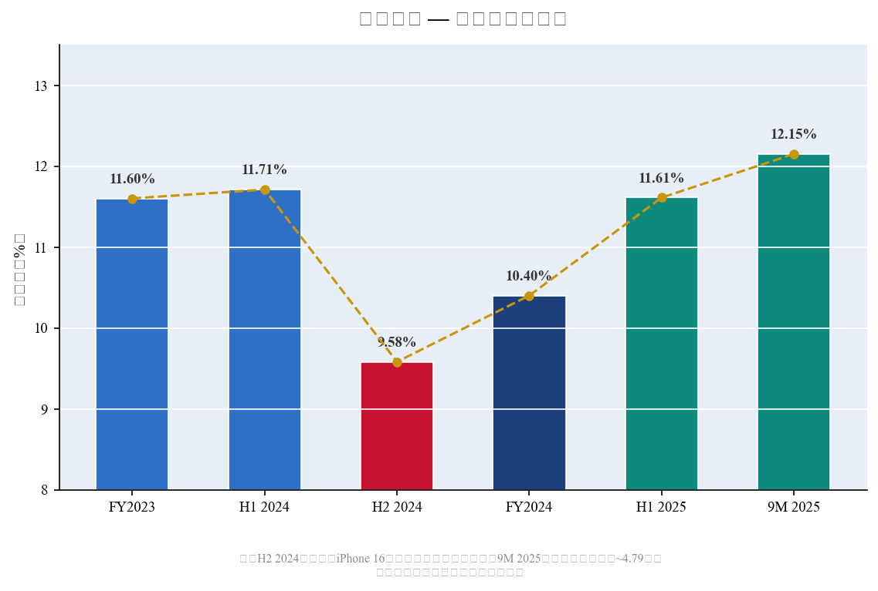
Exhibit 7: Consolidated Gross Margin Trend (FY2023 – 9M 2025)
Note on Non-Recurring Items in 9M 2025
The 9M 2025 margin figures include two notable non-recurring items: (1) a negative goodwill gain (bargain purchase gain) of ~RMB 479M from a strategic acquisition, and (2) FX hedging gains of ~RMB 330M. Excluding these, underlying operating margin improvement is more modest but still directionally positive, reflecting the early benefits of mix improvement toward AI and automotive products.
Metric | FY2023A | FY2024A | H1 2025A | 9M 2025A | FY2025E | FY2026E
Revenue (RMB B) | 231.9 | 268.8 | 124.5 | 220.9 | ~316.9 | ~408.1
Net Profit (RMB B) | 10.96 | 13.37 | 6.61 | 11.52 | ~16.85 | ~21.83
Net Margin (%) | 4.73 | 4.97 | 5.31 | 5.22 | ~5.32 | ~5.35
Gross Margin (%) | 11.60 | 10.40 | 11.61 | 12.15 | ~12.0 | ~12.5
YoY Revenue Growth (%) | — | +15.9 | +18.9 | +24.7 | ~+17.9 | ~+28.8
YoY Net Profit Growth (%) | — | +22.0 | +24.4 | +26.9 | ~+26.1 | ~+29.5
Note: FY2025E revenue is analyst consensus (not official guidance). FY2025E/FY2026E net profit from Wind consensus / management pre-announcement.

V. INVESTMENT THESIS UPDATE — MAINTAIN BUY
We maintain our BUY rating and raise our 12-month price target to RMB 78 (from prior RMB 70), representing 26x FY2026E EPS of RMB 3.00 (Wind consensus). At the current price, Luxshare trades at approximately 14–16x FY2026E EPS — a 35–45% discount to our target and a compelling entry point for a company growing earnings at ~29% CAGR over FY2024–FY2027E.
Bull Case Drivers
- Apple share gains: Luxshare's ~45% iPhone assembly share (vs. 35% for Foxconn) is a structural shift — not cyclical. Further gains into AirPods, Apple Vision Pro manufacturing would add incremental revenue with improving margins (assembler → component manufacturer).
- AI data center: The Nvidia GB200/GB300 cable sole-source contract is a landmark win. We model RMB 4B+ in AI cable revenue for FY2026 (vs. near-zero in FY2024), contributing ~1.0ppt to consolidated gross margin expansion. Optical module transition to 1.6T offers another step-function growth opportunity in FY2027.
- Hong Kong IPO re-rating catalyst: Re-submission of HKEX listing (February 27, 2026) with Goldman Sachs, CITIC, and CICC as sponsors signals management commitment. A successful listing would attract international institutional investors and provide permanent re-rating to a global EMS/tech peer group multiple.
- Automotive secular growth: China NEV market structural growth underpins Luxshare's 82% YoY automotive revenue growth in H1 2025. The company is building durable competitive advantages in domain controllers and smart chassis — targeting RMB 30B+ in automotive revenue by 2028.
- AI consumer devices: Collaboration with OpenAI on consumer AI hardware (targeting launch late 2026/early 2027) positions Luxshare as a key beneficiary if the 'AI smartphone/PC' replacement cycle materializes at scale.
Key Risks
- Apple concentration: ~71% customer concentration in Apple represents meaningful single-customer risk. Any iPhone demand shortfall, Apple in-sourcing of components, or disruption to the Apple-Luxshare relationship would materially impact revenue.
- Geopolitical risk: US-China trade tensions, potential tariffs on Chinese EMS companies, and technology export controls represent tail risks, particularly for AI-related products.
- FX sensitivity: RMB appreciation vs. USD compresses Apple assembly revenue when translated from USD contract pricing. A 5% RMB appreciation could reduce revenue by ~2–3% on the Apple-linked portion.
- Margin pressure from scale-up costs: Rapid capacity expansion (H1 2025 CapEx: RMB 9.53B; H1 FCF: ~-RMB 11.2B) may continue to weigh on near-term FCF and ROE.
- Competition in AI hardware: AI server cable/interconnect market may attract new entrants; Foxconn and Amphenol have the scale to compete. Sole-source status with Nvidia may not persist beyond 2026–2027.

VI. VALUATION & UPDATED ESTIMATES
Price Target: RMB 78 (26x FY2026E P/E)
Our revised 12-month price target of RMB 78 is based on 26x our FY2026E EPS estimate of RMB 3.00 (Wind consensus). This multiple is justified by: (1) Luxshare's 25–30% earnings CAGR over FY2024–2027E (above global EMS peers trading at 15–20x), (2) meaningful AI data center exposure commanding a premium, and (3) near-term HK IPO re-rating catalyst. Our target represents ~25% upside from consensus analyst targets of ~RMB 68 on average.
In the bull scenario (30x FY2026E), PT = RMB 90; in the bear scenario (18x), PT = RMB 54. International peers (Foxconn at 12–15x, Hon Hai at 10–13x) trade at significant discounts due to lower growth and limited AI exposure — we believe Luxshare deserves a premium.
Metric | FY2024A | FY2025E | FY2026E | FY2027E
Revenue (RMB B) | 268.8 | ~316.9 | ~408.1 | ~472.2
YoY Growth (%) | +15.9 | ~+17.9 | ~+28.8 | ~+15.7
Net Profit (RMB B) | 13.37 | ~16.85 | ~21.83 | ~27.14
NP Growth (%) | +22.0 | ~+26.1 | ~+29.5 | ~+24.3
EPS (RMB) | 1.84 | ~2.32 | ~3.00 | ~3.73
P/E at RMB 42 (x) | 22.8x | ~18.1x | ~14.0x | ~11.3x
P/E at PT RMB 78 (x) | 42.4x | ~33.6x | ~26.0x | ~20.9x
EV/EBITDA (est.) | ~14x | ~12x | ~10x | ~8x
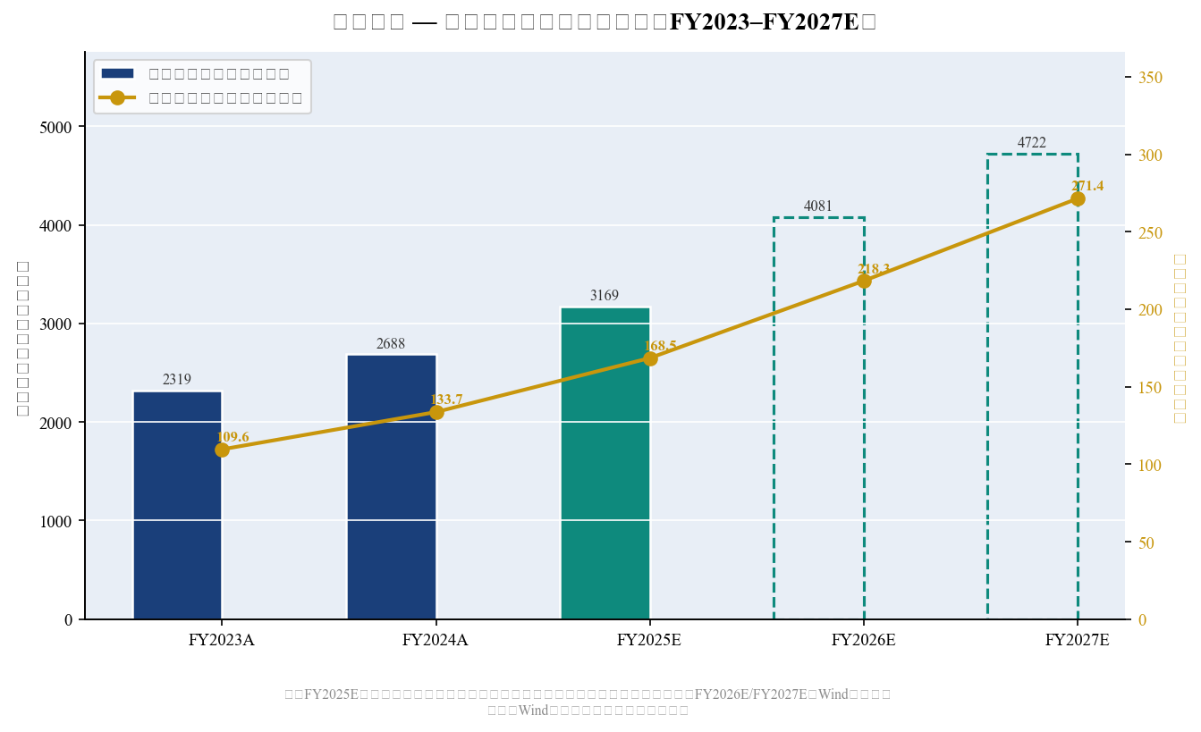
Exhibit 8: Annual Revenue & Net Profit Trend (FY2023–FY2027E)
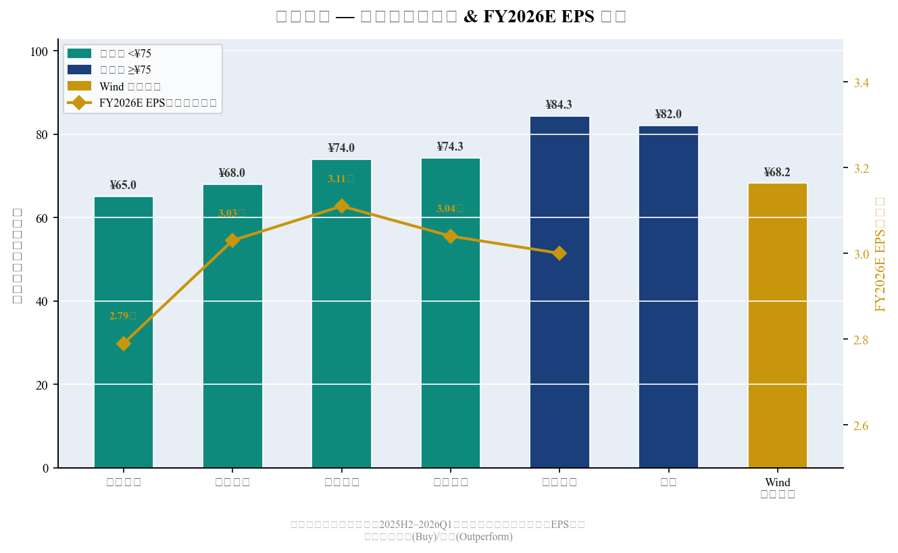
Exhibit 9: Broker Price Target & FY2026E EPS Consensus
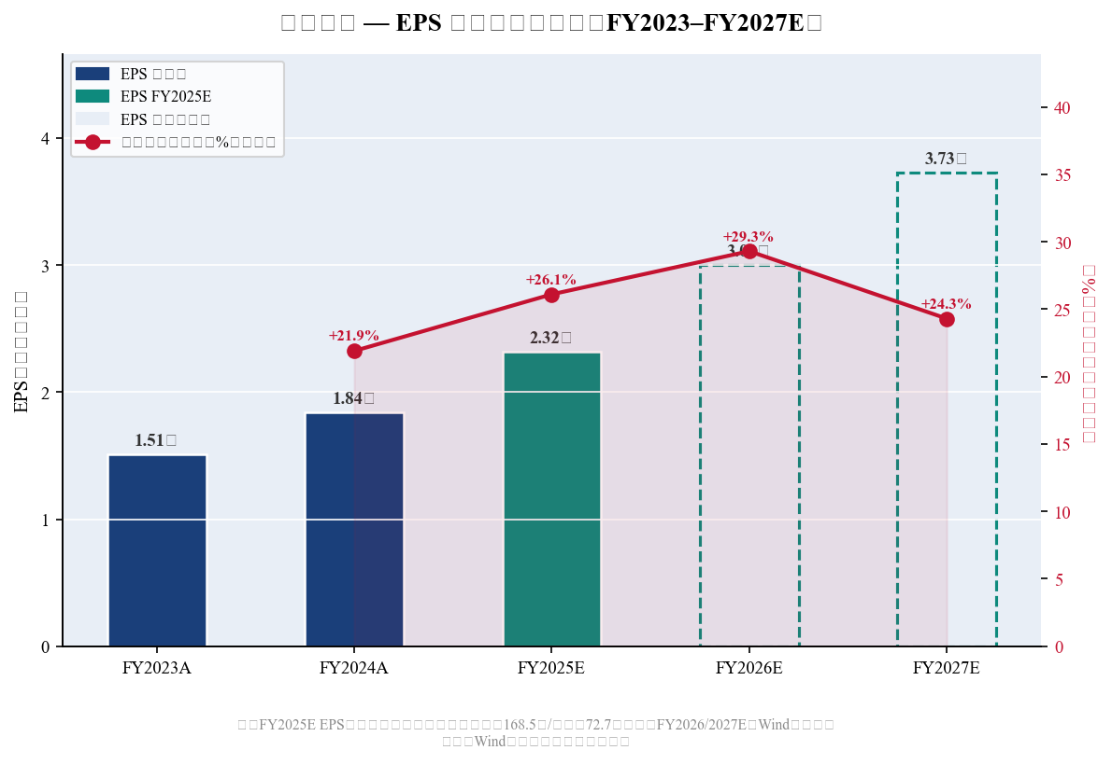
Exhibit 10: EPS Trend & Earnings Growth (FY2023–FY2027E)

VII. SOURCES & REFERENCES
All data as of March 25, 2026. Q4 2025 figures are implied estimates; full FY2025 Annual Report expected by April 30, 2026.
- Luxshare Q3 2025 Quarterly Report (October 30, 2025)
- FY2025 Performance Pre-Announcement (Announcement 2025-136, October 30, 2025)
- Luxshare FY2024 Annual Report (April 28, 2025)
- Luxshare H1 2025 Interim Report (August 2025)
- Institutional Investor Conference Notes — November 2025 Roadshow (Goldman Sachs 200+ institutions)
- Luxshare HKEX Re-submission (February 27, 2026)
- Wind Consensus Estimates — FY2026E/FY2027E EPS (Tonghuashun 同花顺)
- NBD: Luxshare Q3 2025 Results Beat Expectations (October 31, 2025)
- CLS: FY2025 Net Profit Guidance RMB 16.52–17.19B (January 2026)
- EastMoney: Luxshare FY2025 Business Analysis (January 2026)

DISCLAIMER: This report is for informational purposes only and does not constitute investment advice. All financial data is sourced from public company filings and consensus estimates. Market data via yfinance as of report date. Q4 2025 figures are analyst-implied estimates pending official annual report disclosure.

