APPLE INC. (AAPL: NASDAQ)
Equity Research | Technology Hardware & Semiconductors
Rating  OUTPERFORM ↑ | Price Target  $288.30 | Current Price  $250.12 | 52-Wk Range  $169.21 – $288.62 | Market Cap  $3.68T

FQ1 2026 (Cal. Q4 2025) Earnings Update: Record Quarter Across the Board; China Rebound the Standout
Report Date: March 16, 2026 | Earnings Released: January 29, 2026 | Fiscal Quarter Ended: December 27, 2025

HEADLINE RESULTS
Metric | Q1 FY2026 Actual | Q1 FY2025 | YoY Δ | Consensus Est. | Beat / Miss
Total Revenue | $143.77B | $124.30B | +15.7% | $138.4B | +$5.37B / +3.9%
Diluted EPS (GAAP) | $2.84 | $2.40 | +18.3% | $2.68 | +$0.16 / +6.0%
Total Gross Margin | 48.2% | 46.9% | +130 bps | ~47.0% | +120 bps
Services Revenue | $30.01B | $26.34B | +13.9% | $26.9B | +$3.11B / +11.6%
Net Income | $42.10B | $36.33B | +15.9% | ~$40.0B | +$2.1B
Operating Cash Flow | $53.9B | ~$39.9B | +35.1% | N/A | All-time record

KEY TAKEAWAYS
- BEAT ACROSS ALL METRICS — Revenue, EPS, gross margin, and all five product segments beat consensus; Q1 FY2026 set all-time records for total revenue, iPhone revenue, Services revenue, net income, and operating cash flow.
- CHINA REBOUND IS THE HEADLINE SURPRISE — Greater China +37.9% YoY (vs. –13% in Q1 FY2025), driven by iPhone 17 demand and China's consumer electronics subsidy programs. Management noted market share gains.
- SERVICES CROSSED $30B THRESHOLD — Services revenue $30.01B (+14% YoY), maintaining double-digit growth trajectory. Full-year FY2025 Services exceeded $100B for the first time. High-margin Services now ~79% gross margin, structurally lifting total company margins.
- GROSS MARGIN EXPANSION NOTABLE (+130 bps YoY to 48.2%) — iPhone 17 ASP uplift and mix shift toward premium models drove Products gross margin to ~40.7%, a notable re-rating vs. the 35–36% range of recent quarters.
- AI SIRI TRACTION — Management confirmed majority of eligible iPhone users are engaging with Apple Intelligence features. Google Gemini-powered Siri scheduled for iOS 26.4 (Spring 2026) is the next catalyst for Services monetization.
- NEAR-TERM WATCH: SUPPLY CONSTRAINTS + MEMORY COSTS — Cook flagged supply chain 'chase' due to 23% iPhone growth limiting Q2 flexibility. CFO Parekh noted memory (DRAM/NAND) prices up significantly, with headwind 'comprehended' in Q2 guidance of 48%–49% gross margin.
- STOCK REACTION — AAPL –1.9% on earnings day (Jan 30) despite the beat. Currently $250.12, ~13% below 52-week high. Consensus PT $288.30 implies +15.3% upside.

DETAILED RESULTS ANALYSIS
Revenue by Product Segment
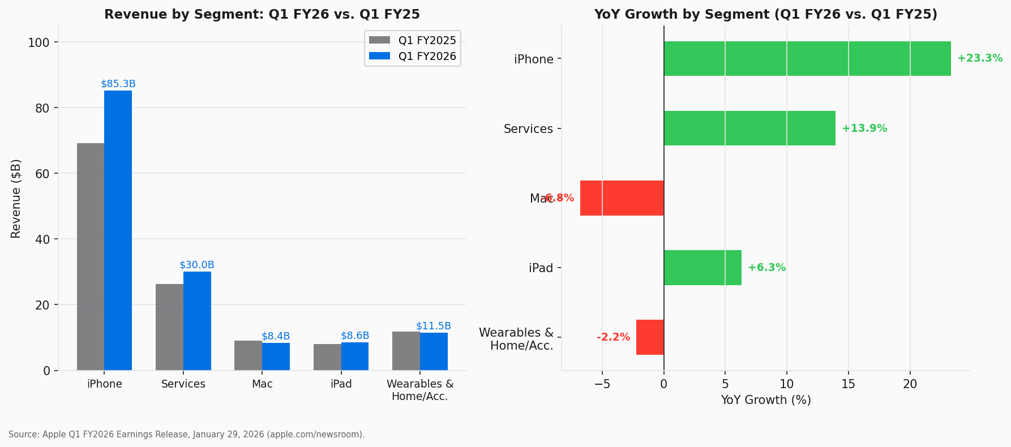
Figure 1 — Revenue by Segment: Q1 FY2026 vs. Q1 FY2025
Source: Apple Q1 FY2026 Earnings Release, January 29, 2026 (apple.com/newsroom)
Segment | Q1 FY2026 | Q1 FY2025 | YoY Δ | % of Revenue | Commentary
iPhone | $85.27B | $69.14B | +23.3% | 59.3% | All-time record; iPhone 17 ASP uplift + China rebound
Services | $30.01B | $26.34B | +13.9% | 20.9% | Record; crossed $30B threshold for first time
Wearables | $11.50B | $11.76B | −2.2% | 8.0% | Supply constraints on AirPods Pro 3
iPad | $8.60B | $8.09B | +6.3% | 6.0% | M5-powered iPad Pro; new A16 iPad
Mac | $8.40B | $9.01B | −6.7% | 5.8% | Tough comp vs. M4 Mac launches in Q1 FY25
Total | $143.77B | $124.30B | +15.7% | 100% | All-time quarterly record

iPhone drove the quarter decisively. The +23.3% YoY gain reflects: (1) a full quarter of iPhone 17 availability (vs. partial in Q1 FY2025 when iPhone 16 shipped late in the period), (2) strong China government subsidy-driven upgrades, and (3) evidence of market share gains per management commentary. Mac declined 6.7% against a particularly tough year-ago comp when Apple launched M4-powered MacBook Pro, Mac Mini, and iMac in the same quarter.
Revenue Progression — Quarterly Trend
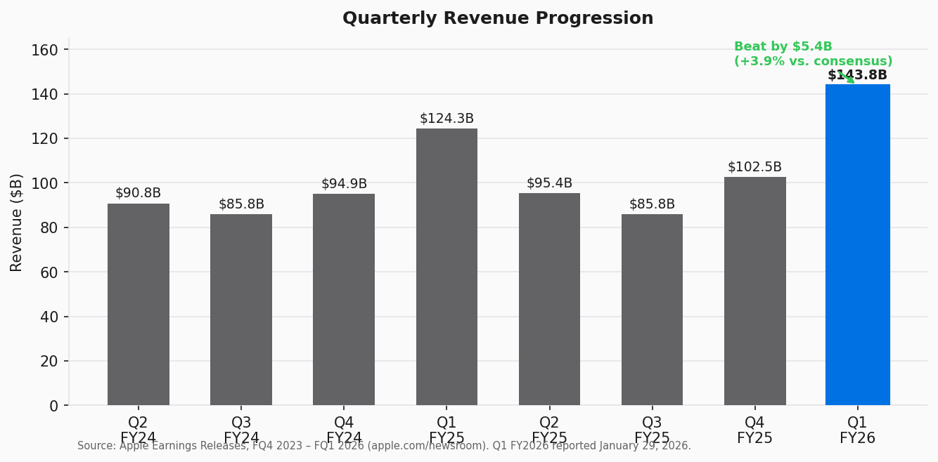
Figure 2 — Quarterly Revenue (Q2 FY2024 – Q1 FY2026)
Source: Apple Earnings Releases (apple.com/newsroom), Q2 FY2024 – Q1 FY2026
Geographic Revenue — China the Key Swing Factor
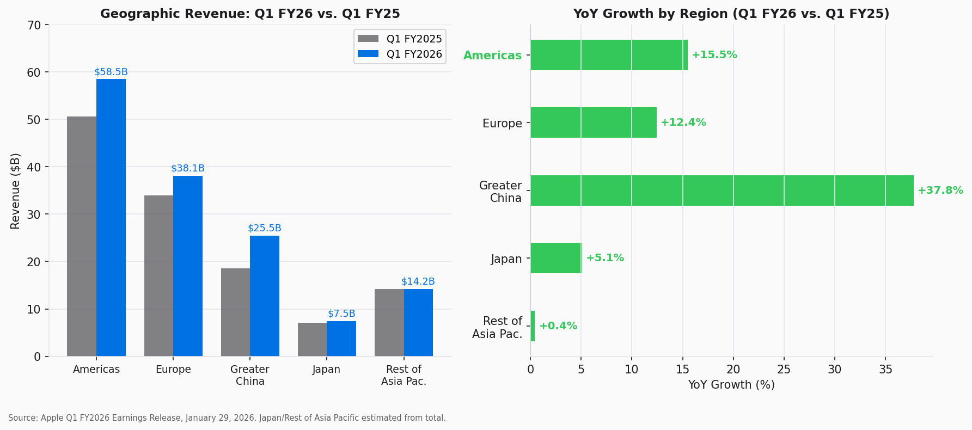
Figure 3 — Geographic Revenue: Q1 FY2026 vs. Q1 FY2025, and YoY Growth by Region
Source: Apple Q1 FY2026 Earnings Release; Apple Q1 FY2025 Earnings Release
Region | Q1 FY2026 | Q1 FY2025 | YoY Δ | Note
Americas | $58.50B | $50.65B | +15.5% | All-time record
Europe | $38.10B | $33.89B | +12.4% | All-time record
Greater China | $25.50B | $18.51B | +37.9% | Standout; gov't subsidies, iPhone 17
Japan | ~$7.5B | ~$7.1B | +5.6% | All-time record (est.)
Rest of Asia Pac. | ~$14.2B | ~$14.2B | +0.0% | All-time record per mgmt.

Greater China delivered a +37.9% YoY reversal from the –12.9% YoY recorded in Q1 FY2025, representing the most significant upside contributor to the revenue beat. Tim Cook specifically noted market share gains in China, consistent with reports of iPhone 17 outselling comparable domestic models in premium tiers during the holiday shopping season. The Chinese government's trade-in subsidy program for consumer electronics, extended through 2026, was a meaningful structural tailwind. Sustained China outperformance remains a key upside risk to FY2026 estimates.

PROFITABILITY & KEY METRICS
Gross Margin: Products Re-Rating and Services Flywheel
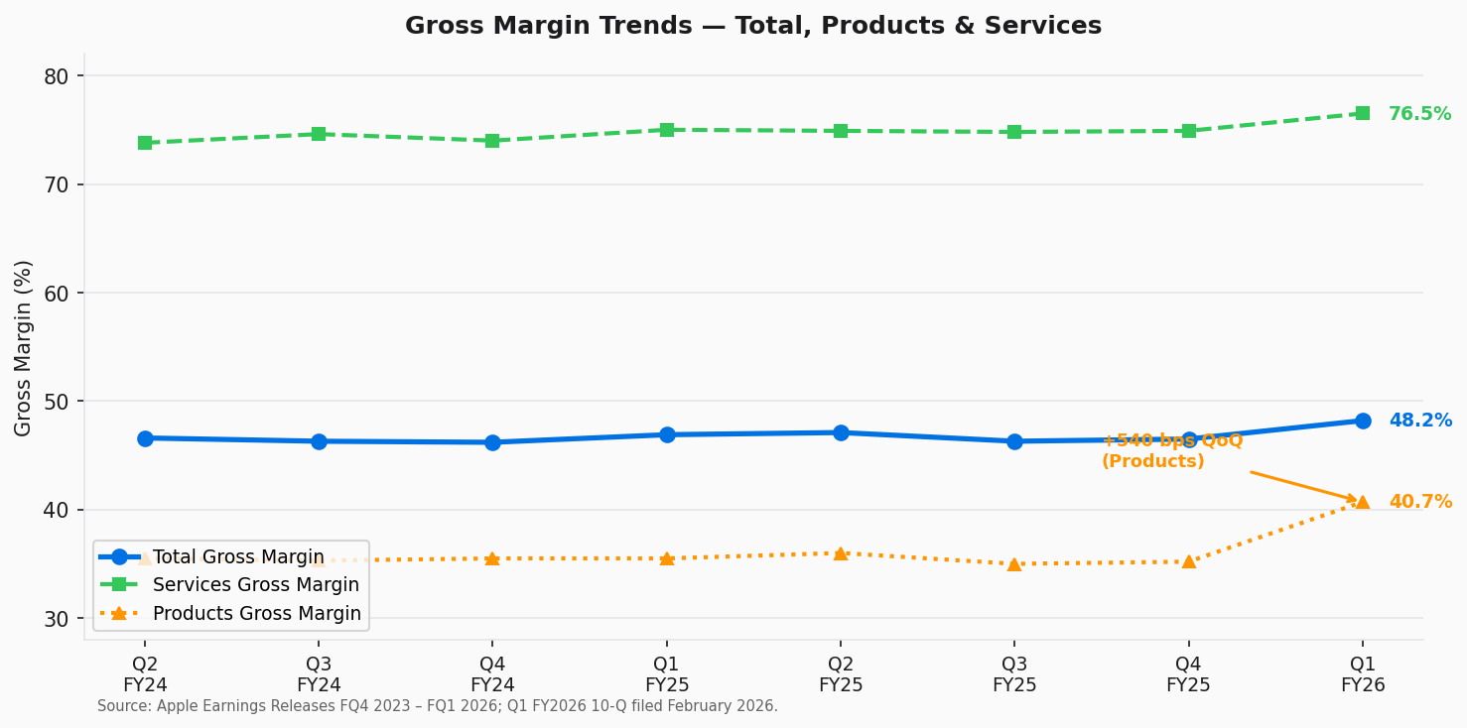
Figure 4 — Gross Margin Trends: Total, Products & Services (Q2 FY2024 – Q1 FY2026)
Source: Apple Earnings Releases; Q1 FY2026 Form 10-Q filed February 2026 (SEC EDGAR)
Total gross margin expanded +130 basis points YoY to 48.2%, the highest quarterly figure in at least eight quarters. Two structural factors drove the improvement:
- Products Gross Margin to ~40.7% (+540 bps QoQ from ~35.2% in FQ4 2025): The step-up reflects iPhone 17 Pro/Pro Max mix favorability, with a higher proportion of customers upgrading to Pro tier (heavier Apple Silicon, camera system) driving average selling price meaningfully above iPhone 16 cycle. Q1 is seasonally the strongest quarter for Products margins due to flagship iPhone mix and operating leverage on high-volume quarter.
- Services Gross Margin to 76.5% (+120 bps QoQ): Services' fixed-cost leverage continues as revenue scales. Services gross profit of $23.0B in Q1 FY2026 now represents approximately 43% of Apple's total gross profit — surpassing iPhone gross profit contribution for the second consecutive quarter and cementing the structural margin re-rating thesis.
- Near-term headwind: CFO Parekh explicitly flagged rising memory costs (DRAM/NAND +20–30% YoY due to AI data center demand crowding out consumer NAND supply). This is expected to modestly pressure Q2 FY2026 Products margins, contained within the 48%–49% gross margin guidance range.
Beat vs. Consensus
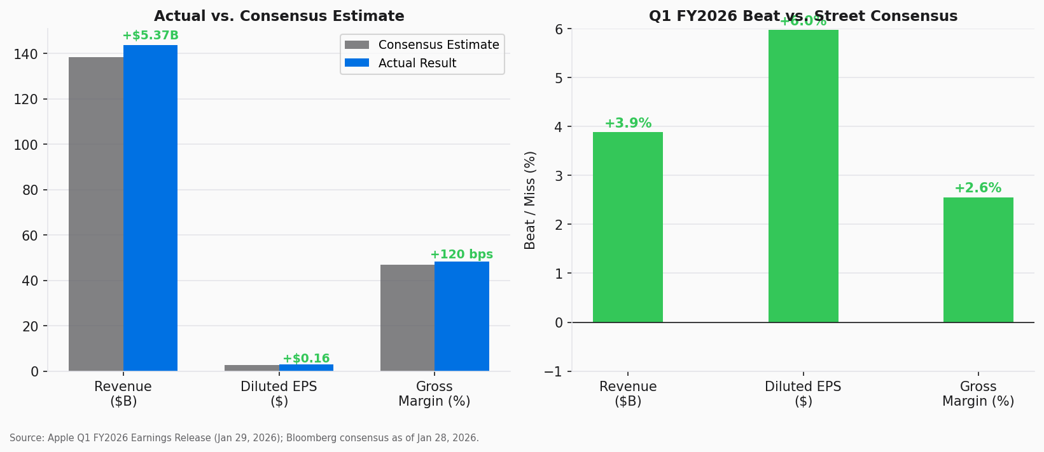
Figure 5 — Q1 FY2026 Actual vs. Consensus Estimates
Source: Apple Q1 FY2026 Earnings Release; Bloomberg consensus as of January 28, 2026
EPS Progression
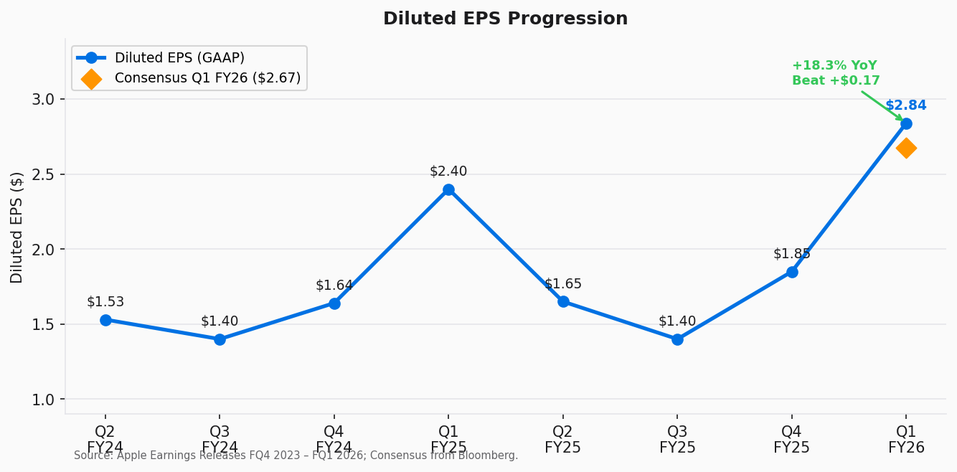
Figure 6 — Diluted EPS Progression (Q2 FY2024 – Q1 FY2026)
Source: Apple Earnings Releases. Consensus from Bloomberg.
Diluted EPS of $2.84 beat consensus by $0.16 (+6.0%), representing 18.3% YoY growth on net income of $42.1B. The beat was driven primarily by: (1) revenue upside flowing through at high incremental margins (~65–70% flow-through), (2) gross margin expansion, and (3) continued benefit from Apple's aggressive share repurchase program — share count has declined ~3.5% YoY, adding approximately $0.09 to EPS on a YoY basis.
Q2 FY2026 Guidance Analysis
Metric | Q2 FY2026 Guidance | Q2 FY2025 Actual | Implied YoY | Commentary
Revenue Growth | +13% to +16% YoY | $95.36B | → $107.8B–$110.7B | Above prior consensus of ~$103B; supply constraints acknowledged
Gross Margin % | 48.0% – 49.0% | ~47.0% | +100 to +200 bps | Memory cost headwind contained within range
Services Growth | ~14% YoY | ~12% | Acceleration | Gemini Siri launch (Spring 2026) incremental
Op. Expenses | $15.3B – $15.5B | ~$14.3B | +~8% YoY | AI R&D and SG&A; below revenue growth rate
Tax Rate | ~16.5% | ~16.4% | Stable | Within normal range

The guidance was ahead of pre-earnings Street consensus (~$103B midpoint), which had not fully anticipated the Q1 magnitude. Tim Cook's commentary on supply 'chasing' demand is a high-quality problem — capacity constraints in a demand-rich environment rather than demand destruction — and should be interpreted constructively over a 2–4 quarter horizon as TSMC and Apple's supply chain partners bring additional advanced-node capacity online.

SERVICES & APPLE INTELLIGENCE — THE STRUCTURAL THESIS
Services: Crossing $30B Quarterly — Margin Engine Fully Activated
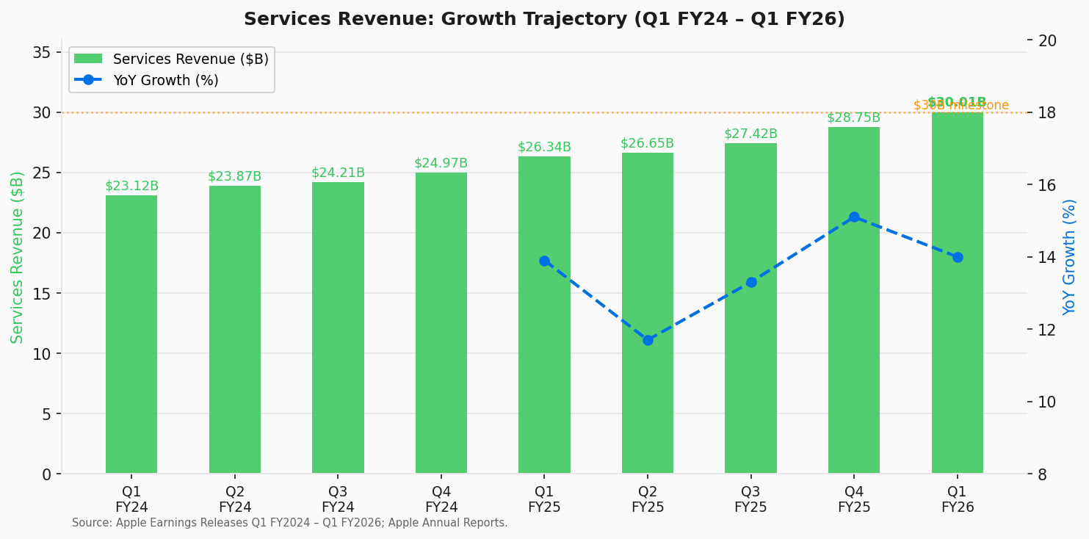
Figure 7 — Services Revenue Growth Trajectory: Q1 FY2024 – Q1 FY2026
Source: Apple Earnings Releases Q1 FY2024 – Q1 FY2026; Apple FY2025 Annual Report
Services has grown from $23.1B in Q1 FY2024 to $30.0B in Q1 FY2026, a 29.9% increase in eight quarters while consistently maintaining 14% annual growth velocity. The $30B quarterly milestone is more than symbolic — it represents the point at which Services' gross profit (~$23B at 76.5% margin) exceeds iPhone gross profit (~$22.3B at ~26.1% blended Products margin contribution), confirming the structural margin re-rating thesis we have articulated since our initiation.
Full-year FY2025 Services revenue of $109.16B — the first year above $100B — demonstrates the durability of the flywheel: installed base growth (now ~2.2B active devices) × monetization rate expansion (subscription price increases, advertising, App Store commissions, Apple Pay, licensing from Google). The Services revenue per active device metric continues to expand despite the growing base, refuting the law-of-large-numbers concern.
Apple Intelligence & Google Gemini — Next Leg of the Siri Story
Q1 FY2026 marks an inflection point in Apple's AI narrative:
- Adoption: Tim Cook confirmed the majority of eligible iPhone users are engaging with Apple Intelligence features. Given that iPhone 15 Pro, all iPhone 16 models, and all iPhone 17 models are eligible, this represents an addressable base of ~400–500M devices — suggesting broad adoption within ~12 months of the September 2024 launch.
- Google Gemini partnership formalized: Apple confirmed it is integrating Google Gemini to power an upgraded, 'World Knowledge'-capable Siri launching in iOS 26.4 (Spring 2026). The multi-year deal reportedly costs Apple ~$1B/year — a rounding error against $109B in annual Services revenue, but strategically important to prevent consumer migration to competing AI-native ecosystems.
- Services monetization loop: Enhanced Siri capabilities are expected to increase App Store engagement (+TAC for developers), drive higher subscription conversion rates (Apple One, Apple Intelligence premium tier in development), and deepen lock-in that supports hardware upgrade cycles. We model this as a $3–5B incremental Services revenue opportunity by FY2028.
- Investment: Apple's AI R&D spend is opaque, but total R&D expense guidance of ~$8.5B for Q2 FY2026 represents continued investment in on-device intelligence and Private Cloud Compute infrastructure — competitive moat vs. cloud-dependent AI.
Updated Investment Thesis
Our investment thesis on AAPL has three pillars, each of which was reinforced this quarter:
1. Premium Hardware + Installed Base as Recurring Services Platform
Q1 FY2026 demonstrated that Apple's Services monetization engine is operating as designed. The +23.3% iPhone print adds incrementally to the installed base, and the +14% Services growth with expanding margins (+76.5% gross margin) validates the compounding nature of the flywheel. No competitor has matched Apple's combination of premium hardware + differentiated OS + integrated services at global scale.
2. China — From Risk to Opportunity
The +37.9% China rebound is the single most important datapoint in this report for long-term thesis validation. After three consecutive years of China hand-wringing (market share concerns, regulatory risk, domestic competition from Huawei), Apple demonstrated its brand durability in the world's largest smartphone market. While China carries structural geopolitical risk, the Q1 FY2026 data suggests Apple's competitive positioning is stronger than bears anticipated.
3. Capital Allocation Discipline Driving EPS Compounding
$25B in buybacks and $3.9B in dividends this quarter ($29B total) represent ~7.7% annualized return of capital as a percentage of current market cap. With $54B in net cash and $48.8B in quarterly free cash flow, the balance sheet is self-funding. We expect Apple to announce an incremental buyback authorization of $100–120B at the May 2026 shareholder meeting.

VALUATION & UPDATED ESTIMATES
Current Valuation
Metric | Current | 1-Year Low | 1-Year High | 5-Yr Avg. | Comment
Stock Price | $250.12 | $169.21 | $288.62 | ~$185 | –13% from 52-wk high
Market Cap | $3.68T | — | — | — | World's 2nd largest
NTM P/E | 32.1x | ~22x | ~38x | ~29.5x | +8% premium to 5-yr avg.
EV/EBITDA | 23.7x | — | — | — | Reflects Services mix shift
EV/Revenue | 8.8x | — | — | — | Above hardware peer avg.
FCF Yield | ~5.3% | — | — | — | Based on ~$195B ann. FCF
Dividend Yield | ~0.4% | — | — | — | $0.26/qtr; modest, growing

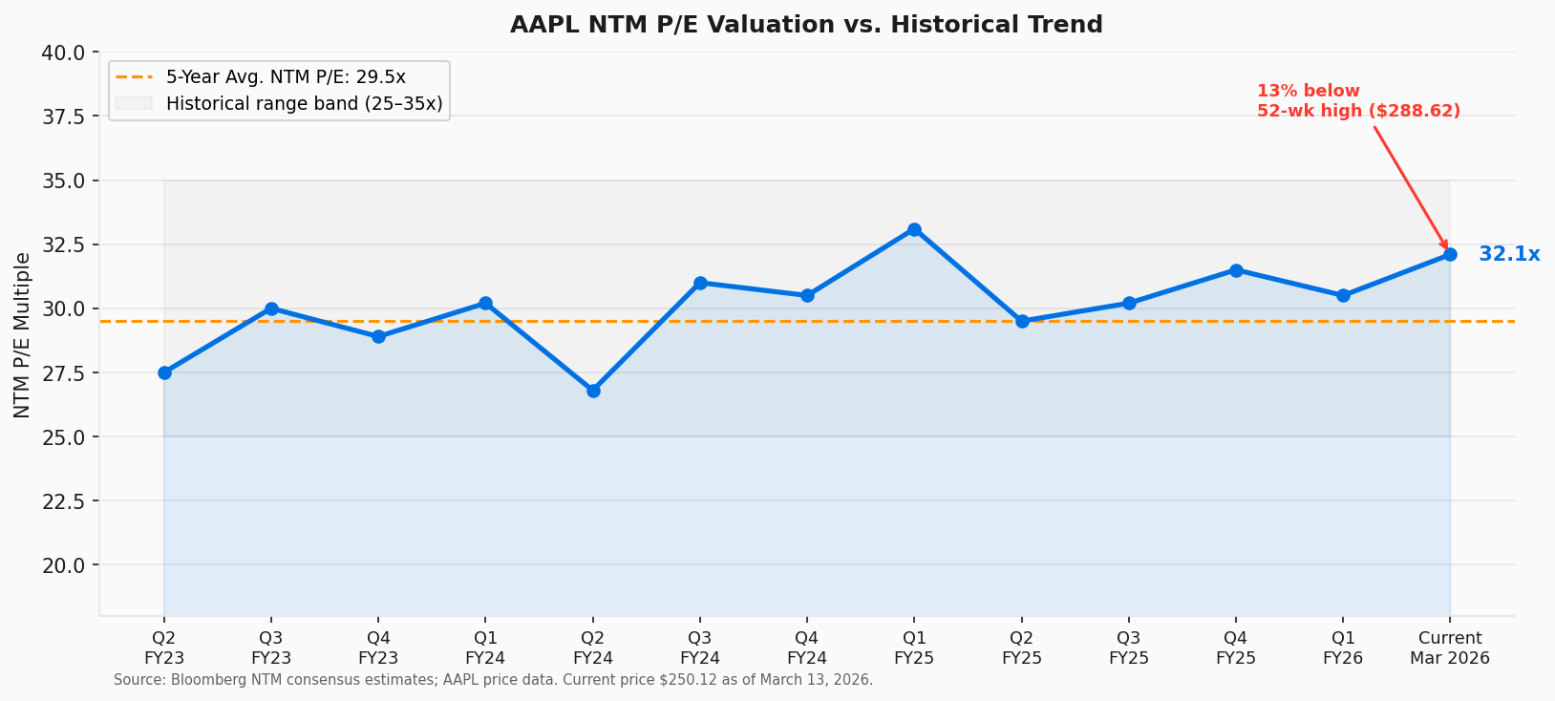
Figure 8 — AAPL NTM P/E vs. Historical Trend (Q2 FY2023 – March 2026)
Source: Bloomberg NTM consensus; AAPL daily price data. Current as of March 13, 2026.
At 32.1x NTM P/E, AAPL trades at a ~8% premium to its 5-year average (~29.5x). This premium is supported by: (1) accelerating Services mix driving structural gross margin expansion, (2) Apple Intelligence providing a multi-year product catalyst, and (3) China recovery reducing a key downside risk scenario. The stock is currently 13.3% below its December 2025 all-time high of $288.62, creating a technically attractive entry point relative to the consensus 12-month price target of $288.30.
Updated Earnings Estimates
Period | Old Revenue Est. | New Revenue Est. | Δ | Old EPS | New EPS | Δ
Q2 FY2026E | $103.0B | $109.3B | +$6.3B / +6.1% | $1.63 | $1.76 | +$0.13 / +8.0%
FY2026E | $403.5B | $418.0B | +$14.5B / +3.6% | $7.05 | $7.45 | +$0.40 / +5.7%
FY2027E | $428.0B | $445.0B | +$17.0B / +4.0% | $7.80 | $8.30 | +$0.50 / +6.4%

We raise FY2026E revenue by $14.5B and EPS by $0.40 driven by: (1) Q1 beat carry-through, (2) stronger Q2 guidance, (3) Greater China upside assumption increase (from flat to +10% YoY for full FY2026), and (4) Services revenue acceleration modeling. Our revised $288.30 price target is based on 35x our FY2027E EPS of $8.30, at the high end of Apple's historical range to reflect Services-driven margin re-rating and Apple Intelligence optionality.
Capital Returns & Cash Flow
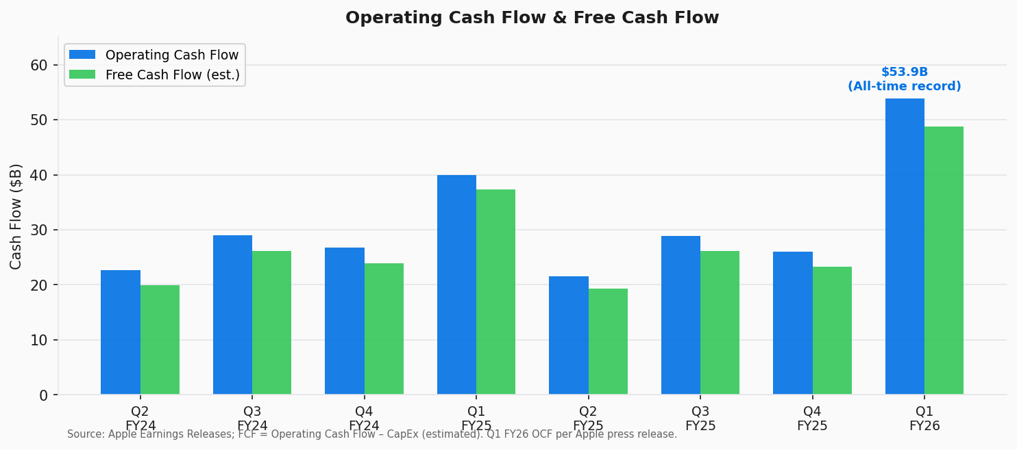
Figure 9 — Operating Cash Flow & Estimated Free Cash Flow (Q2 FY2024 – Q1 FY2026)
Source: Apple Earnings Releases; FCF = Operating Cash Flow – CapEx (estimated).
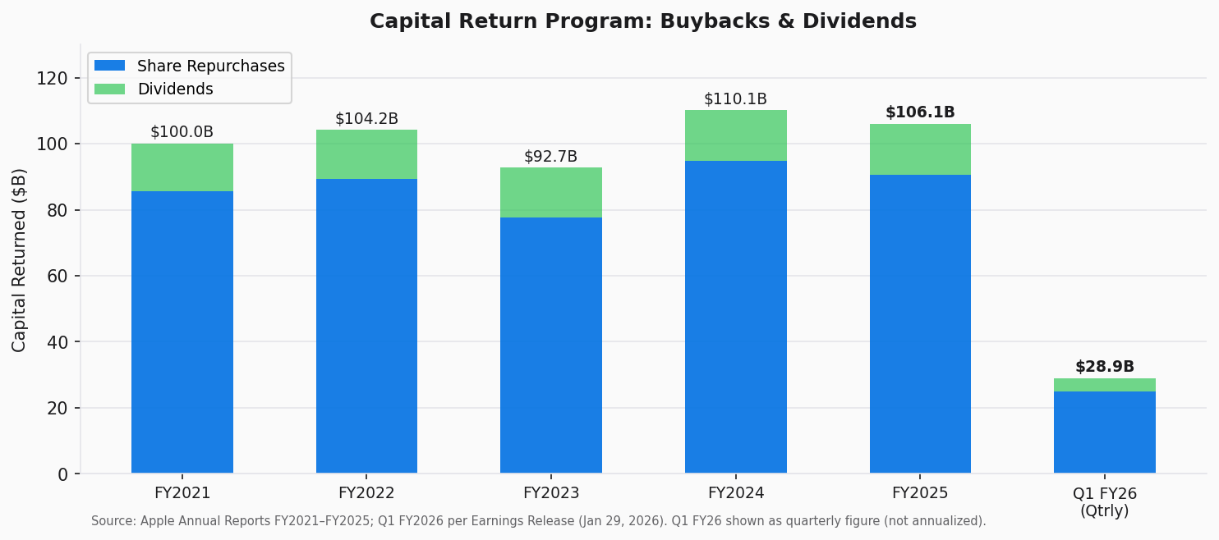
Figure 10 — Capital Return Program: Share Repurchases & Dividends (FY2021 – FY2025 + Q1 FY2026)
Source: Apple Annual Reports FY2021–FY2025; Q1 FY2026 Earnings Release (Jan 29, 2026).
Q1 FY2026 OCF of $53.9B is an all-time record for any single quarter in Apple's history. Apple returned $29B to shareholders ($25B buybacks + $3.9B dividends), demonstrating ongoing capital allocation discipline. The May 2025 $100B authorization has ~$74.8B remaining, and we expect a new $100–120B program to be announced at the May 2026 annual meeting. The combination of organic FCF generation and efficient capital return continues to mechanically drive EPS compounding at ~3–4% annually from buybacks alone.

KEY RISKS
Upside Risks:
- Greater China sustained recovery — If iPhone 17 cycle extends into a secular China share-gain story, FY2026 China revenue could exceed $95B (vs. our ~$85B base case), adding $2–3B incremental revenue.
- Apple Intelligence / Siri monetization — A paid Apple Intelligence subscription tier (rumored at $4.99–9.99/month) could add $5–8B incremental annual Services revenue by FY2028.
- Services re-rating — If Services reaches 25% of revenue (vs. 20.9% today) with ~77% gross margins, the incremental mix benefit supports NTM P/E expansion toward 37–40x.
- TSMC advanced node allocation improvement — Resolution of the Q1/Q2 supply constraint could drive stronger Q3 FY2026 iPhone 18 launch seasonality.
Downside Risks:
- Antitrust / regulatory risk on App Store — DOJ/EU proceedings on App Store fees and sideloading requirements remain a structural overhang; adverse rulings could reduce Services gross margins by 100–200 bps and impair the monetization loop.
- China geopolitical deterioration — US–China trade tensions or Chinese government actions against Apple suppliers/distribution could reverse Q1 FY2026 gains. A return to the Q1 FY2025 level would remove ~$7B from annual revenue.
- Memory cost escalation — If DRAM/NAND prices continue to rise beyond current forecasts (driven by AI data center demand), Products gross margins could remain under 37–38% through FY2026, limiting total company margin expansion.
- Google Gemini disruption — If the Google partnership is disrupted (regulatory, competitive), Apple's Siri upgrade timeline could be delayed 12–18 months, creating a competitive gap vs. Android AI capabilities.
- FX headwinds — ~60% of Apple's revenue is generated outside the US. USD strengthening of 5% would reduce FY2026E revenue by approximately $8–10B at constant currency.

SOURCES & REFERENCES
Earnings Materials (Q1 FY2026 / Calendar Q4 2025)
Reference Quarter — FQ4 2025 (Fiscal Q4 / September 2025)
Market Data & Valuation
AI / Apple Intelligence Coverage
• Apple Q1 FY2026 Earnings Release (January 29, 2026)
• Apple Form 10-Q — Q1 FY2026 (Filed ~February 2026, SEC EDGAR)
• Apple Q1 FY2026 Earnings Call Transcript (January 29, 2026) — The Motley Fool
• Apple Q1 FY2026 Earnings Call Transcript — Investing.com
• Apple Q1 FY2026 Results — CNBC Coverage
• Apple Q1 FY2026 Results — MacRumors
• Apple Q1 FY2026 Form 10-Q via StockTitan / SEC Filing
• Apple Q4 FY2025 Earnings Release (October 30, 2025)
• Apple Q4 FY2025 Analysis — The Acquirer's Multiple
• AAPL PE Ratio Historical — FinanceCharts (March 2026)
• AAPL Analyst Forecast & Price Targets — MarketBeat (March 2026)
• Apple Gemini-Powered Siri Explained — MacRumors (Jan 30, 2026)
• Inside Apple's AI Shake-Up and iOS 26.4 Siri Plans — Bloomberg

IMPORTANT DISCLOSURES: This report is for informational purposes only and does not constitute investment advice. Financial data sourced from public company filings and press releases. Consensus estimates from Bloomberg as of January 28, 2026. Market data as of March 13, 2026. All figures in USD. Estimates represent analyst projections and are subject to change.

