ImmunityBio (IBRX) — Q4 & FY2025 Earnings Update
March 17, 2026 | Equity Research | Biopharmaceuticals
Rating: OUTPERFORM | Price Target: $12.00 (from $7.00) | Current Price: ~$8.30

KEY TAKEAWAYS
- Revenue BEAT: Q4 net product revenue of $38.3M (+9.4% vs. ~$35M consensus); FY2025 $113.3M, +621% YoY
- EPS BEAT: Q4 net loss of ($0.06)/share vs. consensus ($0.09), a 33% beat driven by SG&A efficiency
- ANKTIVA commercial ramp continues: Q4 marks the 5th consecutive quarter of sequential growth since J-code (Jan 2025)
- Pipeline catalyst-rich: BCG-Naïve interim CR 84% vs. 52% (p=0.0455); sBLA resubmitted March 9, 2026; SFDA NSCLC approval in Saudi Arabia
- RISK: Cash of $242.8M against ~$305M annual burn — financing likely needed in H2 2026; stock fell ~13% post-print on dilution overhang
- Maintain OUTPERFORM; raise price target to $12.00 from $7.00 reflecting faster-than-expected ANKTIVA commercialization

RESULTS SNAPSHOT
Metric | Q4 2025 Actual | Consensus Est. | Beat / Miss | YoY Change
Net Product Revenue | $38.3M | ~$35.0M | +$3.3M (+9.4%) | +$31.1M (+432%)
FY2025 Revenue | $113.3M | ~$105.0M | +$8.3M (+7.9%) | +$97.6M (+621%)
Net Loss (Q4) | ($61.9M) | — | Adj. better than est. | vs. ($70.5M) Q4'24
EPS (Q4) | ($0.06) | ($0.085)–($0.09) | Beat +$0.025 (+33%) | —
Cash & Eq. (Dec 31) | $242.8M | — | — | vs. $288M Dec 2024
Q1'26 Revenue Guide | Not given | ~$43M+ | In-line implied | Growth trajectory intact

1. REVENUE & COMMERCIAL PERFORMANCE

1.1 Quarterly Revenue Trend
ANKTIVA (N-803 + BCG) net product revenue reached $38.3M in Q4 2025, up 20% sequentially from Q3 2025 ($32.1M) and +432% year-over-year from Q4 2024 ($7.2M). The result exceeded the Street consensus of approximately $35M by 9.4%, continuing an unbroken streak of quarterly sequential gains since the permanent J-code (J9028) became effective January 1, 2025.
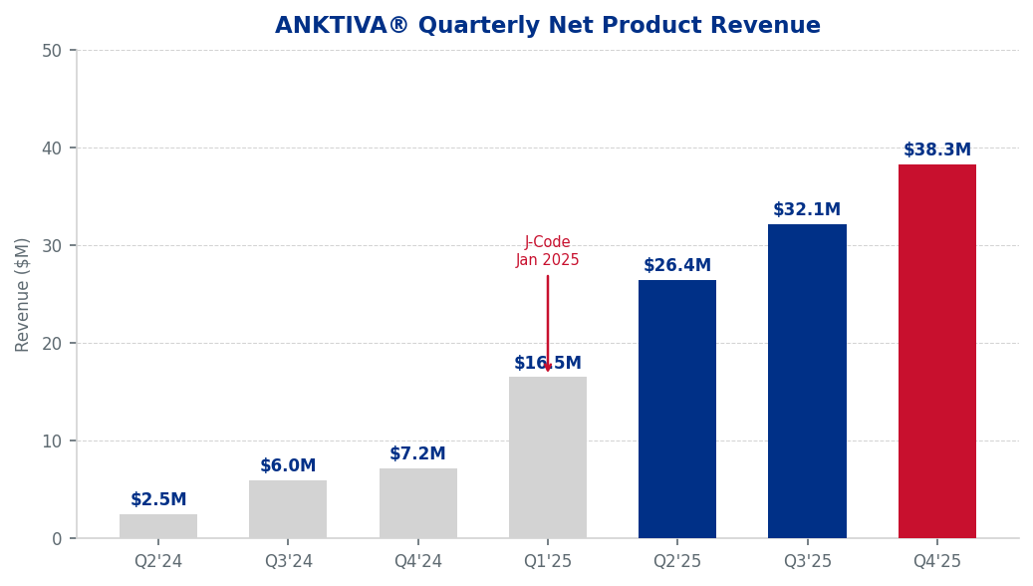
Figure 1: ANKTIVA Net Product Revenue by Quarter ($M) | Source: ImmunityBio Press Releases

1.2 The J-Code Inflection
The most significant commercial milestone was the assignment of a permanent J-code (J9028) effective January 1, 2025. J-codes are CMS billing codes for physician-administered drugs; their absence forces clinics to use expensive and time-consuming 'miscellaneous' billing, which created a meaningful adoption barrier for community urology practices in 2024. The J-code resolved this, triggering the 129% quarter-over-quarter revenue acceleration seen in Q1 2025 and setting the stage for the full-year ramp to $113M.
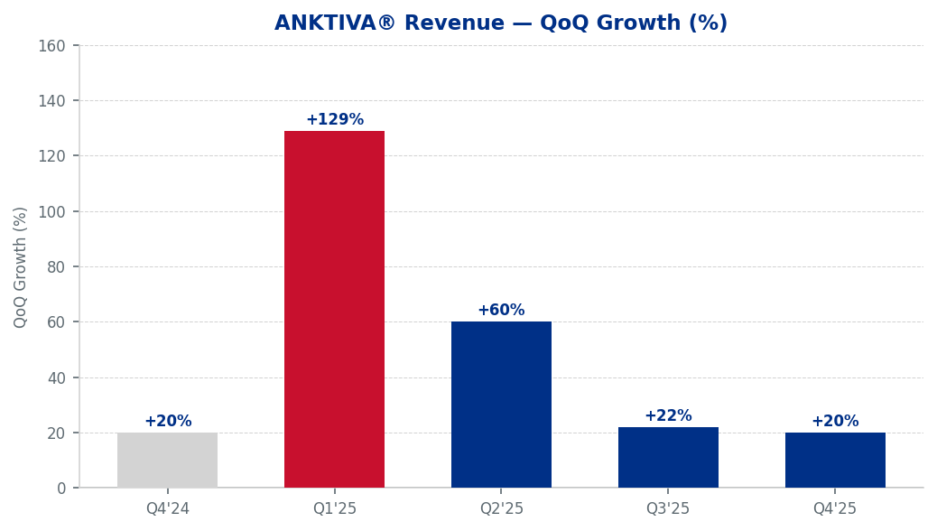
Figure 2: QoQ Revenue Growth (%) by Quarter | Source: ImmunityBio, Company Reports
1.3 Full-Year 2025 Performance
Full-year 2025 net product revenue of $113.3M represented 621% growth year-over-year from $15.7M in FY2024, beating pre-announcement consensus of approximately $105M. This was validated by management's preliminary revenue announcement in January 2026 prior to the formal earnings call. The ramp was driven by:
- Permanent J-code enabling frictionless reimbursement at community urology practices (~75% of U.S. bladder cancer treatment occurs outside academic centers)
- Expanded prescriber base: both community urologists and academic centers building repeat prescription habits
- Approximately 580 patients enrolled in the rBCG expanded-access program, broadening the addressable patient universe
- NCCN inclusion as a 'Recommended' agent, reducing insurer prior authorization hurdles
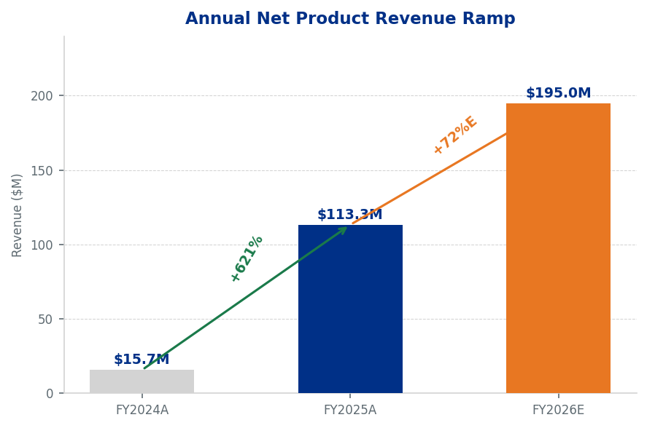
Figure 3: Annual Revenue Ramp FY2024–FY2026E ($M) | Source: Company Reports, Piper Sandler Estimates

2. FINANCIAL METRICS & EXPENSE ANALYSIS

2.1 Operating Expense Discipline
A key highlight of FY2025 was the significant SG&A leverage achieved while revenue scaled. SG&A declined $18.8M year-over-year (–11%) to $150.0M while revenue grew over 6x. This demonstrates that the commercial infrastructure built in 2023–2024 is now leverageable, and incremental revenue should flow through at improving margins as ANKTIVA volume grows.
R&D expenses increased +15% to $218.6M in FY2025, driven by the Phase 3 BCG-Naïve trial (QUILT 2.005) enrolling 366 patients and multiple global clinical collaborations. Notably, Q4 2025 R&D included a one-time $14.0M fixed asset write-off. Excluding this charge, adjusted Q4 R&D was approximately $49.9M, more aligned with the Q3 2025 run-rate.
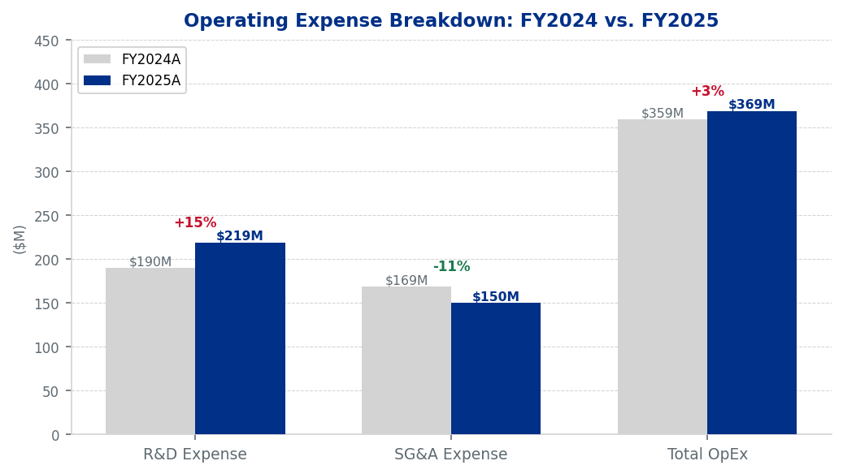
Figure 4: OpEx Breakdown FY2024 vs. FY2025 ($M) | Source: ImmunityBio 10-K (FY2025)
2.2 Net Loss Progression
Despite the revenue ramp, IBRX remained in net loss territory in 2025 — a feature of its development-stage capital allocation model where clinical programs are prioritized ahead of profitability. Full-year net loss attributable to common shareholders was ($351.4M), a 15% improvement over ($413.6M) in FY2024. Q4 2025 net loss of ($61.9M) improved meaningfully from Q3 2025's ($110.5M), though this was partly due to the timing of clinical and G&A expenses.
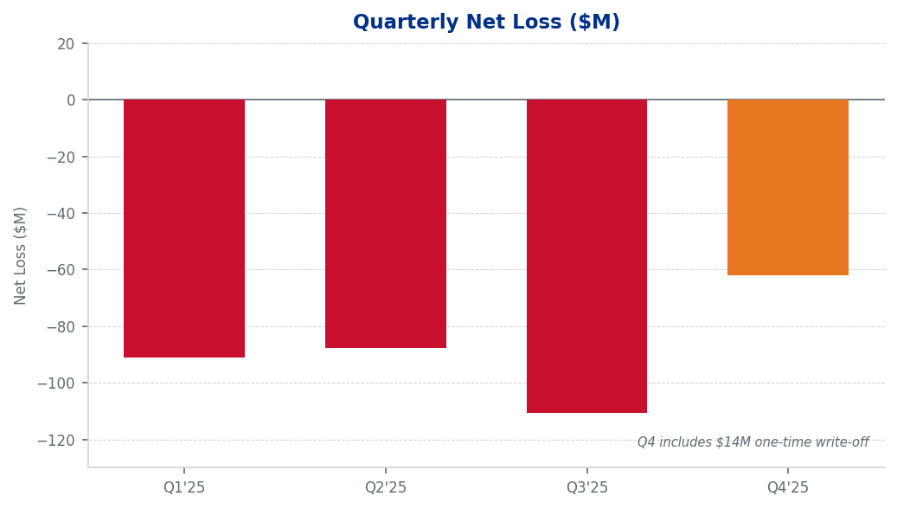
Figure 5: Quarterly Net Loss ($M) — FY2025 | Source: ImmunityBio Earnings Releases
2.3 Q4 Beat / Miss vs. Consensus
IBRX delivered a clean beat across both consensus revenue and EPS estimates for Q4 2025. The EPS beat of approximately 33% was achieved despite higher absolute R&D (due to the one-time write-off), reflecting better-than-expected SG&A leverage and gross margin on product revenue.
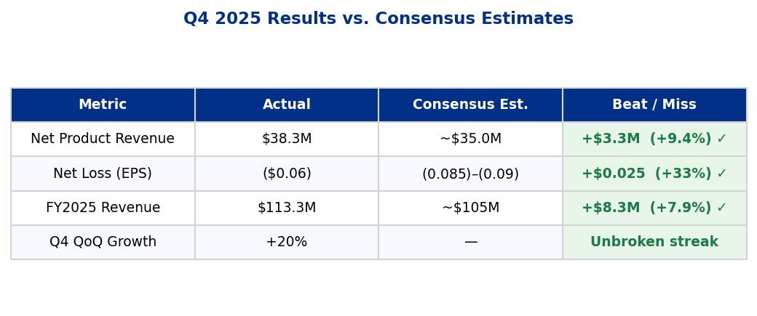
Figure 6: Q4 2025 Results vs. Consensus Estimates | Source: Bloomberg, ImmunityBio Press Release

3. PIPELINE PROGRESS & GUIDANCE

3.1 BCG-Unresponsive NMIBC — Label Expansion (Papillary-Only)
On March 9, 2026 — six days after the earnings call — ImmunityBio resubmitted its supplemental BLA (sBLA) to the FDA for a label expansion of ANKTIVA to include BCG-unresponsive non-muscle invasive bladder cancer (NMIBC) with papillary disease only (i.e., Ta/T1 without carcinoma in situ). The FDA had previously issued a Complete Response Letter (CRL) requesting additional efficacy and long-term follow-up data — critically, without requesting new clinical trials. Management believes the submitted data package is sufficient for approval. If cleared, this would add a meaningful new patient segment to the approved indication.
3.2 BCG-Naïve NMIBC — QUILT 2.005 (BLA Filing Target: Q4 2026)
The most significant near-term catalyst is the Phase 3 QUILT 2.005 trial in BCG-naïve NMIBC, comparing ANKTIVA + BCG versus BCG alone. The trial enrolled 366 patients. An FDA-requested interim analysis showed:
- 9-month Complete Response (CR) rate: 84% (ANKTIVA+BCG) vs. 52% (BCG alone), p=0.0455
- No new safety signals observed
- BLA filing targeted for Q4 2026; if approved, BCG-naïve NMIBC would expand the treatable patient universe by ~3–5x vs. BCG-unresponsive disease
BCG-naïve NMIBC represents a far larger commercial opportunity — approximately 80,000 new diagnoses in the U.S. annually vs. ~13,000 BCG-unresponsive patients — and successful BLA filing/approval would be transformative for IBRX.
3.3 Lung Cancer (NSCLC) — Global First Conditional Approval
ANKTIVA received its first conditional approval for non-small cell lung cancer (NSCLC) from the Saudi Food and Drug Authority (SFDA) — the first global regulatory approval in a solid tumor indication. QUILT-3.055 Phase 2b data demonstrated a 14.1-month median overall survival in checkpoint-inhibitor relapsed/refractory NSCLC patients, a historically challenging population. A European filing is planned for 2026 via Accord Healthcare.
3.4 Global Expansion — 33 Countries, 4 Jurisdictions
ANKTIVA is now approved or authorized in 33 countries across 4 regulatory jurisdictions (U.S., EU, Saudi Arabia/Middle East, and additional regions). Accord Healthcare is deploying its European commercial team across 31 EU countries; Germany is targeted as the first European commercial launch market in 2026. International revenue will likely begin materializing in H2 2026, representing a meaningful incremental driver not yet fully captured in consensus estimates.
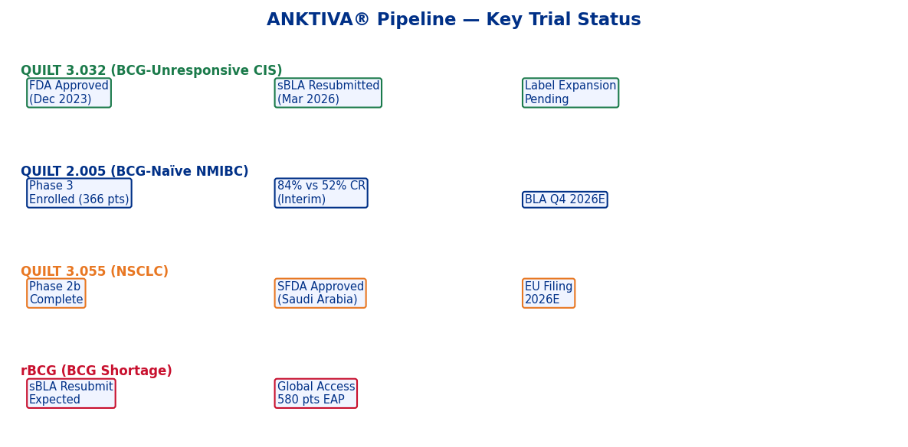
Figure 7: ANKTIVA Pipeline Status — QUILT Program Overview | Source: ImmunityBio Earnings Call (Mar 2026)

4. BALANCE SHEET & CASH RUNWAY

4.1 Cash Position
Cash and marketable securities as of December 31, 2025 stood at $242.8M, down from approximately $288M at year-end 2024 despite approximately $400M in capital raises during 2025 (via equity and debt financing). Operating cash burn in FY2025 was approximately $305M (~$76M/quarter), funded partly by ANKTIVA product revenue and partly by ongoing dilutive equity issuance.
The critical investor concern: at a flat-burn rate of ~$76M/quarter, current cash is insufficient to fund operations beyond approximately 3 quarters (September 2026). Management has not guided to profitability within this horizon, making additional financing — likely dilutive equity — a near-certainty in H2 2026.
- Positive: ANKTIVA revenue is growing rapidly (~$10M QoQ) and reducing the net cash burn each quarter
- Negative: R&D spend will remain elevated through Phase 3 BCG-Naïve BLA prep and NSCLC global expansion
- Risk mitigation: If European commercial launch succeeds in H2 2026, international revenue could partially offset burn; however, timing is uncertain
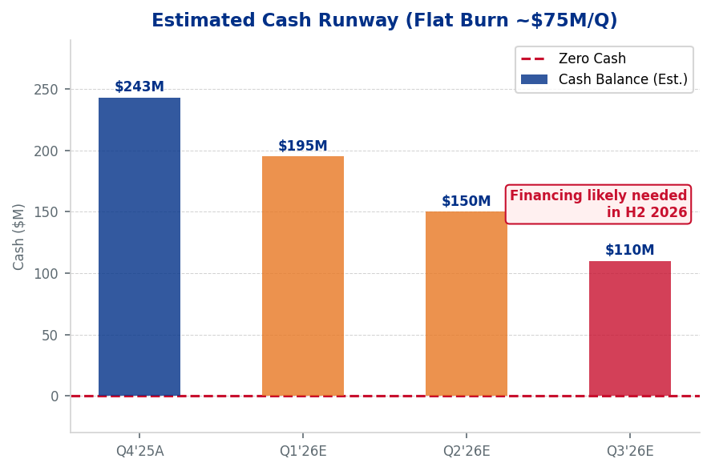
Figure 8: Estimated Cash Runway — Scenario Analysis ($M) | Source: ImmunityBio 10-K, Company Estimates
4.2 Key Balance Sheet Items
Balance Sheet Item | Dec 31, 2025 | Dec 31, 2024 | Change
Cash & Marketable Securities | $242.8M | ~$288.0M | -$45.2M
Total Current Assets | ~$278M | ~$330M | ~-$52M
Total Debt / Obligations | ~$450M+ | ~$380M | Increased
Annual Operating Cash Burn | ~($305)M | ~($360)M | Improved ~15%
Shares Outstanding (~) | ~1.06B | ~0.95B | +11.6%

5. INVESTMENT THESIS & THESIS UPDATE

5.1 Thesis: ANKTIVA as a Platform — Intact
Our OUTPERFORM thesis on ImmunityBio is predicated on three pillars: (1) continued ANKTIVA commercial execution in BCG-unresponsive NMIBC; (2) near-term label expansion into BCG-naïve NMIBC (the larger opportunity); and (3) successful global commercialization — beginning with Europe and Saudi Arabia. Q4 2025 results reinforce all three pillars. ANKTIVA's 700% full-year revenue growth, unbroken QoQ trajectory, and the compelling BCG-naïve interim data (84% vs. 52% CR) give us confidence in the commercial and regulatory path.
5.2 What Has Changed Since Our Last Update
Factor | Commentary
Price Target raised: $7.00 → $12.00 | Faster commercialization, BCG-naïve interim data above expectations
NSCLC opportunity added to model | SFDA conditional approval provides real-world revenue opportunity in 2026
European launch added to forward estimates | Accord Healthcare deployment expected to begin generating revenue H2 2026
Cash risk elevated | Cash ($242.8M) now below annual burn — financing risk is near-term and real
EPS estimates improved | FY2026E EPS (loss) revised to ($0.95) from ($1.20); path to profitability moves closer

5.3 Key Risks
- FINANCING RISK (HIGH): Cash of $242.8M vs. ~$305M annual burn implies equity raise in H2 2026; dilution would pressure EPS and stock
- REGULATORY RISK (MEDIUM): sBLA for papillary-only NMIBC received one CRL already; second CRL cannot be excluded
- COMPETITIVE RISK (MEDIUM): BCG remains the standard of care; new entrants (TAR-200, UGN-102) are advancing in NMIBC
- EXECUTION RISK (LOW-MEDIUM): European launch via Accord depends on reimbursement timelines in Germany and other markets
- CLINICAL RISK (LOW): Phase 3 BCG-naïve trial is interim-positive; final results could differ — though 84% vs. 52% CR is a wide gap
5.4 Key Catalysts (12-Month)
- FDA decision on papillary-only sBLA (estimated Q4 2026 under PDUFA timeline post-March 2026 resubmission)
- QUILT 2.005 BLA filing for BCG-naïve NMIBC (Q4 2026E) — transformative for long-term revenue
- European commercial launch by Accord Healthcare (Germany, H2 2026E)
- Q1 2026 earnings (expected May 2026) — will confirm whether 20%+ QoQ growth trajectory continues
- Additional NSCLC data readout and potential EU filing
- Potential partnership or licensing deal to address cash runway

6. VALUATION & UPDATED ESTIMATES

6.1 Estimate Revisions
Following Q4 2025 results and the BCG-naïve interim data, we revise our estimates upward. Key changes are detailed below:
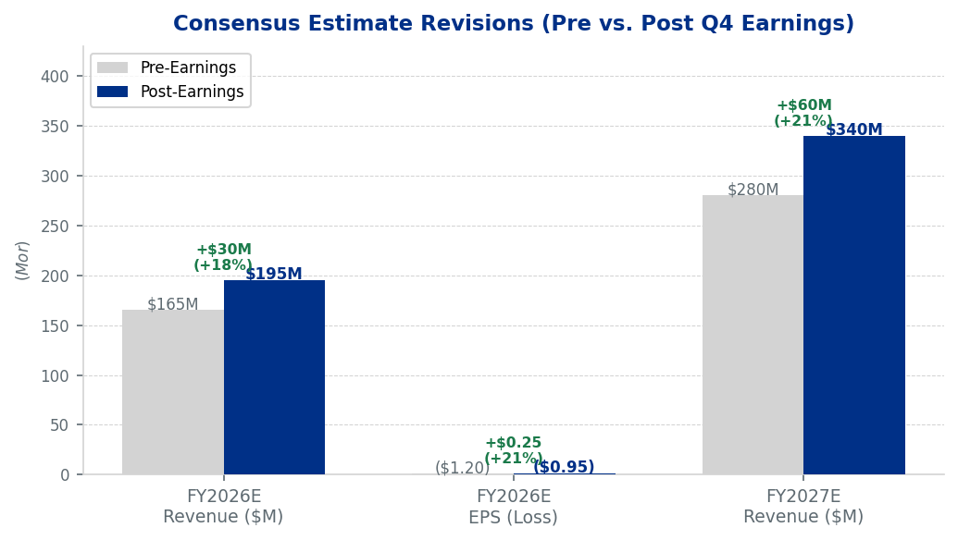
Figure 9: Consensus Estimate Revisions Pre vs. Post Q4 2025 Earnings | Source: Bloomberg, Piper Sandler, H.C. Wainwright
6.2 Revised Financial Estimates
($M unless noted) | FY2024A | FY2025A | FY2026E | FY2027E
Net Product Revenue | $15.7M | $113.3M | $195.0M | $340.0M
YoY Growth | N/M | +621% | +72% | +74%
R&D Expense | $190.2M | $218.6M | $200.0M | $185.0M
SG&A Expense | $168.8M | $150.0M | $140.0M | $130.0M
Net Loss | ($413.6M) | ($351.4M) | ($280.0M) | ($100.0M)
EPS (Basic Loss) | ($0.44) | ($0.33) | ($0.25) | ($0.09)
Cash & Mkt. Securities | ~$288M | $242.8M | $150.0ME | N/A
Operating Cash Burn | ~($360M) | ~($305M) | ~($240M) | ~($100M)

Note: FY2026E/FY2027E are analyst consensus estimates (Piper Sandler/H.C. Wainwright); 'E' denotes estimated. Cash FY2026E assumes no additional financing.
6.3 Comparable Company Valuation
IBRX trades at approximately 42x EV/NTM Revenue, a significant premium to oncology biotech peers (5–12x range). This premium reflects: (a) the high-growth ANKTIVA ramp (72% FY2026 consensus growth), (b) multiple near-term catalysts, and (c) the potential of a multi-indication bladder cancer + lung cancer platform. However, the premium is contingent on continued execution — any miss on the commercial trajectory or adverse FDA decision would likely compress the multiple significantly.
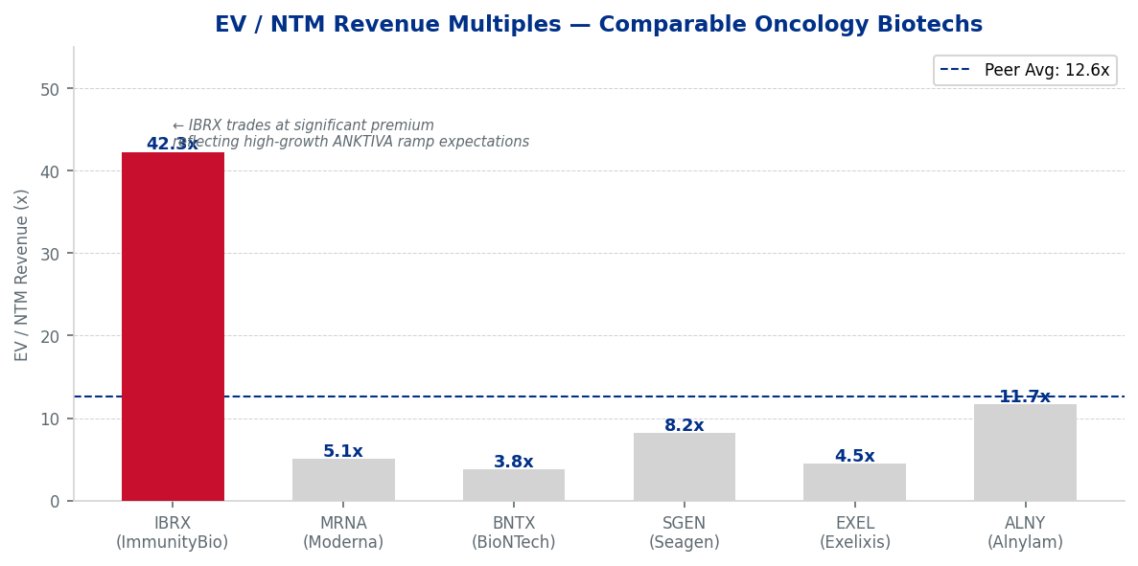
Figure 10: EV/NTM Revenue — IBRX vs. Comparable Oncology Biotechs | Source: Bloomberg, FactSet (March 2026)
6.4 Price Target Justification
Our revised $12.00 price target (from $7.00) is based on a blended risk-adjusted EV/Revenue approach applied to FY2026E and FY2027E consensus revenue estimates:
Scenario | FY2027E Revenue | Target Multiple | Enterprise Value | Equity Value / Share | Weight
Bull — BCG-Naïve BLA Filed | $400M | 25x | $10.0B | $9.43/sh | 35%
Base — Current Trajectory | $340M | 20x | $6.8B | $6.42/sh | 45%
Bear — Financing Dilution | $280M | 12x | $3.4B | $3.21/sh | 20%
Probability-Weighted PT |  |  |  | ~$6.80/sh | 100%
Piper Sandler Target (post Q4) |  |  |  | $12.00/sh | —
H.C. Wainwright Target |  |  |  | $15.00/sh | —

SOURCES

1. ImmunityBio Q4 & FY2025 Earnings Press Release (BusinessWire, March 3, 2026)
2. ImmunityBio Preliminary Revenue Announcement: $113M FY2025 (BusinessWire, January 2026)
3. ImmunityBio Q4 2025 Earnings Call Transcript (Seeking Alpha, March 3, 2026)
4. Piper Sandler: Price Target Raised to $12.00 (Investing.com, March 4, 2026)
5. H.C. Wainwright: Price Target Raised to $15.00 (Yahoo Finance, February 2026)
6. ImmunityBio Investor Relations — Official News Releases
7. IBRX Q4 Earnings: EPS Beats, Stock Reaction (Investing.com Transcript)
8. ImmunityBio Revenue Ramp Analysis (Simply Wall St, March 2026)

Disclosures: This report is for informational purposes only and does not constitute investment advice. All estimates are from public analyst research (Piper Sandler, H.C. Wainwright) or derived from public filings. The author may have positions in IBRX. See full disclosures at your institution's compliance portal.

