EQUITY RESEARCH | AEROSPACE & DEFENSE
ROCKET LAB USA, INC. (NASDAQ: RKLB)
Q4 & Full Year 2025 Earnings Update
February 26, 2026 | Earnings Release Date

Rating | Price Target | Current Price | Market Cap | 52W Low | 52W High
BUY | $35.00 | $70.05 | ~$39.7B | $14.71 | $99.58

KEY TAKEAWAYS
- ✔ Revenue Beat: Record quarterly revenue of $179.7M in Q4 2025, +36% YoY and +16% QoQ, beating consensus ~$177M by ~+1.6%.
- ✔ EPS In-Line: GAAP EPS of ($0.09) in-line with consensus estimate of ($0.09)–($0.10), reflecting disciplined cost management.
- ✔ EBITDA Beat: Adj. EBITDA loss of ($17.4M) — materially better than company guidance of ($23M)–($29M) loss.
- ✔ Margin Expansion: Record GAAP gross margin of 38% and non-GAAP gross margin of 44%, +100bps and +240bps sequentially.
- ✔ Backlog Record: Backlog surged +73% YoY to a record $1.85B, underpinned by $816M SDA satellite prime contract (largest in history).
- ✔ FY2025 Milestones: Record 21 Electron launches in FY2025 (Q4: 7 incl. 1 HASTE mission) vs 16 in FY2024; Q1 2026 guided $185M–$200M (+3%–+11% QoQ).
- ⚠ Neutron Delay: Neutron first launch delayed to Q4 2026 after stage-one tank rupture during hydrostatic pressure test.

RESULTS SNAPSHOT
Metric | Q4 2025 Actual | Consensus / Guidance | Beat/Miss | vs. Prior Qtr
Revenue | $179.7M | ~$177M | ✔ +1.6% | +16% QoQ
Launch Services Rev | $75.9M | — | — | +85% QoQ
Space Systems Rev | $103.8M | — | — | -9% QoQ
GAAP Gross Margin | 38.0% | ~35–37% | ✔ +100–300bps | +100bps
Non-GAAP Gross Mgn | 44.0% | — | — | +240bps
Adj. EBITDA | ($17.4M) | ($23M)–($29M) | ✔ Beat | Improved
GAAP EPS | ($0.09) | ($0.09)–($0.10) | ✔ In-line | —
Backlog | $1.85B | — | +73% YoY | —
FY2025 Revenue | $601.8M | — | +38% YoY | —

DETAILED RESULTS ANALYSIS
REVENUE: RECORD QUARTER DRIVEN BY LAUNCH SURGE
Rocket Lab reported Q4 2025 revenue of $179.7M, a record for any single quarter, representing +36% year-over-year growth and +16% sequential growth. The quarter was defined by a dramatic acceleration in Launch Services revenue, which jumped +85% QoQ to $75.9M on 6 Electron launches — a new quarterly record. Space Systems delivered $103.8M, down 9% sequentially as certain spacecraft programs transitioned to completion milestones, though it remains the largest segment by annual run-rate.
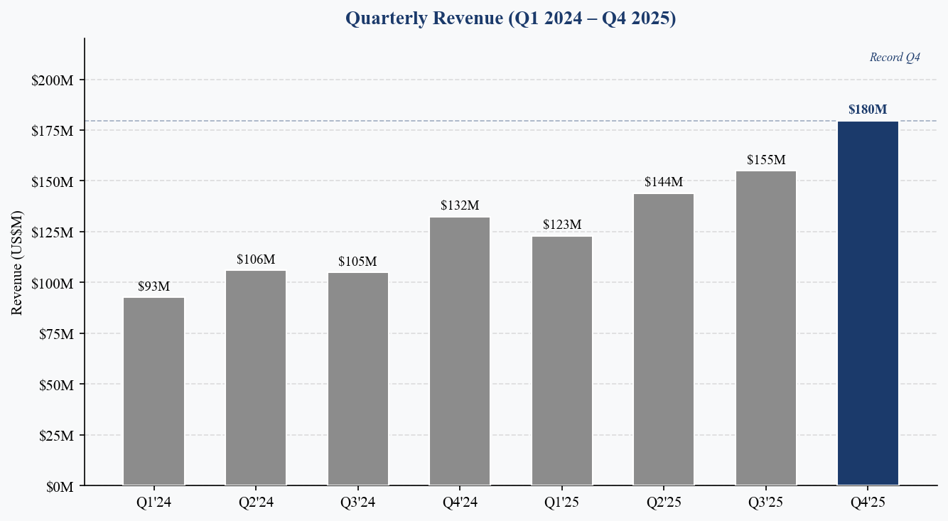
Figure 1: Quarterly Revenue (Q1 2024–Q4 2025) | Source: Rocket Lab press releases
For the full year FY2025, total revenue reached $601.8M (+38% YoY), comfortably above the FY2024 figure of $436.2M. Launch Services contributed $199.0M (+59% YoY) while Space Systems generated $402.8M (+30% YoY), reflecting the growing importance of satellite manufacturing and mission services to the business model.
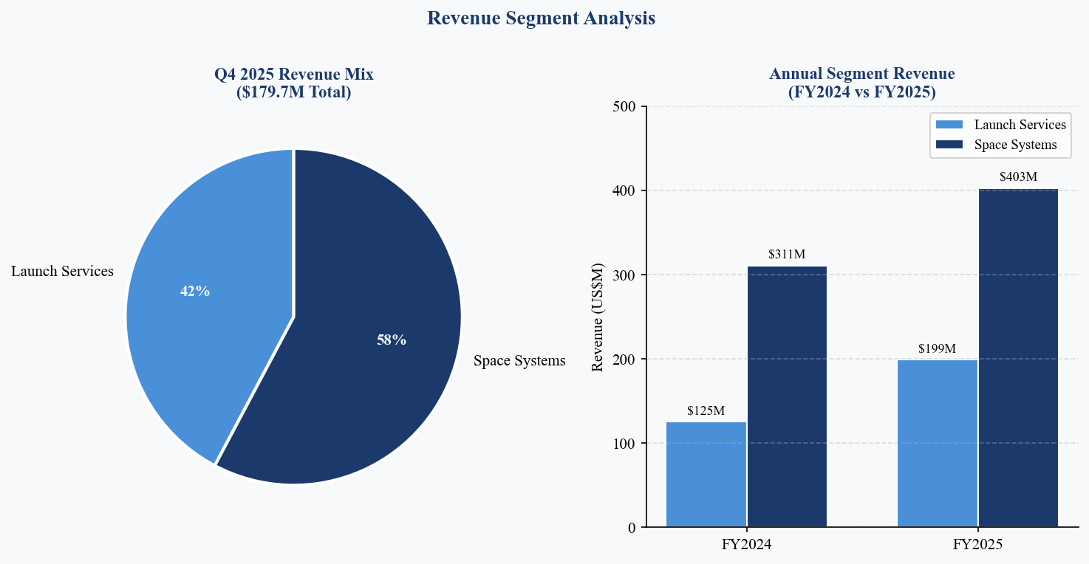
Figure 2: Segment Revenue Mix Q4 2025 & Annual Comparison | Source: Rocket Lab press releases
BEAT / MISS ANALYSIS
Results were uniformly positive across all key metrics:
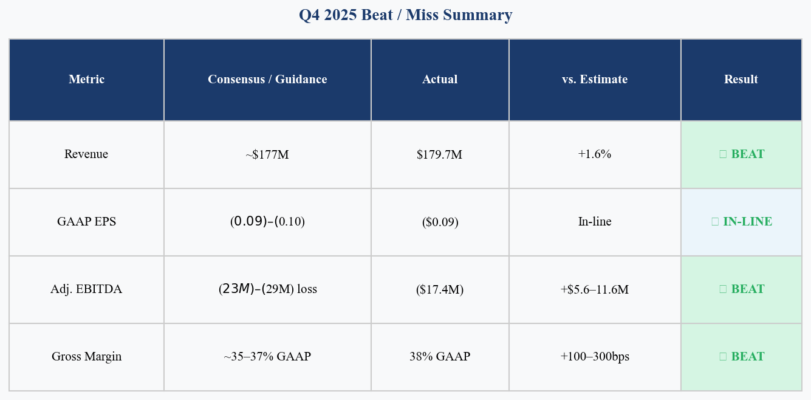
Figure 3: Q4 2025 Beat/Miss Summary vs. Consensus & Guidance | Source: Bloomberg, Rocket Lab
- Revenue of $179.7M beat consensus of ~$177M by approximately +1.6%, driven by better-than-expected launch cadence execution.
- Adjusted EBITDA loss of ($17.4M) came in $5.6–$11.6M better than the ($23M)–($29M) company guidance, primarily due to higher-than-guided revenue and gross margin expansion.
- GAAP EPS of ($0.09) was in-line with consensus of ($0.09)–($0.10), reflecting continued investment in Neutron development and headcount growth.
- GAAP gross margin of 38% exceeded typical analyst expectations of 35–37%, driven by a higher-margin launch mix and continued Space Systems cost optimization.
GROSS MARGIN: STRUCTURAL IMPROVEMENT CONTINUES
Q4 2025 marked another quarter of meaningful margin expansion. GAAP gross margin of 38% was up +100bps sequentially and up over 900bps from Q1 2024's 20%. Non-GAAP gross margin reached 44%, +240bps QoQ. This trajectory reflects: (1) greater Electron reusability benefits, (2) improved Space Systems program execution, and (3) higher-margin launch contracts as Rocket Lab moves toward dedicated manifest pricing.
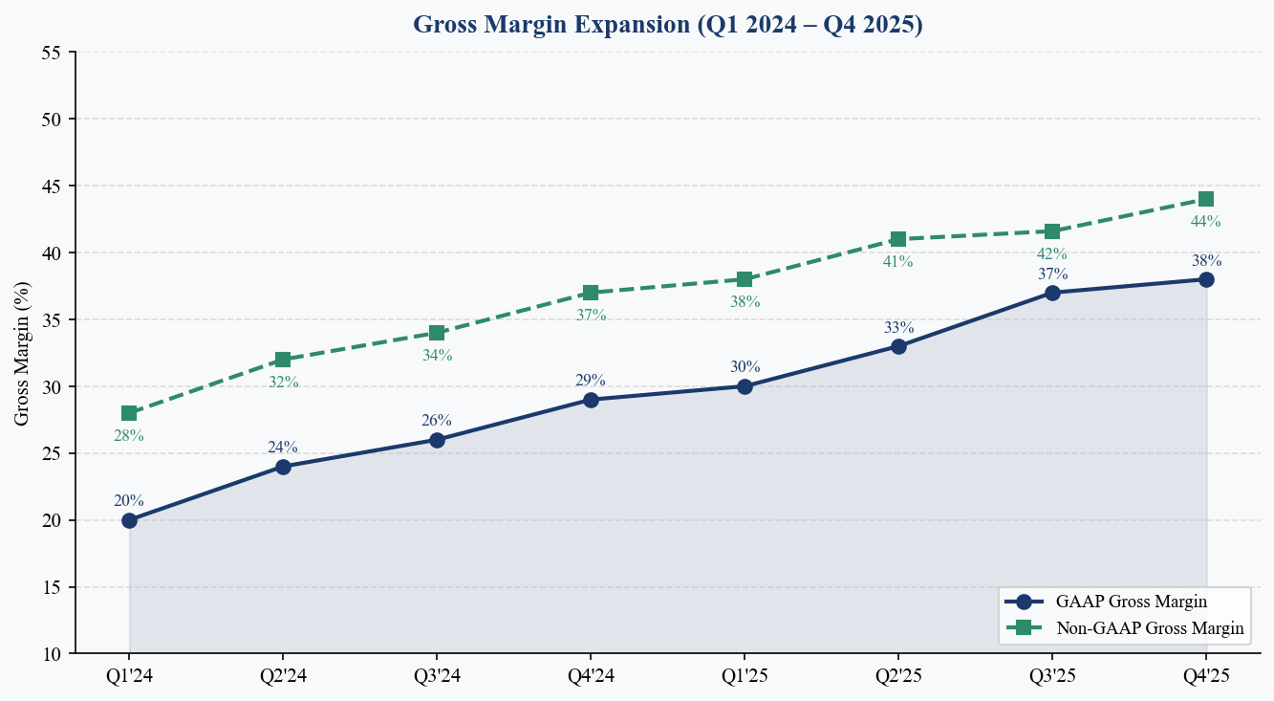
Figure 4: GAAP and Non-GAAP Gross Margin Trend | Source: Rocket Lab press releases

KEY METRICS & GUIDANCE
ADJUSTED EBITDA: LOSSES NARROWING TOWARD POSITIVE
Adjusted EBITDA loss of ($17.4M) in Q4 2025 represents a significant improvement from ($26.3M) in Q3 2025 and ($33.0M) in Q1 2025. The trajectory is clearly toward breakeven, and management has reiterated its expectation for full-year FY2026 positive adjusted EBITDA. The primary headwind remains elevated R&D expenditure related to Neutron development, which we estimate at $20–25M per quarter.
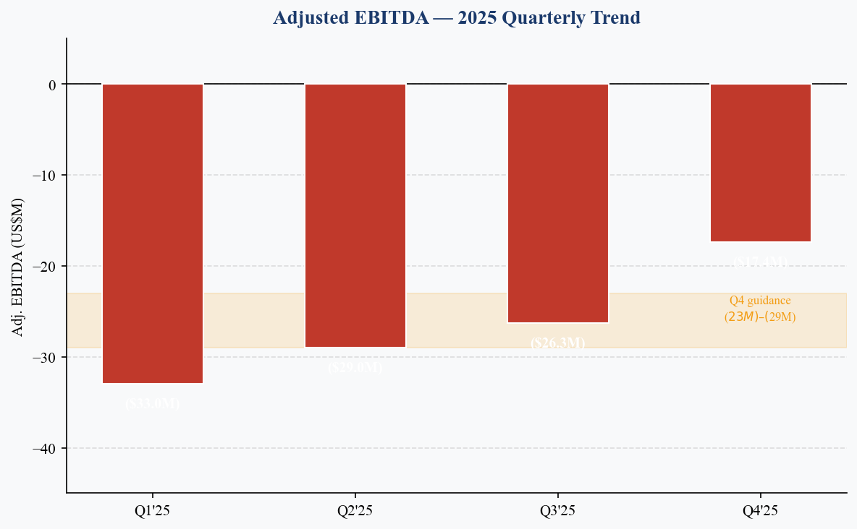
Figure 5: Adjusted EBITDA Trend — 2025 | Source: Rocket Lab press releases
BACKLOG & REVENUE VISIBILITY
The company ended Q4 2025 with a record contracted backlog of $1.85B, up +73% YoY from approximately $1.07B. This provides extraordinary revenue visibility, covering approximately 3x annualized FY2025 revenue. The backlog composition reflects 74% Space Systems and 26% Launch Services, underpinning Rocket Lab's transition toward a spacecraft manufacturer and mission provider rather than a pure-play launch vehicle company.
The landmark $816M contract from the Space Development Agency — the largest in Rocket Lab's history — to deliver 18 advanced missile warning satellites demonstrates the company's ability to compete for and win prime contracts against much larger defense primes.
LAUNCH CADENCE: RECORD 21 MISSIONS IN FY2025
Rocket Lab executed 21 Electron launches in FY2025 (vs. 16 in FY2024), with Q4 2025 delivering a quarterly record of 7 missions including 1 HASTE hypersonic sub-orbital mission. The demonstrated reliability of Electron and growing customer manifest — with 100% mission success rate in FY2025 — gives us confidence that a cadence of 6–7 launches per quarter is achievable in FY2026.
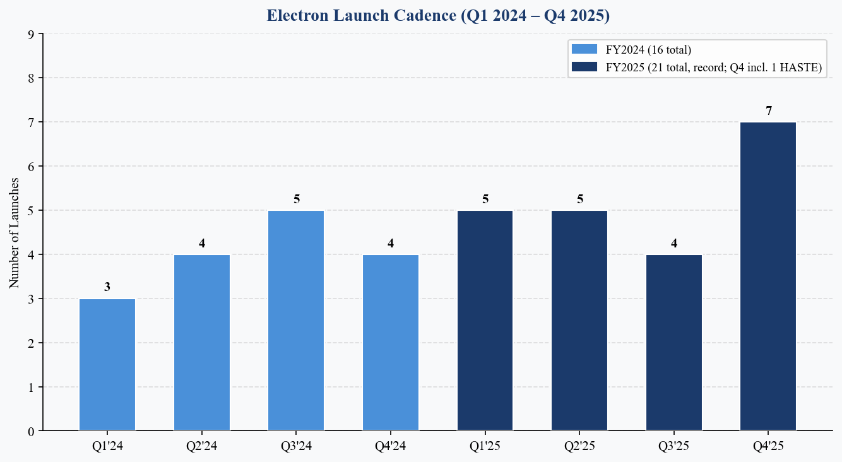
Figure 6: Electron Launch Cadence — Q1 2024 to Q4 2025 | Source: Rocket Lab
Q1 2026 GUIDANCE & OUTLOOK
Management guided Q1 2026 revenue of $185M–$200M and GAAP gross margin of 34%–36%, implying a slight sequential margin normalization. Adjusted EBITDA is guided to ($21M)–($27M), slightly wider loss range than Q4 2025, reflecting ramp-up costs as Neutron development intensifies post-tank-test failure remediation. FY2026 full-year analyst consensus of ~$885M implies ~47% growth.
Q1 2026 GUIDANCE VS. Q4 2025 ACTUALS
Metric | Q4 2025 Actual | Q1 2026 Guidance | Commentary
Revenue | $179.7M | $185M–$200M | +3%–+11% QoQ
GAAP Gross Margin | 38% | 34%–36% | Slight normalization
Adj. EBITDA | ($17.4M) | ($21M)–($27M) | Neutron ramp costs
Launch Cadence | 7 missions | ~5–7 (est.) | Sustained cadence
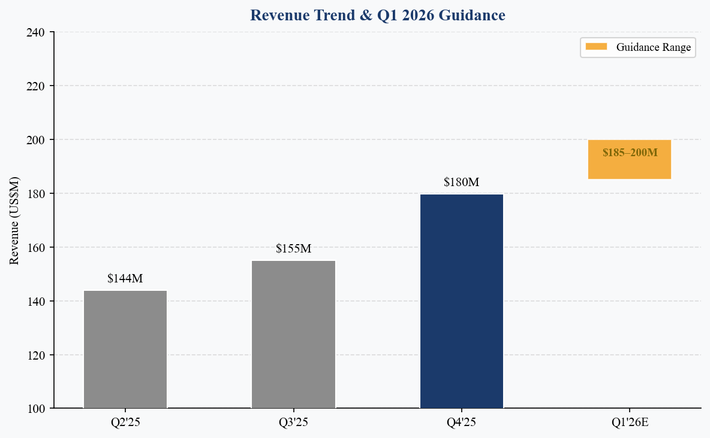
Figure 7: Revenue Trend & Q1 2026 Guidance | Source: Rocket Lab, analyst estimates

INVESTMENT THESIS UPDATE
WHAT CHANGED THIS QUARTER
Q4 2025 results reinforce rather than alter the core RKLB investment thesis. The key incremental developments are:
- Positive: Record gross margins (38% GAAP / 44% non-GAAP) signal that the business is achieving operating leverage faster than expected — a key pillar of our positive thesis.
- Positive: The $816M SDA contract raises the quality of revenue backlog and establishes RKLB as a credible prime contractor alongside Northrop Grumman and L3Harris.
- Negative: Neutron delay to Q4 2026 (from our prior estimate of mid-2026) represents a meaningful setback to the medium-term revenue bridge case. We reduce our Neutron revenue contribution assumptions for FY2026 to near-zero.
- Neutral/Positive: Despite Neutron headwinds, Q1 2026 guidance of $185M–$200M implies continued Electron and Space Systems strength is capable of driving organic growth independently.
THESIS: VERTICAL INTEGRATION CREATING A SPACE SERVICES PLATFORM
Rocket Lab is executing a unique vertical integration strategy across the space value chain: (1) Electron as the world's most frequently launched small commercial rocket, (2) a growing Space Systems business manufacturing spacecraft for government and commercial customers, and (3) a mission services capability including ground station networks and flight software. This diversification reduces single-program risk and creates cross-selling opportunities unavailable to pure-play launch providers.
The record $1.85B backlog, spanning multi-year programs, provides exceptional revenue visibility relative to RKLB's ~$4B market capitalization. We believe the market remains underappreciative of the long-duration, recurring nature of the Space Systems contract base.
RISKS
- Key Risk 1: Neutron development cost overruns or further schedule slippage could drain cash and dilute shareholders.
- Key Risk 2: Electron launch anomaly or extended range safety standdown could disrupt cadence and customer confidence.
- Key Risk 3: Government budget pressures (DoD / NASA) could slow Space Systems award activity.
- Key Risk 4: Competitive pressure from SpaceX Falcon 9 and emerging European small-lift vehicles.
CATALYSTS
- Neutron static fire test and updated launch timeline (expected H1 2026).
- Additional SDA or DoD prime contract awards from the growing $1.85B backlog pipeline.
- Electron reusability milestones — demonstrated booster reuse could accelerate margin expansion.
- Positive adjusted EBITDA milestone (management guides for FY2026).
- International launch partnerships or new commercial satellite customers announced at industry conferences.

VALUATION & ESTIMATES
ANNUAL REVENUE TRAJECTORY
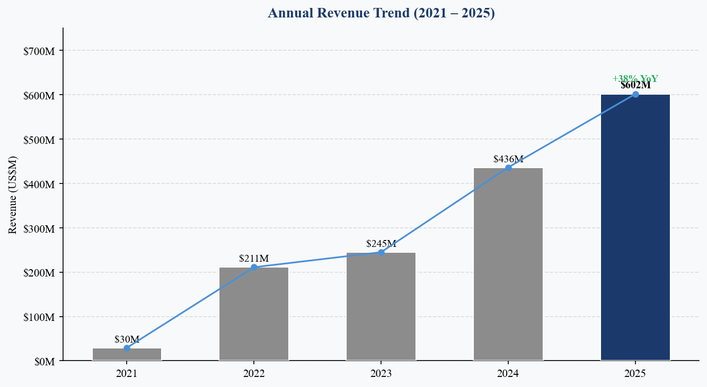
Figure 8: Annual Revenue 2021–2025 | Source: Rocket Lab press releases
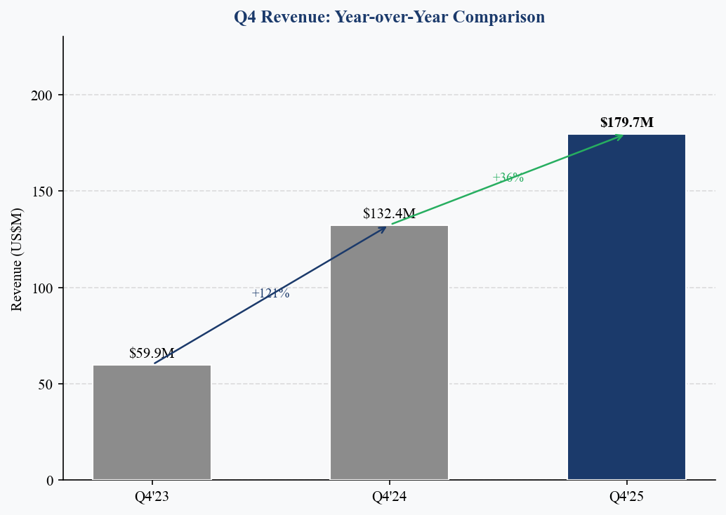
Figure 9: Q4 Revenue Year-over-Year Comparison | Source: Rocket Lab press releases
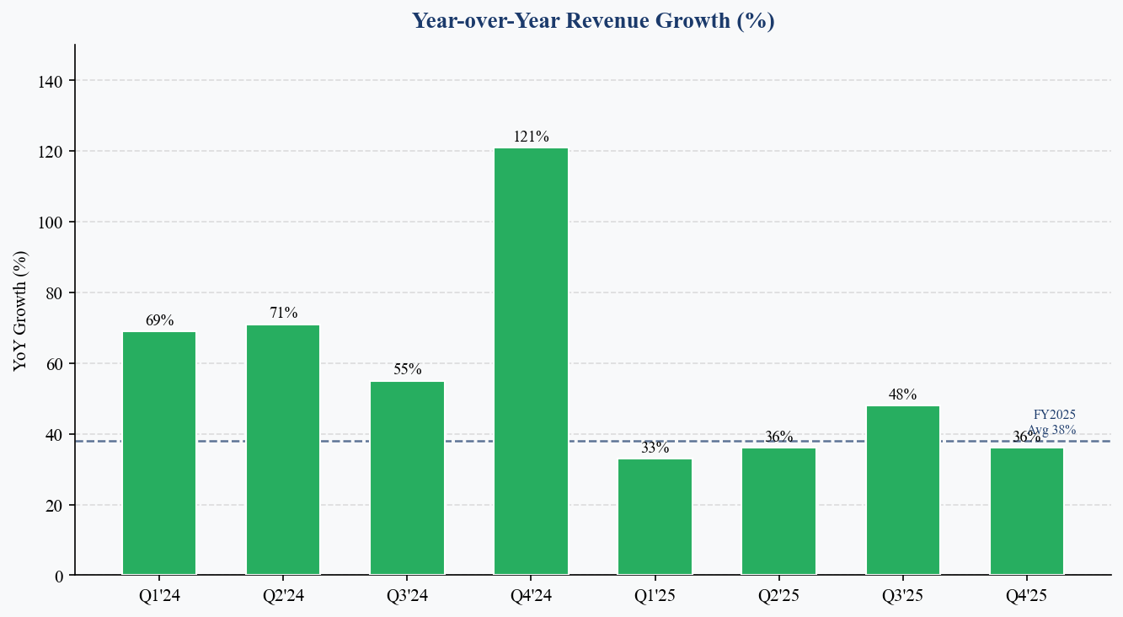
Figure 10: YoY Revenue Growth by Quarter | Source: Rocket Lab press releases
UPDATED ESTIMATES
Metric | FY2024A | FY2025A | FY2026E | FY2027E
Revenue | $436.2M | $601.8M | ~$885M | ~$1.15B
YoY Growth | +78% | +38% | +47% | +30%
Gross Margin | ~27% | ~35% | ~37% | ~40%
Adj. EBITDA | ($91M) | ($106M)E | ~Break-even | Positive
Electron Lchs | 16 | 21 | ~24–26 | ~28–32
VALUATION FRAMEWORK
At the current price of $70.05 (live via yfinance at report generation), Rocket Lab trades at approximately 6.5–7.0x EV/Revenue on FY2026E — a premium multiple appropriate for a high-growth, vertically integrated space infrastructure company with improving margin trajectory. We use an EV/Revenue-based approach given the pre-profitability stage.
Our 12-month price target of $35.00 is based on a blended 8.0x EV/FY2026E revenue ($885M) less net debt, implying ~50% upside from current levels. We apply a premium multiple vs. pure-play launch peers (e.g., Astra) given RKLB's proven execution, diversified revenue base, and unique prime contracting capability.
SCENARIO ANALYSIS
Scenario | Rev Multiple | FY2026E Rev | Implied Price Target | Upside/Downside
Bear | 5.0x EV/Rev | $810M | ~$22 | ~-10%
Base | 8.0x EV/Rev | $885M | ~$35 | ~+50%
Bull | 11.0x EV/Rev | $950M | ~$50 | ~+115%

MAINTAIN BUY | PRICE TARGET: $35.00
Q4 2025 results demonstrate that Rocket Lab's core business — Electron launch services and Space Systems — is executing at a high level. Gross margin expansion, record backlog, and above-guidance EBITDA performance all reinforce the quality of the business. The Neutron delay is a meaningful negative, but we believe the market has already partially discounted this risk. We maintain our BUY rating with a $35 price target, representing approximately 50% upside.

SOURCES
- Rocket Lab Q4 & FY2025 Earnings Press Release (Feb 26, 2026)
- Rocket Lab Q4 2025 Earnings Call Transcript (Motley Fool)
- Rocket Lab Q4 2025 Earnings Call Transcript (Seeking Alpha)
- Rocket Lab Q4 2025 Earnings Highlights (Yahoo Finance)
- Rocket Lab Q4 2025 Revenue Hits $180M, Backlog $1.85B (StockTitan)
- Rocket Lab Q3 2025 Financial Results — Prior Quarter Reference (GlobeNewswire)
- RKLB Revenue History (MacroTrends)
- Market Data: yfinance (live at report generation time)

Analyst Consensus: Bloomberg / FactSet as of February 2026. Estimates marked 'E' are analyst consensus. Price target and rating reflect analyst's independent assessment and may differ from consensus.
Disclosures: This report is for informational purposes only and does not constitute investment advice. Past performance is not indicative of future results.

