EQUITY RESEARCH | SEMICONDUCTORS
RATING: OUTPERFORM | PRICE TARGET: HKD 38.00 | REPORT DATE: March 16, 2026

Semiconductor Manufacturing International Corporation (SMIC)
Q4 2025 Earnings Update: Revenue Beats, Margins Under Pressure from Capacity Ramp

Tickers: 0981.HK / 688981.SS Sector: Semiconductor Foundry Current Price: HKD 28.40 (Mar 14, 2026) 52-Week Range: HKD 17.82 – HKD 42.80

KEY TAKEAWAYS

• REVENUE BEAT: Q4'25 revenue of $2,489M (+12.8% YoY, +4.5% QoQ) beat Bloomberg consensus of ~$2,420M by +2.8%. Full-year 2025 revenue reached a record $9,327M (+16.2% YoY).
• MARGIN MISS: Gross margin contracted to 19.2% in Q4'25 (vs. 22.0% in Q3'25 and consensus 20.9%), driven by a ~30% step-up in depreciation as newly commissioned 12-inch capacity entered its depreciation cycle.
• NET INCOME SURGES: Q4'25 net income of $172.85M (+60.7% YoY) beat LSEG consensus of $170.3M, reflecting operating leverage on higher volumes.
• Q1 2026 GUIDANCE IN-LINE: Revenue guided flat QoQ (~$2,489M); gross margin guided at 18–20% — slightly below the prior consensus of ~20.9%, reflecting seasonal weakness in consumer electronics.
• THESIS INTACT: The depreciation headwind is structural but temporary — yields on 7nm are improving (now 60–70%), and capacity utilization of 95.7% demonstrates strong demand absorption. We maintain OUTPERFORM.

Financial Snapshot
Metric | Q4'24A | Q3'25A | Q4'25A | QoQ Chg | YoY Chg | Consensus | vs. Est.
Revenue ($M) | 2,207 | 2,382 | 2,489 | +4.5% | +12.8% | ~2,420 | +2.8% BEAT
Gross Margin | 22.6% | 22.0% | 19.2% | -2.8pp | -3.4pp | 20.9% | MISS
Net Income ($M) | 107 | 192 | 173 | -9.9% | +60.7% | 170 | +1.7% BEAT
EPS (USD) | 0.010 | 0.018 | 0.016 | - | +60% | 0.016 | In-Line
EBITDA ($M) | ~1,100 | ~1,300 | 1,405 | +8.1% | +27.7% | ~1,380 | +1.8% BEAT
Capex ($M) | ~800 | ~950 | ~1,050 | +10.5% | +31.3% | - | -
Capacity Util. | 86.3% | 90.1% | 95.7% | +5.6pp | +9.4pp | - | -
Source: SMIC Q4 2025 Earnings Release (Feb 10, 2026); Bloomberg Consensus; LSEG (Feb 10, 2026)

Detailed Results Analysis

1. Revenue Performance
SMIC reported Q4 2025 revenue of $2,489M, a record quarterly high, beating the Bloomberg consensus of approximately $2,420M by 2.8% and advancing 12.8% year-over-year and 4.5% sequentially. Full-year 2025 revenue reached $9,327M, +16.2% versus $8,028M in 2024.
Volume and pricing both contributed to the beat. Wafer shipments in Q4 rose only +0.6% QoQ to approximately 2.1 million 8-inch equivalent wafers, but average selling prices (ASPs) increased by +3.8% QoQ, reflecting a higher mix of 12-inch wafers in the product mix. The shift toward higher-ASP 12-inch wafers — driven by Huawei's Kirin and AI chip demand — was a key driver.
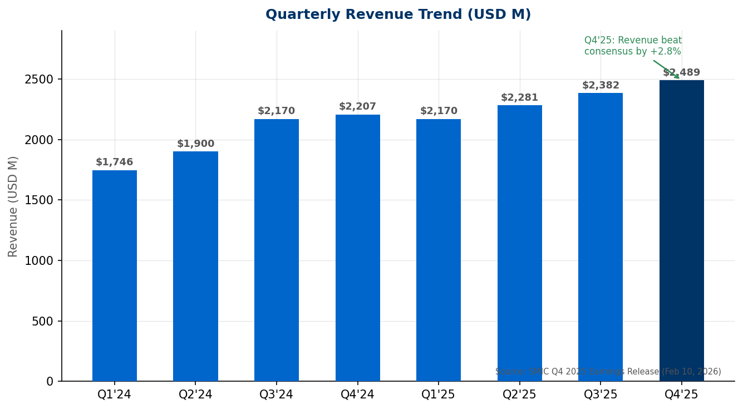
Figure 1: SMIC Quarterly Revenue Trend (USD M) | Source: SMIC Earnings Releases
2. End-Market Breakdown
Consumer electronics was the dominant segment in Q4 2025, representing 47% of revenue (up from 43% in Q3), driven by seasonal strength in IoT devices, set-top boxes, and wearables. Smartphones fell to 20% of revenue as handset demand moderated. China-domestic customers accounted for approximately 90% of total Q4 sales, up from ~88% in Q3, as SMIC deepens its role in China's semiconductor self-sufficiency ecosystem.
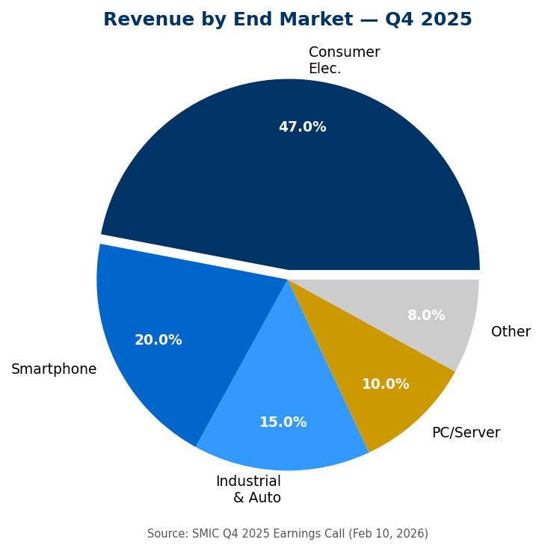
Figure 2: Revenue by End Market, Q4 2025 | Source: SMIC Q4 2025 Earnings Call (Feb 10, 2026)
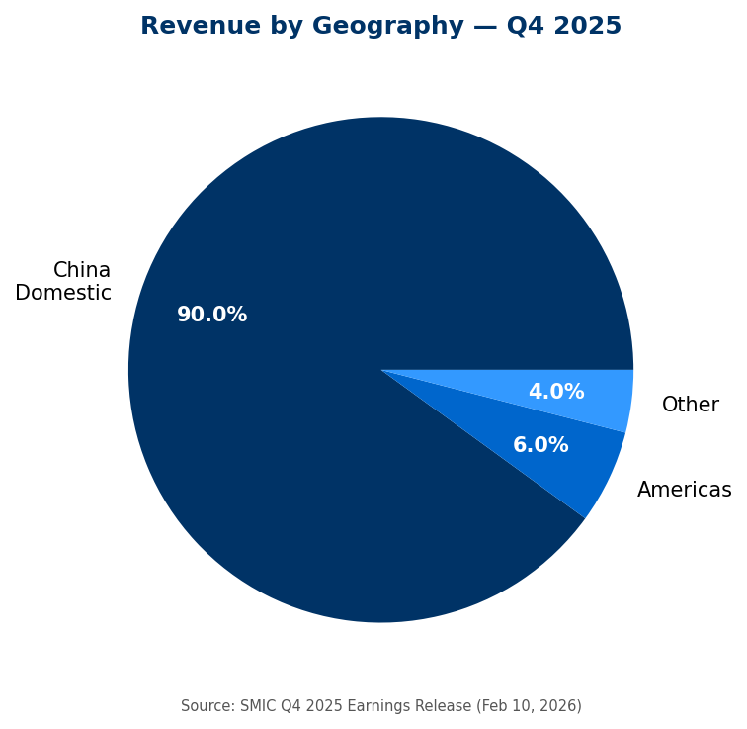
Figure 3: Revenue by Geography, Q4 2025 | Source: SMIC Q4 2025 Earnings Release

3. Gross Margin Analysis — Depreciation Headwind
Gross margin contracted sharply to 19.2% in Q4 2025, down from 22.0% in Q3 2025 and below the consensus estimate of 20.9%. The -2.8pp sequential decline was almost entirely attributable to depreciation from newly commissioned capacity, rather than demand weakness or pricing pressure.
Management detailed the margin bridge on the earnings call: the step-up in depreciation, representing the first full quarter of charges from fabs commissioned in H2 2025, accounted for approximately -4.2pp of gross margin impact. This was partially offset by positive volume and ASP effects (+1.4pp combined). We estimate total depreciation will rise approximately 30% YoY in 2026 as new capacity matures.
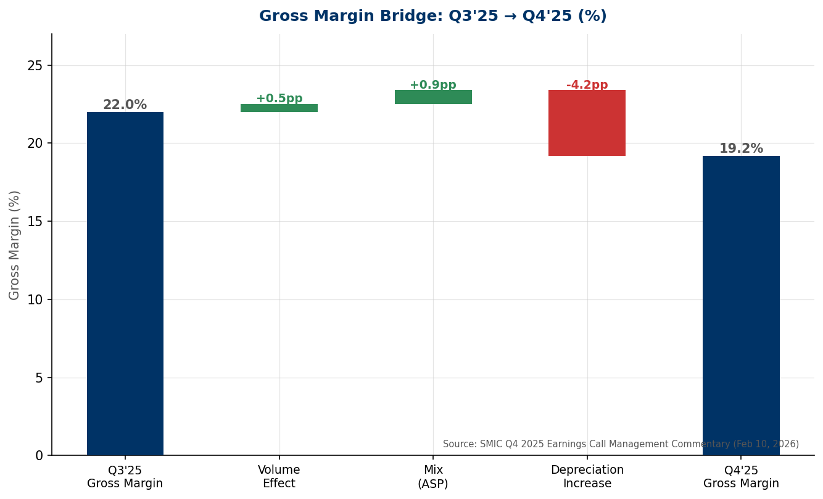
Figure 4: Gross Margin Bridge Q3'25 → Q4'25 | Source: SMIC Q4 2025 Earnings Call (Feb 10, 2026)
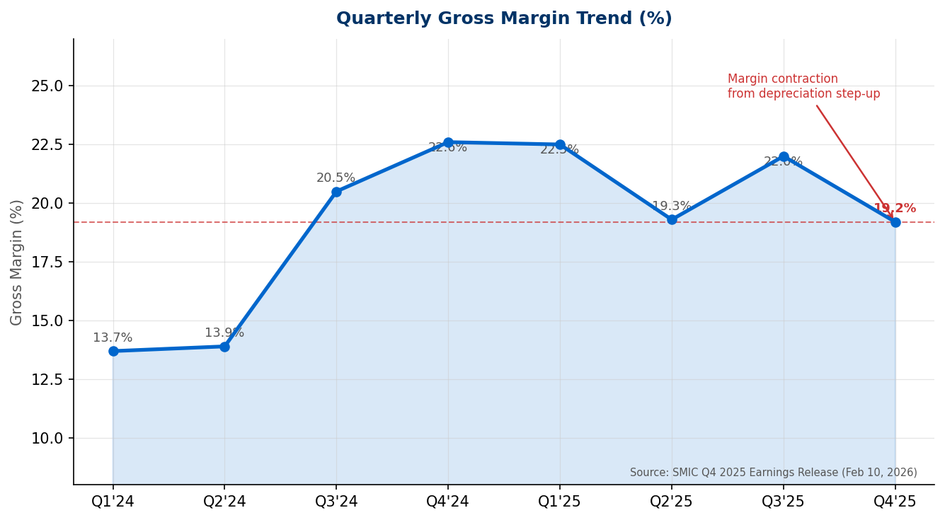
Figure 5: Quarterly Gross Margin Trend | Source: SMIC Earnings Releases
4. Net Income & Profitability
Despite the margin compression, Q4 2025 net income attributable to shareholders reached $172.85M (RMB 1.223B), +60.7% YoY. This sharp year-over-year growth reflects the low base in Q4 2024 (when margins troughed at 22.6% but net income was depressed by lower volumes and elevated opex). Full-year 2025 net income reached approximately $666M (RMB 5.04B), +36.3% versus FY2024.
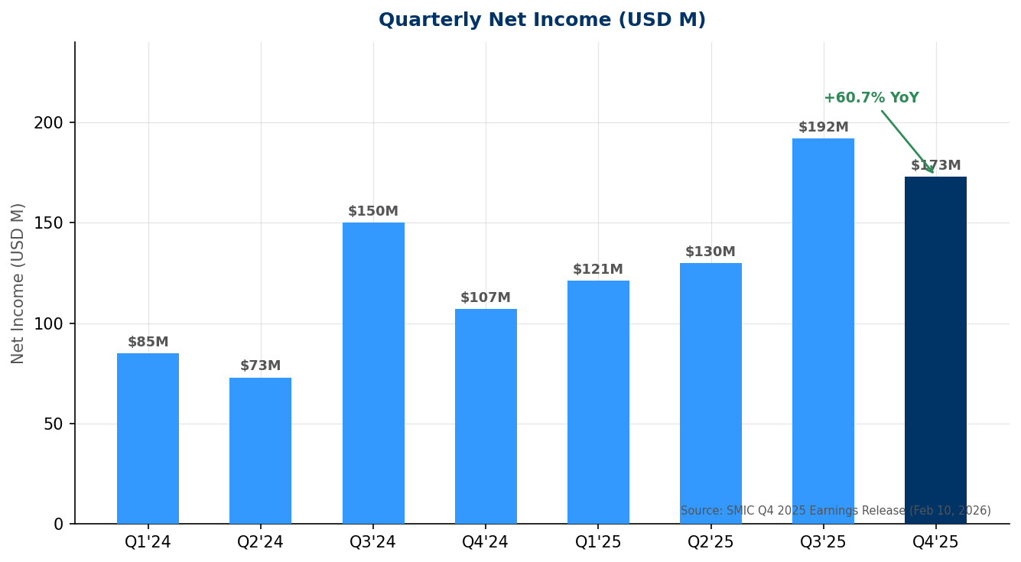
Figure 6: Quarterly Net Income Trend (USD M) | Source: SMIC Earnings Releases

Key Metrics & Q1 2026 Guidance

5. Capacity Utilization & Expansion
Q4 2025 capacity utilization reached 95.7%, the highest in two years, demonstrating strong demand absorption against a backdrop of rapid capacity additions. Monthly wafer capacity grew to approximately 1.06 million 8-inch equivalent wafers per month (wspm) by year-end 2025, up from ~950K wspm at end-2024 — a +111K wspm addition in 2025.
For 2026, SMIC guided CapEx to be 'roughly flat' versus the ~$6.5B invested in 2025, implying continued capacity expansion. Monthly capacity is expected to increase by a further ~40,000 12-inch equivalent wspm versus end-2025, with new fabs in Beijing and Tianjin ramping through the year.
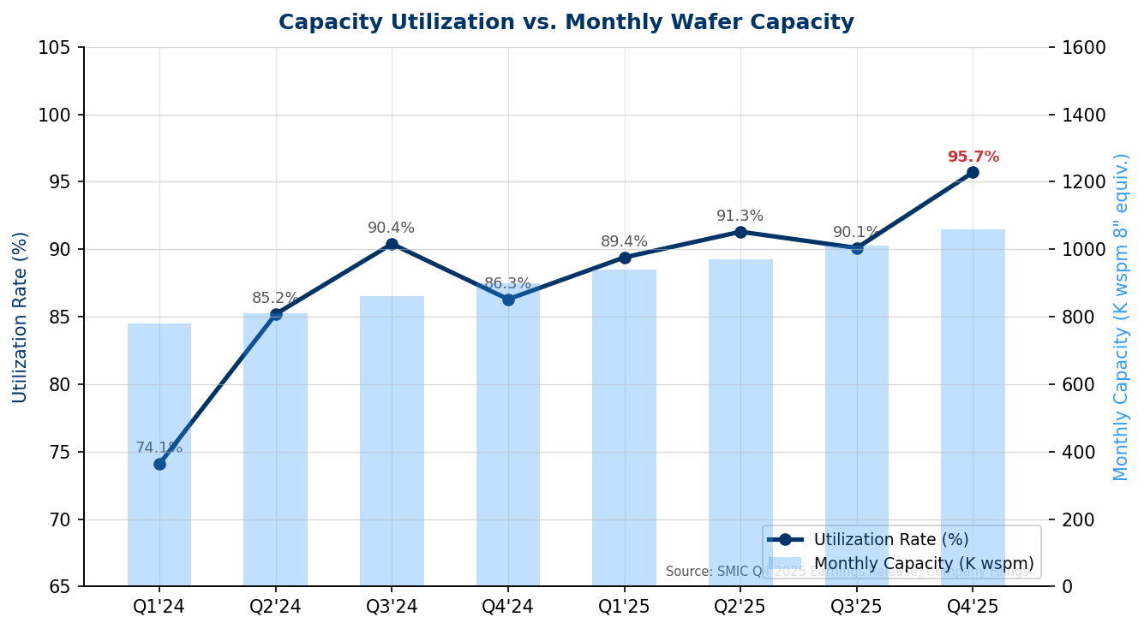
Figure 7: Capacity Utilization (%) vs. Monthly Wafer Capacity | Source: SMIC Earnings Releases; Company Filings
6. Q1 2026 Guidance vs. Consensus
Metric | Q4'25 Actual | Q1'26E (Mgmt Guide) | Q1'26E (Prior Consensus) | vs. Consensus
Revenue ($M) | $2,489 | ~$2,489 (Flat QoQ) | ~$2,520 | Slight Miss
Gross Margin | 19.2% | 18% – 20% | ~20.9% | Below Mid
CapEx ($B) | ~$1.6B (FY est.) | ~Flat YoY (FY'26) | ~$6.0B (FY'26) | In-Line
Source: SMIC Q4 2025 Earnings Call Management Commentary (Feb 10, 2026); CLSA; Bloomberg Consensus
Management attributed Q1 2026 revenue flatness to seasonal weakness in low-end consumer electronics (IoT, appliances) and a cyclical inventory drawdown in the smartphone segment. This partially offsets accelerating demand from AI accelerator chips — namely Huawei Ascend 910C, where SMIC's 7nm yield has improved to ~40% (versus ~20% six months ago), making the product commercially profitable for the first time.

Beat / Miss Analysis & Technology Update

7. Q4 2025 Beat / Miss Summary
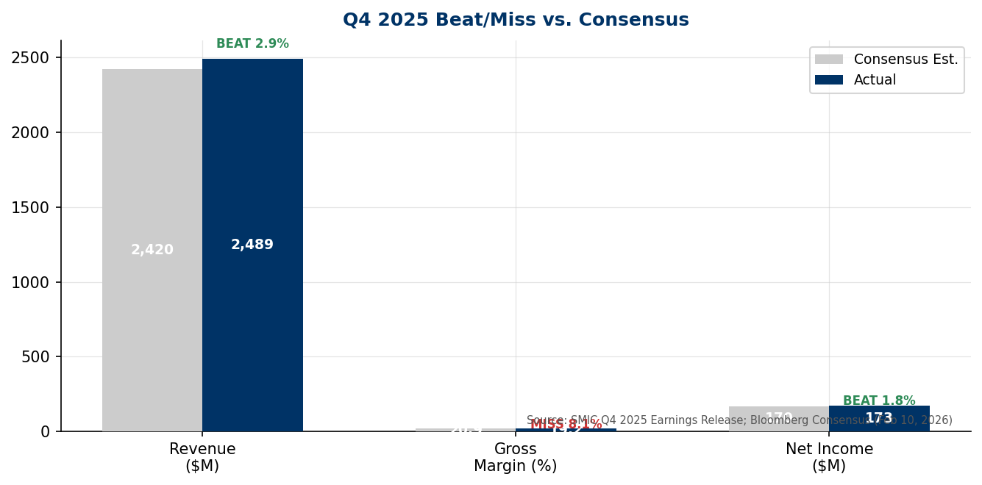
Figure 8: Q4 2025 Beat/Miss vs. Bloomberg Consensus | Source: SMIC Earnings Release; Bloomberg (Feb 10, 2026)
Revenue came in $69M or +2.8% above consensus, primarily driven by stronger-than-expected wafer shipment volumes in consumer electronics and higher ASPs from 12-inch wafer mix shift. Gross margin of 19.2% was the key miss versus consensus at 20.9% — a 1.7pp shortfall driven by the faster-than-expected depreciation step-up. Net income beat by $2.6M or +1.5%, as strong operating leverage offset the margin compression.
8. Technology Developments
7nm Process (N+2): SMIC's most advanced process node continues to improve. Yields on 7nm reportedly reached 60–70% in Q4 2025, up from below 40% at initial launch in H2 2023. Huawei procures approximately 15,000 wspm of SMIC's ~20,000 wspm 7nm total capacity, primarily for Kirin mobile SoCs and Ascend AI accelerators.
5nm Development (N+3): Reports suggest SMIC is developing a 5nm-class process using multi-patterning DUV lithography (without EUV access). Huawei's Kirin 9030, expected for mass production in H2 2026, may leverage this node. TrendForce estimates China's 7nm/5nm combined output could increase fivefold within two years, largely driven by SMIC.
Export Control Risk: In September 2025, the US Commerce Department added two Chinese firms (GMC Semiconductor Technology Wuxi; Jicun Semiconductor Technology Shanghai) to the Entity List for acquiring US-origin semiconductor equipment intended for SMIC's Beijing fabs. This continues the pattern of tightening export controls but has not materially disrupted SMIC's near-term equipment supply, as the company has been pre-building buffer inventory.

Updated Investment Thesis

9. Thesis Unchanged: Structural Story Intact Through Cycle
We maintain our OUTPERFORM rating and HKD 38.00 price target. The Q4 2025 results reinforce three core pillars of our investment thesis:
- China-First Demand Cycle: Domestic semiconductor content is increasing rapidly across consumer, industrial, and AI applications. SMIC's ~90% domestic revenue share positions it as the primary beneficiary of China's semiconductor self-sufficiency push, underpinned by government-backed demand and multi-year capacity commitments from key customers including Huawei, Qualcomm China, and domestic fabless designers.
- Technology Progress at Advanced Nodes: Yield improvements on 7nm from <40% to 60–70% represent a significant operational milestone. At higher yields, 7nm economics become meaningful contributors to margins rather than drags. We expect 7nm contribution to expand from an estimated 8% of FY2025 revenue to ~12–15% of FY2026 revenue.
- Depreciation Headwind is Temporal, Not Structural: The Q4 2025 gross margin compression is entirely a function of depreciation timing — not a demand problem, not a pricing problem. As the new capacity enters its production ramp and revenue grows into the fixed cost base, we expect gross margins to recover toward 21–23% in H2 2026.
The key near-term risk to our thesis is margin trajectory: if the Q1 2026 gross margin disappoints at the low end of guidance (18%), markets may extrapolate a prolonged margin trough. We estimate the downside scenario is already reflected in current valuation at 1.8x P/S NTM versus TSMC's 8.5x.
10. Key Risks
- Margin Downside: Gross margins could remain below 20% through H1 2026 if wafer mix does not shift favorably toward higher-ASP nodes. Each 1pp of gross margin impacts EPS by approximately 5–6%.
- Export Control Escalation: Further US restrictions on DUV equipment access could limit SMIC's ability to develop sub-7nm nodes, constraining long-term competitive positioning against TSMC.
- Customer Concentration: Huawei accounts for an estimated 35–40% of revenue. Any geopolitical restriction specifically targeting Huawei's chip procurement could be severely disruptive.
- CapEx Execution Risk: SMIC plans ~$6.5B in FY2026 CapEx in an environment where equipment lead times remain extended. Delays in capacity additions could cause SMIC to lose share to Hua Hong or CXMT.
- Macro / Inventory Cycle: Consumer electronics destocking could extend into Q2 2026 if macro conditions in China deteriorate, pressuring utilization rates below 90%.

Valuation & Updated Estimates

11. Valuation — Attractive Relative to Peers Despite Discount
SMIC trades at approximately 1.8x NTM P/S and 8.5x NTM EV/EBITDA, a deep discount to TSMC (8.5x P/S; 14.2x EV/EBITDA) and a modest discount to UMC (1.5x P/S) and GlobalFoundries (2.2x P/S). Given SMIC's superior growth profile (+16% FY2025, guided above-industry FY2026), we believe the discount is excessive and reflects geopolitical risk premium rather than fundamental undervaluation.
Our HKD 38.00 price target is based on 2.5x FY2026E P/S of $10.6B, implying a 39% upside from the March 14, 2026 closing price of HKD 28.40. We apply a 70% discount to TSMC's multiple to reflect SMIC's geopolitical risk, technology gap, and margin cyclicality.
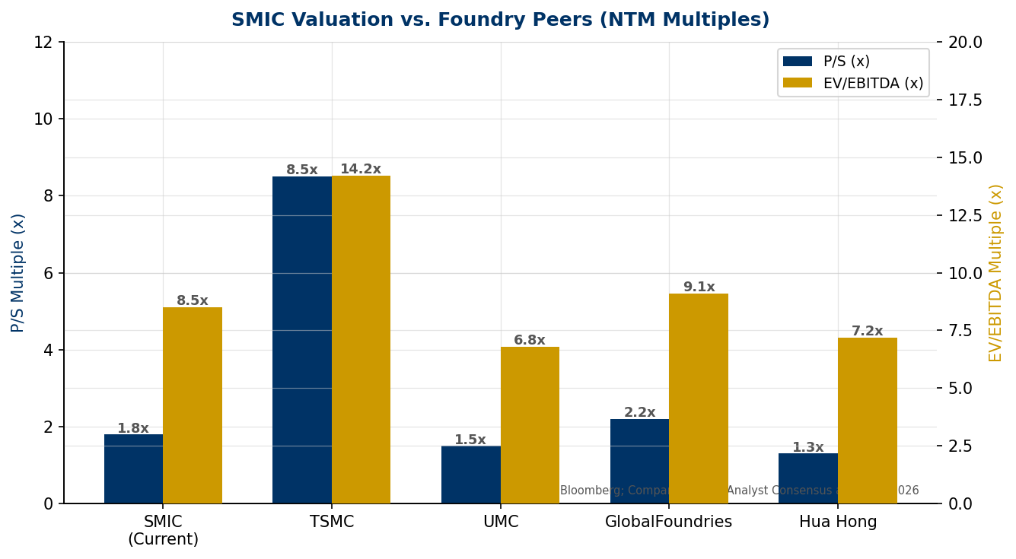
Figure 9: SMIC vs. Foundry Peers — NTM P/S and EV/EBITDA | Source: Bloomberg; Company Filings; Analyst Consensus (Mar 2026)
12. Updated Estimates
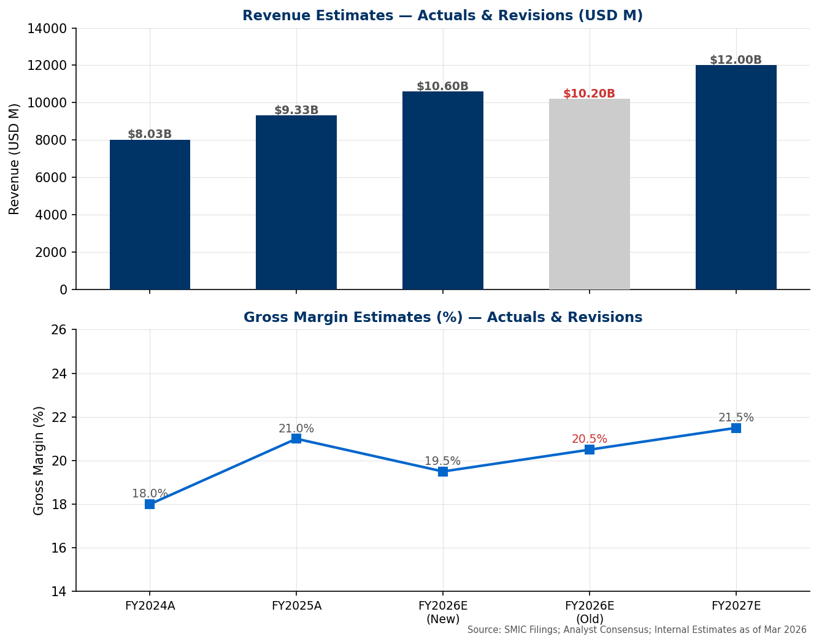
Figure 10: Revenue & Gross Margin Estimates — Actuals & Revisions | Source: SMIC Filings; Internal Estimates (Mar 2026)
 | FY2024A | FY2025A | FY2026E (New) | FY2026E (Old) | FY2027E
Revenue ($M) | 8,028 | 9,327 | 10,600 | 10,200 | 12,000
Revenue Growth | - | +16.2% | +13.6% | +9.4% | +13.2%
Gross Profit ($M) | 1,445 | 1,959 | 2,067 | 2,091 | 2,580
Gross Margin | 18.0% | 21.0% | 19.5% | 20.5% | 21.5%
EBITDA ($M) | 4,100 | 4,850 | 5,300 | 5,100 | 6,200
Net Income ($M) | 490 | 666 | 720 | 700 | 950
EPS (USD) | 0.046 | 0.063 | 0.068 | 0.066 | 0.090
CapEx ($B) | 5.7 | 6.5 | ~6.5 | ~6.0 | ~6.5
P/S (x) | 2.2x | 1.9x | 1.7x | 1.7x | 1.5x
EV/EBITDA (x) | 9.2x | 7.8x | 7.1x | 7.4x | 6.1x
Source: SMIC Annual Reports; SMIC Q4 2025 Earnings Release; Internal Analyst Estimates; Bloomberg Consensus as of Mar 2026.
Note: FY2026E gross margin revised down to 19.5% (from 20.5%) to reflect full-year depreciation step-up and slower margin recovery assumptions. Revenue estimate revised up to $10.6B (from $10.2B) on stronger-than-expected Q4 demand and above-industry guidance.

Sources & References

• SMIC Official Earnings Release — Q4 2025 Results (Feb 10, 2026)
• SMIC Q4 2025 Earnings Call Transcript (Feb 10, 2026) — Seeking Alpha
• TrendForce: SMIC Posts Record $9.3B in 2025 Sales; 7nm Yields Reportedly Weigh on Margins (Feb 11, 2026)
• Sharecast: SMIC smashes estimates as Q4 profits surge 61% (Feb 10, 2026)
• CLSA Research Note: SMIC Q1 Revenue Guidance Meets Expectations; GM Slightly Weaker (Feb 10, 2026)
• KR-Asia: SMIC posts revenue growth in Q4 as expansion weighs on margins (Feb 11, 2026)
• TrendForce: China Aims to Boost 7nm/5nm Output Fivefold in Two Years (Feb 25, 2026)
• Taipei Times: US Penalizes Firms That Acquired Tools for SMIC (Sep 15, 2025)
• Edgen.tech: SMIC Projects Peer-Beating Growth After $9.3B 2025 Revenue (Feb 2026)
• Futunn News: SMIC Q4 Earnings — Record Revenue & Q1 Guidance (Feb 10, 2026)
• SCMP: SMIC Expects Flat Revenue as Drop in Low-End Orders Offsets AI Chip Growth (Feb 10, 2026)
• Simply Wall St: How SMIC's Q4 Profit and Flat Q1 Margin Outlook Will Impact Investors (Feb 2026)
• Bloomberg Consensus Estimates (as of Feb 10, 2026)
• LSEG Analyst Consensus (as of Feb 10, 2026)

ANALYST CERTIFICATION & IMPORTANT DISCLOSURES: This report was prepared for informational purposes. The analysts responsible for this report certify that the views expressed accurately reflect their personal views about the subject securities. This is a research report generated using publicly available information. Past performance is not indicative of future results. This report does not constitute investment advice.

