EQUITY RESEARCH | URANIUM & CRITICAL MINERALS
Energy Fuels Inc. (UUUU / EFR.TSX)
Q4 & Full Year 2025 Earnings Update | Rating: BUY (Consensus) | Price Target: $27.25 (H.C. Wainwright)
Date: March 17, 2026 | Reporting Date: February 26–27, 2026 | Current Price: ~$18.67 | Market Cap: ~$4.51B

Investment Summary
Energy Fuels (UUUU) reported Q4 and full year 2025 results on February 26–27, 2026. The company delivered a breakout year operationally — mining 1.72M lbs U3O8 (exceeding guidance by ~11%), processing 1.015M lbs of finished uranium, and closing a landmark $700M convertible note offering that lifted working capital to ~$927M. Revenue came in at $27.1M for Q4 and $65.9M for FY2025, down from $78.1M in 2024 due to the winding down of Kwale HMS operations. The net loss widened to $86.1M ($0.38/share) as the company absorbs costs of an aggressive multi-front growth strategy spanning uranium, rare earth elements (REE), heavy mineral sands (HMS), and medical isotopes.
Key positives: uranium COGS/lb fell from $53 to $43; six long-term contracts secured through 2032; dysprosium oxide pilot production validated by South Korean automotive manufacturers; Phase 2 REE feasibility study shows $1.9B NPV ($410M capex); and management succession secured (Ross Bhappu becomes CEO April 15, 2026). On the negative side, Q4 EPS of ($0.08) missed consensus of ($0.07) by $0.01.
Key Metrics Snapshot
Metric | Q4 2025 | Q4 2024 | FY2025 | FY2024
Total Revenue ($M) | $27.1 | $39.9 | $65.9 | $78.1
Uranium Revenue ($M) | ~$27.1 | ~$12.6 | $48.2 | $37.9
Heavy Mineral Sands ($M) | — | ~$27.3 | $15.8 | $39.9
Net Income/(Loss) ($M) | ($20.9) | ($28.8) | ($86.1) | ($47.8)
EPS (Basic) | ($0.08) | ($0.19) | ($0.38) | ($0.28)
EPS vs Consensus | Miss ($0.01) | Miss ($0.12) | — | Miss ($0.18)
Revenue vs Consensus | +$0.1M Beat | — | — | —
Uranium Sold (klbs) | 360 | ~150 | 650 | 450
Avg Realized Price ($/lb) | $74.93 | ~$84.0 | $74.21 | $87.2
Working Capital ($M) | — | — | $927.4 | $170.9
Sources: Energy Fuels press releases (Feb 26, 2026; Dec 29, 2025); Zacks; H.C. Wainwright research.
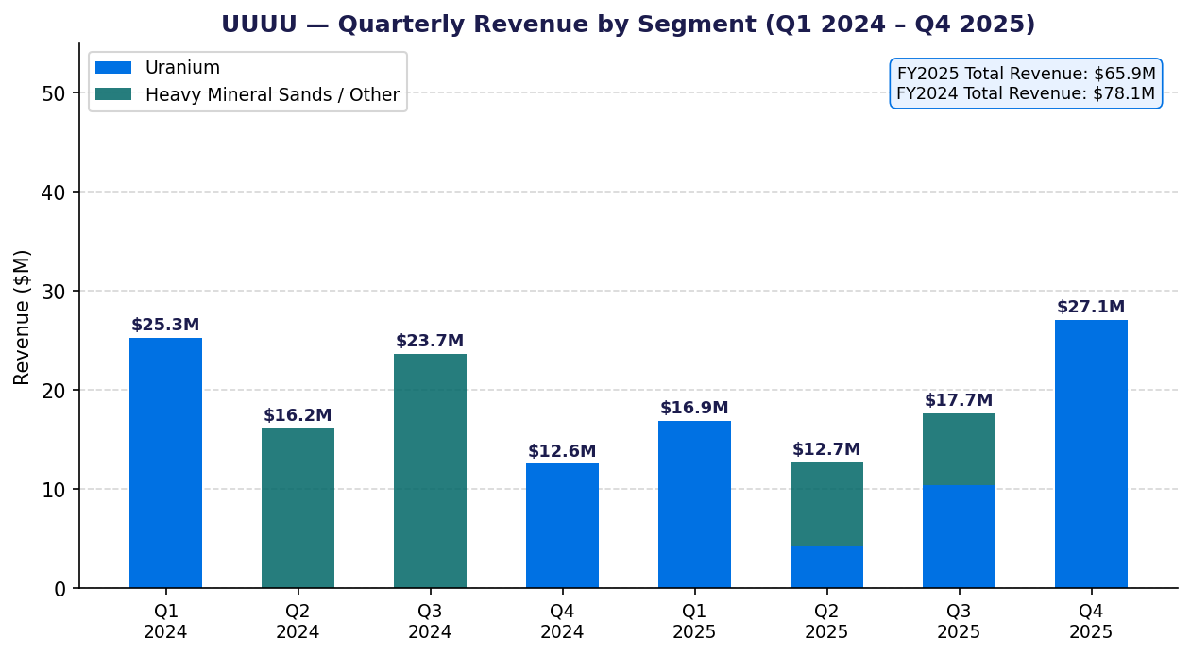
Chart 1: UUUU Quarterly Revenue by Segment (Q1 2024 – Q4 2025)

1. Q4 2025 Detailed Financial Results
Revenue & Earnings
Q4 2025 total revenue was $27.1M, a beat of $0.1M (+0.38%) vs the Zacks consensus estimate of $27.0M. This compares to $39.9M in Q4 2024, with the decline entirely attributable to the cessation of Kwale Heavy Mineral Sands (HMS) mine operations (which concluded reclamation activities at year-end 2024). Uranium concentrates drove essentially all Q4 2025 revenue.
- Uranium revenue Q4 2025: ~$27.0M (360,000 lbs × $74.93/lb weighted average realized price)
- Heavy mineral sands revenue Q4 2025: Minimal / nil (Kwale HMS ceased production)
- Vanadium revenue: $0 (905,000 lbs V2O5 held in inventory, not sold — awaiting improved market conditions)
- REE/NdPr oxide revenue: minimal at pilot-scale; no commercial REE sales revenue booked in Q4 2025

EPS & Net Income
Q4 2025 net loss was approximately ($20.9M), or ($0.08) per diluted share, versus the consensus estimate of ($0.07) — a miss of $0.01/share. This compares favorably to Q4 2024's loss of ($28.8M) or ($0.19)/share, reflecting improved uranium unit economics despite higher corporate costs associated with the convertible note offering and ramp-up investments.
- Q4 2025 EPS: ($0.08) actual vs ($0.07) consensus → MISS by $0.01
- Q4 2024 EPS: ($0.19) | Q3 2025 EPS: ($0.07) | Q2 2025 EPS: ($0.10)

Uranium Operations — Q4 2025
The uranium segment was the primary driver of Q4 2025 performance, with the White Mesa Mill operating its conventional ore processing campaign (commenced Q4 2025, expected to continue through Q2 2026). The mill demonstrated an ability to average ~250,000 lbs/month, including 350,000 lbs of finished U3O8 produced in December 2025 alone.
Metric | Q4 2025 | Q3 2025 | Q2 2025 | Q1 2025
Uranium Sold (klbs) | 360 | 240 | ~150 | ~50
Avg Realized Price ($/lb) | $74.93 | $69.6 (est.) | $79.0 (est.) | $80.0 (est.)
Uranium Revenue ($M) | ~$27.0 | ~$10.4 | ~$4.2 | ~$7.0
Spot Sales (klbs) | N/A Q4 | — | — | —
Contract Sales (klbs) | N/A Q4 | — | — | —
COGS/lb (approx.) | ~$43 | ~$43 | ~$47 | ~$50
Note: Q2 and Q1 2025 uranium revenue estimated from total quarterly revenues net of HMS contribution.

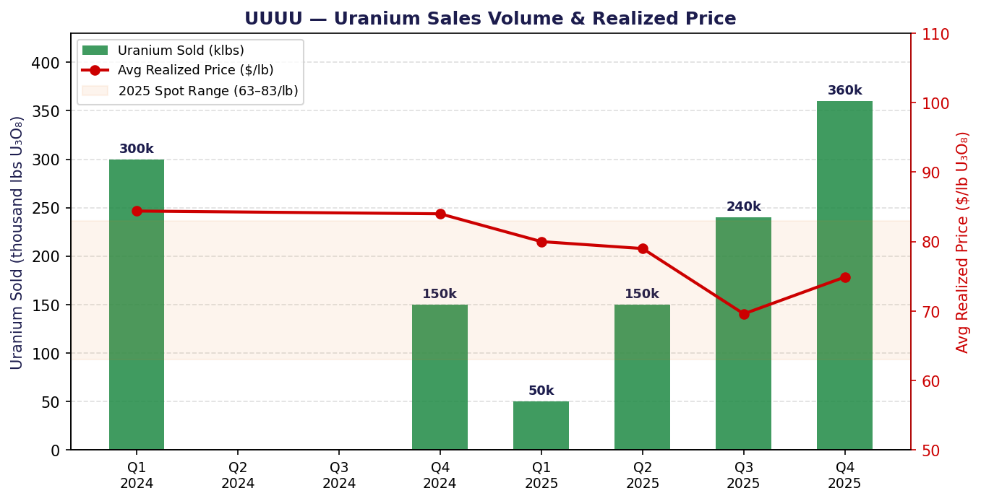
Chart 2: Uranium Sales Volume & Realized Price per Pound (Q1 2024 – Q4 2025)
Vanadium
Energy Fuels held 905,000 lbs of finished V2O5 in inventory as of Q3 2025 (no update to year-end 2025 inventory provided in the press release, implying no material sales). The company has elected to hold vanadium inventory and not sell below management's target price. No vanadium revenue was recognized in FY2025 (also $0 in FY2024). The vanadium inventory represents a meaningful optionality call on vanadium prices, which are currently around $6–7/lb.
Rare Earth Elements — Q4 2025 Milestones
No commercial REE revenue was booked in Q4 or FY2025 from separated rare earth oxides (beyond minimal pilot-scale production). However, the company achieved critical qualitative milestones:
- 29 kg of dysprosium (Dy) oxide produced at 99.9% purity at White Mesa Mill by Q3 2025
- Dy oxide validated by a major South Korean automotive manufacturer (permanent magnet use in EV motors)
- 1.2 MT of NdPr oxide manufactured into ~3.0 MT of rare earth permanent magnets powering ~1,500 EV vehicles
- First kilogram of terbium (Tb) oxide production targeted for early Q1 2026
- Inventory as of Q3 2025: 37,000 kg finished NdPr oxide; 9,000 kg Sm+ heavy REE carbonate

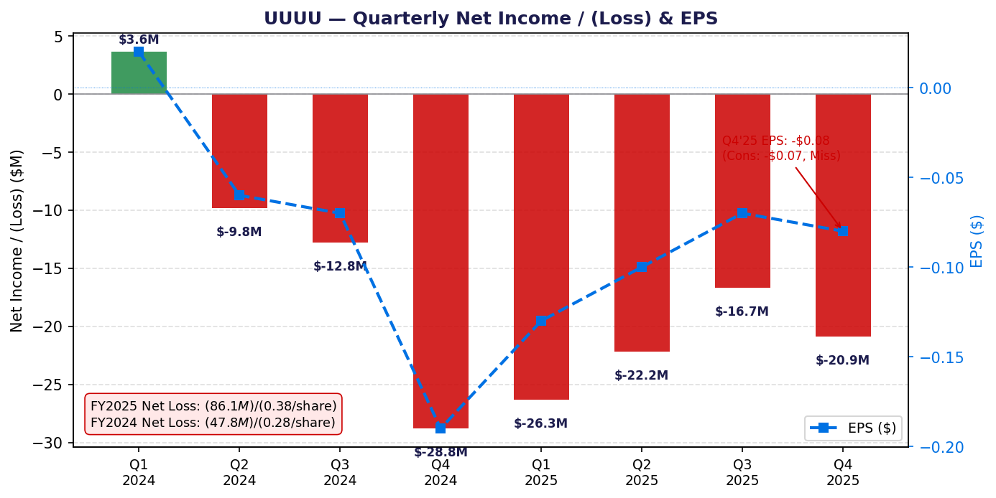
Chart 3: Quarterly Net Income/(Loss) & EPS (Q1 2024 – Q4 2025)
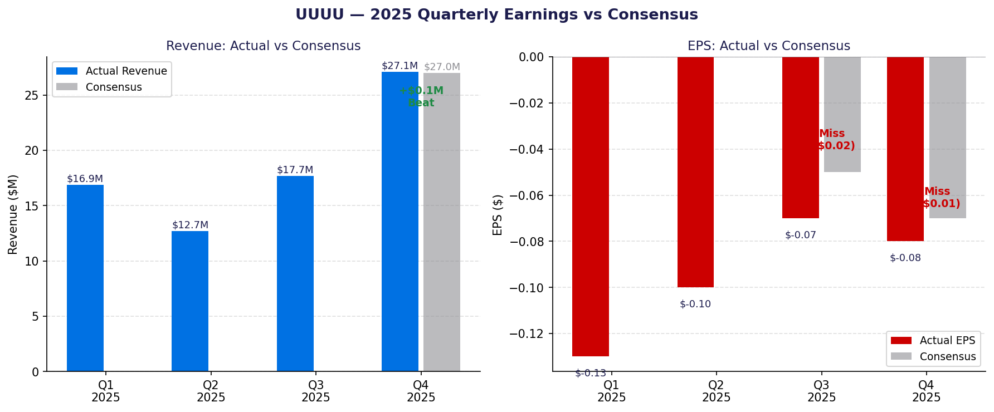
Chart 4: 2025 Quarterly Earnings vs Consensus Estimates

2. Full Year 2025 Financial Results
Income Statement Summary
 | FY2025 | FY2024 | Change | Notes
Total Revenue ($M) | $65.9 | $78.1 | –15.6% | Kwale HMS wind-down
Uranium Concentrates | $48.2 | $37.9 | +27.2% | 650k lbs @ $74.21/lb
Heavy Mineral Sands | $15.8 | $39.9 | –60.4% | Kwale final yr / Donald pending
Vanadium | $0 | $0 | — | 905k lbs held in inventory
REE / Other | ~$1.9 | ~$0.3 | — | Pilot-scale / minimal
Gross Profit ($M) | ~$20.3 | ~$28.2 | –28.0% | Uranium: ~42% GM
Operating Loss ($M) | (~$58M) | (~$19M) | — | SG&A + exploration + DD&A
Net Loss ($M) | ($86.1) | ($47.8) | –80.1% | Incl. conv. note offering costs
Net Loss per Share | ($0.38) | ($0.28) | –35.7% | Shares ~226M diluted
Source: Energy Fuels press release, February 26, 2026 (PRNewswire).

Uranium Segment — Full Year 2025
Metric | FY2025 | FY2024
Uranium Sold (klbs) | 650 | 450
Avg Realized Price ($/lb) | $74.21 | $87.2
— Spot Sales | 350k lbs @ $76.90/lb | 250k lbs @ $91.51/lb
— Contract Sales | 300k lbs @ $71.06/lb | 200k lbs @ $75.13/lb
Uranium Revenue ($M) | $48.2 | $37.9
COGS/lb (weighted avg) | ~$43 | ~$53
Gross Margin (uranium) | ~42% | ~56%
Mined ore (Mlbs U3O8) | 1.72 | 1.10
Processed/finished (Mlbs) | 1.015 | 0.55
Long-term contracts | 6 (through 2032) | 4

The FY2025 uranium segment demonstrates a clear positive trajectory: volumes sold increased 44% YoY, production nearly doubled, and unit costs fell meaningfully. While the realized price declined from $87.2/lb to $74.21/lb (reflecting the slide in uranium spot prices from 2024 peaks toward $63–$83/lb range in 2025), the economics remain robust at a ~42% gross margin.
Uranium Inventory Position (as of December 31, 2025)
Category | Lbs U3O8 | Notes
Mined ore / mineralized material | 1,240,000 | Underground and surface stockpile
Work-in-process | 130,000 | At White Mesa Mill
Finished U3O8 | 810,000 | Ready for delivery / sale
TOTAL | ~2,180,000 | ~2x End-2024 inventory of ~980k lbs

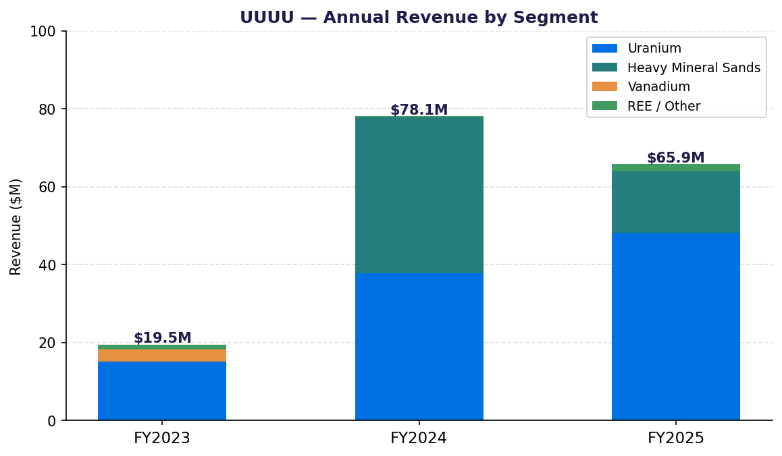
Chart 5: Annual Revenue by Segment (FY2023–FY2025)
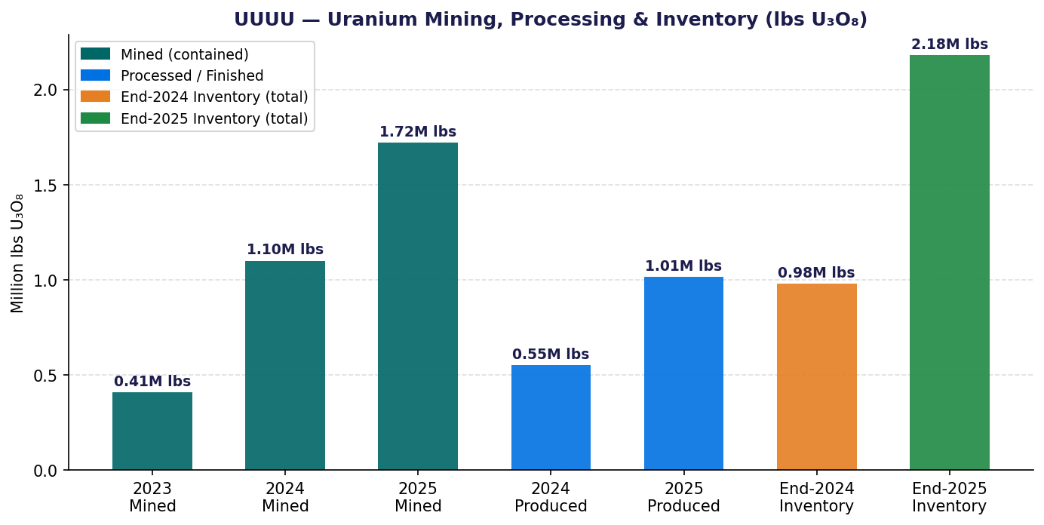
Chart 6: Uranium Mining, Processing & Inventory (lbs U3O8)
Balance Sheet (December 31, 2025)
Item | Dec 31, 2025 | Dec 31, 2024
Working Capital | $927.4M | $170.9M
Cash & Cash Equivalents | $64.7M | $38.6M
Marketable Securities | $797.1M | $80.9M
Total Cash & Securities | ~$861.8M | ~$119.5M
Trade Receivables | ~$22M (est.) | $37.8M
Inventory (all) | ~$100M+ (est.) | $66.5M
Total Assets | $1,410M | ~$470M
Total Liabilities | $729.3M | ~$0 (no debt)
Convertible Senior Notes | $700M @ 0.75% | —
Net Equity | ~$680M | ~$470M
The $700M convertible note offering (October 2025, 0.75% coupon, 7x+ oversubscribed, mature 2031) transformed the balance sheet. Initial conversion price: $20.34/share. With capped call overlays, the effective dilution threshold rises to $30.70/share (100% premium to issue price).
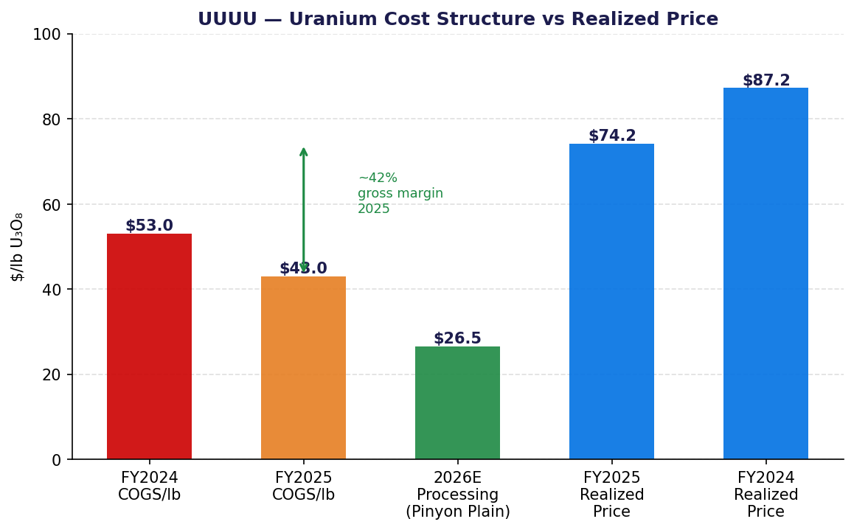
Chart 7: Uranium Cost Structure vs Realized Price
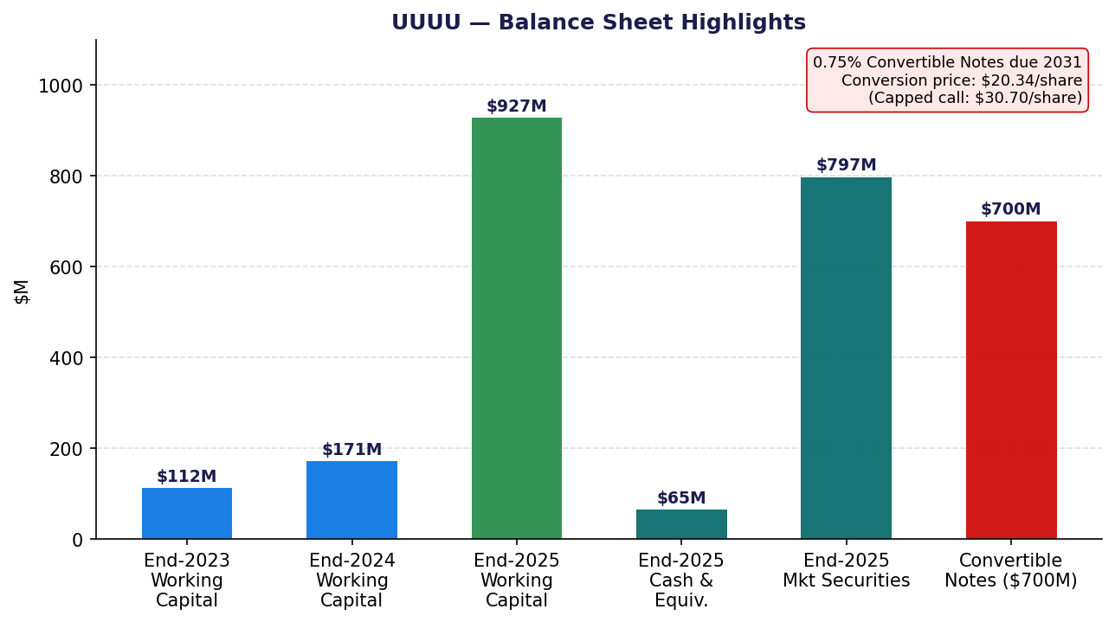
Chart 8: Balance Sheet Highlights

3. Uranium & REE Market Context
Uranium Spot Price — 2025 Trend
The uranium spot market was range-bound and under pressure for most of 2025, trading between $63/lb (April low) and $82–83/lb (September high) — a significant correction from the January 2024 peak of ~$106/lb. Key drivers of the 2025 decline included: (1) speculative unwinding of long positions that built during the 2023–2024 run-up; (2) secondary supply from enrichment underfeeding and inventory drawdowns by utilities; and (3) macro uncertainty under the Trump administration affecting policy outlooks.
In contrast, the long-term contract price steadily rose from ~$80/lb to ~$86/lb across 2025, reflecting robust utility demand for multi-year fuel supply security. This divergence — weak spot, firm long-term — actually benefits Energy Fuels, as it is selling under long-term contracts (300k lbs in FY2025 at $71.06/lb) and building inventory for future delivery.
Period | U3O8 Spot ($/lb) | LT Contract ($/lb) | Commentary
Jan 2024 | ~$106 | ~$68 | Post-Cameco/Kazatom supply fears peak
Q2 2024 | ~$85–90 | ~$73 | Gradual pullback begins
Q4 2024 | ~$78–82 | ~$78 | Convergence of spot & LT
Q1 2025 (Apr low) | ~$63–65 | ~$80 | 18-month low; LT > Spot
Q3 2025 (Sep high) | ~$82–83 | ~$84 | Partial recovery
Q4 2025 | ~$70–76 | ~$85 | Softening into year-end
Jan 2026 | ~$98–100 | ~$87 | Sharp recovery; near 2-year highs
Sources: UxC, TradeTech, Sprott Uranium Outlook 2026, ANS Nuclear Newswire.

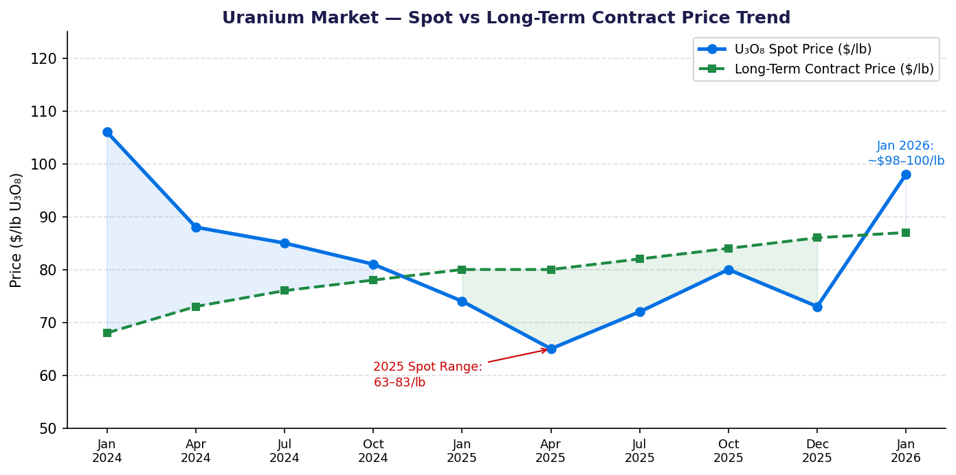
Chart 11: Uranium Spot vs Long-Term Contract Price Trend (2024–Jan 2026)
Structural Uranium Market Outlook
- Global uranium mine supply deficit of ~130M lbs/year; demand accelerating from new reactor builds and data centers
- 6 new nuclear reactors connected to the grid in 2024 (China-led); >60 reactors under construction globally
- US Prohibiting Russian-enriched uranium imports (2024 Prohibitions Act) structurally benefits domestic U.S. producers
- Uranium futures rose to ~$100/lb in January 2026 — highest since February 2024
- Energy Fuels is one of only 3 active U.S. uranium producers alongside Cameco-Cigar and enCore Energy

REE Market Context
Western rare earth supply chains remain critically concentrated in China, which controls ~85% of global REE processing. U.S. and allied government demand for domestic REE separation has accelerated, driven by defense/EV permanent magnet needs. Energy Fuels' White Mesa Mill is the only facility in the Western Hemisphere capable of producing separated heavy REEs (dysprosium, terbium) commercially outside China.
- NdPr oxide price: ~$50–60/kg (2025); Dy oxide: ~$300–360/kg; Tb oxide: ~$1,400–1,600/kg
- DOE and DOD are actively funding domestic REE supply chain development
- Energy Fuels' NdPr qualified by Samsung SDI-type permanent magnet manufacturer (South Korea)

4. Fiscal Year 2026 Guidance
Uranium Production & Sales
Metric | 2026 Guidance | FY2025 Actual | Change
Mined U3O8 (Mlbs) | 2.0–2.5 | 1.72 | +16% to +45%
Processed/Finished (Mlbs) | 1.5–2.5 | 1.015 | +48% to +146%
Uranium Sales (Mlbs) | 1.5–2.0 | 0.65 | +131% to +208%
Avg Cost of Finished Inv. ($/lb) | Low $30s (target) | ~$43 | –25%+ improvement
Uranium COGS ($/lb, Pinyon Plain) | $23–30 | ~$43 (blended) | Significant reduction
Mining / Transport | $10–14/lb | — | —
Milling | $13–16/lb | — | —
Long-term Contracts | 6 through 2032 | 6 | Stable

Management guided to a near-doubling of uranium sales volume in 2026, supported by: (1) continued Pinyon Plain high-grade ore processing at White Mesa; (2) potential restart of La Sal and Pandora mines; and (3) the 2.18M lb finished + in-process inventory entering 2026. The expected unit cost decline to the 'low $30s' implies gross margins could expand to 55%+ at current uranium prices (~$80–100/lb).
REE 2026 Targets
- Phase 1 (NdPr from monazite): ~850–1,000 tonnes NdPr/yr at full Phase 1B/1C capacity by 2027
- Heavy REE commercial separation: Dy, Tb, and potentially Sm capacity commissioned Q4 2026 at White Mesa
- Terbium oxide: First kilogram production targeted Q1 2026
- Feasibility study (Phase 2): $410M capex; 5,513 t NdPr + 165 t Dy + 48 t Tb/yr; NPV $1.9B; IRR 33%
- Phase 2 permitting: Begin 2026/2027; commissioning target late 2028 – early 2029

Capital Expenditure & Strategic
- Capex 2026: Not explicitly guided; focus on White Mesa REE circuit upgrades and mine development
- Donald Project (Australia, 49% JV with Astron): FID expected Q1 2026; AUD $520M total capex; AUD $80M EFA debt letter of support
- Donald target production: H2 2027; heavy REE feedstock for White Mesa
- Vara Mada Project (Madagascar): NPV $1.8B at 10% discount, ~38-yr mine life; investment agreement discussions ongoing with Government
- Medical Isotope: Radium-226 R&D pilot facility commissioning 2026; commercial production target 2028
- Management succession: Ross Bhappu (President → CEO) effective April 15, 2026; Mark Chalmers retires, remains 2-yr consultant

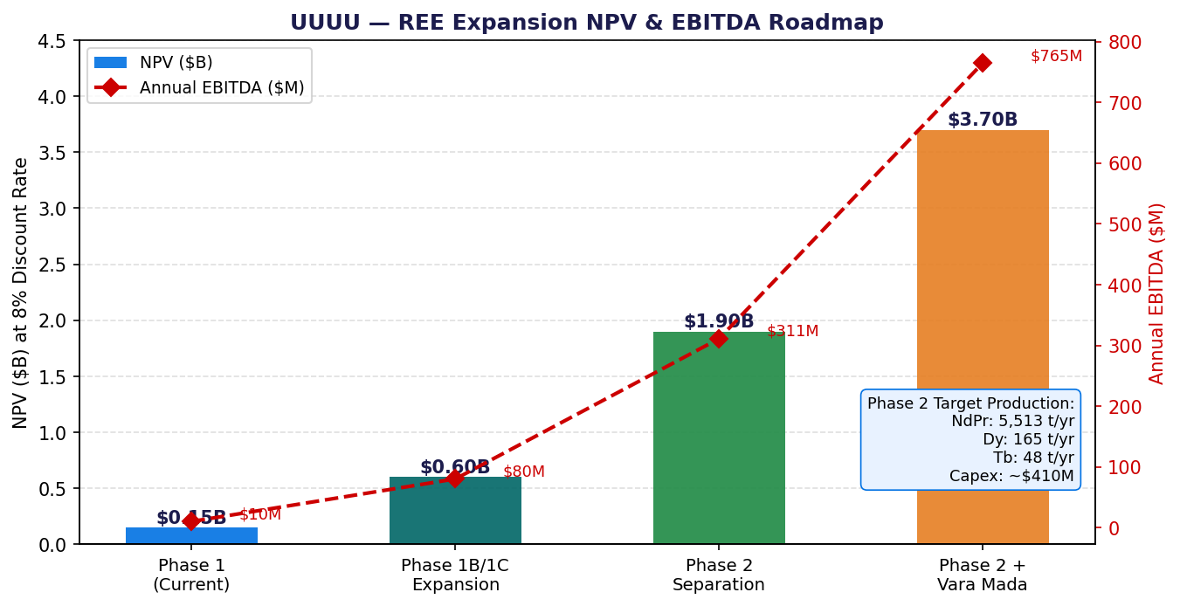
Chart 9: REE Expansion NPV & EBITDA Roadmap by Phase

5. Earnings Call Highlights (February 27, 2026)
White Mesa Mill — Operations
The White Mesa Mill in Blanding, Utah remains the centerpiece of Energy Fuels' operations — the only conventional uranium mill currently operating in the United States and the only facility in the Western Hemisphere producing separated heavy rare earth oxides.
- Mill licensed capacity: 8 million lbs U3O8/year
- Conventional ore processing campaign commenced Q4 2025; running through Q2 2026
- Peak throughput: ~350,000 lbs finished U3O8 produced in December 2025 alone
- Average throughput demonstrated at ~250,000 lbs/month
- REE pilot circuit producing Dy oxide at 99.9% purity; Tb oxide imminent
- Cost improvements: COGS/lb declined from $53 (2024) → $43 (2025) → targeting low $30s (2026)

Pinyon Plain Mine — Arizona
Pinyon Plain is the primary driver of uranium production growth and one of the highest-grade uranium mines in U.S. history by management's account.
- FY2025 mined ore: ~1,530,000 lbs U3O8 contained at ~1.62% eU3O8 average grade
- Mine life and resource remain large; additional development drilling ongoing
- Updated pre-feasibility study (PFS) in progress — may improve project economics and expand resource estimate
- Processing costs (2026E): $23–30/lb total ($10–14 mining/transport + $13–16 milling)

La Sal Complex & Other Mines — Utah/Colorado
- La Sal Complex (Utah) contributed ~190,000 lbs contained U3O8 to FY2025 mined total
- Pandora Mine (Colorado): active but at reduced rates
- Whirlwind Mine (Colorado): standby / care-and-maintenance
- Management guided to potentially restart additional mines in 2026 as needed to meet 2.0–2.5M lb target

Alta Mesa ISR — Texas (Note: enCore Energy Asset)
Note: Alta Mesa ISR is operated by enCore Energy (EU), not Energy Fuels. Energy Fuels does not have direct operations at Alta Mesa. Energy Fuels' ISR exposure is through potential future ISR projects. This distinction is important when analyzing the company.

REE Separation Facility — Strategic Vision
Management outlined the most detailed REE expansion roadmap to date on the earnings call:
- Phase 1 (current): NdPr separation from monazite; ~850–1,000 t NdPr/yr at full Phase 1B/1C scale
- Phase 1 commercial-scale Dy/Tb/Sm separation: Target Q4 2026 commissioning at White Mesa
- Phase 2 Feasibility Study (announced Jan 2026): $410M capex, 40-yr project, 5,513 t NdPr + 165 t Dy + 48 t Tb/yr
- Phase 2 NPV: $1.9B standalone; $3.7B combined with Vara Mada (Madagascar) feedstock
- Phase 2 + Vara Mada EBITDA: ~$765M/yr (first 15 years)
- Phase 2 IRR: 33% post-tax; per-share NPV: $7.96/share (Phase 2 alone) to $15.26/share (Phase 2 + Vara Mada)
- Donald Project (Australia) provides heavy REE feedstock — FID Q1 2026, production H2 2027

Key Strategic Announcements & Acquisitions
- Australian Strategic Materials (ASM) acquisition: Energy Fuels agreed to acquire ASM (ASX:ASM) to add downstream rare earth metal alloy production — completing a fully integrated Western critical minerals supply chain
- Two new long-term uranium supply contracts signed Q4 2025 (now 6 total through 2032)
- Export Finance Australia issued non-binding AUD $80M debt letter of support for Donald Project
- Vulcan Elements partnership: Joint venture to advance U.S. rare earth magnet security
- Management succession: CEO Mark Chalmers retiring April 15, 2026; replaced by President Ross Bhappu

6. Analyst Reactions & Price Targets (Post-Earnings)
Analyst / Firm | Rating | Price Target | Change | Key Commentary
H.C. Wainwright | Buy | $27.25 | Raised (from $26.75) | Strong uranium production ramp; Pinyon Plain PFS catalyst; REE pilot milestones de-risk Phase 1
Consensus (6–8 analysts) | Strong Buy | $23.08 avg  ($15.50–$34.00 range) | — | 7 Buy / 1 Hold / 0 Sell as of Mar 9, 2026
Implied upside (avg target) | — | ~24% vs current | — | Based on $23.08 avg target vs $18.67 current price
Implied upside (HC W. target) | — | ~46% vs current | — | Based on $27.25 vs $18.67 current price

While Q4 2025 EPS missed consensus by $0.01, the headline revenue beat and the strong 2026 guidance (uranium sales 1.5–2.0M lbs vs 0.65M in 2025) drove generally constructive analyst commentary. The Phase 2 REE feasibility study NPV of $1.9B–$3.7B was viewed as a significant underappreciated asset at current market cap levels (~$4.5B). The ASM acquisition, adding downstream alloy capability, was seen as strategically completing the Western REE supply chain and potentially attracting government (DOE/DOD) offtake and financing support.
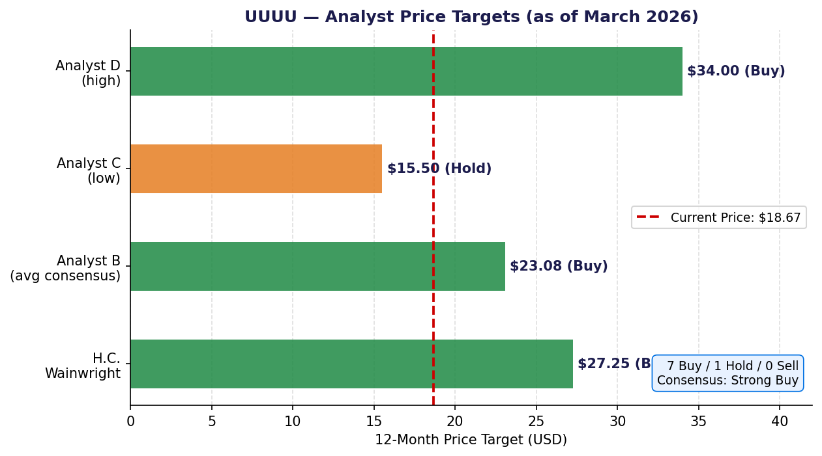
Chart 10: Analyst Price Targets vs Current Price (March 2026)
7. Stock Price & Market Context
Metric | Value
Current Price (Mar 16, 2026) | ~$18.67
Market Capitalization | ~$4.51B
52-Week Range | $3.20 – $27.90
Year-to-Date Performance | Significant decline from 52-wk high
Exchange | NYSE American (UUUU) / TSX (EFR)
Shares Outstanding (approx.) | ~242M
Enterprise Value (approx.) | ~$4.35B (net cash ~$162M adj. for conv. notes)
EV / FY2025 Revenue | ~66x (early-stage/growth premium)
EV / FY2026E Revenue (consensus) | ~17–20x (at 1.75M lbs @ $80/lb = $140M rev est.)
Next Earnings Date | ~May 7, 2026 (Q1 2026)

UUUU's stock surged nearly 400% from its April 2025 lows (~$3.20) to its 52-week high of $27.90, driven by the $700M convertible note offering, REE milestones, and uranium production ramp. Since the January 2026 highs, the stock has retraced to ~$18.67 as uranium spot prices softened and broader market volatility increased. The market cap of ~$4.51B now trades at a substantial premium to current earnings but embeds significant optionality from the $3.7B Phase 2 + Vara Mada REE NPV.

8. Historical Quarterly Data — Trend Analysis
Quarter | Revenue ($M) | Net Inc/(Loss) ($M) | EPS ($) | U Sold (klbs) | U Price ($/lb) | U Revenue ($M)
Q1 2024 | $25.3 | +$3.6 | +$0.02 | 300 | $84.4 | $25.3
Q2 2024 | ~$16.2 | ~($9.8) | ($0.06) | ~0 | — | ~$0
Q3 2024 | ~$23.7 | ~($12.8) | ($0.07) | ~0 | — | ~$0
Q4 2024 | ~$39.9 | ($28.8) | ($0.19) | ~150 | ~$84 | ~$12.6
FY 2024 | $78.1 | ($47.8) | ($0.28) | 450 | $87.2 | $37.9
Q1 2025 | $16.9 | ($26.3) | ($0.13) | ~50 | ~$80 | ~$7.0
Q2 2025 | ~$12.7 | ($22.2) | ($0.10) | ~150 | ~$79 | ~$4.2
Q3 2025 | $17.7 | ($16.7) | ($0.07) | 240 | ~$70 | $10.4
Q4 2025 | $27.1 | ~($20.9) | ($0.08) | 360 | $74.93 | ~$27.0
FY 2025 | $65.9 | ($86.1) | ($0.38) | 650 | $74.21 | $48.2
Sources: Energy Fuels quarterly press releases (Q1–Q4 2024, Q1–Q4 2025); Zacks; StockTitan SEC filings.

Key trends observable in the quarterly data: (1) Q2 and Q3 2024 had $0 uranium sales as the company built inventory; (2) uranium sales accelerated sharply in H2 2025, with Q4 2025 representing the largest quarterly uranium revenue in company history; (3) unit economics improved consistently through 2025 (COGS/lb declining each quarter); (4) HMS revenue has trended toward zero as Kwale concluded; (5) the net loss trajectory in 2025 reflects heavy investment/ramp-up costs rather than structural operational weakness.
9. Key Risks
Downside Risks
- Uranium price risk: Spot price remains volatile; a sustained fall below $60/lb would pressure margins
- Execution risk: REE Phase 2 capex ($410M) requires financing — reliant on capital markets, government support, or offtake
- Dilution risk: $700M convertible notes create potential dilution at $20.34/share conversion price; ~34.4M shares if fully converted
- Regulatory / permitting risk: Vara Mada (Madagascar) faces government negotiations; Donald Project environmental approvals
- REE pricing risk: NdPr, Dy, Tb prices subject to China supply policy and global EV demand fluctuation
- Management transition: CEO succession (Bhappu replaces Chalmers) introduces execution continuity risk

Upside Catalysts
- Uranium price recovery toward $100+/lb would drive significant earnings leverage on 1.5–2.0M lb 2026 sales plan
- DOE/DOD contract awards for REE supply — government offtake would de-risk Phase 2 construction financing
- Phase 2 REE Final Investment Decision and financing announcement
- Donald Project (Australia) FID confirmation and commencement of mining
- Vanadium inventory monetization — 905k lbs V2O5 could generate $5–7M if sold at current prices
- Pinyon Plain PFS update with improved resource estimate or mine-life extension
- Medical isotope (Ra-226) commercial agreements — provides additional critical minerals diversification

Sources & Disclosures
- Energy Fuels Inc. Press Release: '2025 Results and 2026 Guidance' (Feb 26, 2026) — investors.energyfuels.com
- Energy Fuels Inc. Press Release: 'Year-End Production and Sales Exceeding Guidance' (Dec 29, 2025)
- Energy Fuels Inc. Press Release: 'Q3-2025 Results' (Nov 3, 2025)
- Energy Fuels Inc. Press Release: 'Q2-2025 Results' (Aug 6, 2025)
- Energy Fuels Inc. Press Release: 'Q1-2025 Results' (May 7, 2025)
- PRNewswire: 'Energy Fuels Announces 2025 Results and 2026 Guidance' (Feb 26, 2026)
- H.C. Wainwright Research: Price target raise to $27.25 (Feb 27, 2026) — investing.com
- Yahoo Finance / Zacks: Q4 2025 earnings summary, consensus data
- GuruFocus / Investing.com: Q4 2025 earnings call highlights
- Sprott: 'Uranium Outlook 2026'; 'Uranium's Tale of Two Markets'
- Nasdaq.com: 'Uranium Price Forecast: Top Trends for Uranium in 2026'
- TipRanks: 'Energy Fuels Earnings Call Highlights Bold Growth Pivot'
- StockTitan: UUUU SEC Filing (10-Q) — Q3 2025 revenue $17.7M
- MarketBeat / WallStreetZen / StockAnalysis: Analyst consensus data
- ANS Nuclear Newswire: Uranium spot price data 2025

DISCLAIMER: This report is for informational purposes only. It does not constitute investment advice or a solicitation to buy or sell securities. All financial data is sourced from public filings and press releases. Estimates marked 'est.' are derived from partial data and may differ from official reported figures. Past performance does not guarantee future results.

