Ping An Bank (000001.SZ)
Q4 2025 / FY2025 Earnings Update — NIM Stabilization Signals Recovery; Maintain BUY
Equity Research | April 5, 2026 | 000001.SZ (A-share, Shenzhen)

Rating  BUY ↑ | Price Target  (A-share)  RMB 14.00 | Current Price  RMB 11.12 | Market Cap  ~RMB 216B (~USD 30B) | 52W High/Low  RMB 13.33 / RMB 10.43 | Shares Out.  ~19.4B shares

I. EXECUTIVE SUMMARY
Ping An Bank (000001.SZ) reported FY2025 full-year results on March 20, 2026, delivering net profit attributable to shareholders of RMB 42.63B (-4.2% YoY), in line with consensus expectations of ~RMB 42.2B. Operating revenue of RMB 131.44B declined -10.4% YoY, consistent with the bank's ongoing structural revenue pressure. The headline story, however, is inflection: Q4 2025 net interest income grew +2.76% YoY — the first positive YoY NII growth in multiple quarters — and the full-year NIM declined only 9bps to 1.78% vs. FY2024's -51bps compression. Asset quality improved, with the NPL formation rate declining to 1.63% (-17bps YoY). Management declared the 'most difficult period has passed' at the March 23 analyst conference.
Key Takeaways
- Revenue in-line; net profit slight beat: FY2025 NP of RMB 42.63B vs. consensus ~RMB 42.2B (+1.0% beat). Revenue of RMB 131.44B was slightly below consensus ~RMB 132.0B (-0.4%).
- NIM stabilization — the critical inflection: Full-year NIM of 1.78% (-9bps YoY vs. FY2024's -51bps) reflects sharp deceleration in spread compression. Q4 NII turned positive YoY (+2.76%) for the first time in several quarters, driven by a 47bps decline in average funding costs to 1.67%.
- Asset quality improving: NPL ratio stable at 1.05% (-1bp YoY); NPL formation rate fell 17bps to 1.63%; personal loan NPL improved -16bps to 1.23%. Provision coverage declined 30pp to 220.88%, as elevated provisions normalize.
- Capital strengthening: CET1 rose 24bps to 9.36% YoY; Tier 1 up 80bps to 11.49% — driven by Q4 retained earnings and reduced risk-weighted asset growth.
- Retail transformation on track: Retail banking net profit surged +828% YoY to RMB 2.68B (FY2024: RMB 289M). Private banking clients grew +9.1% to 105,600; wealth management fee income +15.8% to RMB 5.06B.
- Dividend: Total FY2025 dividend of RMB 0.596/share (含税), payout ratio 28.83%; dividend yield ~5.5% at current price. Management targets 20–30% payout ratio, with aspiration to increase in 2026.
- Maintain BUY with PT RMB 14.00, implying 0.56x FY2026E BPS of ~RMB 24.9 and ~29% upside. Management's '2026 return to growth' target is credible given NIM stabilization and declining credit costs.

Results Snapshot — FY2025 vs. Consensus
Metric | FY2025 Actual | Consensus (Pre-Results) | Beat/Miss | YoY Change
Operating Revenue (RMB B) | 131.44 | ~132.0 | -0.4% miss ↓ | -10.4%
Net Interest Income (RMB B) | 88.02 | ~88.5 | -0.5% miss ↓ | -5.8%
Net Profit Attr. (RMB B) | 42.63 | ~42.2 | +1.0% beat ✓ | -4.2%
EPS (RMB) | 2.07 | ~2.04 | +1.5% beat ✓ | -4.2%
NIM (%) | 1.78% | ~1.76% | +2bps beat ✓ | -9bps
NPL Ratio (%) | 1.05% | ~1.07% | -2bps beat ✓ | -1bp
Provision Coverage (%) | 220.88% | ~225% | -4pp miss ↓ | -29.8pp
CET1 Capital Ratio (%) | 9.36% | ~9.20% | +16bps beat ✓ | +24bps
Cost-to-Income (%) | 29.06% | ~29.0% | In Line | +1.4pp
ROE (%) | 9.15% | ~9.2% | In Line | -0.93pp
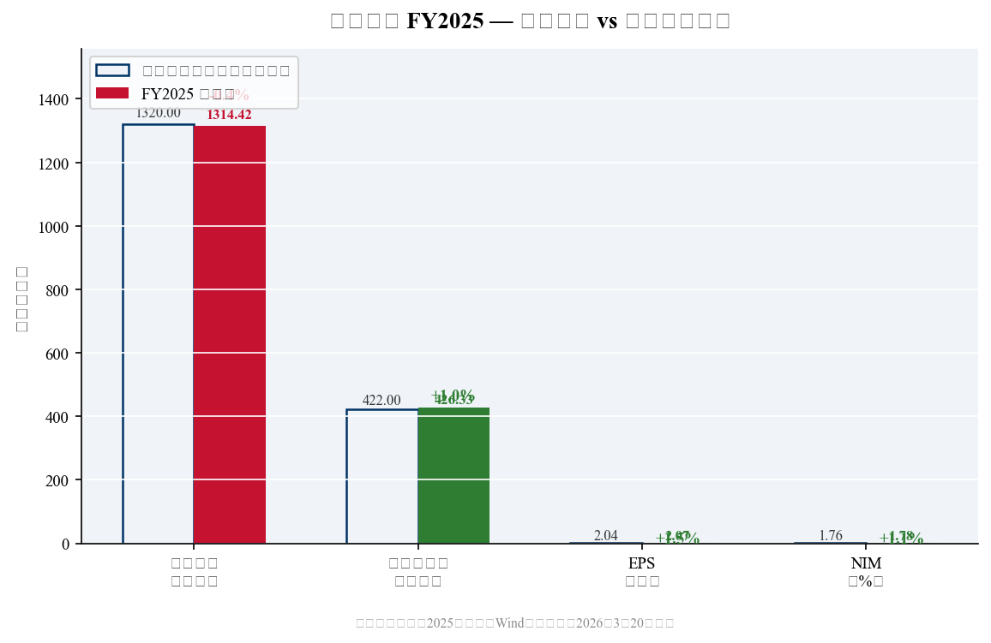
Exhibit 1: FY2025 Actual vs. Pre-Results Consensus (Key Metrics)

II. DETAILED QUARTERLY & FULL-YEAR RESULTS
Revenue — Cyclical Low; Q4 Shows Sequential Stabilization
FY2025 operating revenue of RMB 131.44B declined -10.4% YoY (FY2024: RMB 146.70B), the third consecutive year of double-digit revenue contraction driven primarily by NIM compression and declining non-interest income. On a quarterly basis, Q4 2025 revenue of ~RMB 30.77B declined -12.4% YoY, but sequential performance was more benign: Q1-Q4 2025 revenue was RMB 33.71B / 35.68B / 31.28B / 30.77B, showing relative stability in H2 after Q2's temporary non-interest income boost.
Net interest income of RMB 88.02B (-5.8% YoY) was the primary revenue drag, though the pace of decline sharply decelerated vs. FY2024's implied ~-10% NII decline. Critically, Q4 NII grew +2.76% YoY — a key inflection point attributable to: (1) liability cost improvement (average funding cost fell 47bps to 1.67%); (2) slower asset repricing pressure as LPR cuts moderated; and (3) deposit mix improvement from high-cost time deposits toward lower-cost current/wealth product structures.
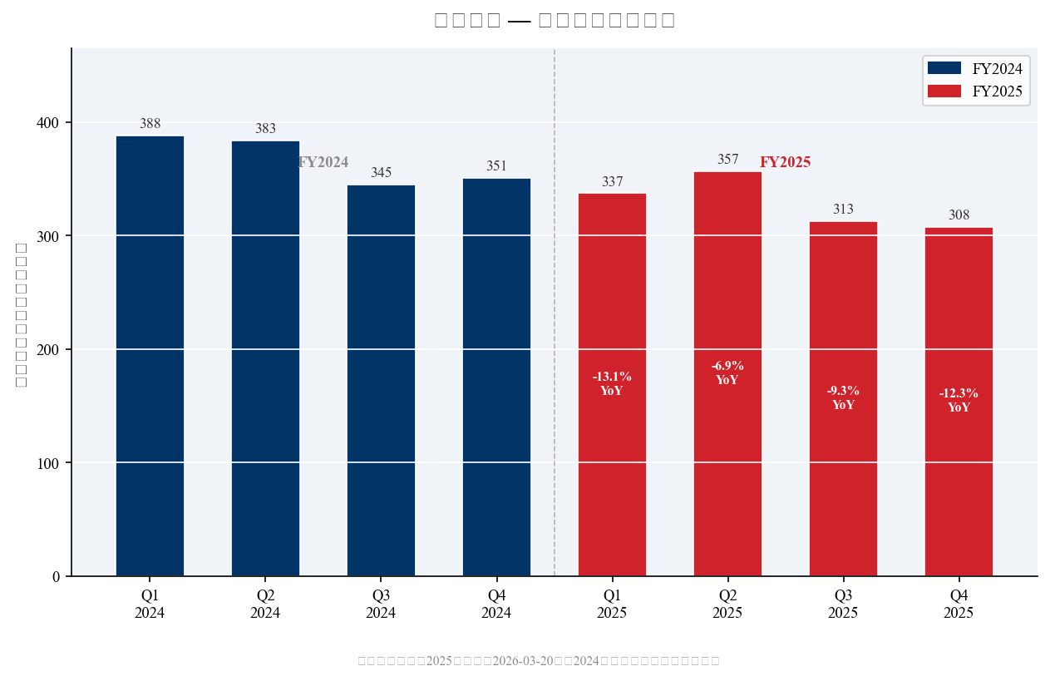
Exhibit 2: Quarterly Operating Revenue (Q1 2024–Q4 2025, RMB Billion)
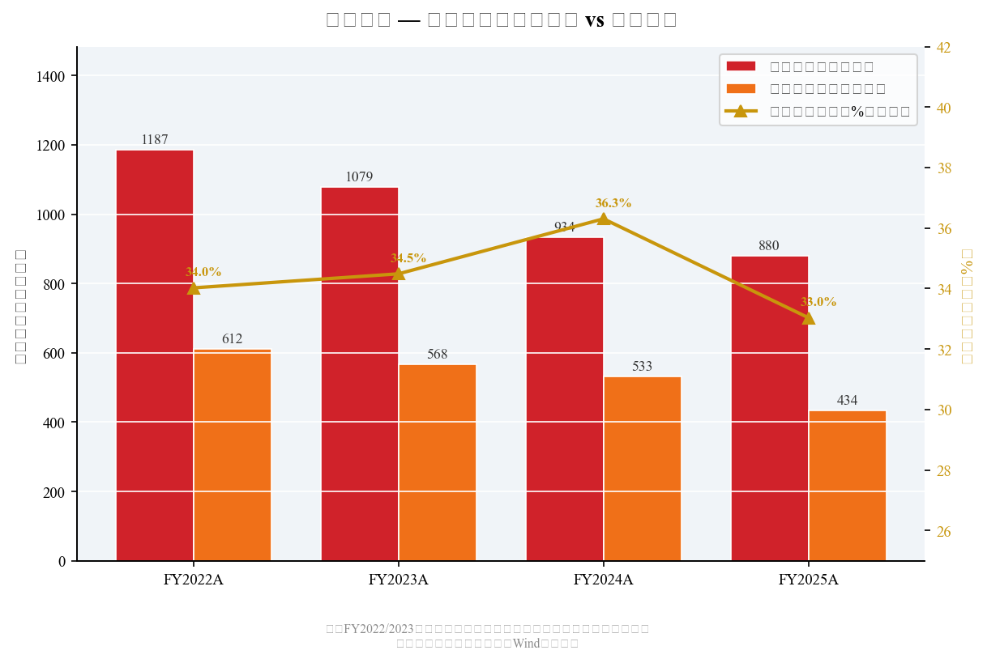
Exhibit 3: Revenue Mix — Net Interest vs. Non-Interest Income (FY2022–FY2025)
Net Profit — Stable Decline; Q4 Heavy Provisioning as Expected
FY2025 net profit attributable to shareholders of RMB 42.63B declined -4.2% YoY (FY2024: RMB 44.51B), a slightly narrowing pace vs. FY2024's -4.2%. The Q4 standalone quarter implied net profit of ~RMB 4.29B was exceptionally weak (~-10% YoY vs Q4 2024's RMB 4.78B), reflecting the bank's customary year-end practice of front-loading provisioning charges into Q4. Provision charges (信用减值损失) declined -17.9% YoY to RMB 40.57B for FY2025, reflecting improving underlying credit quality and reduced need for large reserve builds.
Full-year credit cost fell to 1.38% (-18bps YoY), providing a meaningful tailwind to bottom-line profitability in FY2026E as this normalization continues. The bank's pre-provision operating profit (PPOP) declined ~-11.9% YoY, indicating that revenue contraction remains the primary challenge — but as NIM stabilizes and credit costs normalize, we expect net profit to return to positive growth in FY2026E.
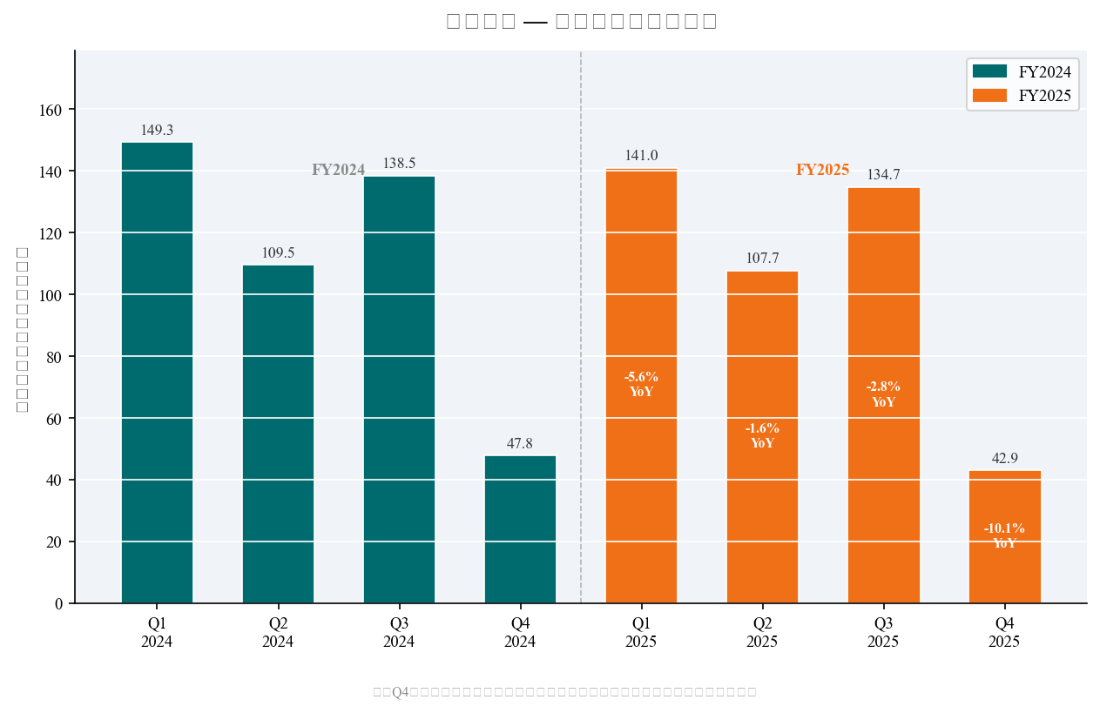
Exhibit 4: Quarterly Net Profit with YoY Growth Labels (Q1 2024–Q4 2025)

III. KEY BANKING METRICS
Net Interest Margin (NIM) — Critical Inflection Confirmed
The FY2025 NIM of 1.78% represents only -9bps of decline vs. FY2024's 1.87%, a dramatic improvement over FY2024's -51bps compression (FY2023: 2.38%). This deceleration reflects: (1) average deposit cost declined 42bps to 1.65%, benefiting from regulatory deposit rate cuts and mix shift; (2) slower LPR-linked asset repricing (only one 10bps LPR cut in H2 2025 vs. multiple cuts in 2024); and (3) incremental benefit from corporate loan growth (+3.5% YoY) vs. declining personal loans (-2.3% YoY, primarily mortgage). Management declared NIM 'essentially stabilized' at the March 2026 investor conference, with FY2026E NIM consensus of ~1.77% — implying near-flat from FY2025.
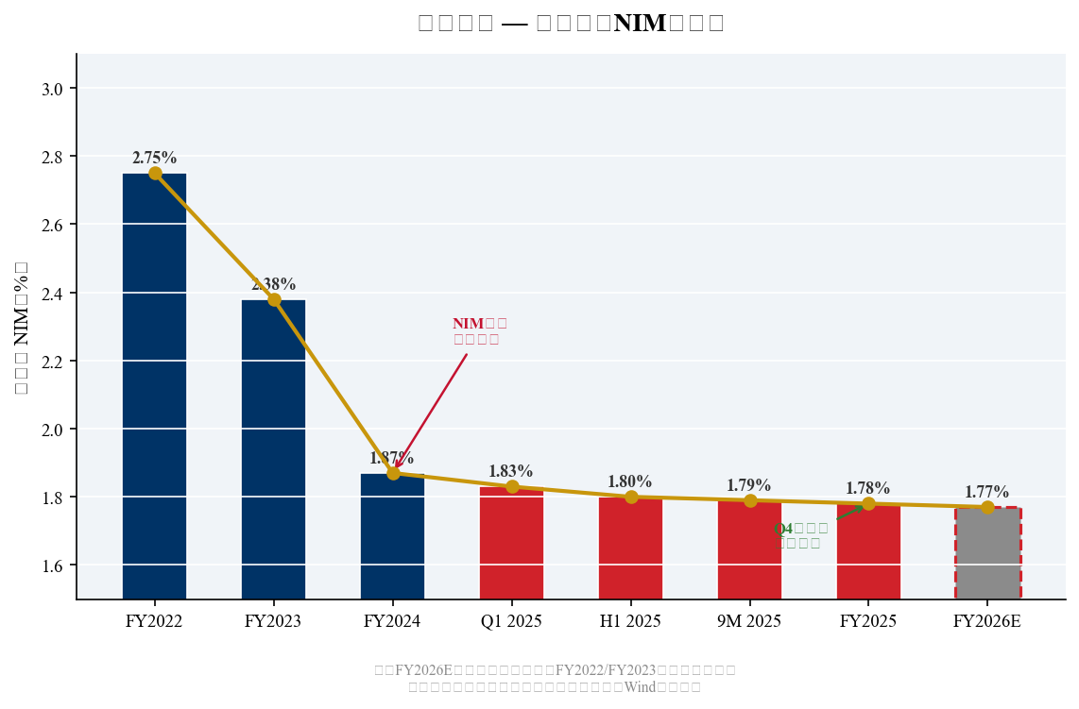
Exhibit 5: NIM Trend (FY2022–FY2025 Actual; FY2026E Consensus)
Asset Quality — Continuing Improvement; Real Estate Remains Watchpoint
Overall asset quality continued to improve in FY2025. The NPL ratio edged down 1bp to 1.05%, with personal loan NPL declining 16bps to 1.23% — signaling that retail credit normalization (post-COVID consumer stress) is progressing. The NPL formation rate declined 17bps to 1.63% and the overdue 90d+ deviation ratio of 0.56x (below 1.0x is favorable) indicates strong forward coverage of potential new NPLs.
Corporate NPL rose 17bps to 0.87%, driven by real estate exposure where the NPL ratio deteriorated 43bps to 2.22% (FY2024: 1.79%). Real estate remains the key credit watchpoint, though the bank has been actively de-risking: real estate loans as a percentage of total corporate loans have declined significantly over 2023–2025. Provision coverage of 220.88% (-29.8pp YoY) is above the regulatory minimum and reflects deliberate normalization as underlying credit quality improves and provisioning needs decline.
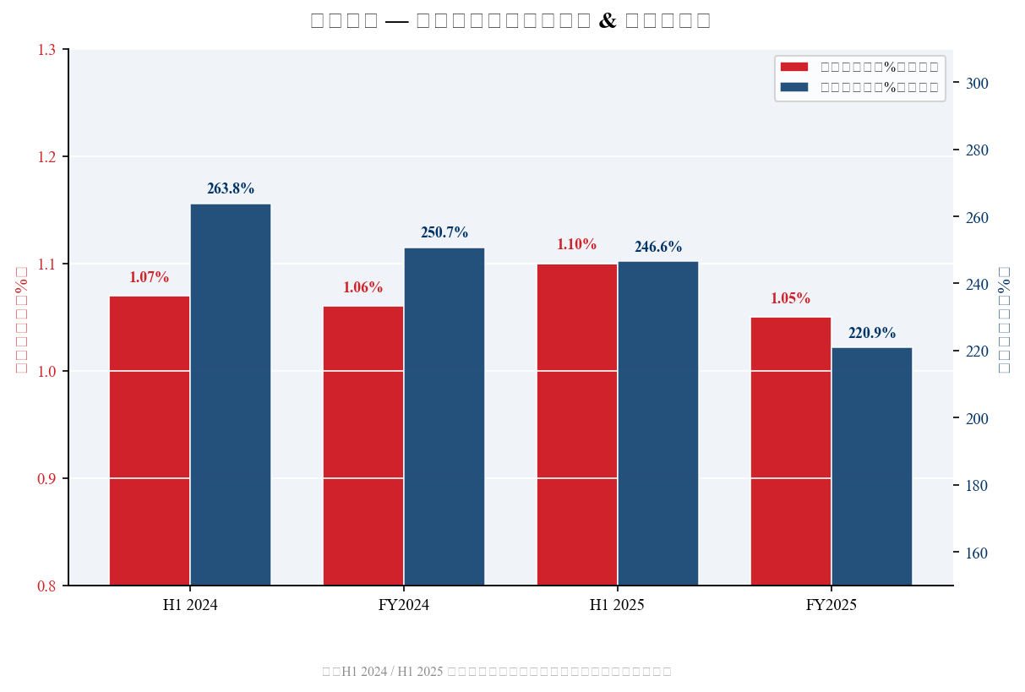
Exhibit 6: NPL Ratio & Provision Coverage Ratio (H1 2024 – FY2025)
Capital — Well-Capitalized; Organic Growth Sufficient
CET1 capital ratio improved 24bps to 9.36% at FY2025 year-end (FY2024: 9.12%), and the total capital ratio rose 66bps to 13.77%. The improvement was driven by retained earnings and controlled risk-weighted asset growth (+0.5% loan growth). Management confirmed no rights offering is planned; organic capital generation is sufficient to support moderate 2026 business expansion. A higher capital base supports the bank's ability to maintain the 20–30% dividend payout target.
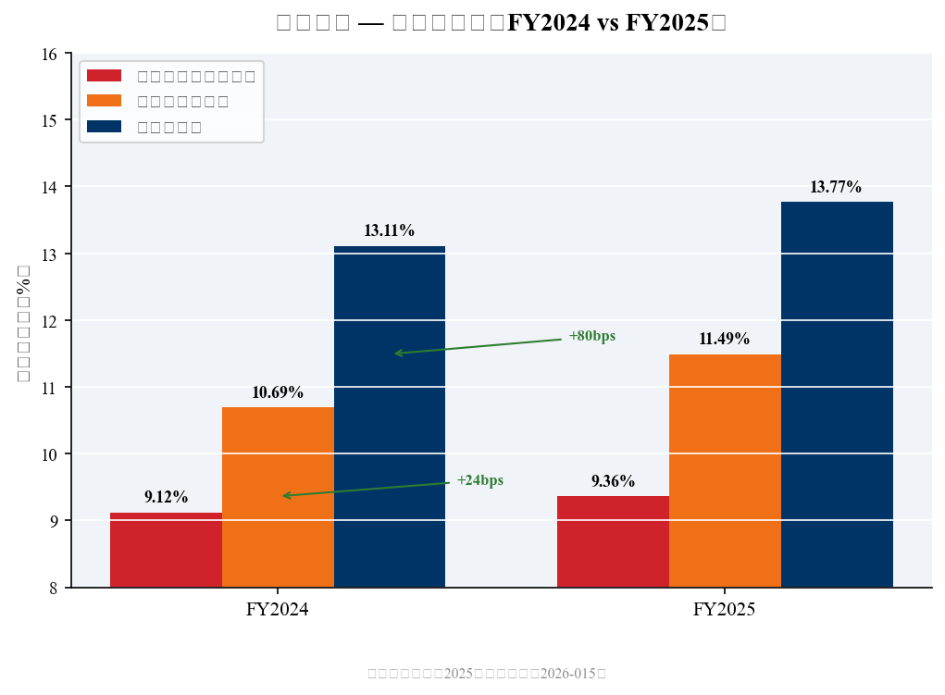
Exhibit 7: Capital Adequacy Ratios (FY2024 vs. FY2025)
Metric | FY2023A | FY2024A | H1 2025A | FY2025A | FY2026E
Revenue (RMB B) | 164.70 | 146.70 | 69.39 | 131.44 | ~135.2
Net Profit (RMB B) | 46.46 | 44.51 | 24.87 | 42.63 | ~43.36
NIM (%) | 2.38 | 1.87 | 1.80 | 1.78 | ~1.77
NPL Ratio (%) | 1.06 | 1.06 | 1.10 | 1.05 | ~1.03
Provision Coverage (%) | 277.6 | 250.71 | 246.6 | 220.88 | ~215
CET1 (%) | 8.84 | 9.12 | 9.20 | 9.36 | ~9.5
ROE (%) | 11.4 | 10.08 | 9.52 | 9.15 | ~8.9
Cost-to-Income (%) | 26.3 | ~27.7 | 28.3 | 29.06 | ~27.7
EPS (RMB) | 2.25 | 2.16 | 1.21 | 2.07 | ~2.19
BVPS (RMB) | 21.1 | ~22.4 | ~23.1 | ~24.0 | ~24.9

IV. RETAIL BANKING TRANSFORMATION PROGRESS
Ping An Bank's multi-year retail transformation remains the central long-term investment thesis. FY2025 marked a breakthrough in retail profitability: retail banking net profit surged +828% YoY to RMB 2.68B (FY2024: RMB 289M), increasing its share of total bank net profit to 6.3% from 0.6% — reflecting the cyclical trough passage in retail credit costs. Management estimates the retail transformation is '~70% complete, ~30% remaining.'
Wealth Management — A Bright Spot
- Total retail AUM: RMB 4.24 trillion (+1.1% YoY vs. RMB 4.19 trillion in FY2024) — modest growth constrained by equity market volatility but demonstrates resilient client relationships.
- Private banking clients: +9.1% to 105,600; private banking AUM: RMB 1.991 trillion (+0.8% YoY). Private banking is the highest-margin retail segment and the key long-term growth driver.
- Wealth management fee income: +15.8% YoY to RMB 5.06B — driven by insurance +53.3%, mutual funds +8.9%, and wealth products +8.8%. Fee income is growing even as total non-interest income declines, indicating structural quality improvement.
- Pocket Bank (口袋银行) MAU ~40M — a key digital distribution advantage for fee income.
- Strategic integration with Ping An Insurance: Cross-selling bancassurance products drove insurance commission income +53.3% YoY; the insurance-bank synergy model is differentiating vs. non-conglomerate peers.
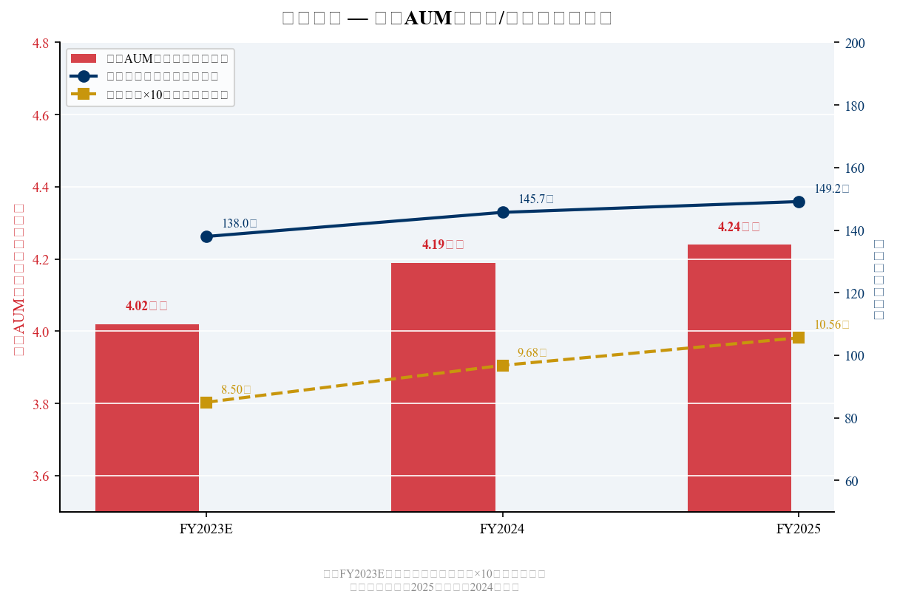
Exhibit 8: Retail AUM, Wealth Clients & Private Banking Clients (FY2023–FY2025)

V. INVESTMENT THESIS UPDATE — MAINTAIN BUY
We maintain our BUY rating with a 12-month price target of RMB 14.00 (0.56x FY2026E BPS ~RMB 24.9), representing ~29% upside from current levels. The investment thesis is predicated on: (1) NIM stabilization as the most critical near-term catalyst; (2) declining credit costs as retail NPL formation peaks; (3) retail transformation driving sustained fee income growth; and (4) a ~5.5% dividend yield providing downside protection at current valuations (~0.44x P/B).
Bull Case Catalysts
- NIM inflection: Q4 NII turned positive YoY for the first time in multiple quarters. If Q1 2026 NII continues to grow YoY, revenue growth will return in 2026 — the single most important catalyst for re-rating.
- Credit cost normalization: NPL formation rate of 1.63% is declining. As retail credit stress (personal loans, credit cards, mortgages) continues to normalize, provisions can decline further from RMB 40.57B in FY2025 to ~RMB 36–38B in FY2026E, directly boosting bottom-line growth even if PPOP is flat.
- Retail profit contribution expansion: Retail banking at 6.3% of total net profit in FY2025 vs. 0.6% in FY2024 demonstrates the transformation is delivering. Targeting 25–30% retail contribution by FY2027E as consumer credit quality normalizes.
- Valuation floor at ~0.44x P/B: Historically low vs. Ping An Bank's 5-year average of ~0.85x P/B. A re-rating to 0.6x P/B alone (still below historical average) implies RMB 15/share upside from current levels.
- Ping An Group parent support: Strong backing from China's largest insurance group provides funding, insurance cross-sell synergies, and systemic importance protection.
Key Risks
- Revenue pressure continuation: If LPR is cut further in 2026 or deposit repricing is slower than expected, NIM could compress again, delaying revenue recovery.
- Real estate NPL deterioration: Corporate NPL rose (mainly real estate at 2.22%). A broader real estate credit event could force fresh provision builds, potentially reversing the credit cost improvement trend.
- Macro slowdown: Consumption softness and SME stress could re-accelerate retail NPL formation, particularly in personal consumption loans and credit card receivables.
- Capital adequacy pressure: CET1 at 9.36% is above minimum but leaves limited buffer for rapid loan growth or unexpected losses. Dividend aspirations could be constrained.
- Competition from state-owned banks: Large state banks (ICBC, CCB, ABC) are aggressively competing in wealth management and corporate lending — Ping An Bank's competitive moat is narrowing in these segments.

VI. VALUATION & UPDATED ESTIMATES
Price Target: RMB 14.00 (0.56x FY2026E BPS)
Our 12-month price target of RMB 14.00 is based on 0.56x FY2026E book value per share of ~RMB 24.9 (consensus). This P/B multiple is justified by our FY2026E ROE estimate of ~8.9%, with a required return of ~10% (COE), implying a justified P/B of ~0.9x via Gordon Growth Model — we apply a 40% discount to intrinsic value to reflect execution risk on the retail transformation and macro uncertainty, yielding 0.56x P/B. The consensus target price of RMB 14.25 (25 institutions) is consistent with our target.
Bull scenario (0.70x FY2026E BPS): RMB 17.4/share — requires full NIM stabilization and accelerating retail profitability. Bear scenario (0.40x FY2026E BPS): RMB 10.0/share — implies renewed credit deterioration and further NIM compression.
Metric | FY2023A | FY2024A | FY2025A | FY2026E | FY2027E
Revenue (RMB B) | 164.70 | 146.70 | 131.44 | ~135.2 | ~139.0
Revenue Growth (%) | -8.5 | -10.9 | -10.4 | ~+2.9 | ~+2.8
Net Profit (RMB B) | 46.46 | 44.51 | 42.63 | ~43.36 | ~44.40
NP Growth (%) | +2.1 | -4.2 | -4.2 | ~+1.7 | ~+2.4
EPS (RMB) | 2.25 | 2.16 | 2.07 | ~2.19 | ~2.26
BVPS (RMB) | ~21.1 | ~22.4 | ~24.0 | ~24.9 | ~26.0
P/B at RMB 10.87 (x) | 0.52x | 0.49x | 0.45x | 0.44x | 0.42x
P/B at PT RMB 14.00 (x) | 0.66x | 0.63x | 0.58x | 0.56x | 0.54x
P/E at current price (x) | 4.83x | 5.03x | 5.25x | 4.96x | 4.81x
Dividend Yield (%) at current | ~5.2% | ~5.1% | ~5.5% | ~5.5% | ~5.7%
Note: FY2026E/2027E are Wind consensus estimates. BVPS estimates based on projected retained earnings.
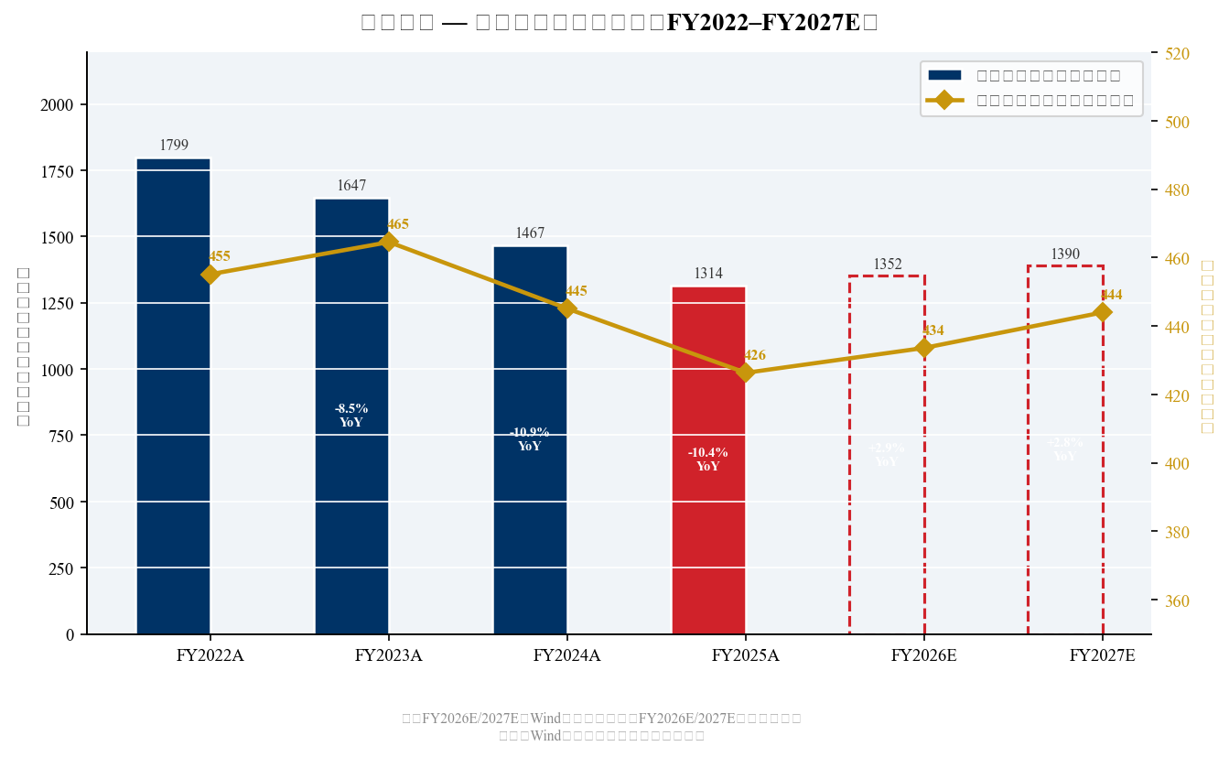
Exhibit 9: Annual Revenue & Net Profit (FY2022–FY2027E)
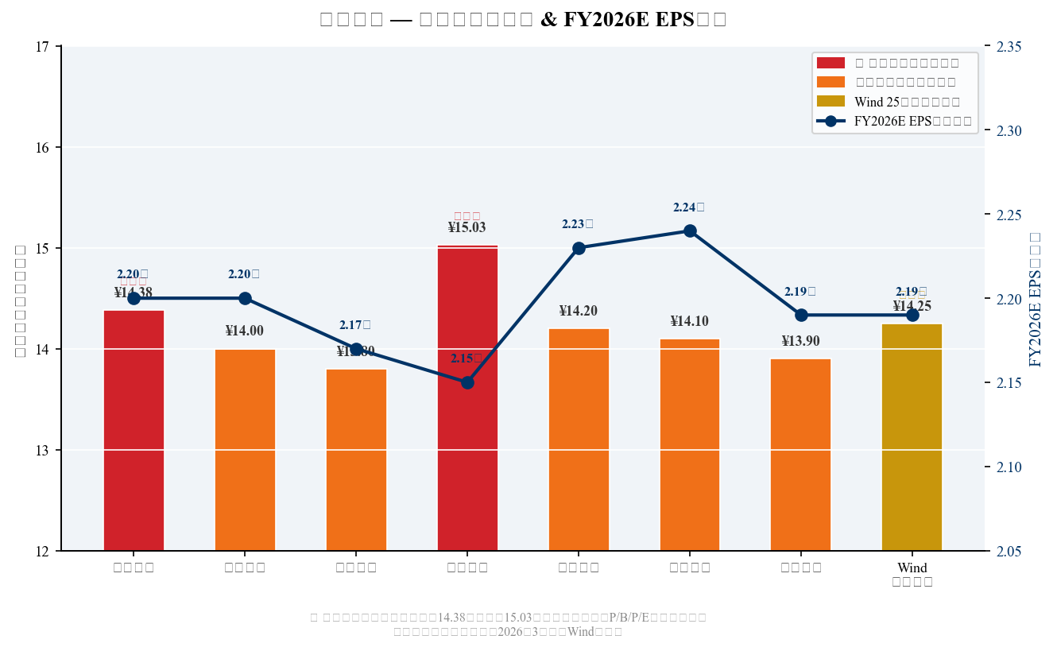
Exhibit 10: Broker FY2026E EPS Estimates & Price Targets

VII. SOURCES & REFERENCES
All data as of April 5, 2026. FY2025 Annual Report officially released March 20, 2026.
- Ping An Bank FY2025 Annual Report Released (Sina Finance, March 20, 2026)
- Ping An Bank FY2025 Net Profit RMB 42.63B; Dividend 5.96元/10 shares (Sina Finance)
- Ping An Bank FY2025 Annual Report Analyst Review — Galaxy Securities (StockStar, March 24)
- Ping An Bank FY2025 Annual Report Deep Dive (Sina Finance, March 31, 2026)
- Ping An Bank 2026 Analyst Conference: 'Full Force Return to Growth' (Sina Finance, March 23)
- Ping An Bank: Consensus PT RMB 14.25; Valuation at Historical Low (Sina Finance, March 22)
- Reading Ping An Bank FY2025 Annual Report: The Most Difficult Period Has Passed (Sina Finance)
- Ping An Bank 2025: First Step Out of the Deep Water Zone (Sina Finance, March 25, 2026)
- 21st Century Business Herald: Annual Report — Dividend RMB 10B, NIM -9bps (March 20, 2026)
- Ping An Bank H1 2025 Net Profit -3.9%; NIM 1.80% (Wall Street CN, August 2025)
- Wind / Tonghuashun F10: FY2026E Consensus Estimates (000001.SZ)
- Retail Transformation 30% Remaining: Ping An Bank 2026 Recovery Methodology Forming (STCN)

DISCLAIMER: This report is for informational purposes only and does not constitute investment advice. All financial data sourced from public company filings and consensus estimates. Market data via yfinance as of report date. FY2026E/2027E figures are analyst consensus estimates.

