EQUITY RESEARCH | EARNINGS UPDATE
Nebius Group N.V. (NASDAQ: NBIS)
Q1 2026 Earnings Update — “Everything We Build, We Sell”
Report date: June 18, 2026 | Rating: BUY | Price Target: $330 | Price (6/17/26): $280.91 | Mkt Cap: ~$71B
Metric | Q1 2026A | Consensus | Beat / (Miss)
Group revenue | $399.0M | $391.6M | +$7.4M / +1.9% ✔
Core AI Cloud ARR | $1.92B | — | +54% QoQ
Group adj. EBITDA | $129.5M | ~$95M | +$34M / Beat ✔
Group adj. EBITDA margin | 32% | ~24% | +8 pts ✔
Adj. EPS (diluted) | $(0.39) | $(0.78) | Narrower loss ✔
GAAP EPS (diluted) | $2.11 | n/m | Incl. $781M ClickHouse gain
Source: Q1 2026 results press release & 6-K (filed May 13, 2026), Nebius IR; consensus per Visible Alpha / Investing.com as of May 12, 2026.
Bottom Line: A Blowout Quarter — Reiterate BUY, Raise PT to $330
Nebius delivered a clean beat-and-build quarter. Group revenue of $399M (+684% YoY, +75% QoQ) topped consensus, core AI Cloud ARR vaulted +54% QoQ to $1.92B, and group adjusted EBITDA more than doubled QoQ to $129.5M (32% margin) as the AI cloud unit hit a 45% adjusted EBITDA margin. The strategic headline was a $27B, five-year Meta agreement plus a $2B NVIDIA equity investment, validating Nebius as a tier-one neocloud. Management raised 2026 capex to $20–25B (from $16–20B) to pull forward 2027 capacity, while reiterating $7–9B exit-ARR and $3.0–3.4B revenue. We raise our PT to $330 (from $300) on higher out-year ARR visibility and a de-risked capital structure ($9.3B cash).
Key Takeaways
- Demand is the bottleneck-free variable. “Everything we build, we sell” — AI cloud pipeline grew 3.5x QoQ (ex-hyperscalers), Nebius raised prices again and is sold out across all chip types. Contracted power reached >3.5 GW (from ~2 GW), with a YE-2026 target of >4 GW.
- Margins inflected hard. Core AI cloud adj. EBITDA margin expanded to 45% (from 24% in Q4'25); group margin hit 32%. Management guides ~40% group adj. EBITDA margin for FY2026, with a back-half-weighted cadence.
- Balance sheet is now a weapon. $6.3B raised in Q1 ($4.3B converts + $2B NVIDIA equity); $9.3B cash and >90% of current capex secured by cash/contracts. Operating cash flow swung to +$2.3B.
- Capacity pulled forward. New 1.2 GW owned AI factory in Pennsylvania (2nd US GW-scale site); >75% of capacity owned. Capex raised to $20–25B funds 2027 supply that begins contributing revenue in H1 2027.
- Watch items. Q2 margins step down on back-loaded deployment; ~$33B+ in deferred/contracted backlog is concentrated in a few mega-deals (Meta, Microsoft); non-core units (Avride, TripleTen, Toloka) remain cash-consumptive and are being prepped for partners/spin.
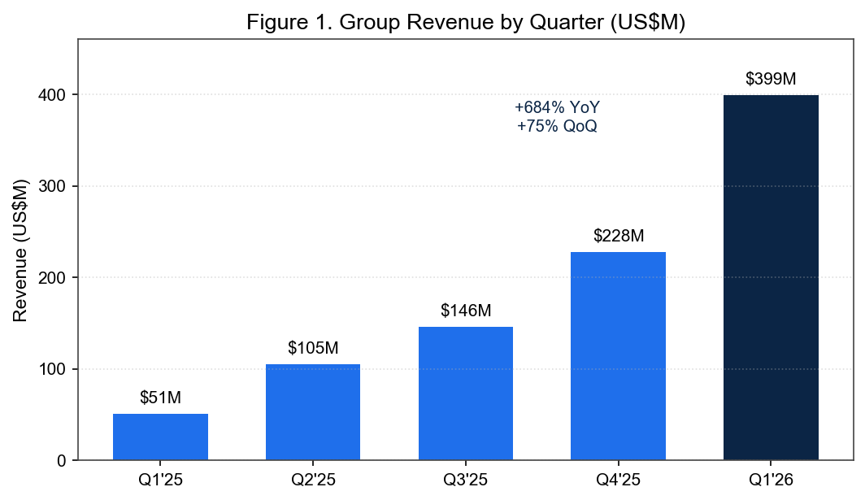
Source: Company quarterly press releases, Q1'25–Q1'26 (SEC EDGAR 6-K filings).

1. Results Detail — Beat Across the Board
Revenue Beat Driven by AI Cloud Ramp
Group revenue of $399.0M beat consensus of $391.6M by ~1.9% and grew 75% sequentially. Nebius AI Cloud revenue was $389.7M (+841% YoY, +82% QoQ), now 98% of the group. The outperformance was driven by faster-than-expected capacity coming online and immediate monetization — utilization remains effectively sold-out. ARR (annualized run-rate of the core infrastructure business) rose to $1.92B, +54% QoQ, implying asset productivity of ~$0.94M of ARR per active MW.
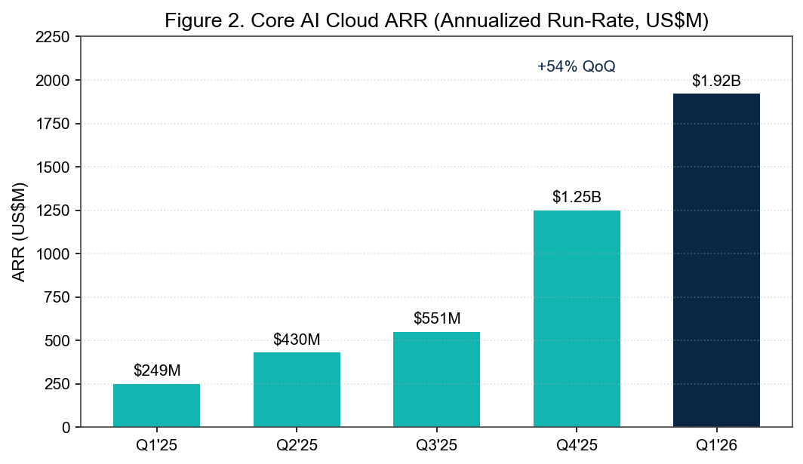
Source: Q1 2026 results press release, Nebius IR (May 13, 2026).
Profitability Inflection
Group adjusted EBITDA was $129.5M (32% margin), up from $15.0M (7%) in Q4'25 and a $(53.7)M loss a year ago. The core AI cloud adjusted EBITDA margin expanded to 45% (from 24% in Q4'25) as fixed costs leveraged against the revenue ramp. Reported GAAP net income from continuing operations was $621.2M, but this is flattered by a one-time $780.6M gain on the revaluation of the ClickHouse equity stake; on an adjusted basis Nebius posted a net loss of $(100.3)M, or $(0.39) per share — a far narrower loss than the $(0.78) consensus.
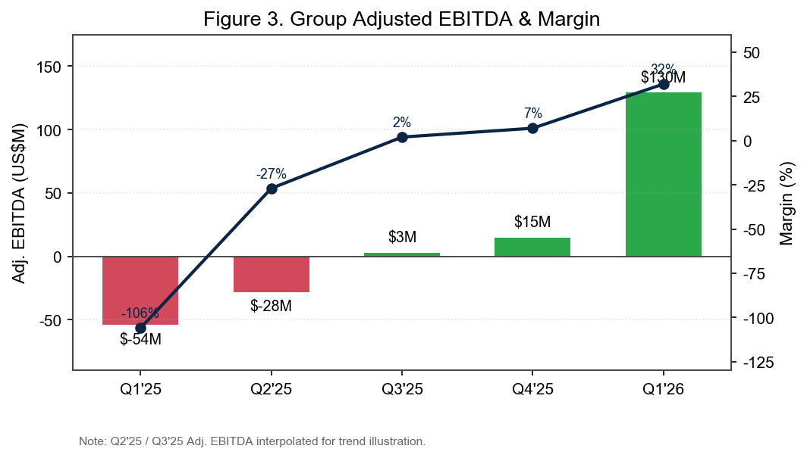
Source: Q1 2026 6-K and results release; Q2'25/Q3'25 adj. EBITDA interpolated for trend. SEC EDGAR.
Beat / Miss Summary
Nebius beat on revenue, adjusted EBITDA, and EPS. The stock rallied ~20% on the print, reflecting both the operational beat and the strategic Meta/NVIDIA validation.
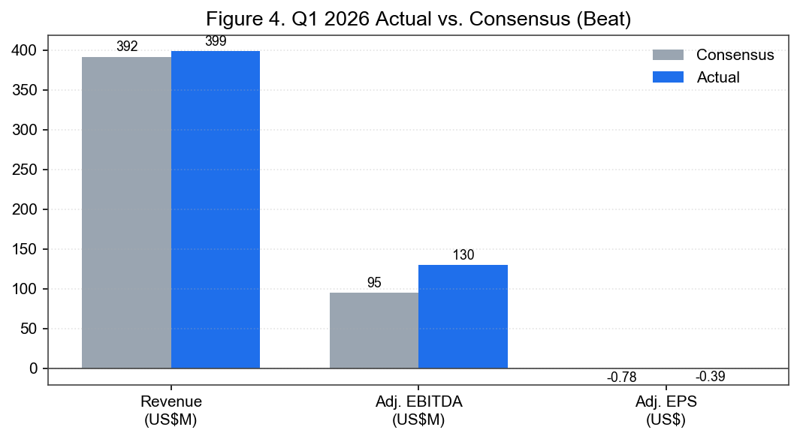
Source: Actuals per Q1 2026 release; consensus per Investing.com / Visible Alpha as of May 12, 2026. Investing.com transcript.

2. Key Metrics, Capacity & Capital
Capacity: Contracting Ahead of Demand
Nebius contracted >3.5 GW of power (up from ~2 GW the prior quarter) and raised its YE-2026 target to >4 GW. It announced a new 1.2 GW owned AI factory in Pennsylvania — its second US gigawatt-scale owned site — and now owns >75% of its capacity stack, a structural cost and control advantage versus lease-heavy neocloud peers. Data-center sites above 100 MW grew to 7 (from 1 at YE-2025). The Pennsylvania facility brings 250–300 MW online by end-2027, scaling to the full 1.2 GW by 2030; Alabama and Missouri projects begin contributing in early 2027.
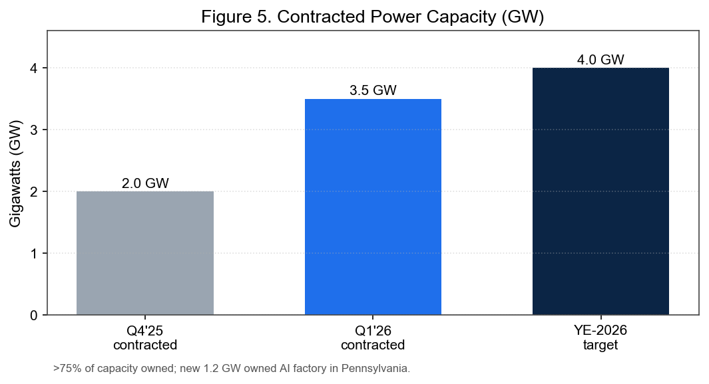
Source: Q1 2026 CEO letter to shareholders & earnings call (May 13, 2026). Nebius IR.
Capital: $9.3B Cash, >90% of Capex Funded
Nebius raised over $6B in Q1 — ~$4.3B of convertible senior notes (1.25%–2.60% coupons) and a $2.0B equity investment from NVIDIA — closing the quarter with $9.3B cash against $8.4B non-current debt. Operating cash flow turned strongly positive at +$2.3B. Management states >90% of current-plan capex is already secured by cash and contractual commitments, materially de-risking the funding of the 2026–27 build-out.
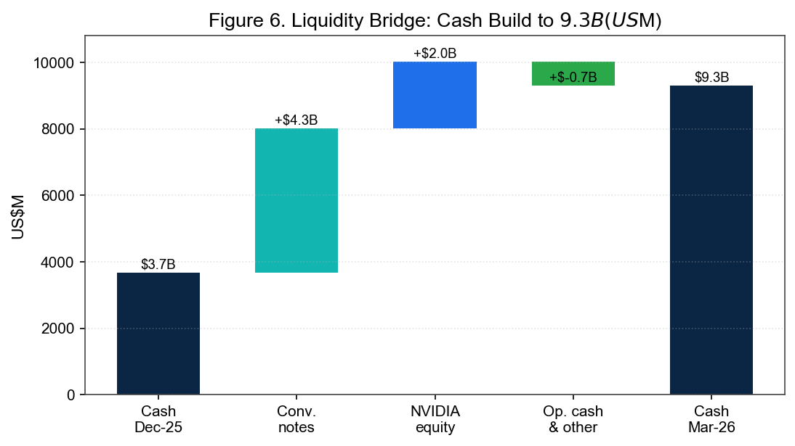
Source: Q1 2026 6-K, cash flow & financing statements. SEC EDGAR 6-K (May 13, 2026).
The Meta & NVIDIA Strategic Anchors
- Meta — $27B / 5 years: $12B of dedicated compute commitment plus $15B of optional capacity Nebius can resell to AI cloud customers at market rates, with Meta as backstop — an asset-backed financing tailwind.
- NVIDIA — $2B equity + preferred-builder status: Exemplar Cloud status on GB300 for training and differentiated access to future Vera Rubin / CPU platforms reinforces supply priority.
- Tuck-in M&A: Tavily, Eigen AI and Clarifai acquired to accelerate the inference / agent roadmap (Token Factory) — talent and tech, not standalone revenue.

3. Guidance & Updated Estimates
FY2026 Guidance Reiterated; Capex Raised
Management reiterated full-year 2026 targets of $7–9B exit-ARR, $3.0–3.4B group revenue, and ~40% group adjusted EBITDA margin, while raising 2026 capex to $20–25B (from $16–20B). The capex raise funds additional 2027 capacity that should begin contributing revenue in H1 2027 — i.e., it is growth capex against contracted demand, not speculative. Q2 margins are guided lower on back-end-weighted capacity deployment, recovering to Q1 levels in Q3 and higher in Q4.
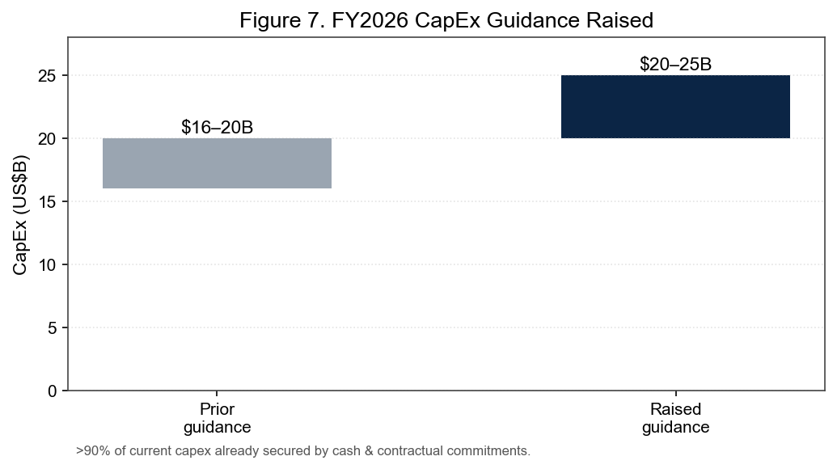
Source: Q1 2026 earnings call & CEO letter (May 13, 2026).
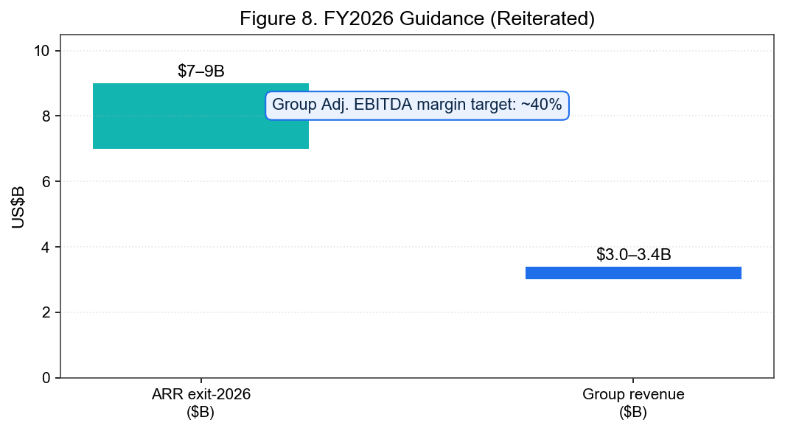
Source: Q1 2026 earnings call, management guidance (reiterated). The Motley Fool transcript.
Updated Estimates (Old vs. New)
Estimate | Old | New | Change | Driver
FY26E revenue | $3.1B | $3.3B | +6% | Faster capacity online; sold-out utilization
FY26E exit-ARR | $7.5B | $8.5B | +13% | Pipeline +3.5x QoQ; price increases
FY26E grp adj. EBITDA mgn | ~35% | ~40% | +5 pts | Core margin inflection to 45%
FY27E revenue | $8.5B | $10.5B | +24% | Pulled-forward 2027 capacity (PA/AL/MO)
FY26E capex | $18B | $22.5B | +25% | Growth capex vs. contracted demand
Source: Firm estimates (illustrative), anchored to reiterated company guidance from the Q1 2026 release.

4. Updated Investment Thesis
Thesis Intact and Strengthened
Our thesis — that Nebius is among the few independent “neocloud” platforms able to convert scarce GPU supply, owned power, and full-stack software into durable, high-margin AI infrastructure revenue — was materially strengthened this quarter. Three pillars improved:
- (1) Demand visibility: ARR +54% QoQ to $1.92B and a 3.5x QoQ pipeline expansion confirm demand outpaces supply; the $27B Meta anchor underwrites multi-year capacity.
- (2) Unit economics: 45% core AI cloud margin and ~$0.94M ARR/MW demonstrate the model scales profitably as capacity fills.
- (3) Funding risk reduced: $9.3B cash and NVIDIA's equity stake remove the financing overhang that pressures lease-heavy competitors.
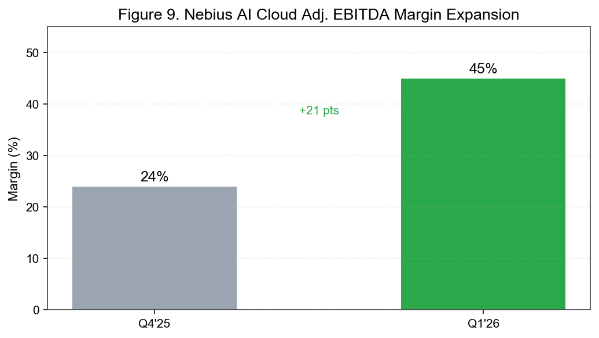
Source: Q1 2026 results release; core AI cloud segment margins. Nebius IR.
Risks to Monitor
- Customer concentration: Mega-deals (Meta, Microsoft) dominate backlog; renewal/ramp timing matters.
- Capex intensity & execution: $20–25B 2026 capex requires flawless construction, power and GPU delivery; cost inflation (low-single-digit %) is so far contained by early procurement.
- Compute pricing / supply normalization: Pricing power assumes continued GPU scarcity; a supply glut would compress margins.
- Non-core drag: Avride, TripleTen and Toloka remain loss-making; management seeks partners/spin-offs.
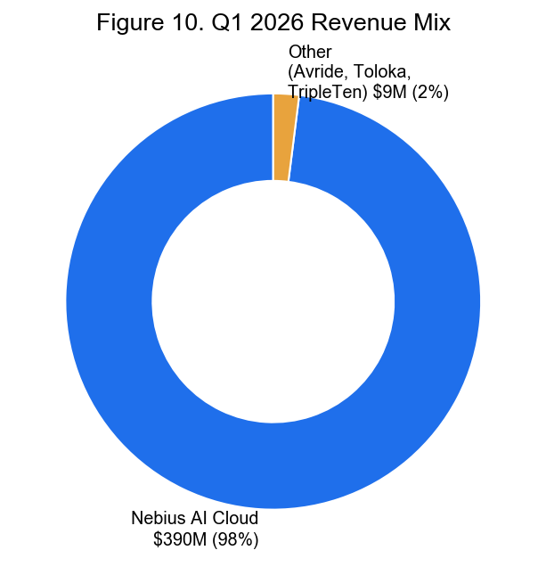
Source: Q1 2026 revenue by business; Nebius AI Cloud = 98% of group. Q1 2026 release.

5. Valuation & Recommendation
Rating: BUY (maintained) | Price Target: $330 (raised from $300)
We value Nebius on EV/ARR and a forward EV/revenue framework given the hyper-growth, pre-steady-state profile. On our raised ~$8.5B FY26 exit-ARR, the stock trades at roughly 8–9x EV/exit-ARR — a premium to legacy IaaS but reasonable versus the growth rate (ARR +54% QoQ) and improving margins. Applying ~10x EV/exit-ARR on de-risked 2026 ARR, net of the $9.3B cash and convertible debt, supports a $330 target (~17% upside from $280.91). Bull case (>$9B exit-ARR, 45%+ blended margins, Meta optional capacity fully resold) supports $400+; bear case (supply normalization, capex overrun, customer ramp slippage) implies ~$190.
Scenario | FY26 exit-ARR | EV/ARR | Implied value
Bull | $9.5B | ~12x | $400+
Base (PT) | $8.5B | ~10x | $330
Bear | $7.0B | ~6x | ~$190
Source: Firm valuation framework; market data via Yahoo Finance (yfinance), price as of June 17, 2026.
Catalysts (next 6–12 months)
- Q2 2026 print (mid-Aug 2026): ARR trajectory toward $7–9B exit; margin cadence confirmation.
- Additional hyperscaler / frontier-lab capacity deals beyond Meta & Microsoft.
- Pennsylvania / Alabama / Missouri construction milestones and power energization.
- Potential monetization (partner or spin) of Avride / TripleTen / Toloka.

Sources & References
Earnings Materials (Q1 2026 — reported May 13, 2026):
- Q1 2026 Results Press Release — Nebius Newsroom (May 13, 2026)
- Q1 2026 Results — BusinessWire distribution (May 13, 2026)
- Form 6-K — Nebius Group N.V., SEC EDGAR (CIK 0001513845)
- Q1 2026 Earnings Call Transcript — The Motley Fool (May 13, 2026)
- Q1 2026 Earnings Call Transcript — Investing.com (May 13, 2026)
- Nebius Investor Hub / Financials
- Q1 2026 Coverage — Seeking Alpha

Disclaimer: This earnings update is prepared for informational purposes only and does not constitute investment advice or an offer to buy or sell any security. Estimates are illustrative. Market data retrieved via Yahoo Finance (yfinance) as of June 17, 2026.

