EQUITY RESEARCH - EARNINGS UPDATE
MICRON TECHNOLOGY, INC. (NASDAQ: MU)
Q3 FY2026: Record Quarter, SCA Visibility, and Another Beat-and-Raise
Rating | Price Target | Current Price | Market Cap | Report Date
BUY / OW | $1,600 | $1,154.29 | ~$1.30T | July 1, 2026
Market data: Longbridge CLI quote MU.US, pulled July 1, 2026 16:24 CST. yfinance was unavailable in the local runtime; price data was pulled dynamically via Longbridge.
EARNINGS SUMMARY
Metric | Reported / Guide | Consensus | Variance | YoY
Revenue | $41.46B | $35.91B | Beat +$5.55B (+15.4%) | +346%
Non-GAAP EPS | $25.11 | $20.86 | Beat +$4.25 (+20.4%) | +1,215%
Non-GAAP Gross Margin | 84.9% | N/A | Company record | +45.9pp
Operating Cash Flow | $25.39B | N/A | Record cash generation | +451%
FQ4 Revenue Guide | $50.0B +/- $1.0B | $43.58B | Guide +15% vs. Street | +342% implied YoY
Source: Micron earnings release; IBD / FactSet consensus
- Top-line beat was large and clean. Revenue of $41.46B was $5.55B above FactSet consensus and rose 74% sequentially, with DRAM and NAND both setting records.
- Margins changed the valuation conversation. Non-GAAP gross margin reached 84.9% and operating margin reached 81.2%, levels that suggest the current memory shortage is not a normal cycle.
- Strategic Customer Agreements reduce historical cyclicality. Micron has signed 16 SCAs; signed-agreement RPO is approximately $100B, with $22B of expected cash deposits and related commitments.
- Maintaining BUY; raising price target to $1,600. Our target reflects higher FY2026/FY2027 EPS, improved revenue visibility, and a higher warranted multiple for a more contracted memory model.

DETAILED RESULTS ANALYSIS
Revenue: record scale and accelerating sequential growth
Micron reported fiscal Q3 revenue of $41.46B for the quarter ended May 28, 2026, up 346% YoY and 74% QoQ. The beat was driven by a severe demand/supply imbalance across both DRAM and NAND, a richer AI-driven mix, and pricing that moved far faster than investors had modeled. The $5.55B revenue beat vs. FactSet was not a rounding issue: it was equivalent to more than half of the revenue Micron generated in the same quarter a year ago.
Figure 1 - Quarterly revenue progression
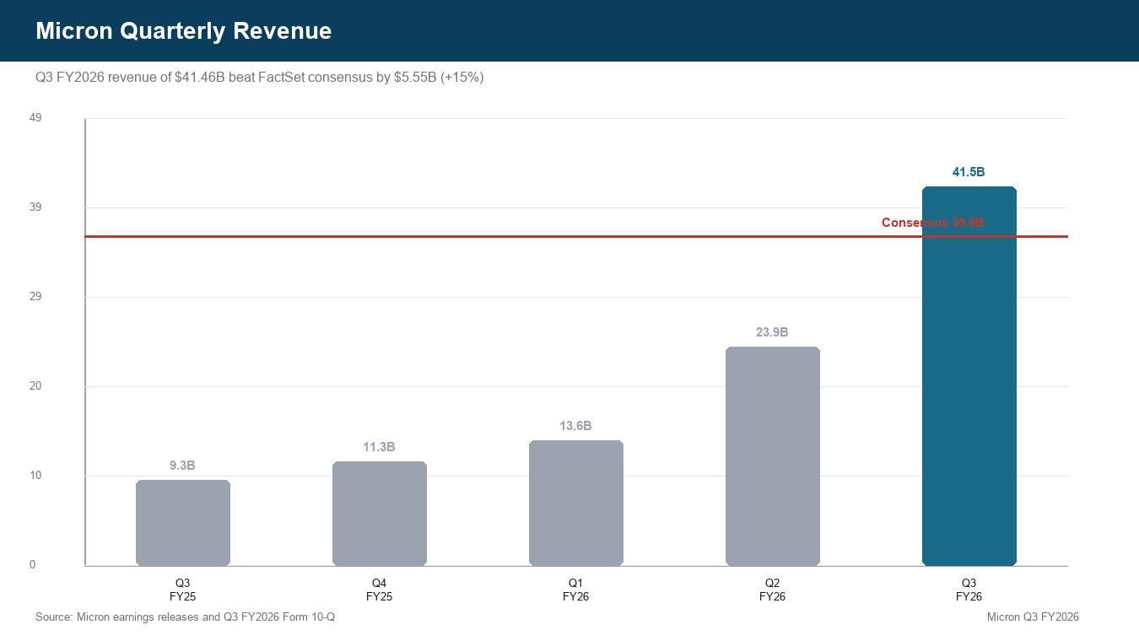
Source: Micron earnings release; Form 10-Q; FactSet via IBD
DRAM and NAND: both businesses are now capacity-constrained
Prepared remarks show DRAM revenue of $31.3B, up 343% YoY and 67% QoQ, representing 76% of company revenue. NAND revenue was $9.9B, up 361% YoY and 99% QoQ, representing 24% of revenue. Management attributed the growth mostly to pricing: DRAM ASPs increased in the low-60% range sequentially, while NAND ASPs increased in the mid-80% range.
Figure 2 - DRAM and NAND revenue by quarter
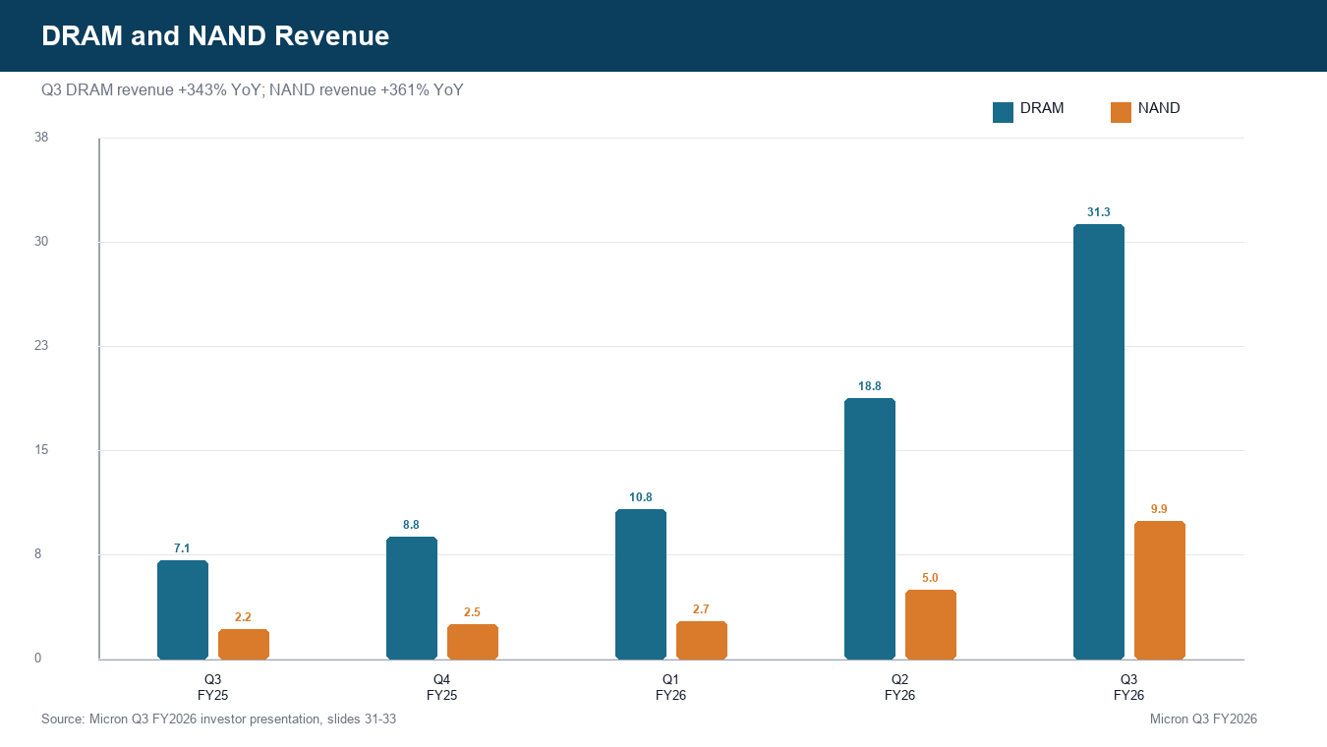
Source: Prepared remarks; Investor presentation
Business units: all four reached records
Business Unit | Revenue | Gross Margin | QoQ | YoY
Cloud Memory | $13.8B | 83% | +78% | +307%
Core Data Center | $11.5B | 87% | +103% | +653%
Mobile & Client | $11.5B | 87% | +49% | +254%
Auto & Embedded | $4.6B | 79% | +71% | +311%
Source: Micron Q3 FY2026 press release; Investor presentation slides 22-24
Figure 3 - Revenue by business unit
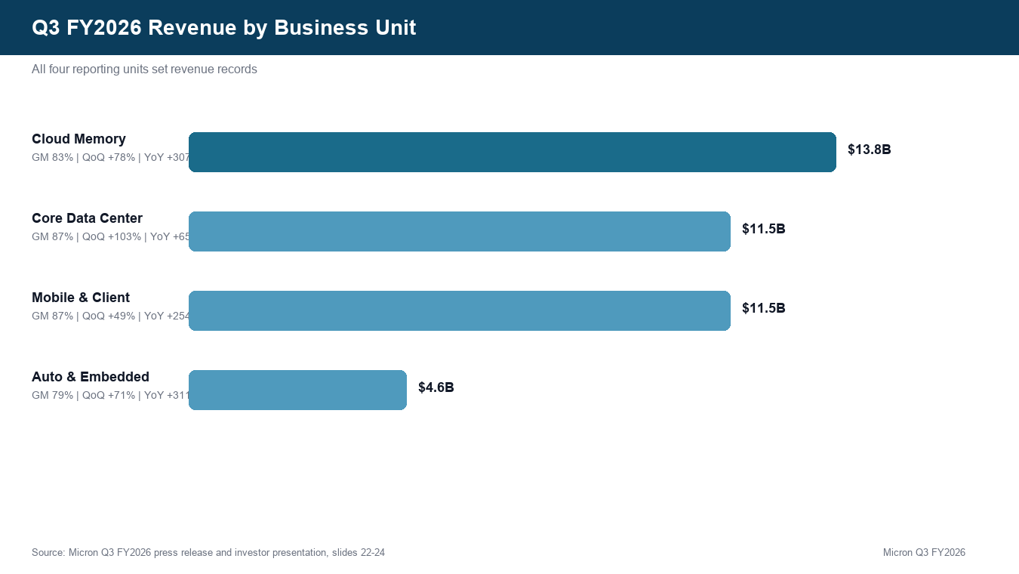
Source: Micron investor presentation

PROFITABILITY AND CASH FLOW
Gross margin expanded 10 points sequentially
Non-GAAP gross margin reached 84.9%, up roughly 10 percentage points sequentially and more than double the year-ago level. The primary driver was pricing, with favorable mix and manufacturing execution also helping. This is the clearest signal that memory has temporarily shifted from commodity oversupply to scarcity economics.
Figure 4 - Gross and operating margin trend
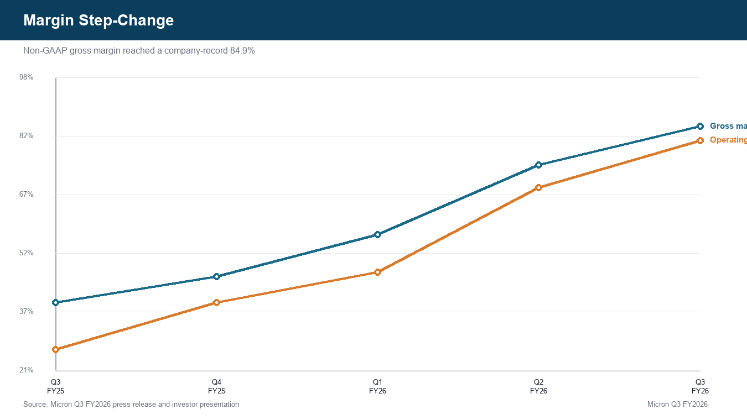
Source: Earnings release; Investor presentation
EPS and cash generation were both far ahead
Non-GAAP EPS of $25.11 beat FactSet consensus by $4.25, or 20%. Non-GAAP operating income was $33.68B, equivalent to an 81.2% margin. Operating cash flow was $25.39B and adjusted free cash flow was $18.3B, a company record even with net capex of $7.1B.
Figure 5 - Non-GAAP EPS progression
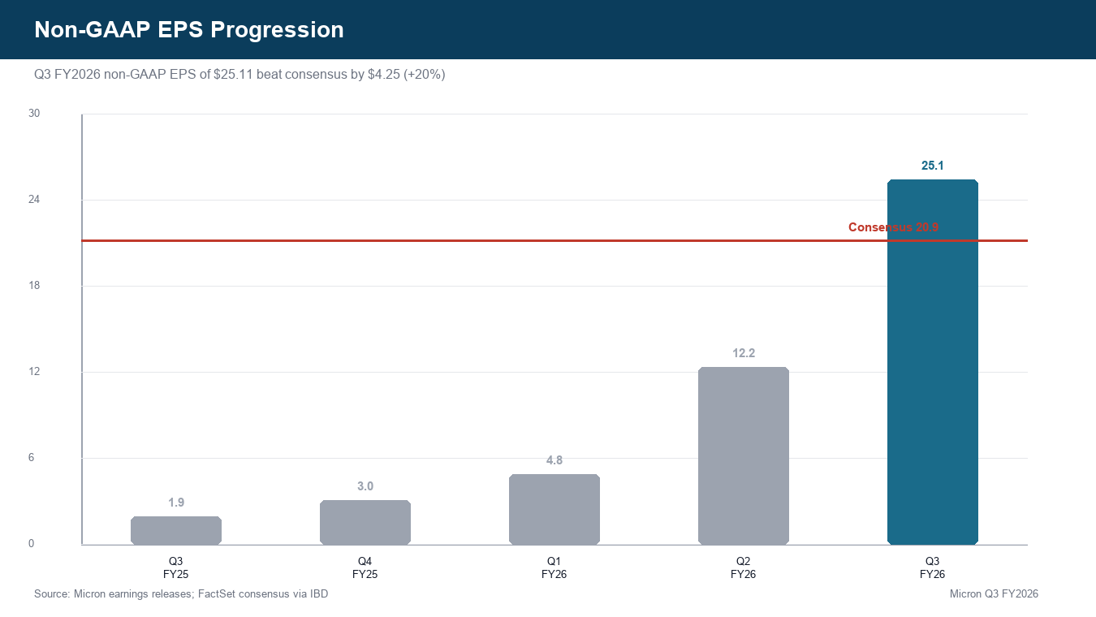
Source: Earnings release; FactSet via IBD
Figure 6 - Operating cash flow and net capex
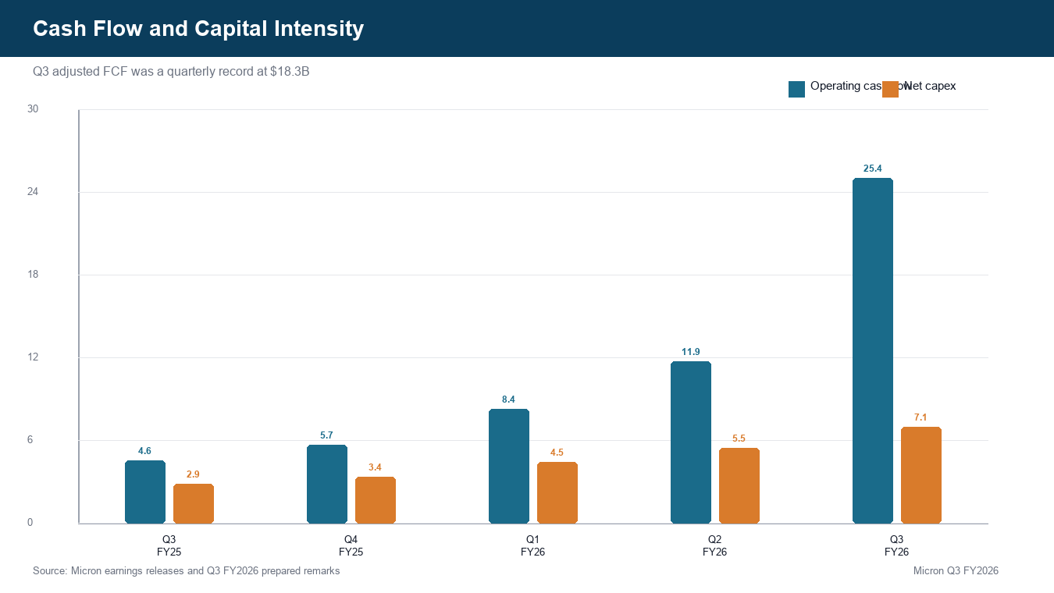
Source: Prepared remarks; Investor presentation

GUIDANCE AND OUTLOOK
FQ4 guide again resets expectations
For FQ4, Micron guided to revenue of $50.0B +/- $1.0B, non-GAAP gross margin of approximately 86%, non-GAAP operating expenses of approximately $1.65B, and non-GAAP EPS of $31.00 +/- $1.00. This was well above pre-earnings Street expectations of $43.58B revenue and $25.72 EPS.
Metric | Micron FQ4 Guide | Consensus | Implication
Revenue | $50.0B +/- $1.0B | $43.58B | +15% vs. Street
Non-GAAP Gross Margin | Approx. 86% | N/A | +110bps QoQ
Non-GAAP EPS | $31.00 +/- $1.00 | $25.72 | +21% vs. Street
Net Capex | ~$10B | N/A | FY2026 capex ~$27B
Source: Micron press release; Prepared remarks; IBD / FactSet
Figure 7 - Q4 guidance vs. Street
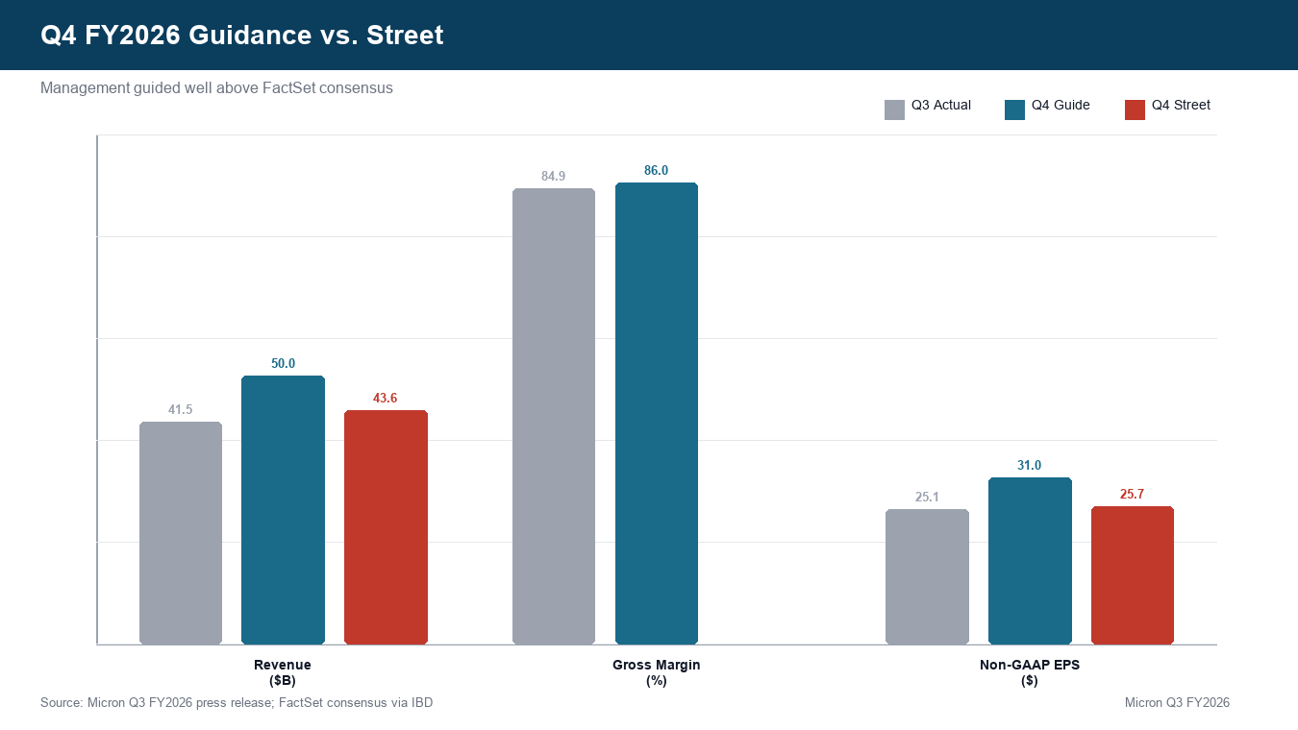
Source: Micron press release; IBD / FactSet
SCA visibility is the new thesis variable
The most important qualitative update was the Strategic Customer Agreement framework. Micron disclosed 16 signed agreements. RPO at FQ3 was over $5B; including agreements executed after quarter-end, RPO is approximately $100B based on minimum committed volumes and minimum pricing. Management expects $22B of cash deposits and related commitments, with approximately $18B in cash deposits.
Figure 8 - Strategic customer agreement visibility
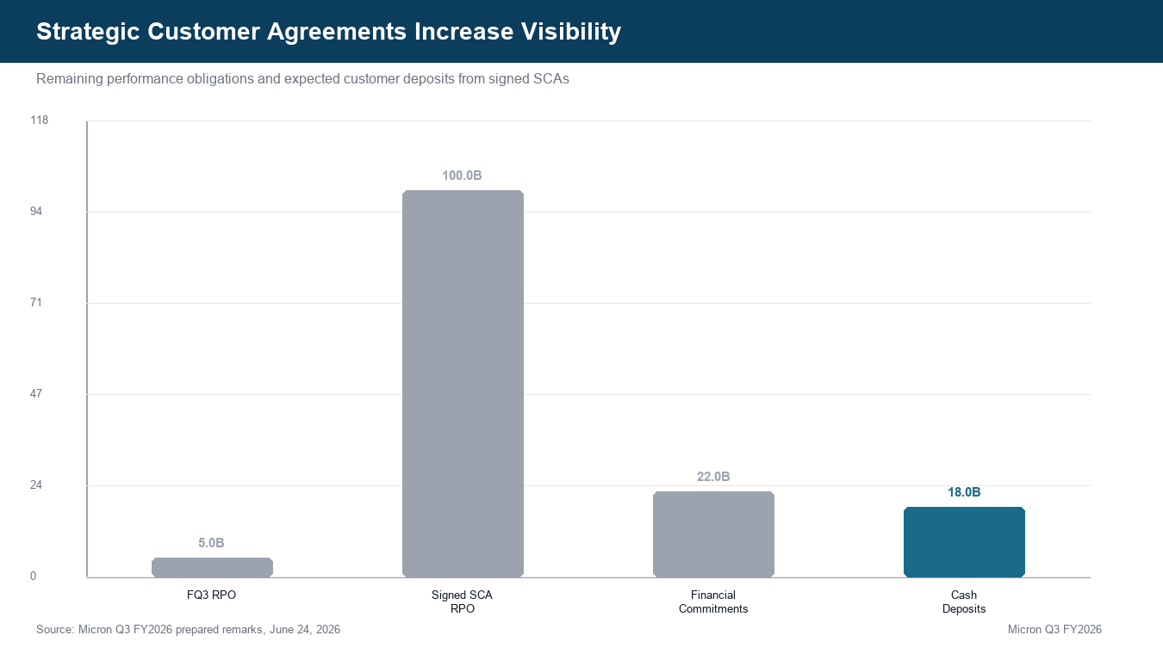
Source: Prepared remarks

UPDATED INVESTMENT THESIS
- Thesis pillar 1 - AI memory has become strategic infrastructure. The quarter confirms that HBM, advanced DRAM, and data-center NAND are no longer simply cyclical components. They are becoming bottleneck resources in AI infrastructure.
- Thesis pillar 2 - Contracted demand supports a higher multiple. SCAs do not remove cyclicality, but they add minimum-volume, minimum-price visibility that should reduce the depth of future downcycles.
- Thesis pillar 3 - Supply will take years, not quarters, to catch up. Prepared remarks state that DRAM and NAND supply-demand conditions are expected to remain tight beyond calendar 2027. New U.S., Taiwan, Singapore, and Japan capacity helps but is not immediate.
- Thesis pillar 4 - Capital intensity rises, but cash flow rises faster. FY2026 capex is now expected at roughly $27B, yet Q3 FCF was $18.3B and management expects FQ4 FCF to increase substantially again.
Risks
- Customer behavior risk: High memory prices could push hyperscalers, OEMs, and AI accelerator vendors to optimize memory usage or delay deployments.
- Cycle risk: Memory remains a cyclical market. If supply additions arrive faster than demand, today’s margin structure could compress quickly.
- Geopolitical risk: Micron’s global footprint and China exposure remain vulnerable to export controls, trade policy changes, and customer restrictions.
- Valuation risk: After a sharp stock move, the market is already pricing in a significant duration of supernormal earnings.

VALUATION AND ESTIMATE REVISIONS
Updated model
We raise our illustrative FY2026 and FY2027 model materially. Q1-Q3 FY2026 non-GAAP EPS already totals approximately $42.09, and FQ4 guidance implies full-year non-GAAP EPS of roughly $73. The old model was anchored to a faster normalization of pricing; the new model assumes tight supply extends through 2027, in line with management commentary.
Metric | Old FY2026E | New FY2026E | Change | FY2027E
Revenue ($B) | 112.0 | 129.0 | +15% | 175.0
Gross Margin | 78.0 | 80.5 | +3% | 82.0
Non-GAAP EPS | 60.0 | 73.1 | +22% | 115.0
Free Cash Flow ($B) | 42.0 | 55.0 | +31% | 75.0
Source: Company filings; Micron prepared remarks; Codex analysis
Figure 9 - Estimate revisions and price target
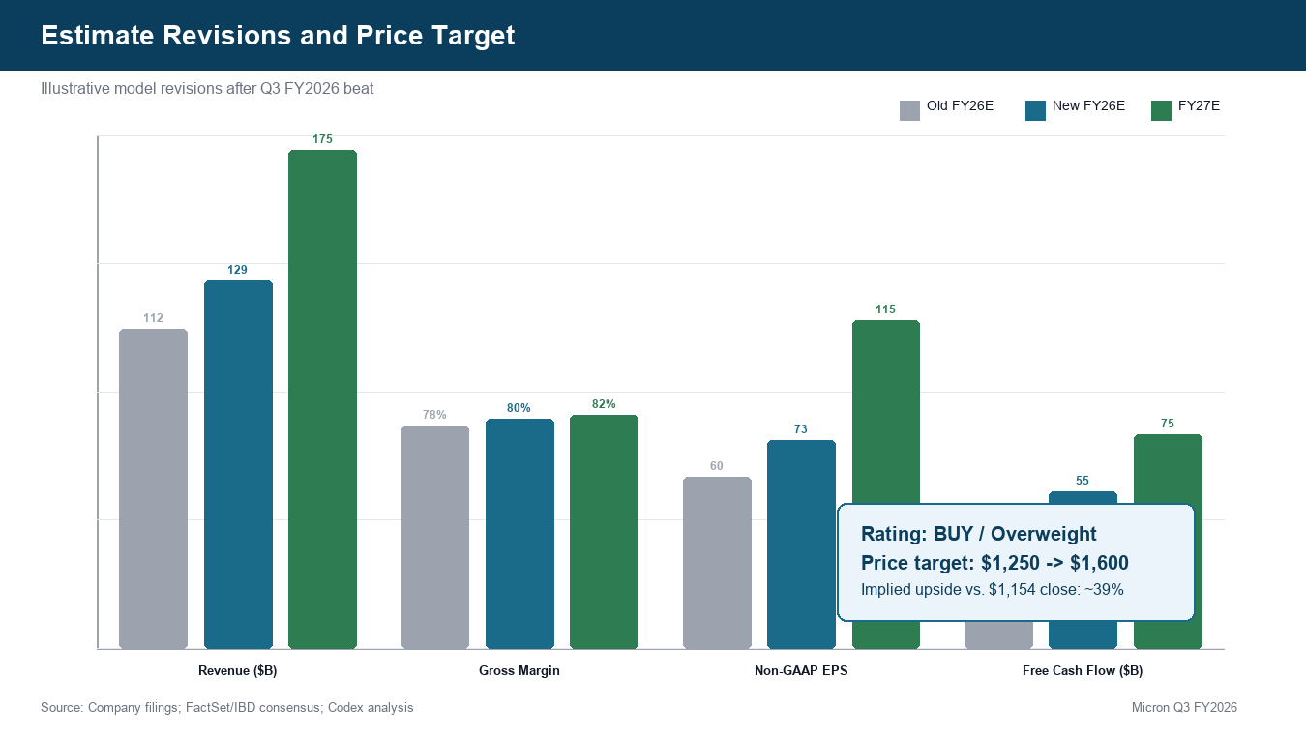
Source: Company filings; Codex analysis
Price target methodology
We raise the illustrative price target to $1,600 from $1,250. The target applies roughly 13.9x our FY2027E non-GAAP EPS estimate of $115, a premium to a normal commodity-memory multiple but justified by signed SCA visibility, a stronger net-cash balance, and structurally higher AI-memory content. The target implies approximately 39% upside from the June 30 close of $1,154.29.
We would revisit the rating if either: (1) SCA cash deposits and RPO conversion fail to appear on schedule, (2) Q4 gross margin falls meaningfully below the 86% guide, or (3) industry supply commentary changes from tight beyond 2027 to normalization inside 2027.
Figure 10 - Headline beat/miss summary
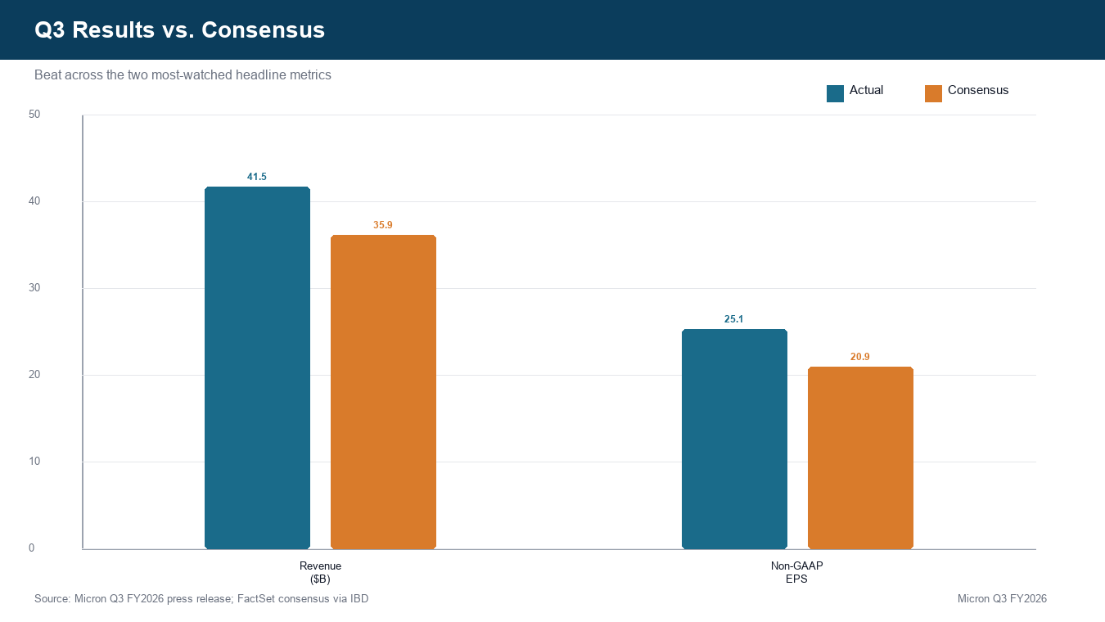
Source: Micron press release; IBD / FactSet

SOURCES AND REFERENCES
Latest-quarter verification: today is July 1, 2026; the latest earnings release was dated June 24, 2026; the 10-Q was filed June 25, 2026. The release is within the last three months and all materials refer to Q3 FY2026, quarter ended May 28, 2026.
- Micron Q3 FY2026 earnings release
- Micron Q3 FY2026 investor presentation
- Micron Q3 FY2026 prepared remarks/webcast materials
- Micron Q3 FY2026 Form 10-Q
- Micron quarterly results page
- Investor's Business Daily / FactSet consensus
- Investopedia / Visible Alpha consensus
Consensus: FactSet consensus cited by Investor's Business Daily, June 24, 2026; additional consensus cross-check from Investopedia / Visible Alpha.
Additional consensus cross-check: Investopedia / Visible Alpha
Disclaimer: This report is for informational purposes only and does not constitute investment advice or a recommendation to buy or sell securities.

