http://localhost:8080/LMS/login to access to the Library Management System:

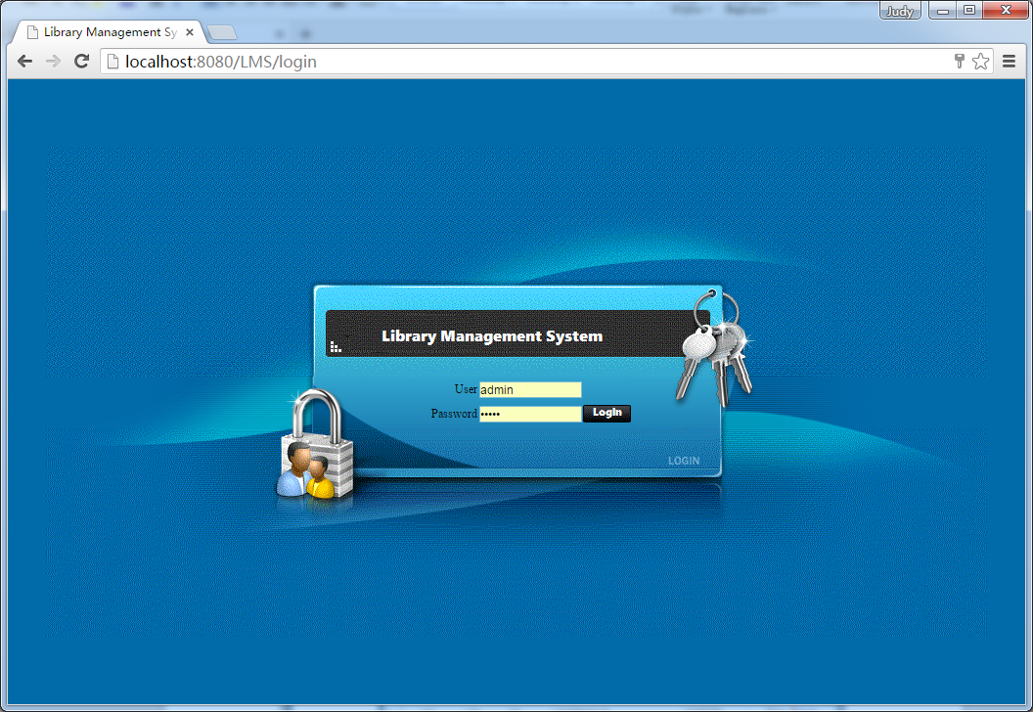

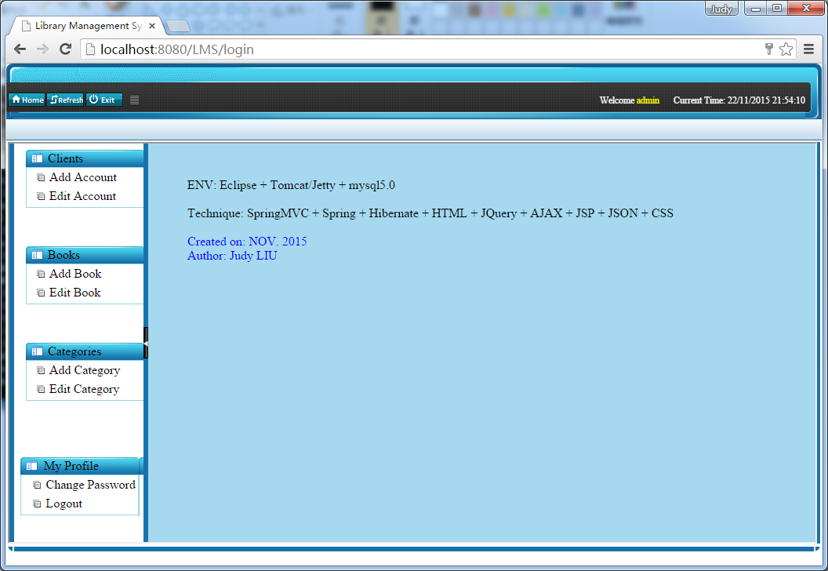
Click “Edit Account”, you will see all the borrower list:

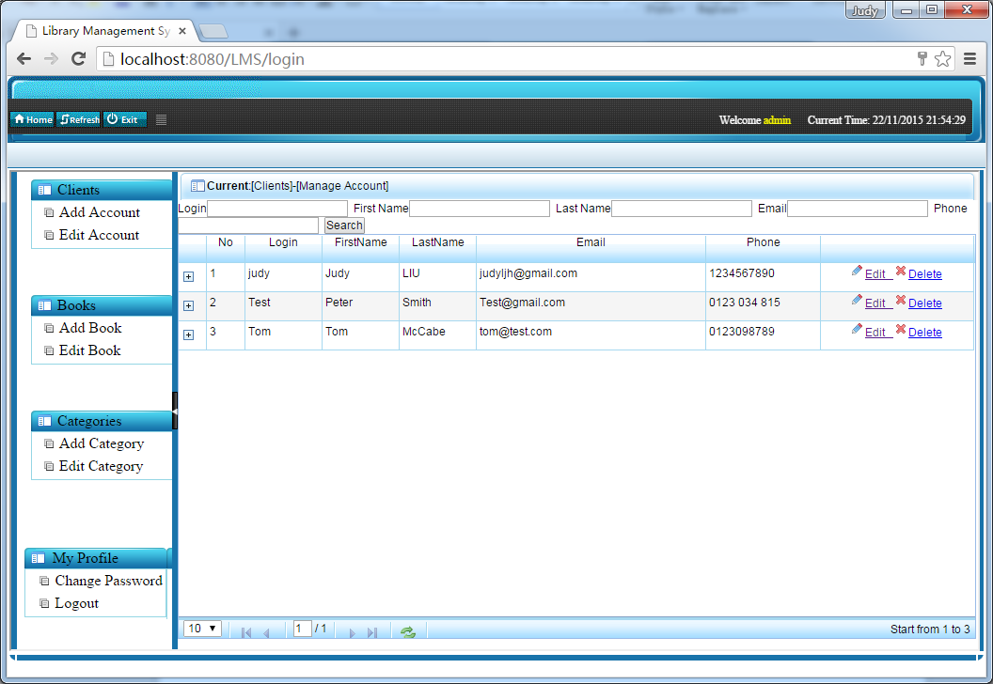

Click “Edit Book”, you will get all the books list:

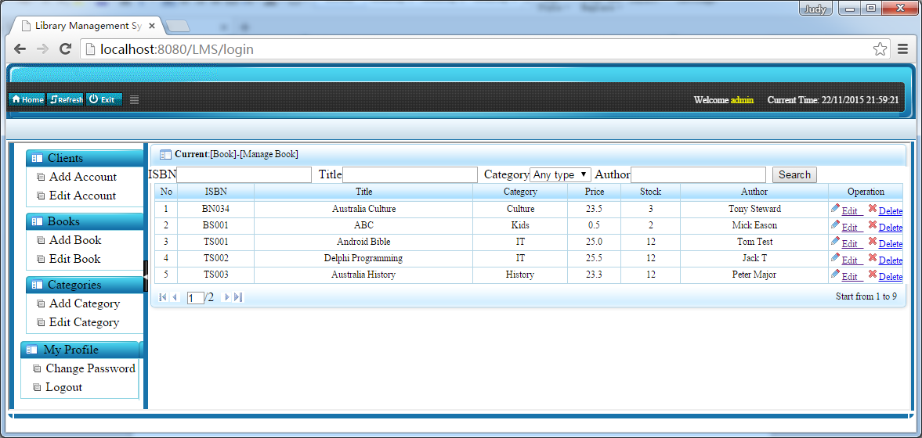

Click () by one of accounts , you will see the books the person have lent:

