|  |  |  |  |  |  |  |  |  |  |  |
| --- | --- | --- | --- | --- | --- | --- | --- | --- | --- | --- |
| 偏转量  阳极电压 | D | 20 | 15 | 10 | 5 | 0 | -5 | -10 | -15 | -20 |
| 700v | 偏转电压U(v) | 17.3 | 13.2 | 9.0 | 4.7 | 0 | -3.8 | -7.9 | -12.4 | -16.6 |
| 900v | 偏转电压U(v) | 21.7 | 16.6 | 11.4 | 6.2 | 0 | -5.2 | -10.8 | -16.3 | -21.8 |

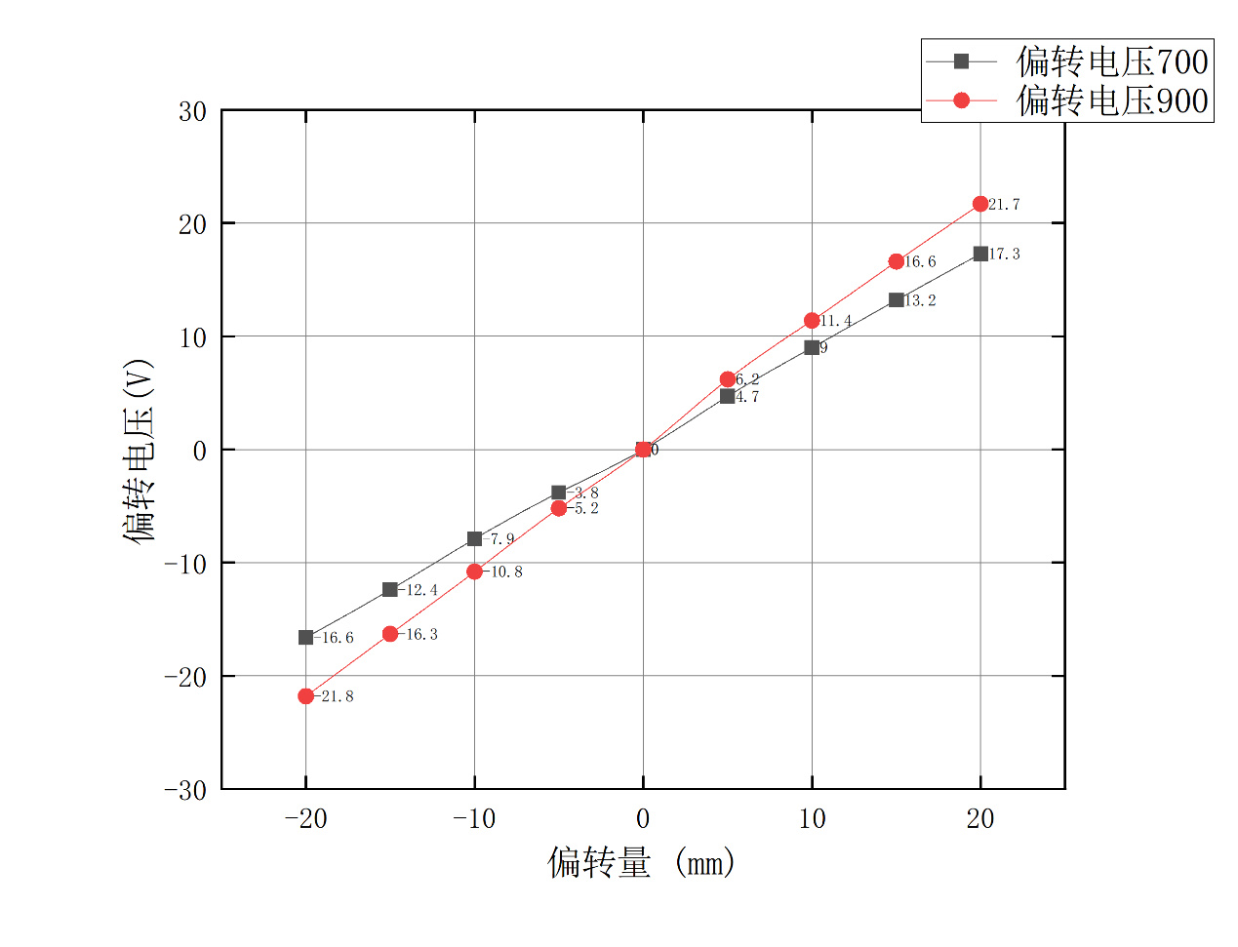

|  |  |  |  |  |  |  |  |  |  |  |
| --- | --- | --- | --- | --- | --- | --- | --- | --- | --- | --- |
| 偏转量  阳极电压 | D | 20 | 15 | 10 | 5 | 0 | -5 | -10 | -15 | -20 |
| 700v | 励磁电流(mA) | 144 | 107 | 72 | 35 | 0 | 36 | 74 | 113 | 146 |
| 900v | 励磁电流(mA) | 161 | 119 | 78 | 40 | 0 | 39 | 80 | 120 | 161 |

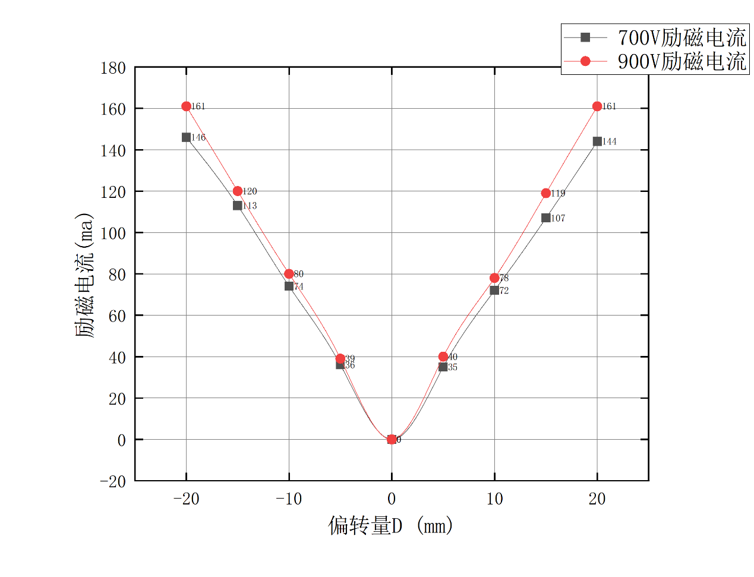

|  |  |  |  |  |
| --- | --- | --- | --- | --- |
| 电压  电流(A) | 700V | 800V | 900V | 1000V |
| I正 | 1.44 | 1.62 | 1.71 | 1.82 |
| I反 | 1.46 | 1.58 | 1.72 | 1.89 |
| I平均 | 1.45 | 1.60 | 1.71 | 1.85 |
|  | 1.62*1011 | 1.52*1011 | 1.50*1011 | 1.42*1011 |
| 平均 | 1.52*1011 | | | |

