CM 515: Spring 2025
Introduction to Protein Bioinformatics Tools (24 pts)
- BLASTP
  - Using BLASTP, identify the protein and species it comes from with the sequence given (1 pt)

Protein: luciferase subunit alpha, Species: Aliivibrio fischeri

  - Copy and paste the amino acid sequence of the three nearest homologs from different species. Include the name of the three species. (1 pt)

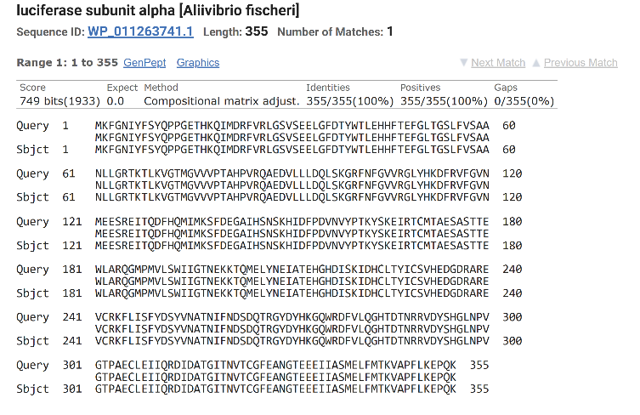
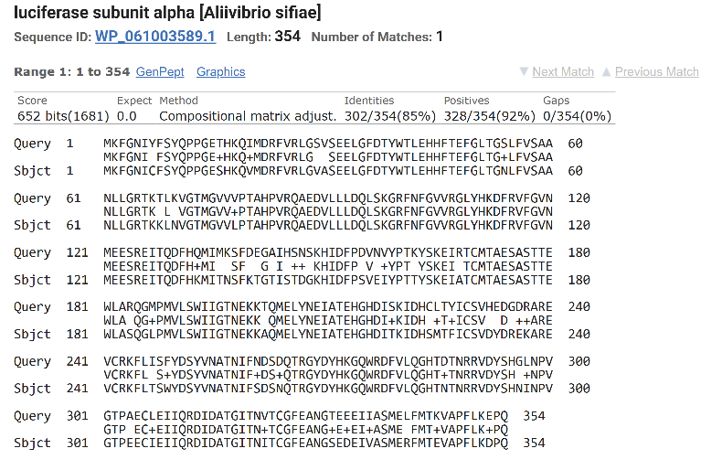

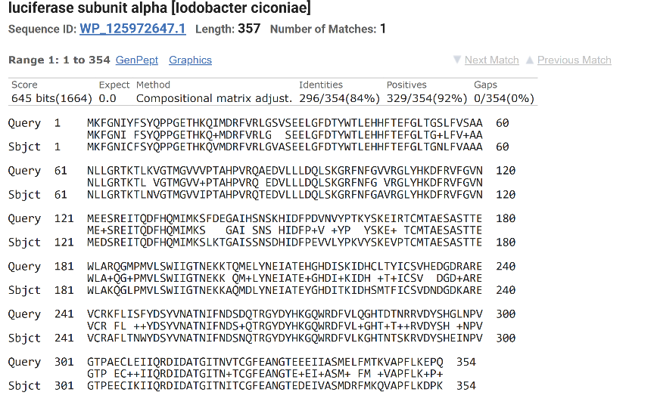

- Clustal Omega
  - Identify three amino acids that are exactly conserved (i.e. the exact same amino acid) across all the homologs (1 pt)
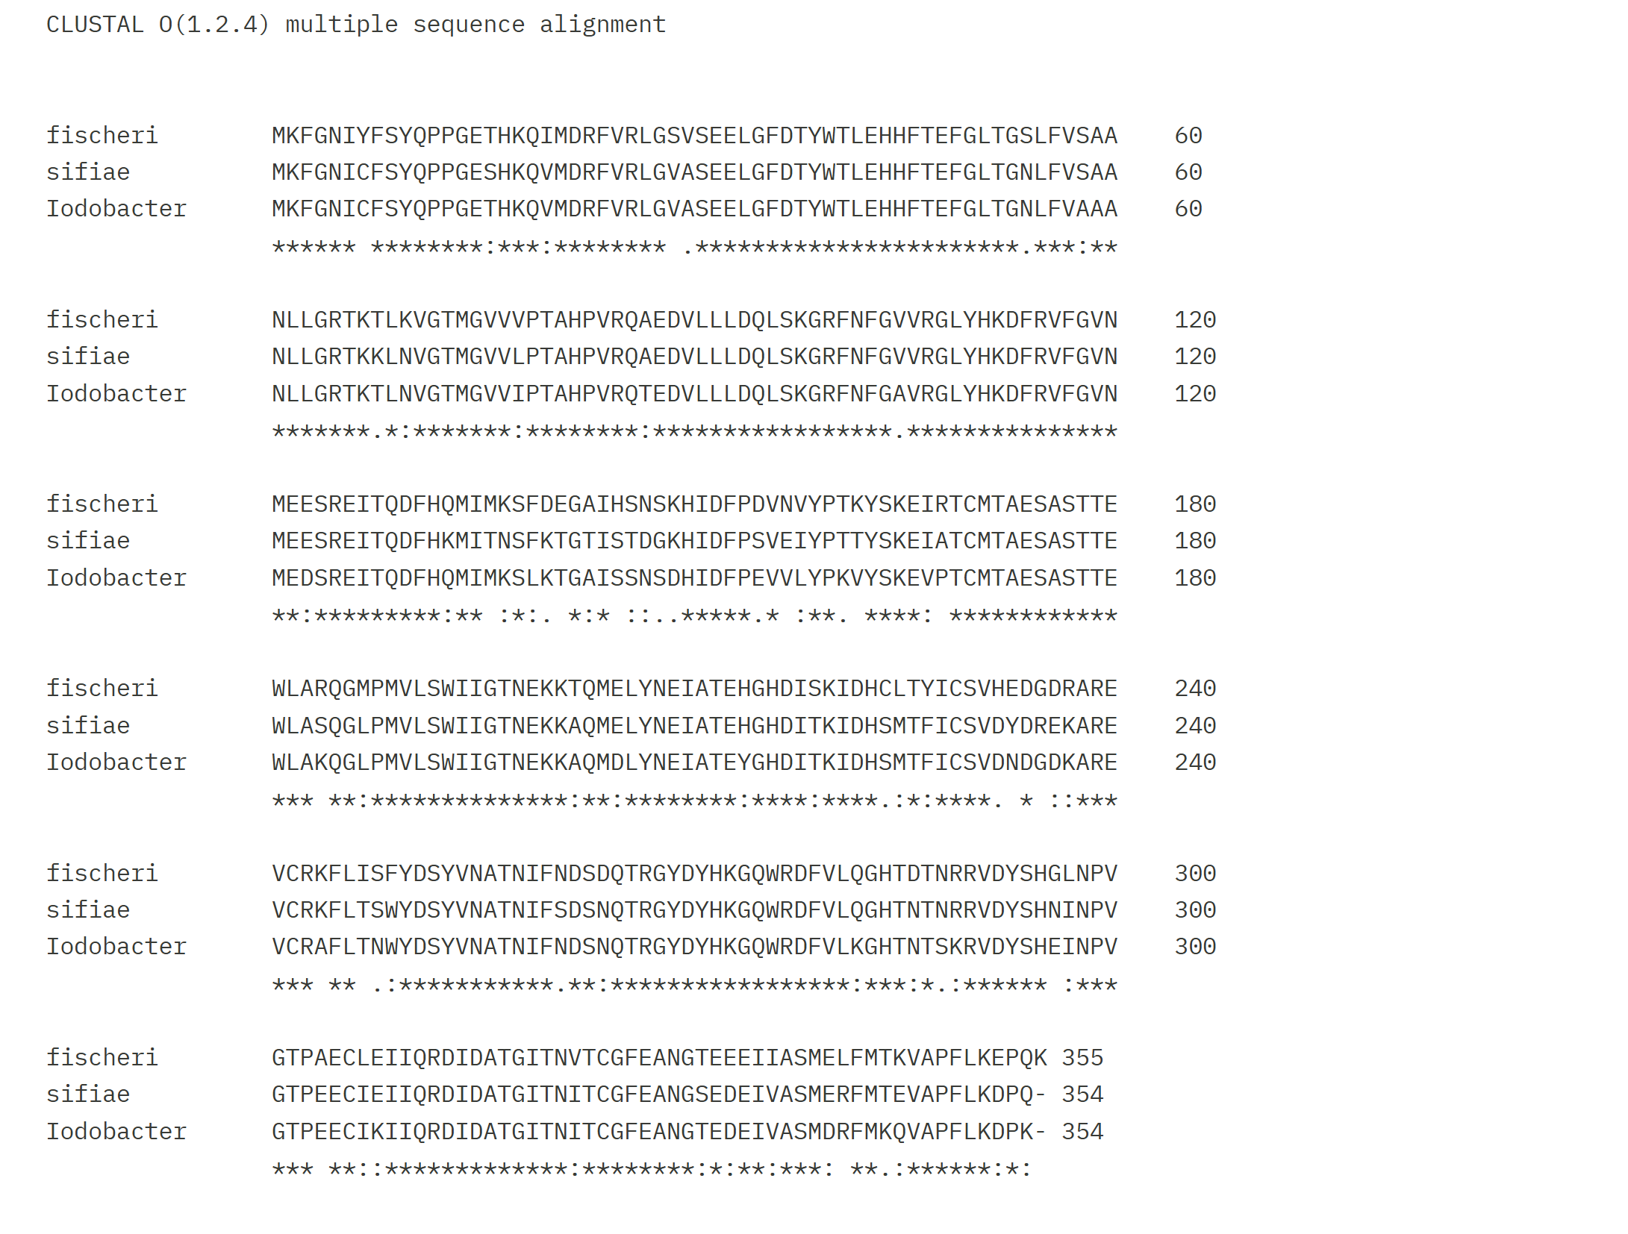

Methionine, Lysine, Phenylalanine

  - Identify three amino acids that are functionally conserved (i.e. similar function, shown as colons in Clustal) across all the homologs (1 pt)


  - Identify the homolog that is the most distant phylogenetically from the rest of the proteins by going to the phylogenetic tree portion of Clustal Omega (1 pt)

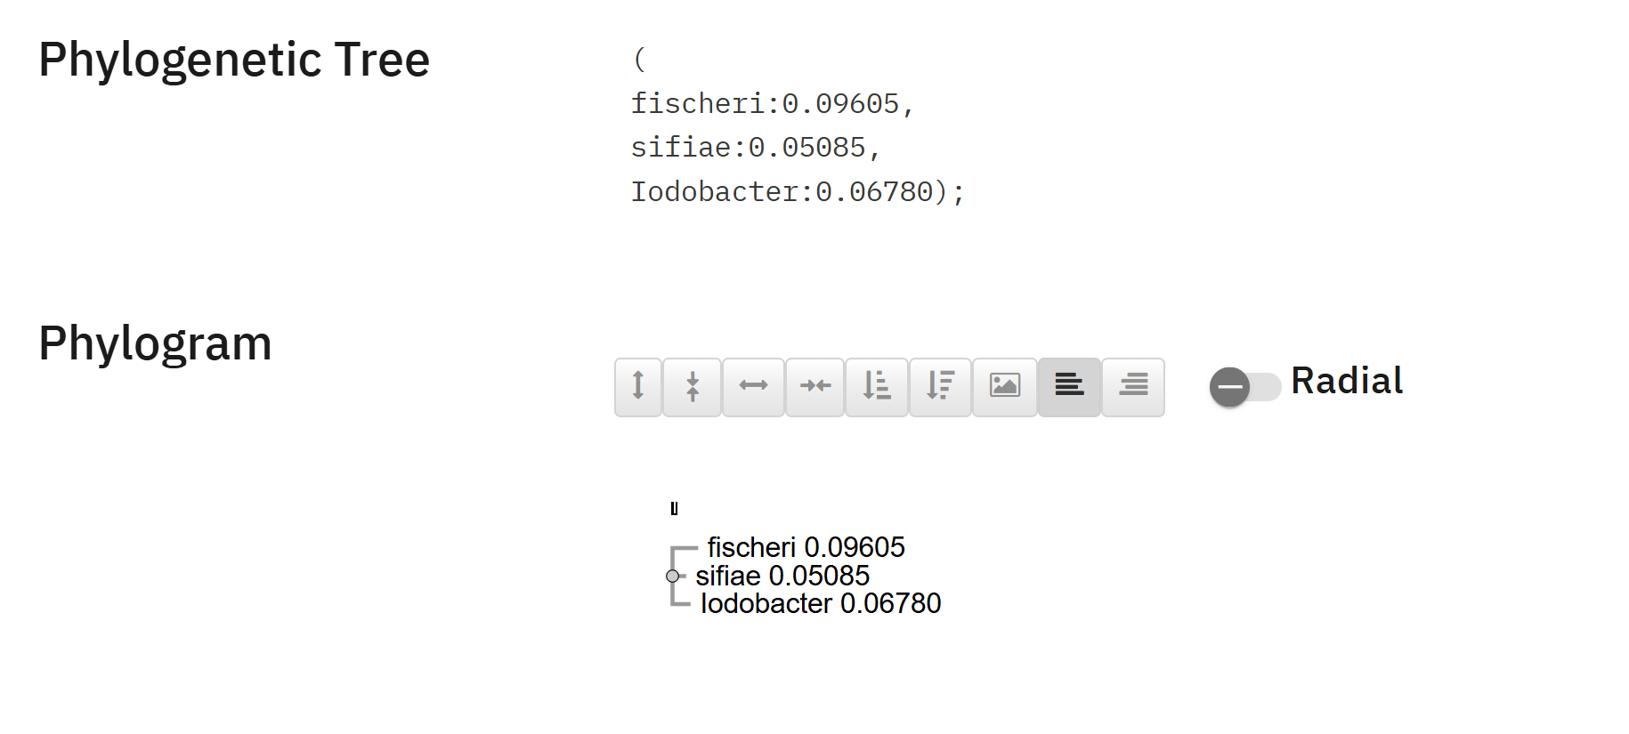

The protein of Aliivibrio fischeri is the most distant phylogenetically

- KEGG
  - Use KEGG Organisms to find the organism code for your species and put it here (1 pt)

Aliivibrio sifiae: No code found

  - Use the organism code and the common name of your protein to find the KEGG page for your protein. Put the KEGG gene code and a screenshot of the KEGG page for your protein here (1 pt)

  - Identify a pathway your protein is a part of and take a screenshot of the pathway with your protein highlighted (1 pt)

  - Navigate to the page of another protein that is part of the pathway and put its name and amino acid sequence here (1 pt)

- UniProt
  - Navigate to the UniProt page for your protein and identify the predicted mass of the protein from the “Sequence” section (1 pt)

  - Find one publication that mentions your protein in UniProt and put the title here (1 pt)

  - Find one hypothesized or experimentally determined interacting partner of your protein and put the amino acid sequence here. UniProt may not have a direct link so you may have to do some digging on your own (1 pt)

  - Find one additional fact about your protein from UniProt and put it here (1 pt)

- RCSB/PDB
  - Find a structure for your protein or a closely related protein. List the name of the crystallized complex, the PDB 4 letter identifier, and the species the structure is from (1 pt)
    - You can search by protein name/species in RCSB, or you can use the sequence to search for matches or structures with similar proteins.

  - What is the experimental method used to find this structure? (1 pt)

  - What paper is the structure from? (1 pt)

  - Take a screenshot of the 3D structure in the PDB viewer (1 pt)

- AlphaFold3: https://alphafoldserver.com/
  - Generate AlphaFold3 structures from the amino acid sequence you received and the three homologs you identified earlier. Post screenshots of the four different structures (1 pt)

  - Generate a structure with both your protein and it’s interacting partner you identified from UniProt and post a screenshot here (1 pt)

  - Based on the generated structure, pTM, and ipTM score does AlphaFold3 support these two proteins interacting directly? There is no right answer here, you should critically think about what these statistics tell you and make an educated guess (1 pt)

- PyMOL: For these questions when it asks for a picture, take a high-quality picture as described in the lecture
  - Pull the AlphaFold3 structure of your original protein into PyMOL. Use your Clustal alignment to color the three exactly conserved residues you identified earlier one color and three positive residues a different color. Take a picture and paste it here. (1 pt)

  - Pull the solved structure you pulled from RCSB/PDB into PyMOL. Align the AlphaFold3 and experimentally determined structures and take a picture and paste it here. (1 pt)

  - Pull the 3 structures of the homologs generated by AlphaFold3 into PyMOL. Align them all and take individual pictures of each of the homologs with your protein. (1 pt)

  - Based on the PyMOL alignment score, which homologs generated structure is the most similar to your proteins generated structure? (1 pt)

