Entity Relationship Diagram (ERD)
Integrated OS Learning Management System (IOSMS)

1. Overview
This Entity Relationship Diagram (ERD) describes the database schema used by the Integrated OS Learning Management System. The database is hosted on SQL Server LocalDB under the name iolsms_db and contains three related tables: users, simulations and results.

2. Diagram
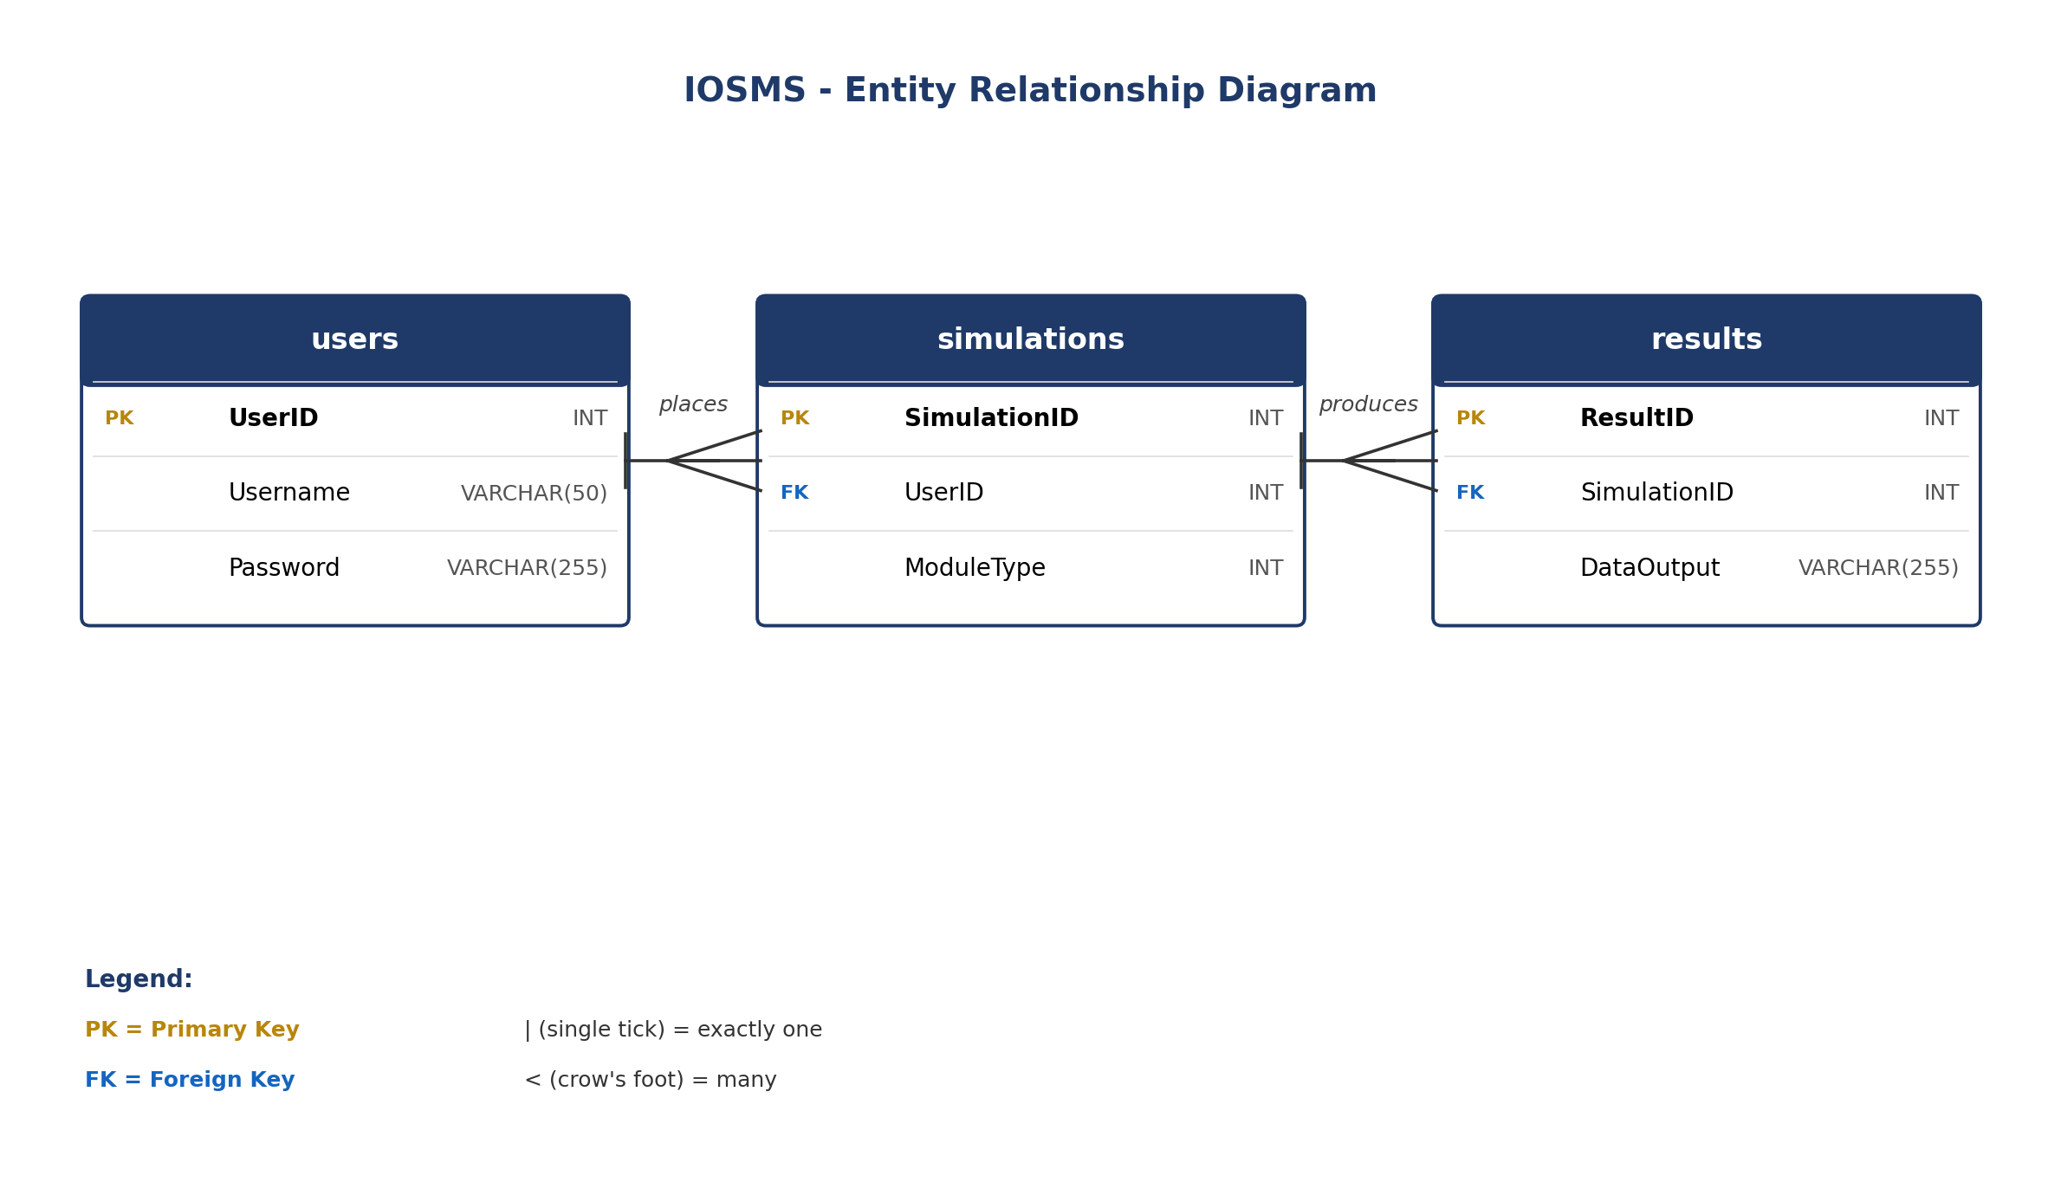
Figure 1. ERD of the iolsms_db database.

3. Entities

users
Stores registered accounts. Each user can place many simulations.
Column | Type | Key | Notes
UserID | INT | PK | Manually assigned (MAX+1).
Username | VARCHAR(50) | UQ | Unique, minimum 3 characters.
Password | VARCHAR(255) |  | PBKDF2-hashed (System.Web.Helpers.Crypto).

simulations
One row per simulation run. Linked to the user that ran it.
Column | Type | Key | Notes
SimulationID | INT | PK | Manually assigned (MAX+1).
UserID | INT | FK | References users.UserID.
ModuleType | INT |  | 1 = CPU Scheduling, 2 = Memory Management, 3 = Deadlock.

results
Stores the textual output produced by a simulation.
Column | Type | Key | Notes
ResultID | INT | PK | Manually assigned (MAX+1).
SimulationID | INT | FK | References simulations.SimulationID.
DataOutput | VARCHAR(255) |  | Algorithm output (Gantt summary, memory map, safe sequence, etc.).

4. Relationships
From | To | Cardinality
users | simulations | 1 : N (one user has many simulations)
simulations | results | 1 : N (one simulation has many results)

5. Notes
Primary keys are not auto-incrementing IDENTITY columns; the application computes the next ID with SELECT ISNULL(MAX(id), 0) + 1 inside DataHelper. The schema is provisioned by Database/iolsms_db.sql, which must be run once against (LocalDB)\MSSQLLocalDB before first use.

