Use Case Diagram
Integrated OS Learning Management System (IOSMS)

1. Overview
This use case diagram models the interactions between users and the Integrated OS Learning Management System (IOSMS). The system is a web-based ASP.NET WebForms application that lets students simulate core operating-system algorithms (CPU scheduling, memory management, and deadlock detection) and review their results.

2. Actors
Actor | Description
Guest | An unauthenticated visitor. May register a new account or log in.
Student (Registered User) | An authenticated user who can run simulations, review the dashboard, view the Gantt chart, save results and log out.

3. Use Case Diagram
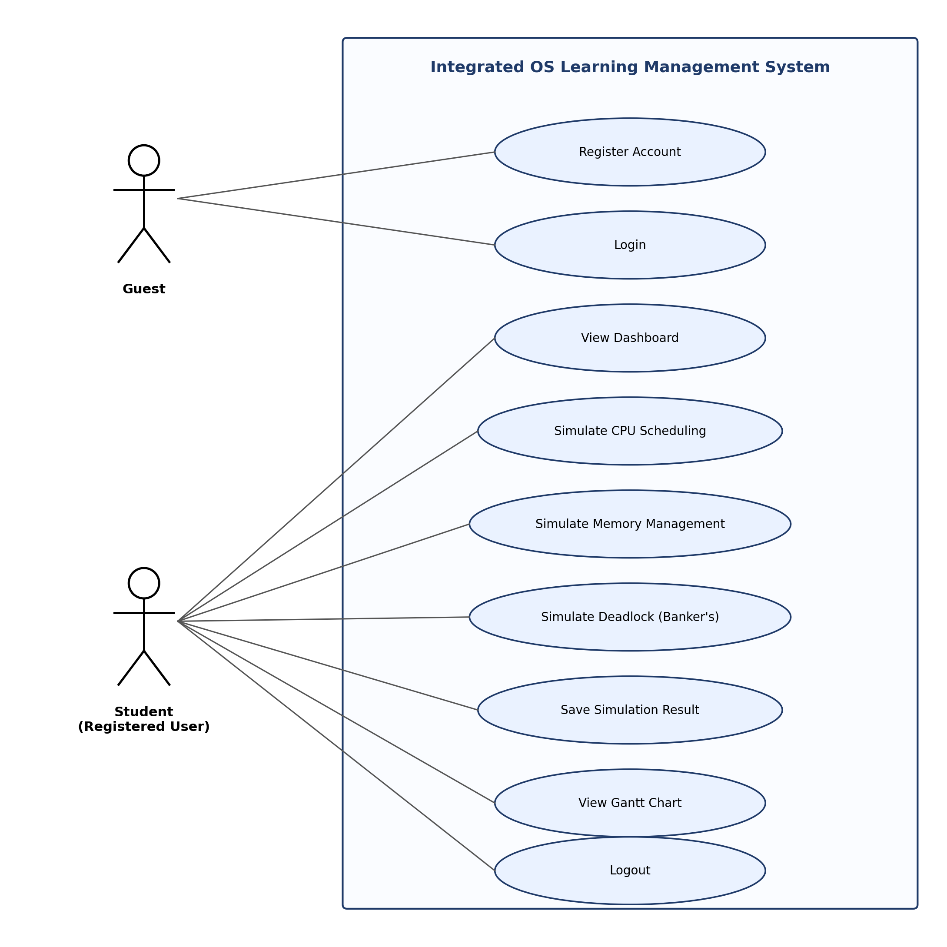
Figure 1. Use case diagram of the IOSMS.

4. Use Case Descriptions
ID | Use Case | Primary Actor | Description
UC-01 | Register Account | Guest | Guest creates an account by providing a username (>= 3 chars) and a password (>= 12 chars with uppercase, lowercase, number and symbol).
UC-02 | Login | Guest | Guest authenticates with username and password. On success a Forms Authentication cookie and session are issued and the user is taken to the Dashboard.
UC-03 | View Dashboard | Student | Displays summary statistics and the most recent simulations of the logged-in user.
UC-04 | Simulate CPU Scheduling | Student | Runs FCFS, SJF, Round Robin or Priority scheduling and renders a server-generated Gantt visualisation plus per-process metrics.
UC-05 | Simulate Memory Management | Student | Runs First Fit, Best Fit, Worst Fit or Paging strategies and shows the resulting memory map and fragmentation table.
UC-06 | Simulate Deadlock (Banker's) | Student | Runs the Banker's safety algorithm against user-supplied Allocation, Max and Available matrices; reports SAFE / UNSAFE state.
UC-07 | Save Simulation Result | Student | Persists the simulation input and output into the simulations and results tables.
UC-08 | View Gantt Chart | Student | Shows the project's planning Gantt chart (Start / In Progress / End task statuses across March-April 2026).
UC-09 | Logout | Student | Clears the session and Forms Authentication cookie and returns the user to the Login page.

