System Architecture

Hardware Architecture

Firmware Architecture

# System Architecture

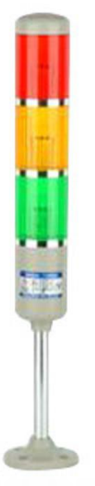

STATION:

**ANDON SYSTEM**

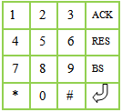

# 

# Hardware Architecture

[PCB DESIGN](https://github.com/jjyothilinga/PCB_AndonXbeeTerminal/)

PIC18F46K22

PORTD

LCD

PORTB

KEYPAD

GREEN LAMP

A0

A1

YELLOW LAMP

A2

HOOTER

A2

RED LAMP

XBEE

C6

C7

# Firmware Architecture

UART

COMMUNICATION

UI

KEYPAD

APP

LCD

[FIRMWARE](https://github.com/JugaadSolutions/AndonXBeeTerminal/)