**TESTING PROCEDURE**

**TEST SETUP:**

1234

1234

ABCDEFGH

PLAN

ACTUAL

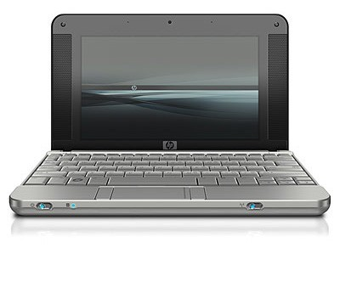

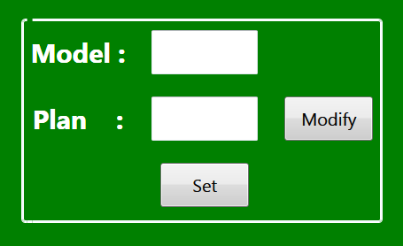

ETHERNET CABLE

230V, AC INPUT

**Testing tools on Github:** [Testing Tools](https://github.com/jjyothilinga/AndonTerminal_TestingTools/)

**Software on Github:** [Software](https://github.com/jjyothilinga/Rangsons/)

**STEP 1:** Procedure to setup the static IP.

Connect the Ethernet cable to the display and follow the below procedure to set the STATIC IP.

a.

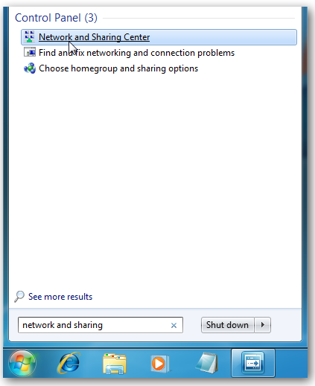

b.

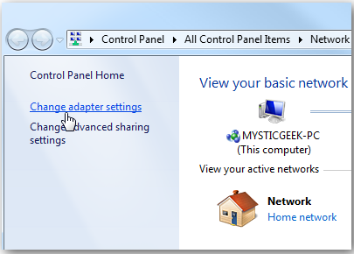

c.

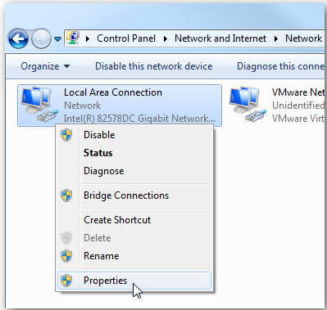

d.

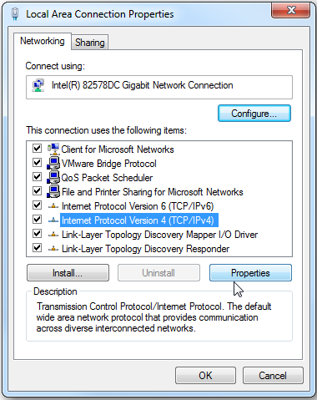

e.

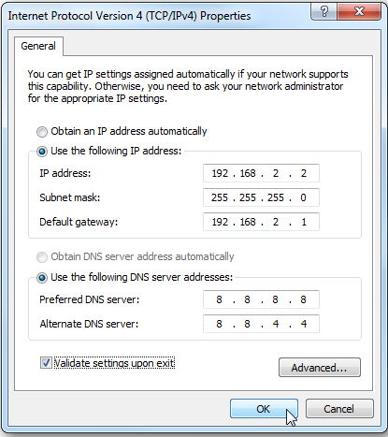

f. Once the IP address has been set, ping the host IP in CMD window to check the connection.

**Note:** The IP address shown in the picture is for example purpose. The actual IP depends on the customer requirement.

**STEP 2: SET THE MODEL, PLAN AND CHECK ACTUAL QUANTITY**

**Precondition: Connection between PC and the display must be established.**

1. **To change MODEL and PLAN:**

Enter the model name and plan quantity and click on SET button to send the command to the display. If the communication is successful, you will receive a message saying that “Command sent successfully”.

1. **To modify the PLAN:**

Enter plan quantity and click on MODIFY button to send the command to the display. If the communication is successful, you will receive a message saying that “Command sent successfully”.

1. **To modify the ACTUAL:**

Give 24V DC to the input in order to see increment in ACTUAL quantity.