**TESTING PROCEDURE**

**TEST SETUP:**

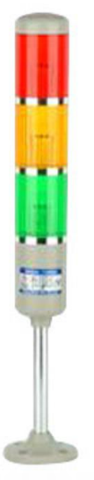

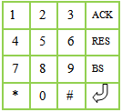

STATION:

**ANDON SYSTEM**

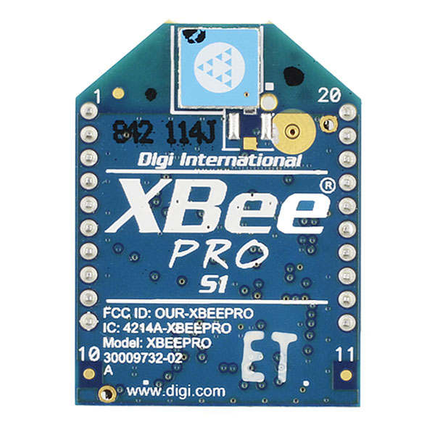

XBEE MASTER

USB TO UART CONVERTER

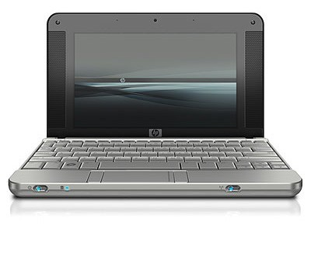

**STEP 1:** Establish communication between PC and Andon Terminal.

1. **Software Requirements:**
2. Terminal
3. CP210x Driver
4. .tmf file
5. **Hardware Requirements:**
6. USB to UART converter
7. Andon Terminal
8. Xbee master
9. **Hardware Configurations:**
10. Xbee Master configuration:

+++

ATAP2

ATMY0

ATBD6

ATID4000

ATWR

ATCN

1. Xbee Slave configuration:

+++

ATAP0

ATMY**n**

ATBDF424

ATID4000

ATWR

ATCN

Note: **n** is Device ID ranges from 0 to 0XFFFF.

1. **Terminal Configuration:**
2. Baud rate = 57600
3. Handshaking = None
4. Load .tmf file
5. **Link to Github:** [Testing Tools](https://github.com/jjyothilinga/AndonTerminal_TestingTools/)

**STEP 2: TO RAISE, ACKNOWLEDGE AND RESOLVE AN ISSUE**

**Precondition: Green Lamp should be ON.**

1. **STATION:**

Enter STATION ID (Valid range 1-99) and press Enter button.

1. **DEPARTMENT:**

Enter department code.

|  |  |
| --- | --- |
| DEPARTMENT | CODE |
| Maintenance | 1 |
| Industrial | 2 |
| Supply Chain | 3 |
| Quality | 4 |
| Production Supervisor | 5 |
| Safety | 6 |

Once the code is entered, press ‘Enter’ button to raise an issue.

Note: Department codes may vary depending on the customer requirement.

1. **ACKNOWLEDGE:**

Press ‘Acknowledge’ button to see the raised issues. By pressing ‘Enter’ button the issue will get acknowledge.

1. **RESOLVE:**

Press ‘Resolve’ button to see the acknowledged issues. By pressing ‘Resolve’ button the acknowledged issue will get resolved.

Note: There could be more than one issue being raised. Each issue has to be acknowledged and resolved.

**STEP 3: TO RAISE AND CHECK ESCALATION OF ISSUE:**