**VPC With resources mapped**

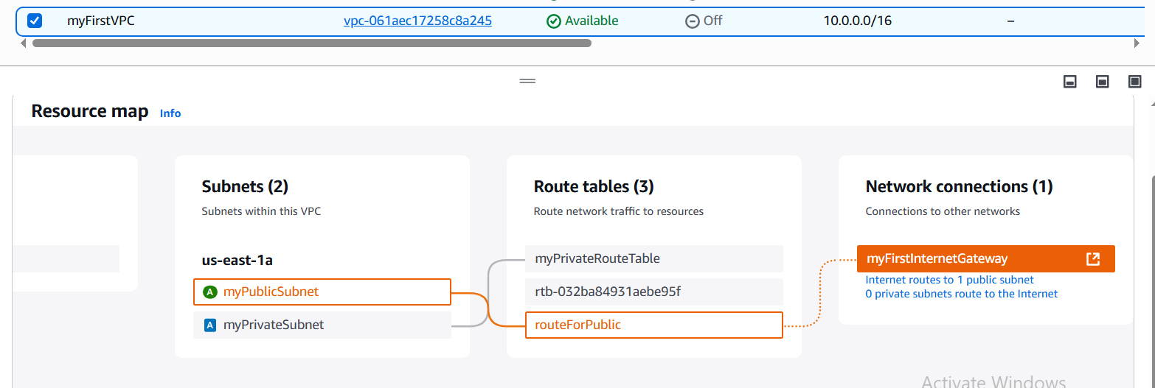

**EC2 Instance with public subnet having range of 256 IP’s**

**Public And Private Subnet connected with VPC**

**Public Subnet Having Internet Gateway open for all**

**Route Tables**

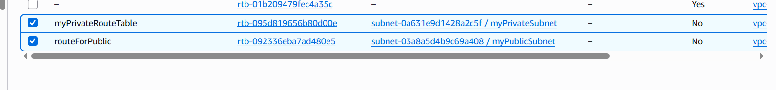

**Internet Gateway**

