**Task:** Launch two ec2-instances and connect it to an application load balancer, where the output traffic from the server must be a load balancer IP address.

**Two EC2 instances:**

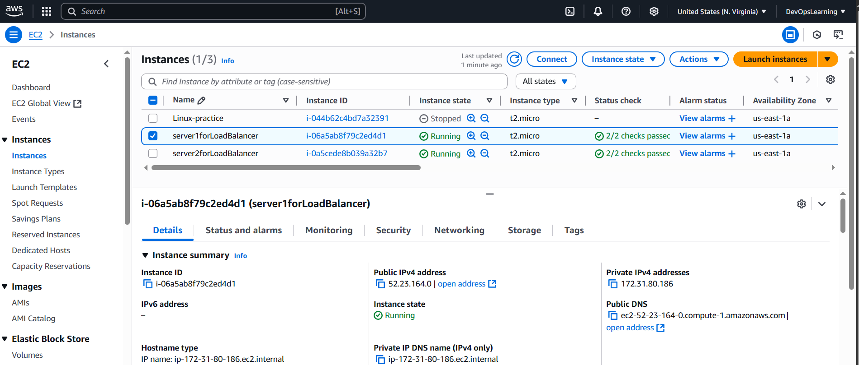

**Load balancer resource map:**

**Load balancer:**

**Server 1 Response with ALB DNS:**

**Server 2 Response with ALB same DNS:**

