**Create private S3 Bucket & View logs**

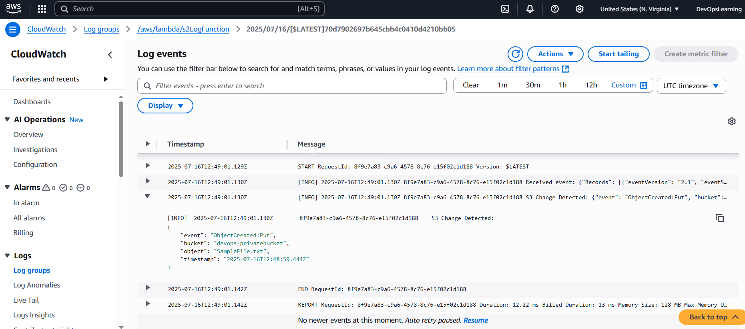

**Lambda Trigger:**

