**Unmounted new volume:**

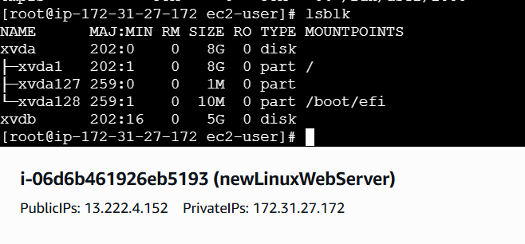

**Mounting New Volume:**

**Volume mount steps**  
sudo mkfs -t xfs /dev/xvdb  
sudo mkdir /data  
sudo mount /dev/xvdb /data

**Verify by**: df -h

**Both Volumes:**

**Snapshot new volume:**

**New volume using snapshot:**

