**Scripting Task 1:**

**Script:  
#!/bin/bash  
http_status=$(curl -s -o /dev/null -w "%{http_code}" https://www.guvi.in)  
echo "HTTP Status Code for guvi.in: $http_status"  
if (( http_status >= 200 && http_status < 300 ));  
then  
 echo "Success: The Request to guvi.in is successful."  
elif (( http_status >= 400 && http_status < 500 ));  
then  
 echo "Failure: Client error ($http_status) - The request cannot be fulfilled."  
elif (( http_status >= 500 && http_status < 600 ));  
then  
 echo "Failure: Server Error ($http_status)"  
else  
 echo "Unexpected error code ($http_status)"  
fi**

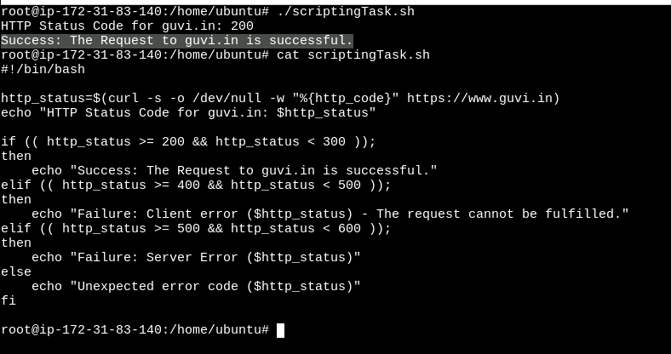

**Scripting Task 2:**

**My_file1.txt content:**  
This is line 1 on file containing give.  
This is line 2 on file containing give. This line also contain welcome.  
This is line 3 on file containing give. This line also contain welcome.  
This is line 4 on file containing give.  
This is line 5 on file containing give. This line also contain welcome.  
This is line 6 on file containing give.  
This is line 7 on file containing give. This line also contain welcome.  
This is line 8 on file containing give. This line also contain welcome.  
This is line 9 on file containing give.  
This is line 10 on file containing give. This line also contain welcome.  
This is line 11 on file containing give.

Command: **sed -i '5,$ { /welcome/ s/give/learning/g }' "my_file1.txt"**

