**Network Task 1**

**Print IP Address of guvi.in**

root@ip-172-31-83-140:/home/ubuntu# nslookup guvi.in  
Server: 127.0.0.53  
Address: 127.0.0.53#53

Non-authoritative answer:  
Name: guvi.in  
Address: 104.26.5.88  
Name: guvi.in  
Address: 172.67.70.207  
Name: guvi.in  
Address: 104.26.4.88  
Name: guvi.in  
Address: 2606:4700:20::ac43:46cf  
Name: guvi.in  
Address: 2606:4700:20::681a:558  
Name: guvi.in  
Address: 2606:4700:20::681a:458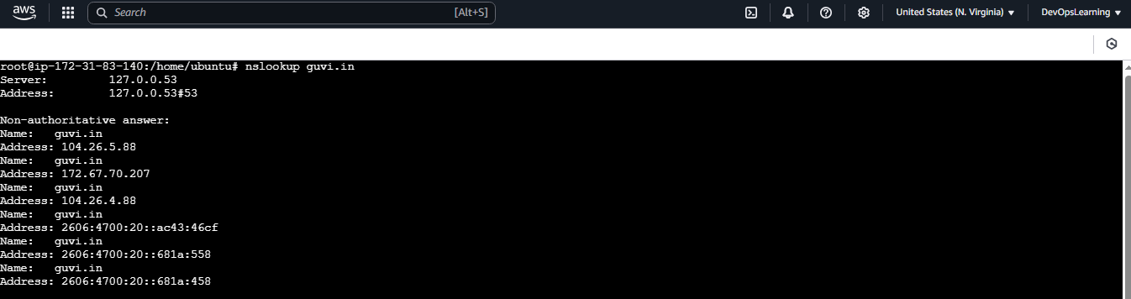

**Print CPU/memory usage**

root@ip-172-31-83-140:/home/ubuntu# top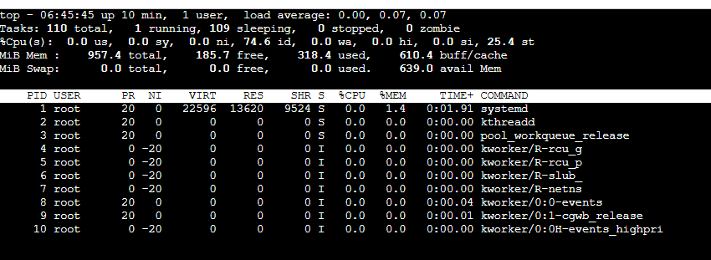

**Print network connectivity of guvi.in**

root@ip-172-31-83-140:/home/ubuntu# ping guvi.in

PING guvi.in (104.26.5.88) 56(84) bytes of data.  
64 bytes from 104.26.5.88: icmp_seq=1 ttl=57 time=1.44 ms  
64 bytes from 104.26.5.88: icmp_seq=2 ttl=57 time=1.38 ms  
64 bytes from 104.26.5.88: icmp_seq=3 ttl=57 time=1.51 ms  
64 bytes from 104.26.5.88: icmp_seq=4 ttl=57 time=1.15 ms  
64 bytes from 104.26.5.88: icmp_seq=5 ttl=57 time=1.59 ms  
64 bytes from 104.26.5.88: icmp_seq=6 ttl=57 time=1.65 ms  
64 bytes from 104.26.5.88: icmp_seq=7 ttl=57 time=1.21 ms  
64 bytes from 104.26.5.88: icmp_seq=8 ttl=57 time=1.15 ms  
64 bytes from 104.26.5.88: icmp_seq=9 ttl=57 time=1.47 ms  
64 bytes from 104.26.5.88: icmp_seq=10 ttl=57 time=1.28 ms  
64 bytes from 104.26.5.88: icmp_seq=11 ttl=57 time=1.23 ms  
64 bytes from 104.26.5.88: icmp_seq=12 ttl=57 time=0.941 ms  
64 bytes from 104.26.5.88: icmp_seq=13 ttl=57 time=1.47 ms

^C

--- guvi.in ping statistics ---

13 packets transmitted, 13 received, 0% packet loss, time 12019ms

rtt min/avg/max/mdev = 0.941/1.345/1.654/0.195 ms

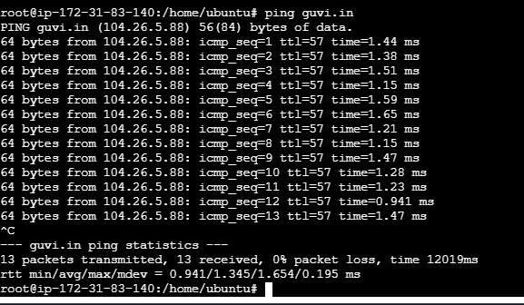

**Network Task 2**

**Print network connectivity over a port for particular domain**

root@ip-172-31-83-140:/home/ubuntu# telnet guvi.com 9000  
Trying 104.21.79.166...

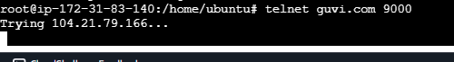

Note* telnet shows blank screen if port is connected