**Docker installed and pulled ubuntu image**

apt-get update -y  
apt-get install docker.io -y  
systemctl start docker  
systemctl enable docker  
docker pull ubuntu  
docker images  
docker run -it ubuntu

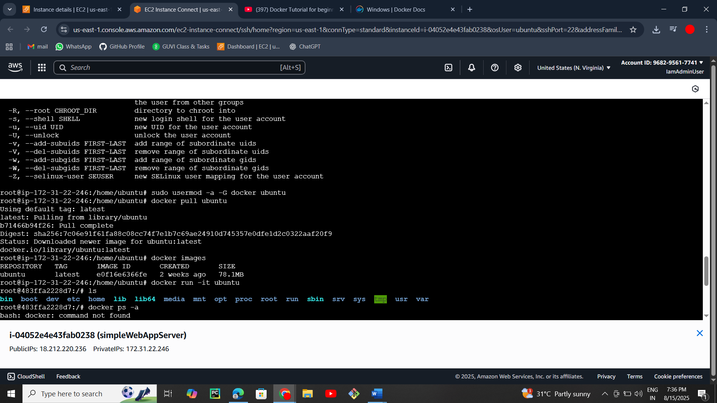

docker volume create my_data  
docker volume ls

**Docker Networks**

docker network ls  
docker network create my_network  
docker run –network my_network --name web-server -d nginx