NAME : | SHAH JUGAL P.
ID NO : | 25AIML065
SUBJECT : | CEUE203

Practical Number | 1A
Code : | import java.util.Scanner;  enum Coin  {  ONE ,  TWO ,  FIVE ,  TEN  }  public class VendingMachine  {  public static void main(String args[])  {  Scanner sc = new Scanner(System.in);  int sum =0 ;  int charge = 15;  System.out.println("Enter Coin :");  while(sum<15)  {  System.out.println("Enter Coin(ONE ,TWO ,FIVE ,TEN) :");  String inp = sc.nextLine().toUpperCase() ;  Coin coinType = Coin.valueOf(inp);  int coin=0;  switch(coinType)  {  case ONE :  coin = 1;  break;  case TWO :  coin = 2;  break;  case FIVE :  coin = 5;  break;  case TEN :  coin = 10;  break;  default :  System.out.println("Enter a valid coin");  }  sum = sum + coin;  };  int change = sum -15;  System.out.println("The Total is : "+ sum);  System.out.println("Paid"+"."+ " Charge: "+change);  sc.close();  }  }
Output: | 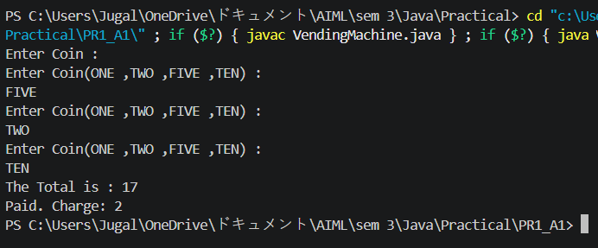

Practical Number: | 1B
CODE : | import java.util.Scanner;  record Vehicle(String number, String type) {}  public class TollBooth {  public static void main(String[] args) {  Scanner sc = new Scanner(System.in);  int total = 0;  int bike = 0;  int car = 0;  int truck = 0;  while (true) {  System.out.print("Enter Vehicle Number (or done): ");  String number = sc.nextLine();  if (number.equalsIgnoreCase("done")) {  break;  }  System.out.print("Enter Vehicle Type (bike/car/truck): ");  String type = sc.nextLine().toLowerCase();  Vehicle v = new Vehicle(number, type);  switch (v.type()) {  case "bike":  total += 20;  bike++;  break;  case "car":  total += 50;  car++;  break;  case "truck":  total += 150;  truck++;  break;  default:  System.out.println("Invalid Vehicle Type");  }  }  System.out.println("Total Toll = " + total);  if (bike == car && car == truck) {  System.out.println("All vehicle types are equally frequent.");  }  else if (bike == car && bike > truck) {  System.out.println("Bike and Car are equally frequent.");  }  else if (bike == truck && bike > car) {  System.out.println("Bike and Truck are equally frequent.");  }  else if (car == truck && car > bike) {  System.out.println("Car and Truck are equally frequent.");  }  else if (bike > car && bike > truck) {  System.out.println("Most frequent: Bike");  }  else if (car > bike && car > truck) {  System.out.println("Most frequent: Car");  }  else {  System.out.println("Most frequent: Truck");  }  sc.close();  }  }
OUTPUT : | 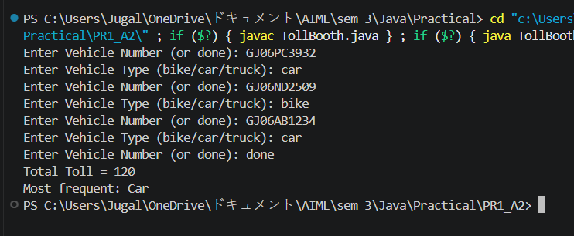

Practical Number : | 1C
CODE : | import java.util.*;  public class RPSLS{  enum Move{  ROCK,  PAPER,  SCISSORS,  LIZARD,  SPOCK  }  public static int winner (Move player,Move computer){  if(player==computer){  return 0;  }  switch(player){  case ROCK:  if (computer == Move.SCISSORS || computer == Move.LIZARD)  return 1;  else  return -1;  case PAPER:  if (computer == Move.ROCK || computer == Move.SPOCK)  return 1;  else  return -1;  case SCISSORS:  if (computer == Move.PAPER || computer == Move.LIZARD)  return 1;  else  return -1;  case LIZARD:  if (computer == Move.PAPER || computer == Move.SPOCK)  return 1;  else  return -1;  case SPOCK:  if (computer == Move.ROCK || computer == Move.SCISSORS)  return 1;  else  return -1;  }  return 0;  }  public static void main(String [] args){  Scanner s=new Scanner(System.in);  Random r=new Random();  int player_score=0,computer_score=0;  for(int i=1;i<=5;i++){  System.out.println("Round "+ i);  System.out.print("Enter your move(rock,scissors,paper,lizard,spock):");  String input=s.nextLine().toUpperCase();  Move player;  if (input.equals("ROCK")) {  player = Move.ROCK;  } else if (input.equals("PAPER")) {  player = Move.PAPER;  } else if (input.equals("SCISSORS")) {  player = Move.SCISSORS;  } else if (input.equals("LIZARD")) {  player = Move.LIZARD;  } else if (input.equals("SPOCK")) {  player = Move.SPOCK;  }  else{  System.out.println("Invalid Move!");  i--;  continue;  }  Move computer = Move.values()[r.nextInt(5)];  System.out.println("Player Move : " + player);  System.out.println("Computer Move : " + computer);  int result=winner(player, computer);  if(result==1){  System.out.println("You win this round");  player_score++;  }  else if(result==-1){  System.out.println("Computer win this round");  computer_score++;  }  else{  System.out.println("It is Tie");  }  }  System.out.println("\nFinal Score");  System.out.println("Player:" + player_score);  System.out.println("Computer:" + computer_score);  if(player_score>computer_score){  System.out.println("You win the game");  }  else if(computer_score>player_score){  System.out.println("Computer win the game");  }  else{  System.out.println("Match draw");  }  s.close();  }  }
OUTPUT : | 