1. Data Processing & ETL Tools
These tools extract data, transform it into useful format, and load it into storage systems.

Apache Airflow

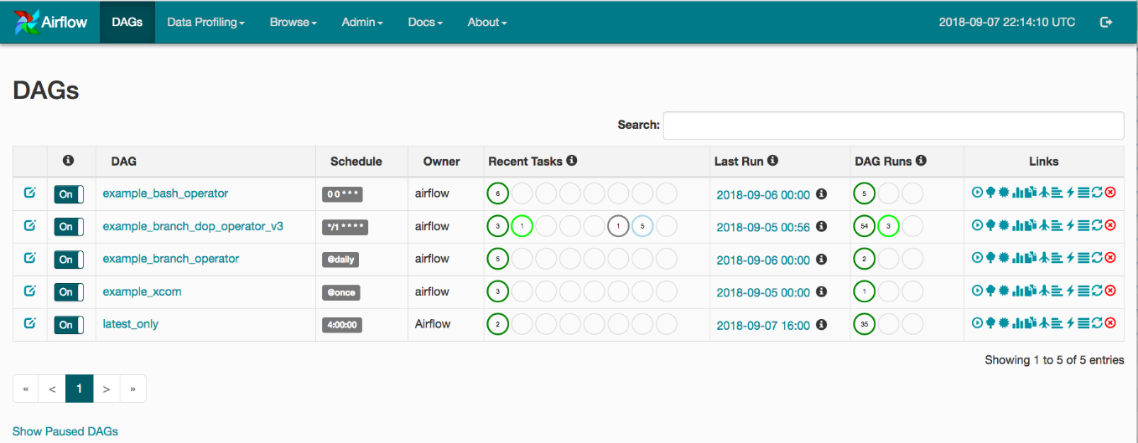
4
Apache Airflow is a workflow orchestration tool used to schedule and manage data pipelines.

How it works
- Data engineers define workflows as DAGs (Directed Acyclic Graphs) in Python.
- Each node in the DAG represents a task (data extraction, transformation, loading).
- Airflow schedules and executes tasks automatically.
- It tracks dependencies between tasks.

Example pipeline
Task 1 → Extract data from API
Task 2 → Transform data using Python
Task 3 → Load data into PostgreSQL
Airflow ensures:
- Tasks run in correct order
- Failures are retried
- Pipelines run on schedule

Why engineers use it
- Pipeline automation
- Monitoring pipelines
- Managing complex workflows

Airbyte
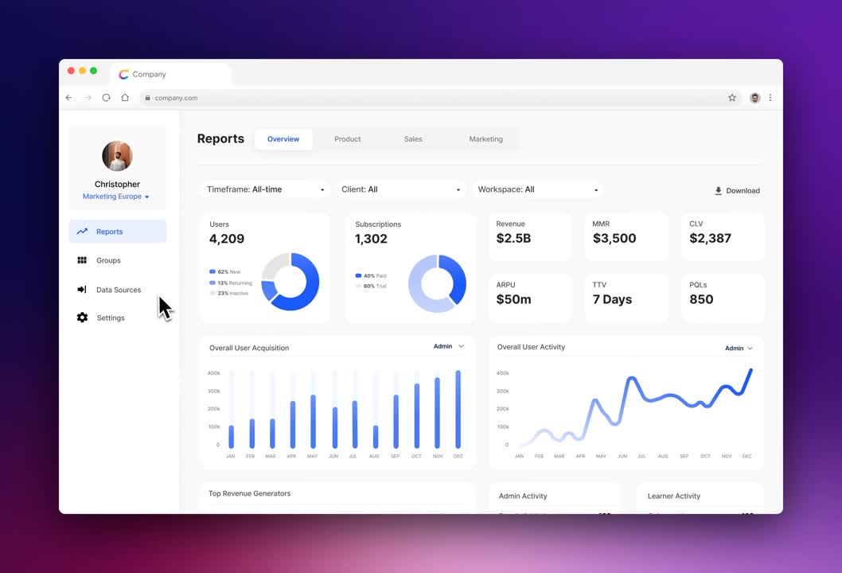
4
Airbyte is an ELT (Extract Load Transform) tool used to move data between systems.

How it works
- Connect to data sources
  - APIs
  - Databases
  - SaaS tools (Shopify, Stripe, Salesforce)
- Extract the data automatically.
- Load it into a data warehouse or database.
- Transformation can be done later using tools like dbt.

Example
Shopify → Airbyte → PostgreSQL

Key feature
Airbyte provides ready-made connectors, so engineers don't need to write extraction scripts.

dbt-core

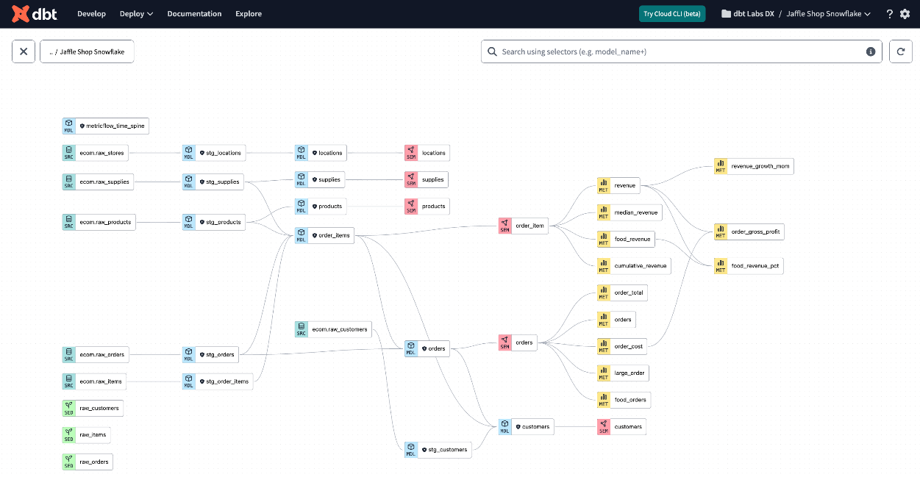
4
dbt (Data Build Tool) is used to transform raw data inside a data warehouse using SQL.

How it works
- Raw data is loaded into a warehouse.
- dbt runs SQL models to transform data.
- It creates clean analytical tables.

Example
Raw table:
orders_raw
dbt transformation:
SELECT
customer_id,
SUM(amount) as total_spent
FROM orders_raw
GROUP BY customer_id
Output table:
customer_spending

Key features
- SQL transformations
- Data lineage tracking
- Testing and documentation

Celery Workers
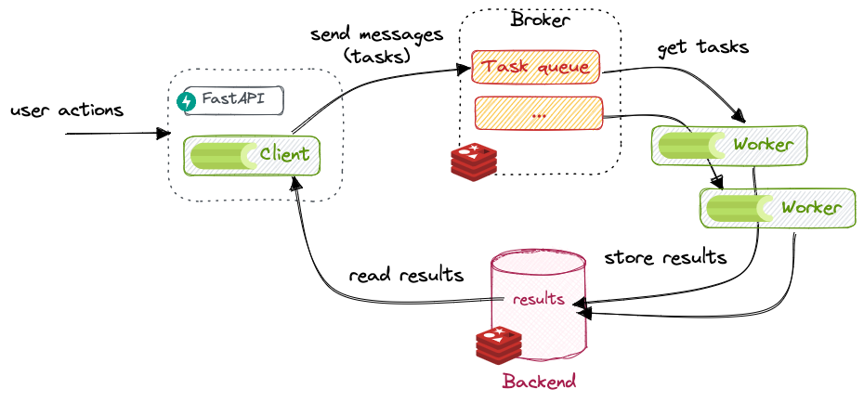

4
Celery is a distributed task queue used for background processing.

How it works
- Tasks are added to a queue.
- Worker machines pick up tasks.
- Tasks run asynchronously.

Example
A data pipeline may include:
Task queue → Celery worker → process large dataset
Example tasks:
- Sending data to warehouse
- Processing ML features
- Running batch jobs

Python (Pandas / PySpark)

Pandas
Used for small to medium datasets.
Example workflow:
Extract data → Pandas cleaning → Store in database
Example:
import pandas as pd
df = pd.read_csv("sales.csv")
df["profit"] = df["revenue"] - df["cost"]

PySpark
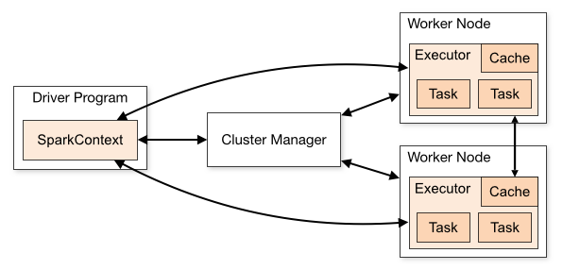
4
Used for big data processing on clusters.

How it works
Data is distributed across many nodes.
Example pipeline:
HDFS → PySpark transformation → Data Warehouse
Benefits
- Handles TB–PB scale data
- Parallel processing

Cron Jobs
Cron is a Linux scheduler used to run scripts at fixed times.
Example:
0 2 * * * python pipeline.py
Meaning:
Run the script every day at 2 AM.
Often used to schedule:
- ETL scripts
- Data refresh jobs
- backups

2. Data Storage Solutions
These tools store processed data.

PostgreSQL
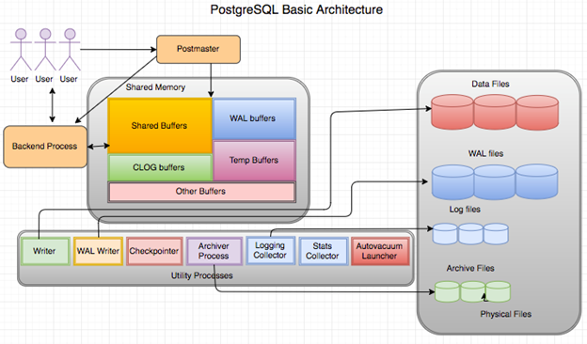
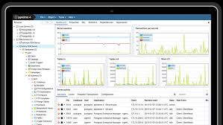
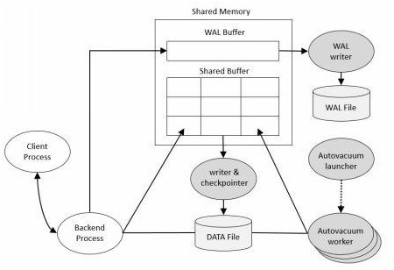
4
PostgreSQL is a relational database (RDBMS).

How it works
- Data stored in tables
- Queried using SQL
Example:
customers table
orders table
products table
Used for:
- analytics databases
- backend systems
- data warehouses (small scale)

DuckDB
DuckDB is an in-process analytical database.

How it works
Runs directly inside applications.
Example:
Python → DuckDB → Query Parquet files
Advantages:
- Fast analytics
- No server needed
- Works with data files

MongoDB
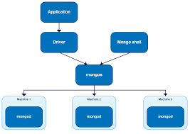

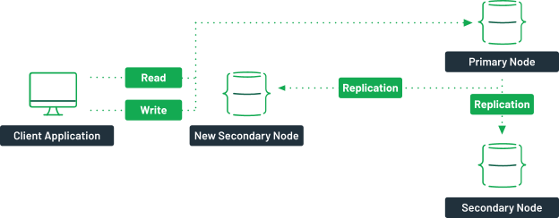
4
MongoDB is a NoSQL document database.

How it works
Data stored as JSON-like documents.
Example:
{
name: "Alice",
age: 25,
skills: ["Python","SQL"]
}
Used for:
- unstructured data
- application databases
- logs and event data

Delta Tables
Delta Lake tables are used in data lakes.

Features
- ACID transactions
- versioning
- scalable storage
Example pipeline:
Raw Data → Delta Lake → Analytics
Used heavily with Spark and Databricks.

Parquet Files
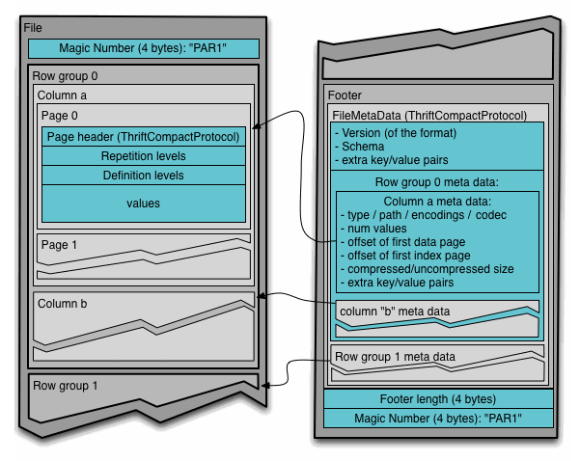
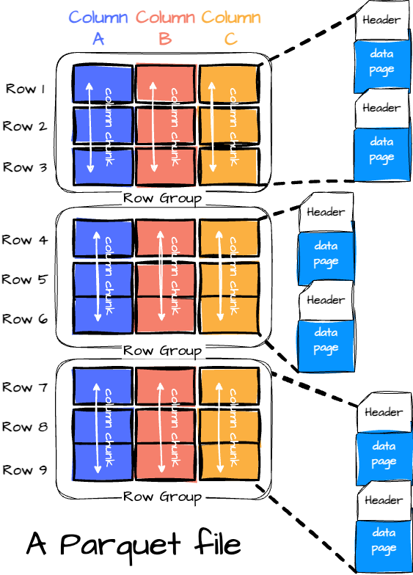

Parquet is a columnar file format for big data.

How it works
Data stored column by column, not row by row.
Example
Row format
[ID Name Age]
[1 Alice 25]
Column format
ID → 1
Name → Alice
Age → 25
Benefits
- Faster analytics
- Smaller file size
- Efficient compression

3. Visualization Tools
These tools convert processed data into dashboards and insights.

Streamlit
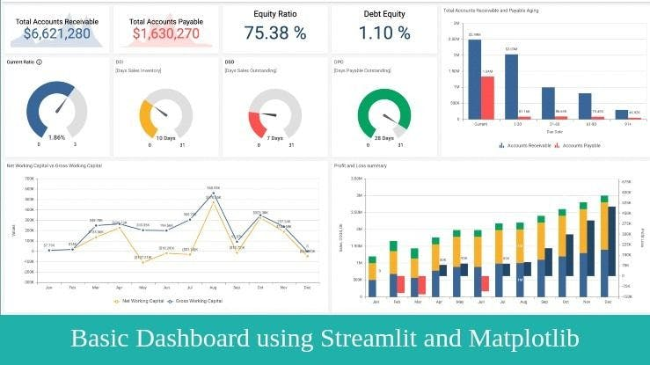

Streamlit is a Python framework for building dashboards quickly.

How it works
Write Python code and it generates a web app.
Example:
import streamlit as st
import pandas as pd
df = pd.read_csv("data.csv")
st.line_chart(df)
Used for
- data science dashboards
- ML apps
- quick analytics tools

Apache Superset

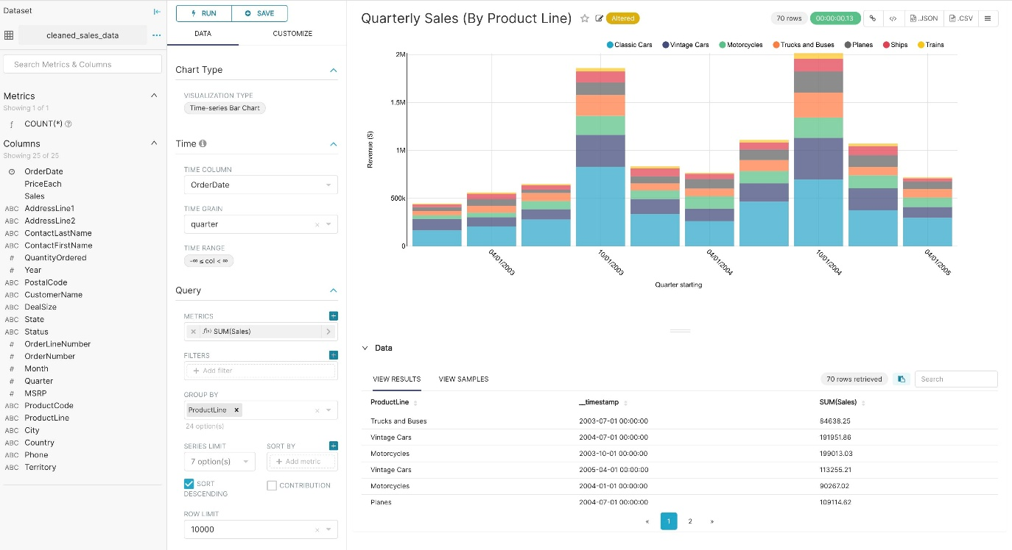
Apache Superset is an open-source BI dashboard tool.

How it works
- Connect database
- Write SQL queries
- Build dashboards
Used for:
- analytics dashboards
- business reporting

Power BI Desktop
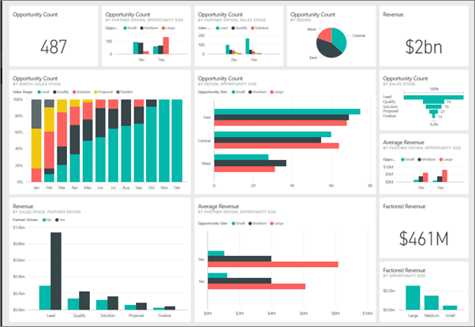

4
Power BI is a business intelligence tool by Microsoft.

How it works
- Connect to data sources
- Transform using Power Query
- Build visual dashboards
Used heavily in business analytics and corporate reporting.

Tableau Desktop
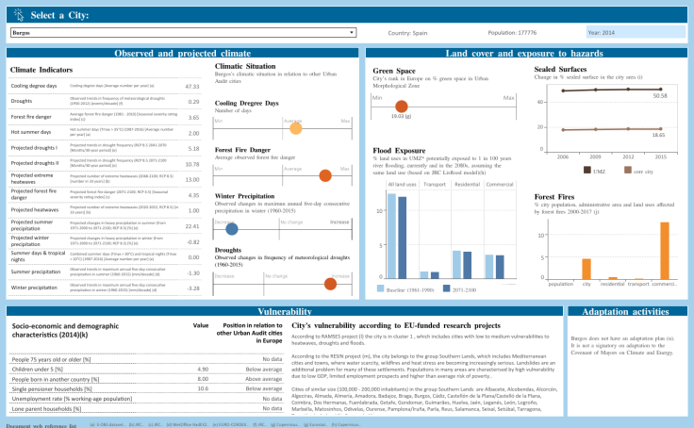
Tableau is a powerful BI visualization platform.

How it works
- Connect data
- Drag-and-drop charts
- Build interactive dashboards
Used for:
- enterprise analytics
- storytelling with data

Complete Data Engineering Pipeline Example
Example architecture:
Data Sources
(API, Logs, Databases)
│
▼
Airbyte (Extract Data)
│
▼
Airflow / Cron (Schedule Pipelines)
│
▼
Python / PySpark / dbt (Transform Data)
│
▼
PostgreSQL / Delta Lake / Parquet (Store Data)
│
▼
Superset / Tableau / Power BI / Streamlit (Visualization)

