API Reference & Database Architecture Guide

1. REST API Concepts Explained Simply

HTTP Methods
- GET: Retrieve data from the server. Idempotent and safe; never modifies database state (e.g., fetching scan history or weather).
- POST: Submit data to create a new resource on the server (e.g., uploading a leaf image for diagnosis or registering a new farm plot).
- PUT: Replace an entire existing resource (e.g., updating a farm plot’s name, village, and coordinates).
- PATCH: Partially update a resource (e.g., updating only the user’s preferred language without touching their name or phone number).
- DELETE: Remove or deactivate a resource (e.g., soft-deactivating a farm plot).

Key HTTP Status Codes
- 200 OK: Request succeeded (e.g., successful diagnosis or scan retrieval).
- 201 Created: Resource successfully created in PostgreSQL (e.g., farm registered).
- 400 Bad Request: Client sent invalid or missing form parameters (e.g., empty crop string).
- 401 Unauthorized: Missing, expired, or cryptographically invalid Bearer JWT token.
- 403 Forbidden: Authenticated user attempted an illegal action (e.g., path traversal attack).
- 404 Not Found: Resource does not exist, or belongs to another user (scoped access control).
- 422 Unprocessable Entity: File uploaded was corrupt, not an image, or failed Pydantic schema validation.
- 503 Service Unavailable: Requested crop has no model loaded into memory.

JSON vs. multipart/form-data
- application/json: Standard format for sending text-based structured key-value data.
- multipart/form-data: Required when uploading binary files (e.g., leaf JPEG images) alongside text fields (crop="chili", language="gu"). The browser sends boundaries separating binary file bytes from text inputs.

2. Comprehensive API Route Reference

A. System & Health Endpoints
Endpoint | Method | Auth | Router File | Purpose
/api/v1/health (alias: /) | GET | Public | main.py | Returns API status ("running"), version, and model load states ({"chili": "loaded"}).
/api/v1/health/db | GET | Public | main.py | Queries SELECT version(); on PostgreSQL; returns connection latency in milliseconds.

B. Authentication & User Profile (backend/routers/auth.py)

1. POST /api/v1/auth/sync
- Purpose: Idempotently finds or registers the authenticated Clerk user in PostgreSQL.
- Auth: Requires Authorization: Bearer <Clerk JWT>.
- Request Body (JSON):
- {
"display_name": "Ramesh Patel",
"preferred_language": "gu"
}
- Response (200 OK):
- {
"status": "success",
"message": "User profile synchronized successfully",
"user": {
"id": "a1b2c3d4-e5f6-7a8b-9c0d-1e2f3a4b5c6d",
"auth_provider": "clerk",
"auth_provider_user_id": "user_2test123",
"display_name": "Ramesh Patel",
"email": "ramesh@example.com",
"phone_number": "+919876543210",
"preferred_language": "gu",
"is_active": true,
"created_at": "2026-10-11T12:00:00Z"
}
}
- Database Effect: Executes INSERT INTO users ... ON CONFLICT DO UPDATE.

2. GET /api/v1/auth/me
- Purpose: Returns the currently authenticated user’s profile from PostgreSQL.
- Auth: Requires Authorization: Bearer <Clerk JWT>.
- Response (200 OK): Returns UserProfileResponse.

3. PATCH /api/v1/auth/preferences
- Purpose: Updates the user’s preferred language tag (en, hi, gu).
- Auth: Requires Authorization: Bearer <Clerk JWT>.
- Request Body (JSON): {"preferred_language": "hi"}
- Response (200 OK): {"status": "success", "preferred_language": "hi"}.

C. Farm Management (backend/routers/farms.py)

1. POST /api/v1/farms
- Purpose: Registers a new farm plot owned by the user.
- Auth: Bearer token required.
- Request Body (JSON):
- {
"name": "North Field",
"village": "Anand",
"district": "Anand",
"state": "Gujarat",
"area_hectares": 2.5,
"latitude": 22.5645,
"longitude": 72.9289
}
- Response (201 Created): Returns registered FarmResponse with generated UUID.
- Database Effect: INSERT INTO farms ....

2. GET /api/v1/farms
- Purpose: Returns all active farms owned by the user (WHERE user_id = :uid AND is_active = true).
- Auth: Bearer token required.
- Response (200 OK): {"status": "success", "count": 1, "farms": [...]}.

3. GET /api/v1/farms/{farm_id}
- Purpose: Retrieves a specific farm plot. Returns 404 if not found or belongs to another user.

4. PUT /api/v1/farms/{farm_id}
- Purpose: Updates farm metadata or GPS coordinates.

5. DELETE /api/v1/farms/{farm_id}
- Purpose: Soft-deactivates the farm (is_active = false). Does not drop scan history.

6. GET /api/v1/farms/{farm_id}/weather
- Purpose: Returns live ambient weather for the farm plot from Open-Meteo or PostgreSQL cache.
- Response (200 OK):
- {
"status": "success",
"farm_id": "a1b2c3d4-...",
"farm_name": "North Field",
"has_location": true,
"message": "Live weather retrieved successfully",
"temperature_c": 28.5,
"humidity_pct": 74.0,
"rainfall_mm": 0.0,
"wind_speed_kmh": 12.4,
"weather_condition": "Partly cloudy",
"data_source": "Open-Meteo",
"recorded_at": "2026-10-11T12:00:00Z"
}

D. Diagnosis & Advisory Pipeline (backend/routers/diagnose.py)

POST /api/v1/diagnose
- Purpose: End-to-end foliar diagnosis: MobileNetV2 inference -> Confidence Gate -> Weather Enrichment -> Groq LLM Advisory Report.
- Auth: Bearer token required.
- Request Format: multipart/form-data
  - crop: "chili"
  - image: <binary JPEG/PNG bytes>
  - farm_id: Optional UUID string
  - language: Optional language code (en, hi, gu)
- Response (200 OK - Confident Diagnosis):
- {
"status": "success",
"crop": "chili",
"is_confident": true,
"confidence": 0.8845,
"threshold": 0.70,
"disease": "Curl Virus",
"disease_display_name": "Chili Leaf Curl Virus",
"scan_id": "9f8e7d6c-5b4a-3210-fedc-ba9876543210",
"message": "Diagnosis accepted with high confidence. Localized advisory report generated.",
"farm": {
"id": "a1b2c3d4-...",
"name": "North Field",
"location_text": "Anand, Anand, Gujarat"
},
"weather": {
"temperature_c": 29.2,
"humidity_pct": 76.0,
"weather_condition": "Mainly clear"
},
"report": {
"id": "11223344-...",
"scan_id": "9f8e7d6c-...",
"language_code": "en",
"disease_name": "Chili Leaf Curl Virus",
"summary": "Foliar curling caused by begomovirus transmitted by whiteflies.",
"symptoms": ["Upward curling of leaves", "Stunted plant growth"],
"possible_causes": ["High whitefly vector activity during warm dry spells"],
"local_context": "Prevalent in Anand district during post-monsoon transitions.",
"management_steps": ["Eradicate heavily stunted plants", "Deploy yellow sticky traps"],
"prevention_steps": ["Use barrier crops", "Spray neem oil at 5ml/L"],
"warning_signs": ["Sudden spread to over 30% of foliage"],
"expert_verification_recommended": false,
"disclaimer": "Advisory generated in consultation with agronomist guidelines."
}
}
- Response (200 OK - Low Confidence Rejection):
- {
"status": "low_confidence",
"crop": "chili",
"is_confident": false,
"confidence": 0.5412,
"threshold": 0.70,
"disease": null,
"scan_id": "9f8e7d6c-...",
"message": "Prediction confidence (54.1%) is below the acceptable certainty threshold (70.0%). The leaf image may be blurry, uncentered, or showing ambiguous symptoms. Please upload a clearer photo.",
"report": null
}

E. Scan History, Image Streaming & PDF Reports (backend/routers/scans.py)

1. GET /api/v1/scans
- Purpose: Paginated list of scans owned by the user.
- Query Params: page=1, page_size=10, crop=chili, status=success, sort_order=desc.
- Response (200 OK): Returns ScanPaginationResponse with total count and page metadata.

2. GET /api/v1/scans/{scan_id}
- Purpose: Full diagnostic inspection of a single scan (prediction, farm, weather, advisory).
- Scoped: Returns 404 if scan belongs to another user.

3. GET /api/v1/scans/{scan_id}/image
- Purpose: Streams the original leaf photo from disk.
- Security Guard: Validates that resolved filepath is inside config.UPLOAD_DIR to prevent path traversal (../../../etc/passwd).

4. GET /api/v1/scans/{scan_id}/pdf?lang=gu
- Purpose: Generates and streams an A4 bilingual diagnostic PDF report using ReportLab.
- Response Headers: Content-Type: application/pdf, Content-Disposition: attachment; filename="crop_report_9f8e7d6c_gu.pdf".

3. Database Entity Relationship Diagram (ERD)
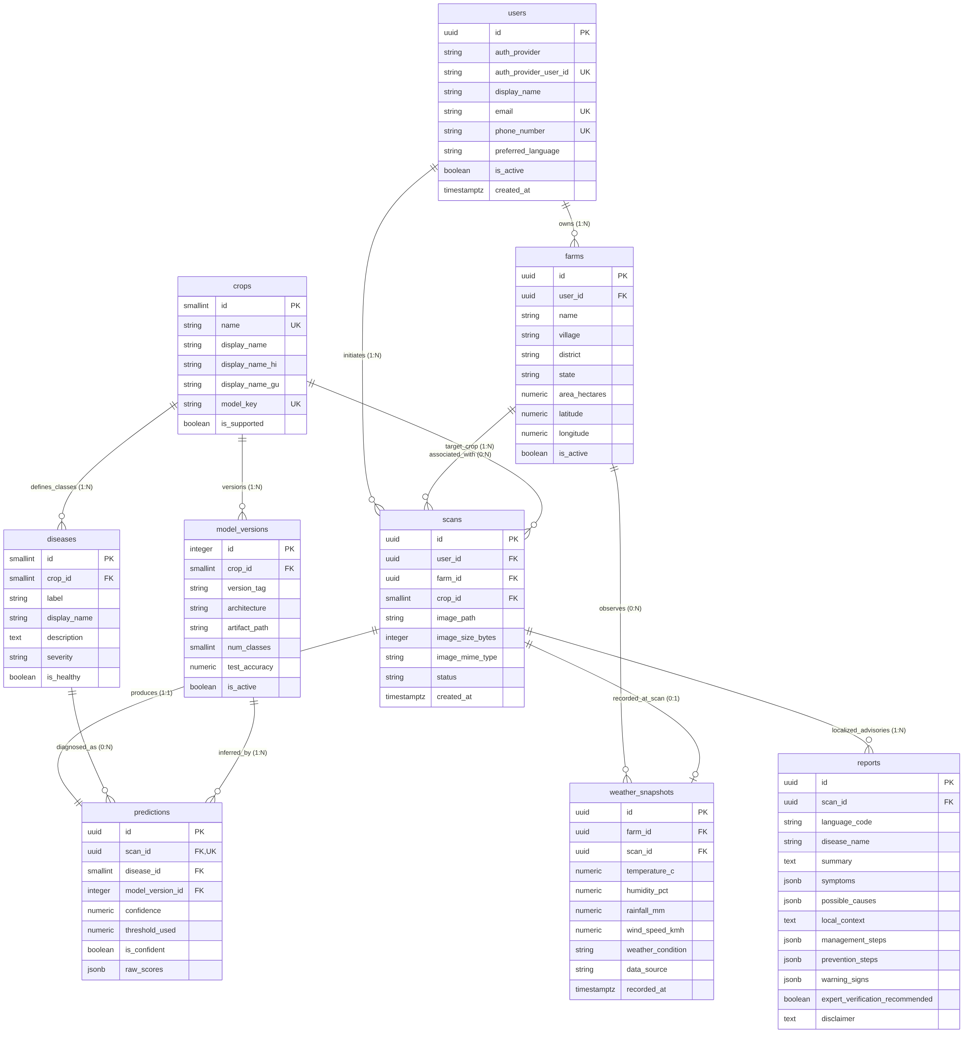
Diagram

4. Database Tables & Architecture Breakdown

1. users (Application Profile)
- Primary Key: id (UUID).
- Key Constraint: UNIQUE(auth_provider, auth_provider_user_id) prevents duplicate accounts.
- Security Rule: Never stores passwords or OTPs; delegates credential verification to Clerk.

2. farms (Agricultural Plots)
- Foreign Key: user_id -> users.id (ON DELETE CASCADE).
- Coordinates: latitude and longitude are stored with precision Numeric(9, 6). They are used only for Open-Meteo weather calls and are never exposed to the LLM.

3. crops (Reference Table)
- Key Field: is_supported. Currently true for "chili", false for potato/groundnut. If is_supported = false, the API rejects diagnosis attempts before loading models.

4. diseases (Reference Table)
- Constraint: UNIQUE(crop_id, label). Contains human-readable display names and severity. Notice: Treatment tips are not hardcoded here; treatment is generated contextually by the LLM and stored in reports.

5. scans (Central Transaction)
- Primary Key: id (UUID).
- Stores the relative file path image_path (e.g. scans/a8f2...jpg). Raw binary pixels are never stored inside PostgreSQL.
- Lifecycle: pending -> success | low_confidence | error.

6. predictions (Authoritative Machine Learning Record)
- Constraint: UNIQUE(scan_id) (1-to-1 relationship with scans).
- raw_scores (JSONB): Stores the full 6-class softmax probability distribution for future retraining and drift analytics.
- Confidence Rule: If is_confident = false, disease_id is set to NULL.

7. weather_snapshots (Contextual Meteorological Cache)
- Foreign Keys: farm_id and optional scan_id.
- Records atmospheric parameters at the moment of scan observation.

8. reports (Structured Multilingual Advisory)
- Constraint: UNIQUE(scan_id, language_code). One scan can have multiple reports (English, Hindi, Gujarati).
- JSONB fields (symptoms, management_steps, prevention_steps, warning_signs): Stored as pre-parsed JSON arrays so the React frontend can map over bullet points without parsing client-side strings.

9. model_versions (ML Governance & Registry)
- Tracks model tag (v1.0.0), architecture (MobileNetV2), and accuracy. Every Prediction is foreign-keyed to a model_version_id, ensuring historical traceability even after model updates.

5. Data Ownership & Security Enforcement
To prevent IDOR (Insecure Direct Object References) where User A guesses the UUID of User B’s scan: Every scan, farm, and report query in the repository layer explicitly joins and filters by the authenticated user’s ID:
stmt = select(Scan).where(
Scan.id == scan_id,
Scan.user_id == current_user_uuid
)
If the scan does not exist OR belongs to another farmer, the query returns None, and the router raises HTTP 404 Not Found.

