FET PROJECT · FORMULA 1 ARCHIVE
PADDOCK

Every season since 2000. Every lap since 2023.
A brushed-silver Formula 1 archive built with Angular 21 and Material 3. The complete 2000–2026 dataset powers instant career, race and championship analysis, while OpenF1 adds session replay, live timing and car telemetry from 2023 to today.
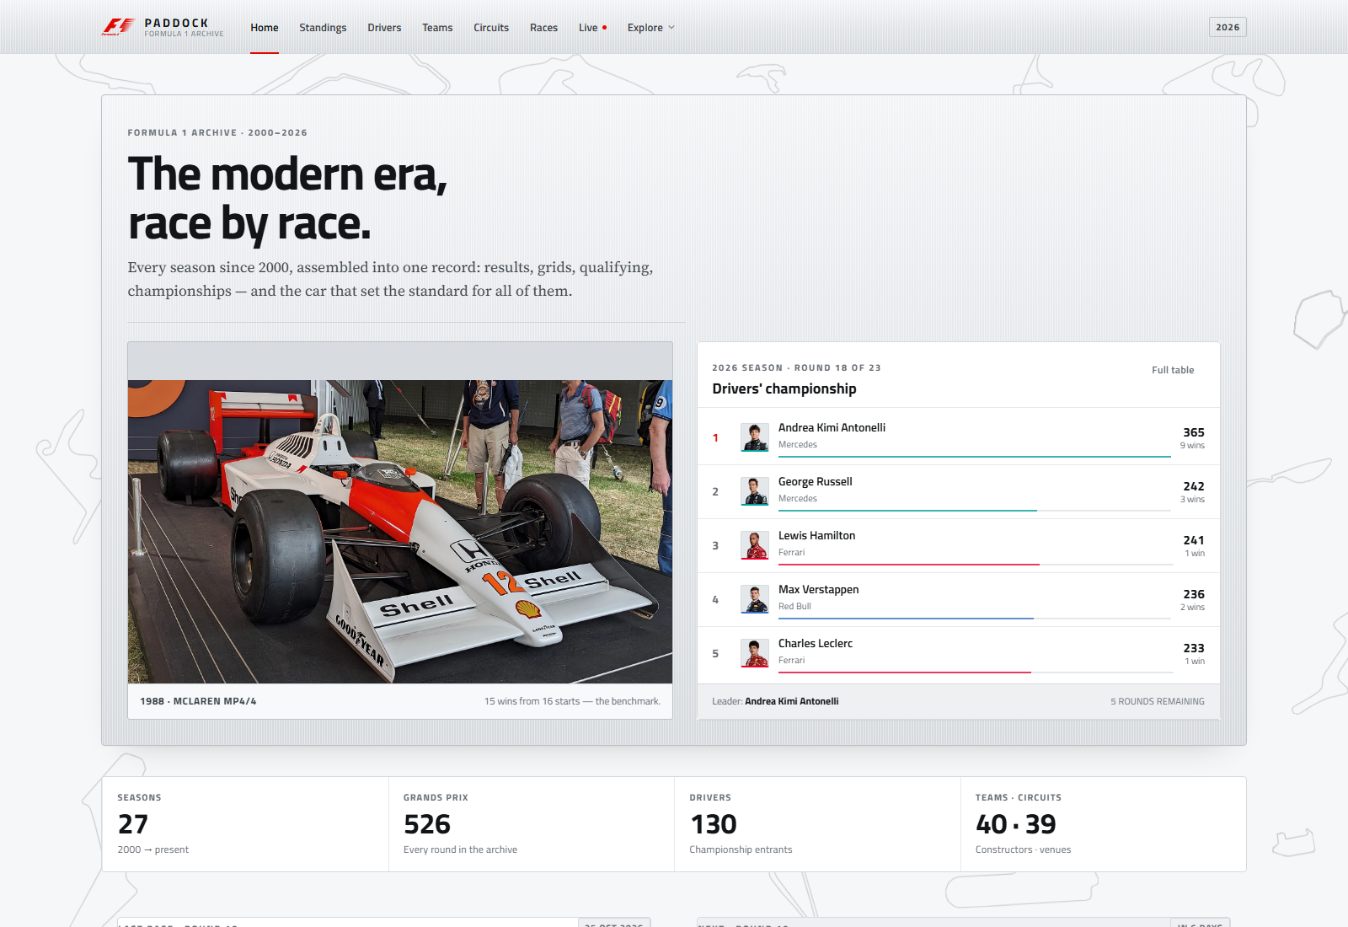
Home · silver editorial theme

NAME | Jugal Patel · Krish Patel · Paavan Sharma
ENROLMENT NO. | 24162581032 · 24162581017 · 24162581052
SUBJECT | FET
DOCUMENT | Project report and README
DATA SCOPE | Archive 2000–2026, reconciled 26 Oct 2026 · OpenF1 2023 → today
STACK | Angular 21 · Angular Material 3 · SCSS · Jolpica · OpenF1

Live app: http://localhost:4200 · API: https://openf1.org

Contents
01 What is in the app
02 Screens
03 Screens and routes
04 Data sources
05 Tech stack
06 Project structure
07 Getting started
08 Scripts
09 OpenF1 live timing and tokens
10 Data pipeline
11 Design system
12 Imagery and licensing
13 Performance and accessibility
14 Production build
15 Optional legacy backend
16 Limitations and next steps
17 License

What is in the app
- Modern-era scope. Only 2000-onward drivers, teams, circuits, races and championships are bundled. Pre-2000 personalities and rivalries are gone from the UI and the shipped CSVs.
- Eleven screens, covering the home page, standings, drivers, teams, circuits, races, race detail, live timing, history, rivalry and image credits.
- The archive runs to the current season. 2000–2025 are complete; 2026 is reconciled through round 18 of 23 (26 October 2026). In-progress seasons show a leader, never a fabricated champion.
- Championship context everywhere. Driver and team profiles show career totals, title years, season history and team-mates, all computed from archive rows rather than hard-coded.
- Race detail pages. Podium, fastest lap, grid gains, full classification, qualifying (Q1/Q2/Q3) and circuit context for all 526 archived races.
- Head-to-head rivalry engine. Any two drivers can be compared by career totals, points trajectory and shared-season championship positions.
- Wikipedia-style history. Five eras, legendary rivalries, a champions table and computed record holders in a single long-form article. The old /timeline route now redirects to /history.
- OpenF1 live timing. Session replay for 2023-onward, timing tower with gaps/intervals/tyres/pit stops, weather, race-control feed and per-lap speed/gear/DRS telemetry.
- Real imagery. Team logos, 39 circuit maps and 28 driver portraits are bundled locally. Historic teams without a licensable mark render a typographic crest rather than a broken image.
- Attribution built in. Every image is listed with its source and licence on /credits, alongside a trademark notice.

Screens
Home | Standings
 | 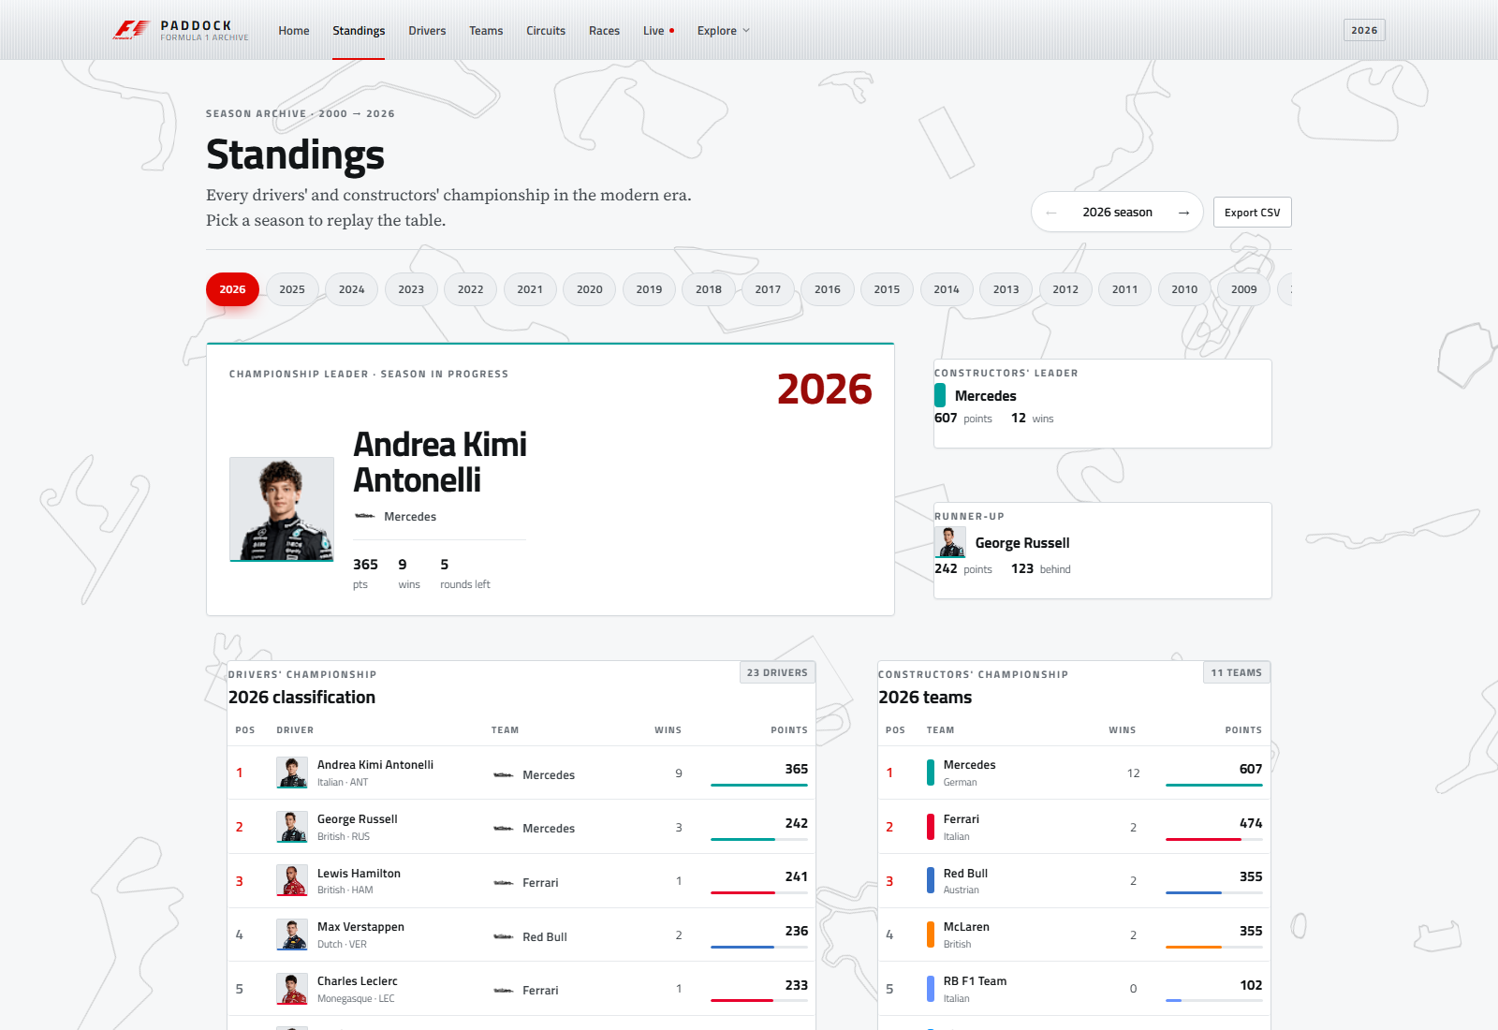

History | Circuits
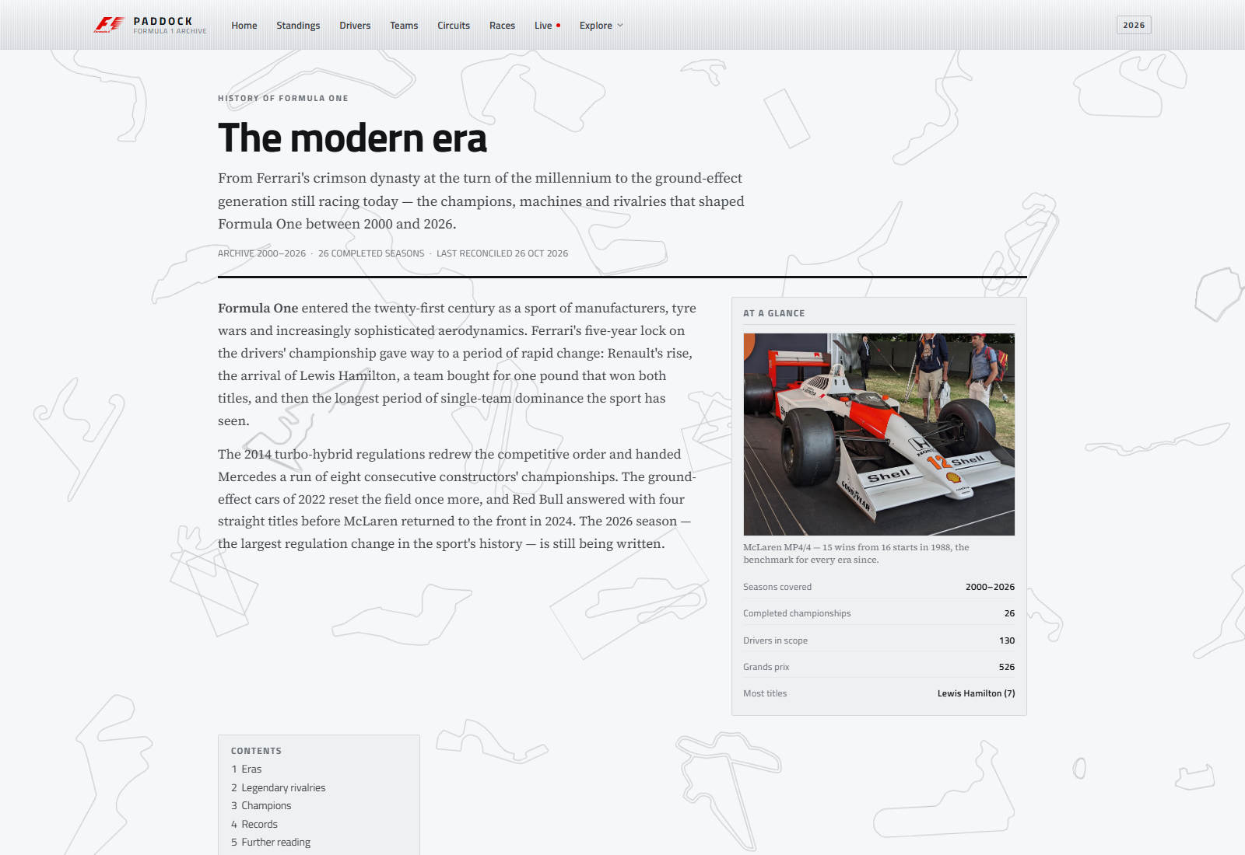 | 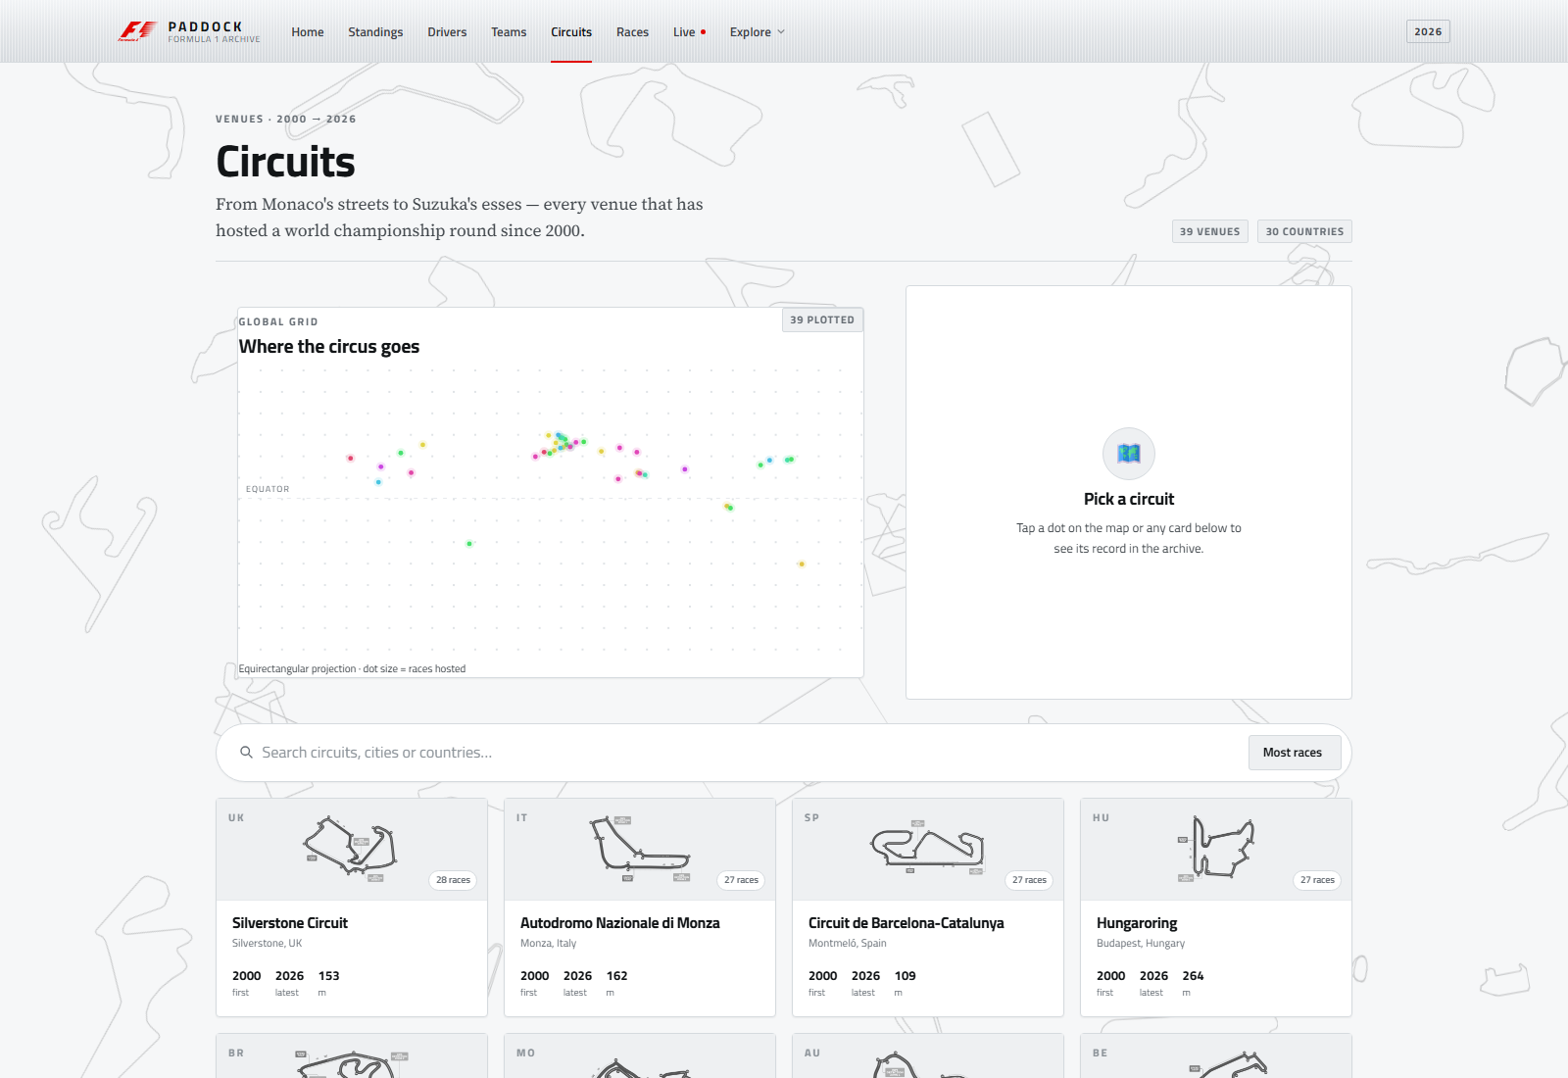

Race detail | Live timing
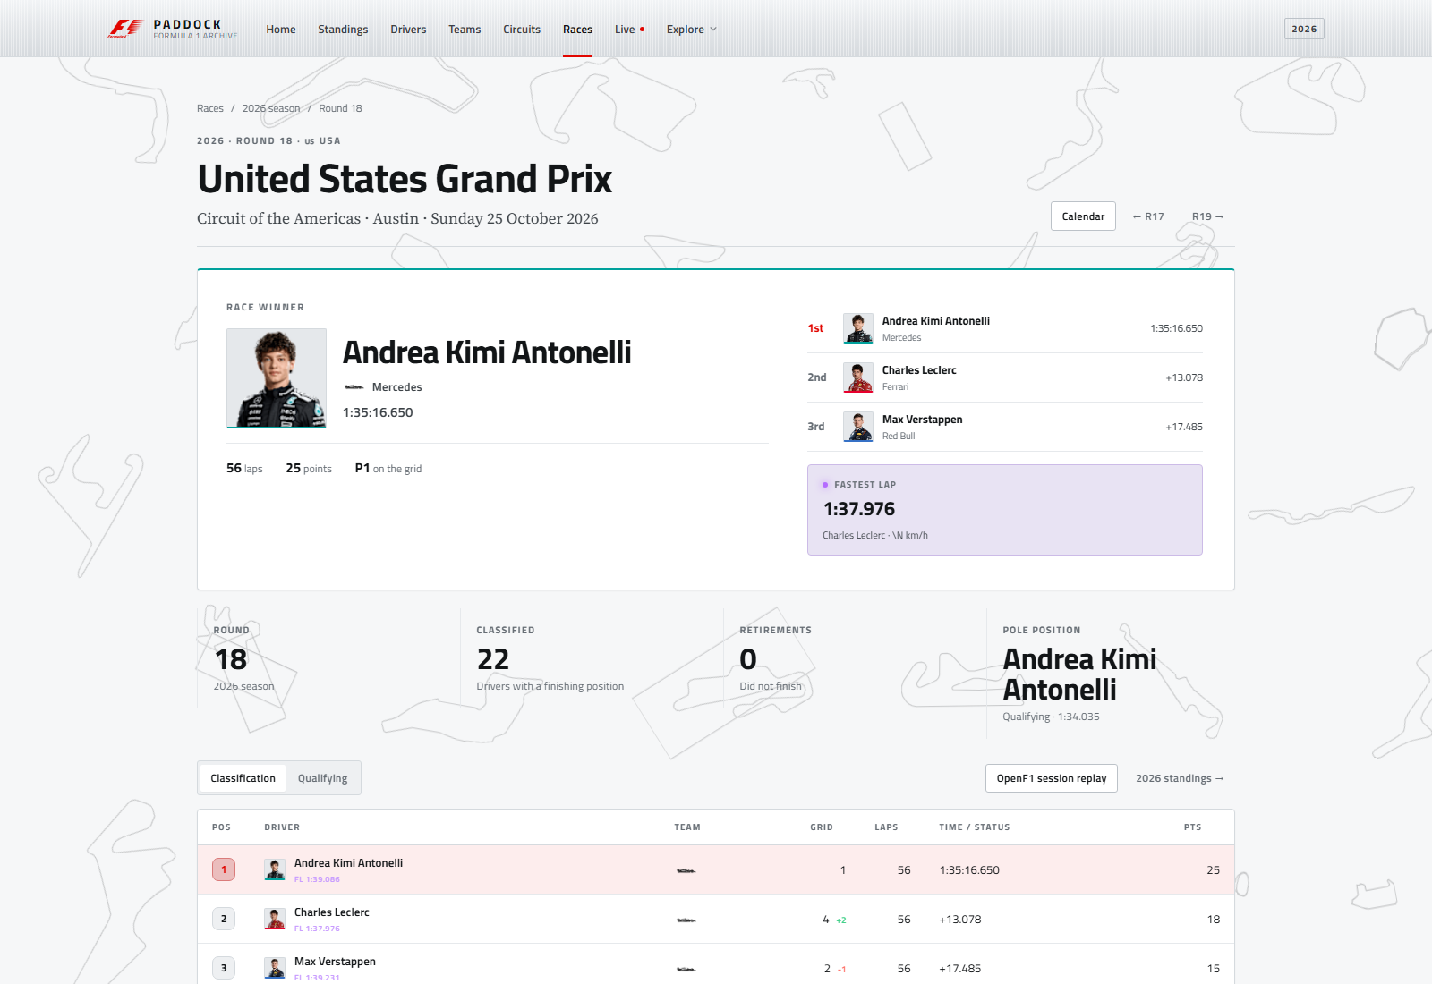 | 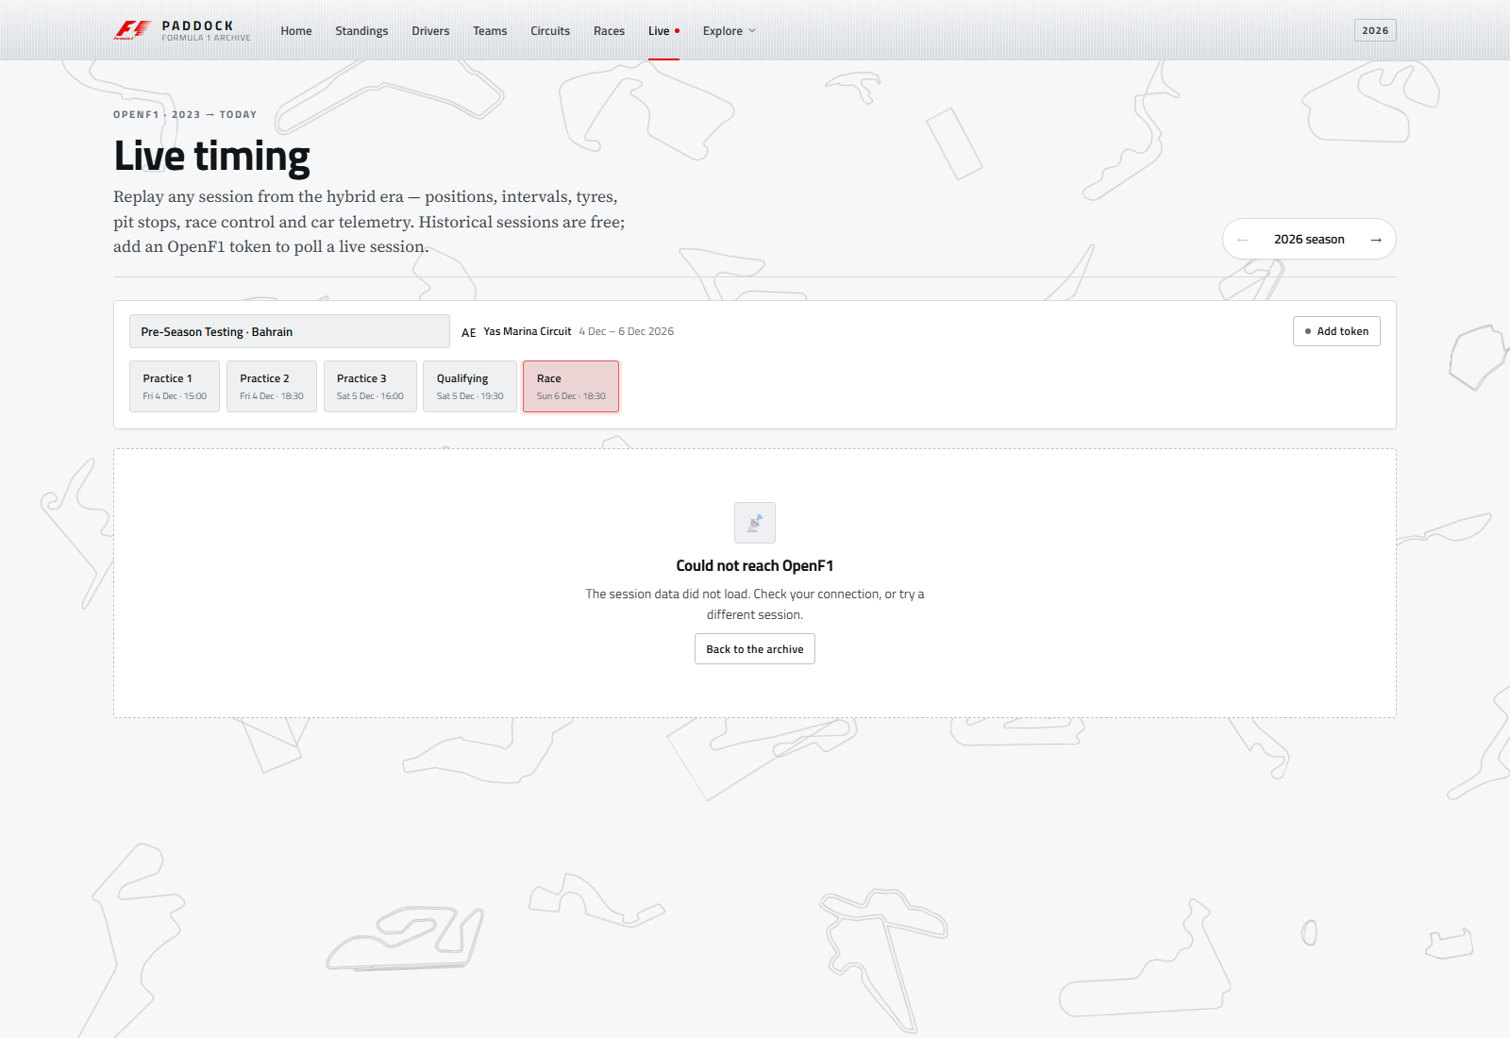

Screens and routes
Route | Screen | Highlights
/ | Home | Brushed hero with the McLaren MP4/4, 2026 top-five board, archive totals, latest and next race, 2025 champion feature
/standings?year=2026 | Season standings | Drivers' and constructors' tables, champion/leader card, points gap, season switcher
/drivers | Drivers | Searchable, sortable grid; profile dialog with career totals, titles, seasons and teams
/constructors | Teams | Team grid with real logos or typographic crests, title years, driver line-ups and career totals
/circuits | Circuits | Searchable circuit library with a world map, circuit-layout images and a detail panel
/races?year=2026 | Races | Season calendar, winners, podiums; year switcher
/races/202618 | Race detail | Winner hero, podium, fastest lap, classification, qualifying tabs, previous/next round, circuit and season context
/live?year=2026 | Live timing | OpenF1 meeting/session pickers, timing tower, weather, race control, lap telemetry, optional token
/history | History | Wikipedia-style article: lead, infobox, five eras, four rivalries, champions table and records
/rivalry?d1=1&d2=830 | Rivalry engine | Two-driver picker, career totals, points chart, season-by-season table, head-to-head score
/credits | Credits | Generated list of every image, its source and licence, plus a trademark notice

All screens are lazy-loaded except Home and share one flat silver component library. The layout responds down to phone widths.

Data sources

Bundled archive (2000–2026)
The frontend reads CSV files from frontend/src/assets/archive/ with PapaParse. The pruned set is about 1.3 MB and contains:
File | Contents
drivers.csv | 130 drivers
constructors.csv | 40 teams
circuits.csv | 39 circuits
races.csv | 526 races across 27 seasons
results.csv | 10,954 race results
qualifying.csv | 9,968 qualifying rows
season_standings.csv | Final or current drivers' standings per season
season_constructor_standings.csv | Final or current constructors' standings per season
status.csv | Result status labels
meta.json | Generated timestamp, year range, complete seasons, current season and row counts

frontend/src/app/core/services/csv-data.service.ts indexes these files once, then derives careers, championships, circuit histories, standings, race details, season summaries and rivalry data. Derived values are cached with shareReplay.
The first 25 seasons come from the Ergast dump. 2025 and 2026 were appended from Jolpica by scripts/sync-current-season.mjs, including sprint-aware results, qualifying, standings and the new Audi, Cadillac and Madring entries.

OpenF1 (2023 → present)
frontend/src/app/core/services/openf1.service.ts wraps the public API:
- https://api.openf1.org/v1 — sessions, meetings, drivers, positions, intervals, laps, stints, pit stops, weather, race control, car data.
- Free tier: historical sessions, no key required.
- Rate limit: 3 requests/second. The client uses a token bucket (burst 3, refill about every 340 ms) plus an in-memory response cache.
- Telemetry is requested only for one driver and one lap at a time, using date-window filters. Whole-session car_data is never downloaded.

Tech stack
Layer | Technology
Framework | Angular 21.2, standalone components, signals, new control flow
UI | Angular Material 21 + CDK, custom SCSS design system
Data | PapaParse / ngx-papaparse, RxJS, Jolpica + OpenF1 REST APIs
Charts | Hand-built SVG spark chart and telemetry trace (no charting dependency)
Typography | Titillium Web (UI) and Source Serif 4 (article body), both self-described in index.html
Imagery | Locally bundled logos, circuit maps, portraits and archive photography
Build | Angular CLI 21 / esbuild, SCSS
Optional backend | Node.js, Express, Mongoose, MongoDB (legacy REST API, not required by the UI)

Project structure
f1/
├── frontend/
│ ├── angular.json # build + budgets
│ └── src/
│ ├── index.html
│ ├── styles.scss # global silver surface/button/table system
│ ├── styles/_tokens.scss # colour, type, radius, elevation, motion tokens
│ └── app/
│ ├── app.ts # shell: floating maps, navbar, router outlet, footer
│ ├── app.config.ts # router, HTTP, animations, Material dialog
│ ├── app.routes.ts # 11 lazy routes + /timeline redirect
│ ├── components/navbar/ # brushed navbar + mobile sheet
│ ├── core/
│ │ ├── config/ # data scope, team colours, asset + outline manifests
│ │ ├── models/ # archive + OpenF1 types
│ │ ├── services/ # CSVDataService, OpenF1Service
│ │ └── utils/ # formatting, countries, flags
│ ├── features/
│ │ └── rivalry/ # head-to-head engine
│ ├── pages/ # home, standings, drivers, constructors,
│ │ # circuits, races, race-detail, live,
│ │ # history, credits
│ └── shared/components/ # panel, page header, stat tile, avatar,
│ # team badge, track background, charts, skeletons
├── scripts/
│ ├── prune-archive.mjs # rebuilds the 2000–2024 base CSVs
│ ├── sync-current-season.mjs # appends 2025–2026 from Jolpica
│ ├── fetch-assets.mjs # downloads logos/maps/photos + manifest
│ ├── extract-circuit-outlines.mjs # builds the floating-map outlines
│ ├── build-docs.py # README.md → README.docx
│ └── build-deck.py # builds the 15-slide presentation
├── archive/ # full source dataset for the backend
├── backend/ # optional Express + MongoDB API
├── docs/screenshots/ # app screenshots used in the docs/deck
├── README.md / README.docx / README.pdf
└── f1-presentation.pptx / f1-presentation.pdf

Getting started

Requirements
- Node.js 20+ (Node 24 tested)
- npm 10+
- A modern browser
- Python 3 with python-docx and python-pptx — only needed to rebuild the report and deck
No database or API key is needed to run the app.

Frontend
cd frontend
npm install
npm start
Open http://localhost:4200. The dev server serves the archive CSVs and local images from src/assets.

Production preview
cd frontend
npm run build
npx http-server dist/frontend/browser -p 8080 -c-1
Any static host works; configure an SPA fallback so deep links such as /races/202618 resolve to index.html.

Root convenience scripts
npm run frontend # Angular dev server
npm run build # production build
npm run data:prune # rebuild the 2000–2024 base archive
npm run data:sync # append 2025–2026 from Jolpica
npm run data:build # prune, then sync (full archive refresh)
npm run assets:fetch # refresh logos, circuit maps, photos + manifest
npm run outlines:build # regenerate the circuit-outline set
npm run docs:build # rebuild README.docx (Python + python-docx)
npm run deck:build # rebuild the presentation (Python + python-pptx)

Scripts
Command | What it does
node scripts/prune-archive.mjs | Reads the full archive/, keeps rows from 2000 onward, rebuilds season standings, writes meta.json, and reports file sizes. Existing untouched archive files are never deleted from the source folder.
node scripts/sync-current-season.mjs | Fetches 2025–2026 seasons, results, qualifying and standings from Jolpica (paginating at 100 rows), synthesises race IDs and rewrites meta.json. Must run after the prune.
node scripts/fetch-assets.mjs | Downloads team logos, official circuit maps, OpenF1 driver headshots and Wikimedia archive photos; writes asset-manifest.ts with the files that actually exist and their credits. Skips existing files and backs off on HTTP 429.
node scripts/extract-circuit-outlines.mjs | Traces circuit map images into the stroke-only SVG paths used by the floating background layer.
python scripts/build-docs.py | Renders README.md into a styled README.docx with a cover, credits page, contents and screenshots. Requires python-docx.
python scripts/build-deck.py | Builds the 15-slide presentation as f1-presentation.pptx. Requires python-pptx.
npm run build (root) | Runs the production Angular build.
npm run start (root) | Starts the optional legacy Express server.

OpenF1 live timing and tokens
The /live page is a full session replay for historical data and an optional live poller for current sessions.
- Pick a season, meeting and session. The selection is mirrored into the URL (?year=…&session=…) with replaceUrl, so links are shareable and the back button does not loop.
- The timing tower combines positions, intervals, laps, stints, pit stops, weather, race control and the final classification. Missing fields render as dashes rather than breaking the table.
- Choose a driver and lap to fetch a windowed telemetry trace (speed, gear, DRS, top/average speed, gear changes).
- Real-time polling is off by default. Add an OpenF1 bearer token in the token panel to enable 15-second refresh. The token is stored in localStorage under paddock.openf1.token, sent only to api.openf1.org, and never committed.
- paddock.openf1.polling remembers whether polling was left enabled.
The free tier covers historical sessions; true real-time access requires a paid OpenF1 subscription. Without a token the page remains a fully functional replay.

Data pipeline
Ergast-style archive (1950–2024)
│
├── scripts/prune-archive.mjs
│ ├── keep 2000–2024 rows
│ ├── rebuild season standings from results
│ └── write frontend/src/assets/archive/*
│
Jolpica (2025 → 26 Oct 2026)
│
└── scripts/sync-current-season.mjs
├── append races, results, qualifying, standings
├── paginate at 100 rows per request
├── synthesise race IDs (year * 100 + round)
└── update meta.json (completeYears, currentYear)

└── frontend CSVDataService
├── index rows once
├── derive careers / champions / rivalries
├── resolve complete vs in-progress seasons
└── shareReplay caches

OpenF1 (2023 → today)
└── OpenF1Service
├── token bucket + response cache
├── session replay board
└── windowed per-lap telemetry
To change the scope, edit DATA_START_YEAR, ARCHIVE_END_YEAR and OPENF1_START_YEAR in frontend/src/app/core/config/data.config.ts, then rerun npm run data:build.

Design system
- One theme, no toggle. Silver is the only surface language. There is no dark mode, no glass, no glow and no gradient wash.
- Tokens: styles/_tokens.scss defines the silver scale, ink scale, one red accent (#e10600), 2–4 px radii and one soft shadow. Components never hard-code surface colours.
- Surfaces: every page uses the same .panel primitive — flat matte silver, hairline border, tiny radius. Brushed metal is reserved for the home hero plate and the navbar.
- Typography: Titillium Web for UI and headlines, Source Serif 4 for article body, tabular numerals for timing and points.
- Red as a signal: the F1 mark, the active nav rule, P1 rows and one primary action per view. Team colours appear only in data bars, badges and 2 px rules — never as backgrounds.
- Background: TrackBackgroundComponent floats thirty distinct, stroke-only circuit outlines in black ink at a uniform 20%, one of every generated circuit. They sit on a loose 6×5 staggered field that spans the full viewport, with alternating rows offset so no columns line up; sizes stay between 125 and 195 px and rotations between −35° and +35°. There is no corner mask, so the top-left carries the same weight as the bottom-right. Each track drifts 5–9 px and rocks 2–4° on its own 40–80 s loop; the field rebuilds to twenty shapes in five columns at 1400 px and ten in two columns at 760 px, and stops animating under prefers-reduced-motion.
- Motion: short eased entrances and a restrained live indicator; all motion respects prefers-reduced-motion.
- Imagery: DriverAvatar and TeamBadge read the generated manifest, lazy-load images and fall back to monograms or typographic crests.

Imagery and licensing
scripts/fetch-assets.mjs builds frontend/src/app/core/config/asset-manifest.ts, which lists only the files that exist on disk. Components consult it before requesting an image, so a missing asset never produces a broken image.
Set | Count | Source | Fallback
Team logos | 35 of 40 | Formula 1 media CDN | Typographic crest
Circuit maps | 39 of 39 | Formula 1 media CDN | Country flag
Driver portraits | 28 | OpenF1 | Monogram
Archive photos | 9 | Wikimedia Commons (CC/PD) | Caption only
F1 mark | 1 | Formula 1 | —

The five teams without a licensable mark are MF1, Spyker MF1, Jaguar, Lotus Racing and Marussia. The 2026 grid includes the new Audi and Cadillac entries.
All sources and licences are listed in-app on /credits. Formula 1, F1, the F1 logo, team marks and circuit names are trademarks of Formula One Licensing B.V., the FIA and the respective teams; they appear for identification and commentary only. This is an unofficial, non-commercial student project.

Performance and accessibility
- Route-level code splitting; the production initial bundle is about 580 kB raw / 154 kB transferred.
- Archive data is fetched once and indexed; no per-page CSV downloads.
- OpenF1 cache prevents duplicate calls; the token bucket keeps the app under the 3 req/s limit.
- Semantic headings, tables with captions, labelled controls, visible focus, keyboard-operable navigation, aria-selected on tabs and an sr-only utility.
- Silver-on-ink text meets readable contrast; reduced motion and reduced transparency are handled in CSS.

Production build
cd frontend
npm run build
Output: frontend/dist/frontend/browser/.
Current build characteristics:
- Initial: ~580 kB raw, ~154 kB transferred
- Lazy chunks: under 45 kB each (live timing is the largest)
- Budgets in angular.json: 1.5 MB warning / 2.5 MB error initial; 24 kB warning / 40 kB error per component style
Deploy the browser folder to any static host (Netlify, Vercel, GitHub Pages, S3, Nginx) with an SPA fallback to index.html.

Optional legacy backend
The repository still contains the original Express + MongoDB API (backend/) and the full untrimmed dataset (archive/). The redesigned frontend does not call it at runtime; it is kept for reference and for anyone who wants a server-side API.
npm install
cd backend && npm install
npm run import # requires MongoDB on localhost:27017
npm start # http://localhost:3000
Endpoints include /api/health, /api/drivers, /api/races, /api/results/:raceId, /api/latest-results and /api/standings/:year.

Limitations and next steps
- 2026 is in progress. 18 of 23 rounds are complete as of 26 October 2026. The app labels the current leader as a leader and lists no 2026 champion.
- The 2026 calendar has unusual entries: Sakhir and Jeddah were cancelled, Sepang hosts the Bahrain Grand Prix in Malaysia, and Madrid uses the madring circuit reference.
- Driver portraits are only available for drivers OpenF1 lists from 2023 onward; earlier drivers intentionally use monograms. Arvid Lindblad has no portrait yet.
- True real-time polling requires an OpenF1 paid token.
- Possible extensions: sprint results in the archive, saved favourite drivers, deeper stint/tyre analytics and a server-side cache for OpenF1.

License
Educational project for the FET subject. Formula 1 data belongs to its respective owners; OpenF1 is used under its public API terms.
Built with Angular, Material 3, a lot of SCSS, and an unreasonable amount of Formula 1 data.

