Testing:Assignment 2-Counting VowelS
Dr. Larry Hughes
Department of Electrical and Computer Engineering
Dalhousie University

NAME: SYED SHANTO
ID: B00779367
DATE:15-SEPT-2022
Test 1: Test build script
Purpose: This test checks if the solution can be built easily with the build script on a UNIX-system
Configuration: The CLI is used to run this script. The script is written using Posix Shell Command Language.
cd Assigment2:Counting_vowels
chmod +x build
./build
Expected results: The script will create an executable module called count_vowels in the directory Assigment2:Counting_vowels
Actual results: It is the same as the expected result and is shown in the image below:
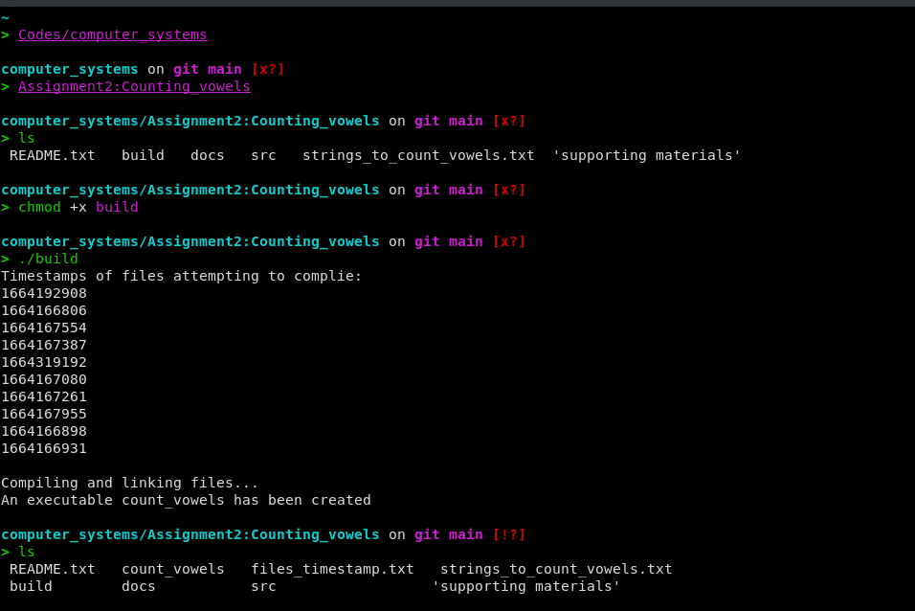

Test 2: Missing file name test
Purpose: This test checks for missing input file
Configuration: The program is built on Linux and the Linux CLI is used to pass the file names. The name of the executable module, count_vowels, should be entered after the prompt, followed by <Enter>.

The program is also expected to work in windows environment but has not been tested due not having access to a windows machine.

Expected results: In either mode, the program should display the message, Missing filename, and then pause, waiting for <Enter>. The program terminates after <Enter>.

Actual results: In a Linux CLI the program, the missing file name error was produced if a file was not passed. After producing the error message the program terminates.

The results of count_vowels module in a CLI:
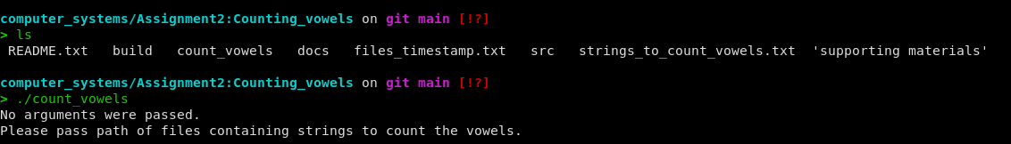

PASS/FAIL: The test was successful.

TEST 2: Input file does not exist

Purpose: A file name is supplied, but the file does not exist.

Configuration: The test can be only run in a CLI and requires the tester to supply a name or names of a file that does not exist in the directory.

Expected Result: It prints the name of the file that does not exist and informs the user how many invalid arguments were passed. The program also terminates after printing the error message.

Actual Result: A missing file name message was produced and the program paused, waiting for input.

The results of count_vowels module in a CLI:
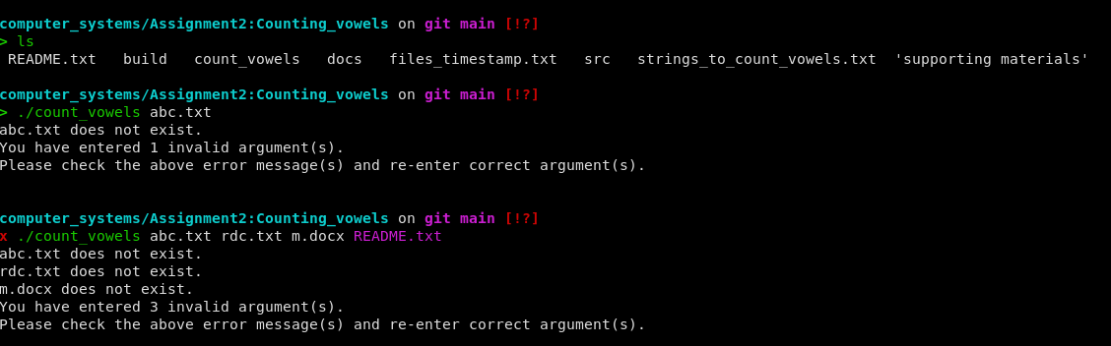

PASS/FAIL: The test was successful.

TEST 3: One input file

Purpose: Test if the program is capable of detecting vowels in strings from the file.

Test Configuration: A test file, strings_to_count_vowels.txt, containing the following record is used:
This is a TEST String
ECED 3401 Systems Analysis Assignment 3
Conscience doth MAKE cowards OF US All.
#

Expected Result: The program prints the output and waits for a <enter> to terminate.
The expected output is:
#FILE NAME: strings_to_count_vowels.txt
This is a TEST String
i:3 a:1 e:1 o:0 u:0
ECED 3401 Systems Analysis Assignment 3
e:4 a:3 i:2 o:0 u:0
Conscience doth MAKE cowards OF US All.
o:4 a:3 e:3 i:1 u:1

Actual Result: The output is from the above input shown in the test configuration.
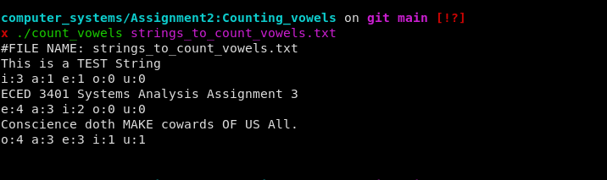

PASS/FAIL: The test was successful.

Test 4: More than one input file

Purpose: To check if the program can handle more than one input file.

Test Configuration: A test file, strings_to_count_vowels.txt, containing the following record is used:
This is a TEST String
ECED 3401 Systems Analysis Assignment 3
Conscience doth MAKE cowards OF US All.
#

Another test file README.txt containing the following record is used:
The story begins like this. I wrote the program, however, since every thing was in one file it looked hideous and was hard to debug.
So, I decided to spit them up. However, every time I made some small tweaks it was a pain to compile those multiple files in the CLI interface.
Therefore, to make my life easier I decided to wirte a simple posix conforming shell script to build the solution.

How to build?
cd Assignment2:Counting_vowels
chmod +x build
./build

These commands will create the executable count_vowel
Typical use case: count_vowel file1 file2 file3 .............. file_(N)

Program Folder Structure
src: contains the source code .c files
src/headers: contains the header .h files

Note:- executable gets created on the top folder where the build script is located and this README.txt is located.

Expected Result: The program prints the output and waits for a <enter> to terminate.
The expected output is:
#FILE NAME: strings_to_count_vowels.txt
This is a TEST String
i:3 a:1 e:1 o:0 u:0
ECED 3401 Systems Analysis Assignment 3
e:4 a:3 i:2 o:0 u:0
Conscience doth MAKE cowards OF US All.
o:4 a:3 e:3 i:1 u:1
#FILE NAME: README.txt
The story begins like this. I wrote the program, however, since every thing was in one file it looked hideous and was hard to debug.
e:15 i:10 o:9 a:5 u:2
So, I decided to spit them up. However, every time I made some small tweaks it was a pain to compile those multiple files in the CLI interface.
e:18 i:13 a:7 o:7 u:2
Therefore, to make my life easier I decided to wirte a simple posix conforming shell script to build the solution.
e:13 i:11 o:9 a:3 u:2
How to build?
o:2 i:1 u:1 a:0 e:0
cd Assignment2:Counting_vowels
e:2 i:2 o:2 a:1 u:1
chmod +x build
i:1 o:1 u:1 a:0 e:0
./build
i:1 u:1 a:0 e:0 o:0
These commands will create the executable count_vowel
e:9 a:3 o:3 u:2 i:1
Typical use case: count_vowel file1 file2 file3 .............. file_(N)
e:7 i:5 a:2 o:2 u:2
Program Folder Structure
e:2 o:2 u:2 a:1 i:0
src: contains the source code .c files
e:4 o:3 i:2 a:1 u:1
src/headers: contains the header .h files
e:6 a:3 i:2 o:1 u:0
Note:- executable gets created on the top folder where the build script is located and this README.txt is located.
e:16 a:6 o:6 i:5 u:2

Actual Results:
The output is the same as the expected results.

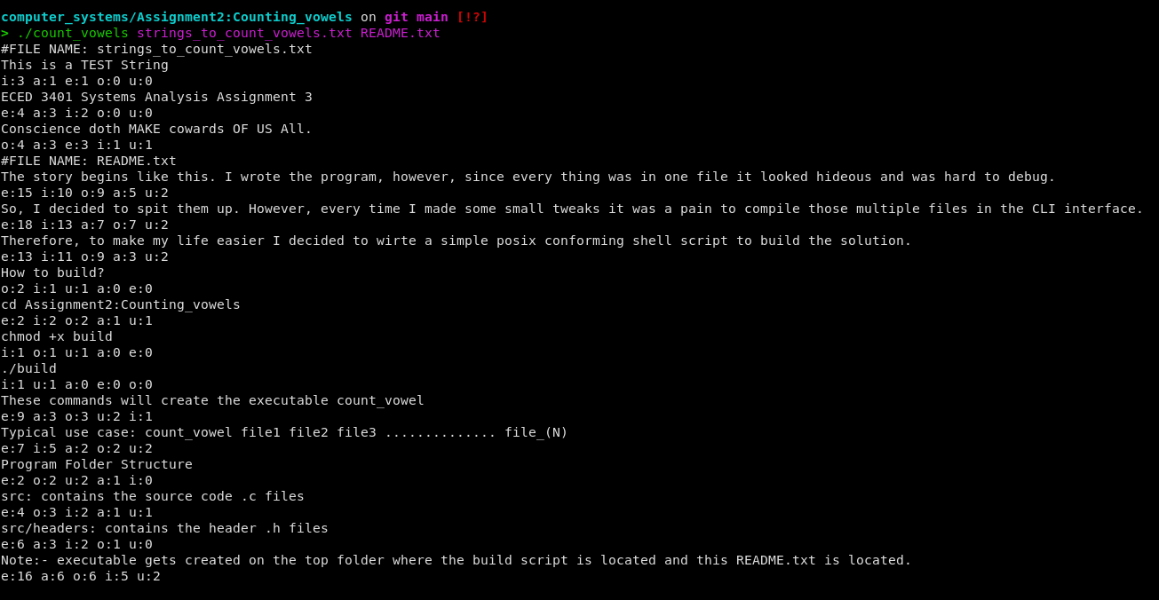

PASS/FAIL: The test was successful.

Conclusion: All the tests were successful. All the test shown here are successful. However, there may be more tests that can be done. The program appears to be bug free on the basis of these tests.

