Testing: Assignment 3
Arctic Sea-Ice Loss
Dr. Larry Hughes
Department of Electrical and Computer Engineering
Dalhousie University

NAME: SYED SHANTO
ID: B00779367
DATE:04-OCT-2022
Test 1: Test build script

Purpose: This test checks if the solution can be built easily with the build script on a UNIX-system

Configuration: The CLI is used to run this script. The script is written using Posix Shell Command Language.
cd Assigment2:Counting_vowels
chmod +x build
./build

Expected results: The script will create an executable module called search_arctic in the directory Assigment3:Arctic Sea-Ice Loss

Actual results: It is the same as the expected result and is shown in the image below:
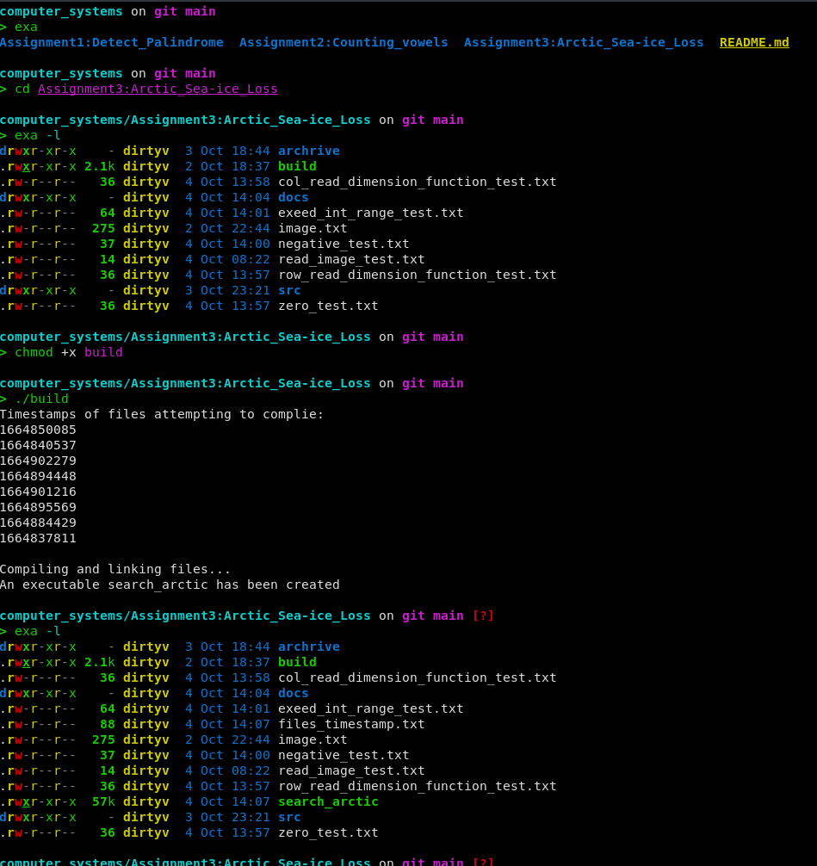

Test 2: Missing file name test

Purpose: This test checks for missing input file

Configuration: The program is built on Linux and the Linux CLI is used to pass the file names. The name of the executable module, search_arctic, should be entered after the prompt, followed by <Enter>.

The program is also expected to work in windows environment but has not been tested due not having access to a windows machine.

Expected results: The program should display the message, “You have either not passed a file name or you have passed more than one file name. The program requires only one file name to operate.”, and then pause, waiting for <Enter>. The program terminates after <Enter>.

Actual results: In a Linux CLI the program, the missing file name error was produced if a file was not passed. After producing the error message the program terminates.

The results of search_arctic module in a CLI:
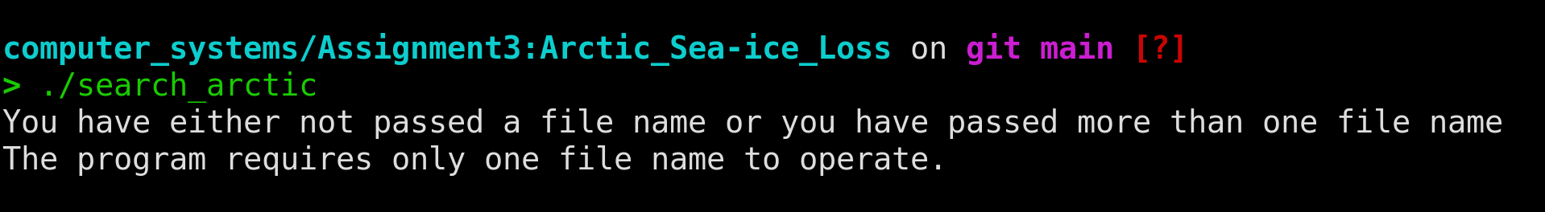

PASS/FAIL: The test was successful.

TEST 2: Input file does not exist

Purpose: A file name is supplied, but the file does not exist.

Configuration: The test can be only run in a CLI and requires the tester to supply a name of a file that does not exist in the directory.

Expected Result: No error message is printed. This is checked using the <assert.h> header. If the file does not exist the assertion fails and the program terminates.

Actual Result:
The results of search_arctic module in a CLI:
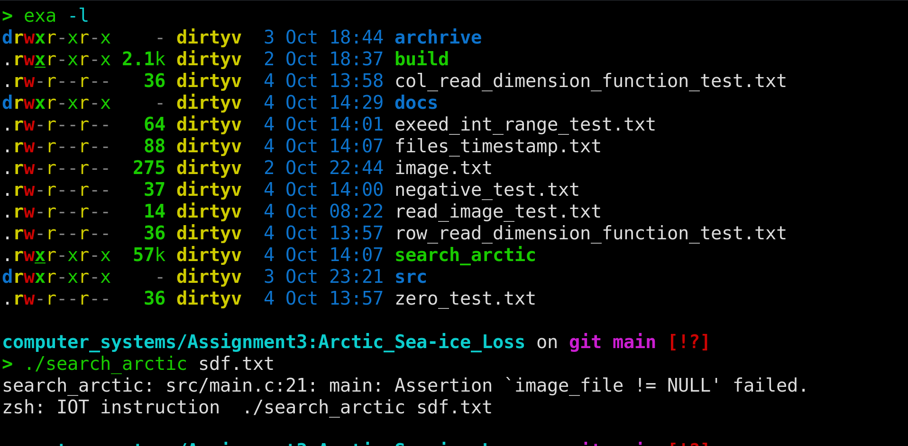

PASS/FAIL: The test was successful.

TEST 3: One input file

Purpose: Test if the program is capable of detecting matches.

Test Configuration: A test file, image.txt, containing the following record is used:
2 2
#.
##
3 5
#.#.#
#####
.###.
1 3
#.#
3 6
##..##
.#.#.#
#.#...
3 3
#..
#.#
#..
5 36
#......#........................#...
#.#....#.#...#.........#............
#......#.#...##....#...##......###..
.......#.....#...#.#...##........#.#
...................#.....#.......#..
0 0

Expected Result: The program prints the output and waits for a <enter> to terminate.
The expected output is:
4
3
4

Actual Result: The output is from the above input shown in the test configuration.
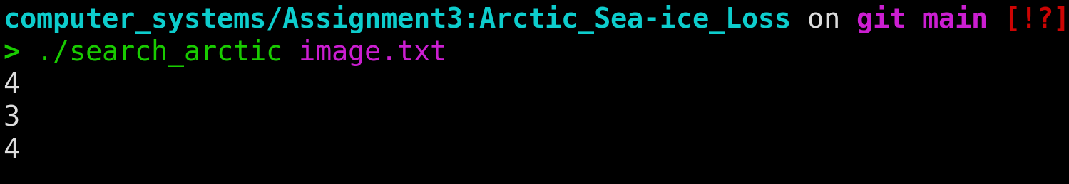

PASS/FAIL: The test was successful.

Test 4: More than one file as inputs

Purpose: To check if the program can handle more than one input file.

Test Configuration: The name of the executable module, search_arctic, should be entered after the prompt, followed by files that exist. In this test image.txt and zero_test.txt is used.

Expected Result: The program can not handle more than one input file. The program should display the message, “You have either not passed a file name or you have passed more than one file name. The program requires only one file name to operate.”, and then pause, waiting for <Enter>. The program terminates after <Enter>.

Actual Results:
The output is the same as the expected results.

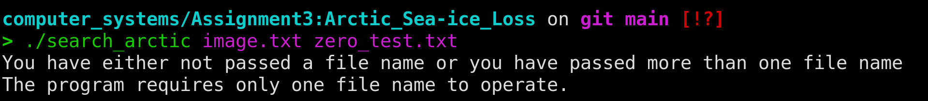

PASS/FAIL: The test was successful.

Test 5: When input files contains non-digit characters for dimensions

Purpose: To check how the program handles input files that has wrong dimensions for images.

Test Configuration: A test file, col_read_dimension_function_test.txt, containing the following record is used:
2 2
#.
##
3 a
#.#.#
#####
.###.
0 0
Another test file, row_read_dimension_function_test.txt, containing the following record is used:
a 2
#.
##
3 5
#.#.#
#####
.###.
0 0

Expected Result: The program should print for the 1st file, “Error: column value contains non-digit characters. Failure to read arctic dimension from file. Exiting Program” and “Error: row value contains non-digit characters. Failure to read search dimension from file. Exiting Program” for the second file.

Actual Results: The output is the same as the expected results.
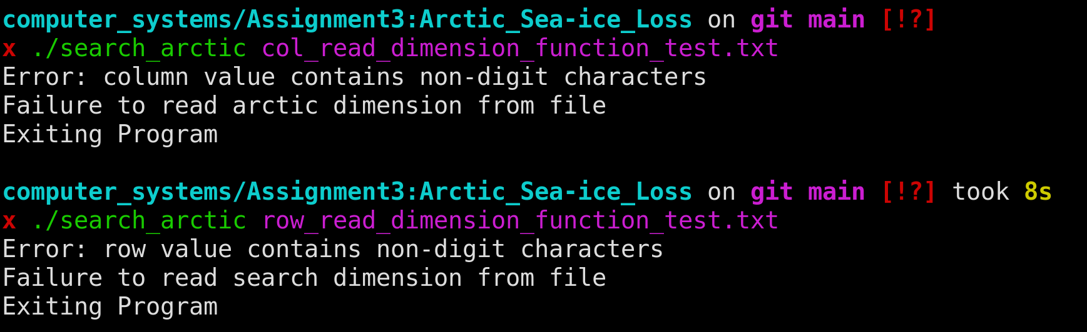

PASS/FAIL: The test was successful.

TEST 6: When input files contains 0 for the value of either row or column and the other is a non-zero digit.

Purpose: To check how the program handles input files that has only one of the dimensions as 0 for images.

Test Configuration: A test file, zero_test.txt, containing the following record is used:
2 2
#.
##
3 0
#.#.#
#####
.###.
0 0

Expected Result: The program should print “Error: row value or column value is 0 when the other is not. Failure to read arctic dimension from file. Exiting Program”

Actual Results: The output is the same as the expected results.
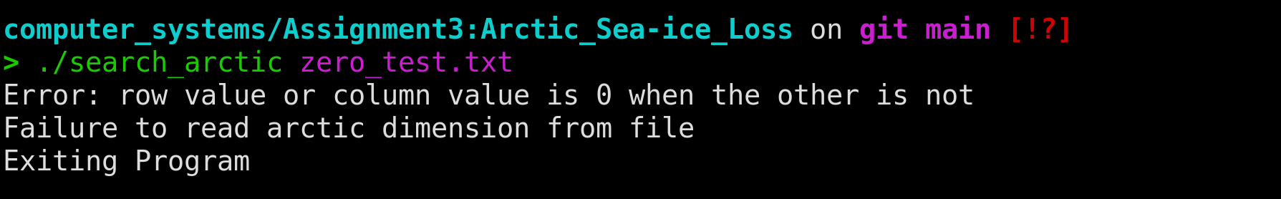

PASS/FAIL: The test was successful.

TEST 7: When input files contains negative value of dimensions.

Purpose: To check how the program handles input files that has negative digits as image dimensions.

Test Configuration: A test file, negative_test.txt, containing the following record is used:
2 2
#.
##
-1 3
#.#.#
#####
.###.
0 0

Expected Result: The negative sign is read as a not digit character. Hence, it cannot detect the negative sign explicitly but it can detect that the input is not correct.

“Error: row value contains non-digit characters
Failure to read arctic dimension from file
Exiting Program”

Actual Results:
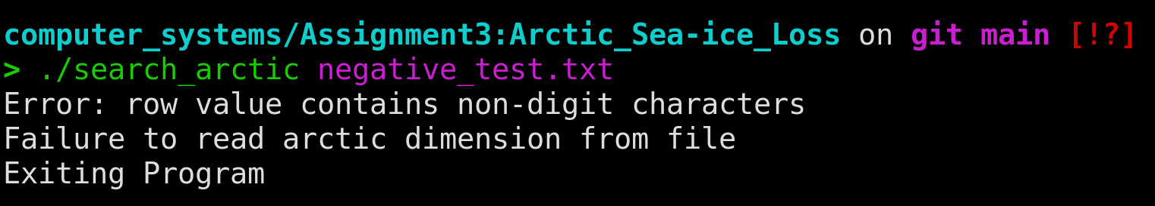

TEST 8: When search image dimensions are incompatible with arctic image dimensions.

Purpose: To check how the program handles input files that has incompatible dimensions.

Test Configuration: A test file, incompatible_dimensions.txt, containing the following record is used:
3 5
#.#.#
#####
.###.
2 2
#.
##
0 0

Expected Result: There is an assert condition for this case. It does not print any error message to the terminal expect showing assertion failed.
This the error that you see:
“search_arctic: src/search_arctic_find_match.c:12: search_arctic_find_match: Assertion `search_image != NULL && arctic_image != NULL && search_row < arctic_row && search_col < arctic_col' failed.”

Actual Result:
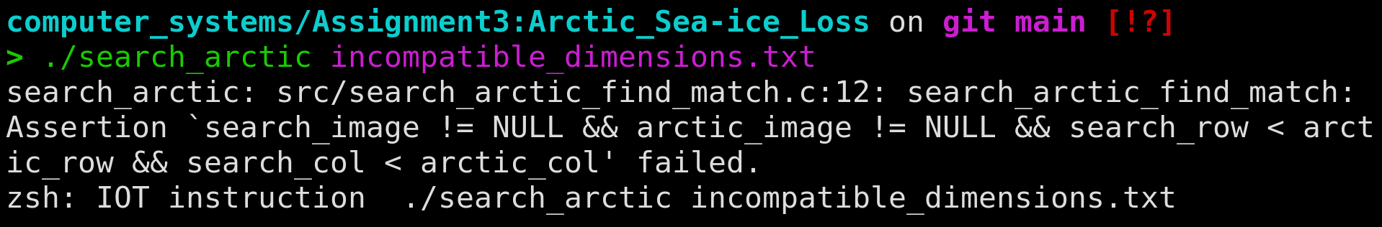

PASS/FAIL: The test was successful.

TEST 9: When image contains invalid characters

Purpose: To check how the program handles input files that has image that contains invalid characters.

Test Configuration: A test file, read_image_test.txt, containing the following record is used:
2 2
#.
##
3 5
#.#.#
##~#
.###.
0 0

Expected Results: The program prints:
Error: image contains invalid characters
Failure to read arctic image from file
Exiting Program

Actual Results:
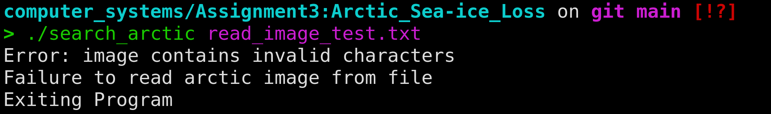
PASS/FAIL: The test was successful.

TEST 10: What happens when row or column exceeds the int range in C.

Purpose: To check how the program handles input files that has dimensions greater than int range.

Test Configuration: A test file, exceed_int_range_test.txt, containing the following record is used:
22323232323324234423423424345656662222234345666778890043543534456767232 2323232323232323
#.
##
3 0
#.#.#
#####
.###.
0 0

Expected Result: Unexpected behaviour

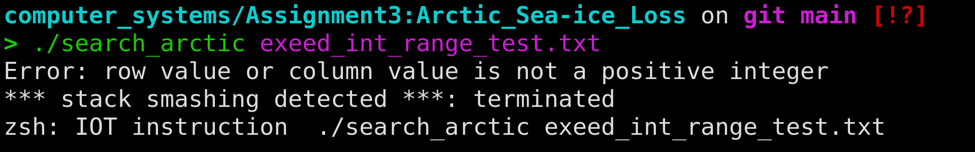
Actual Results:
The row and column gets converted to a negative number by atoi and probably these not enough space in the buffer stack to hold the string as well. This is an unexpected behaviour. However, it will be considered a pass since the program terminates safely without any issue.

PASS/FAIL: The test was successful.
Conclusion: All the tests were successful. All the test shown here are successful. However, there may be more tests that can be done. The program appears to be bug free on the basis of these tests.

