Testing: Assignment 4
Morse Code Decoder
Dr. Larry Hughes
Department of Electrical and Computer Engineering
Dalhousie University

NAME: SYED SHANTO
ID: B00779367
DATE:04-OCT-2022
Known Limitations (that are not tested but known because simply I did not introduce any handling for such cases):
1) The code cannot read broken morse code due to line feed. For example “---” is O but if it appears in the file like “-\n--”, it will be read as TM instead. The program treats \n the same way it treats spaces.
2) The spaces has to be before or after ‘\n’. For example, “ \n“ or “\n “ is fine but not “ \n “ is not fine or handled. It will cause Segmentation fault. So, The 3 spaces must appear at the beginning or at the middle of a sentence but if it appears at the end it must remain as a whole and cannot be separated using a ‘\n’.
Test 1: Test compilers.

Purpose: This checks if the solution builds with different compilers. Compilers: GCC, minGW

Configuration: The test is done by changing the compiler using cmake.

Cmakelists.txt contents:
cmake_minimum_required(VERSION 3.16)
#ONLY SUITABLE FOR PERSONAL PROJECTS
#COMPIER
set(CMAKE_SYSTEM_NAME Linux)
set(CMAKE_C_COMPILER "gcc") # GCC version > 10 #x86_64-w64-mingw32-gcc does not work
set(CMAKE_C_STANDARD 17) # THE DOCUMENTATION OF THIS STANDARD USED WHILE CODING
set(CMAKE_C_STANDARD_REQUIRED ON) # Therefore this is set on
#FLAGS
set(CMAKE_C_FLAGS_DEBUG "${CMAKE_C_FLAGS_DEBUG} -O0 -ggdb3")
set(CMAKE_SHARED_LIBRARY_LINK_C_FLAGS "")
set(CMAKE_C_FLAGS "${CMAKE_C_FLAGS} -Wall -Wextra")
#PROJECT
project(MORSE_CODE_DECODER LANGUAGES C)
enable_language(C)
set(CMAKE_RUNTIME_OUTPUT_DIRECTORY ${CMAKE_CURRENT_SOURCE_DIR})
# HOW TO COMPILE AND FILE LOCATIONS
set(SRC "${CMAKE_CURRENT_SOURCE_DIR}/src") # set main.c dir and sub directory style library but can be libries without any change.
set(INC "${CMAKE_CURRENT_SOURCE_DIR}/inc") # INCLUDE_DIRECTORY ./inc/ where all headers *.h files are. main.h links them all.
file(GLOB_RECURSE LIB_SRC "${SRC}/*/*.c") # GET LIB_SRC. You cab have multiple libraries and it will compile to 1 static library .a file that gets linked but here only src/morse_lib
# LINK FILES
add_library(MORSE_LIB STATIC ${LIB_SRC}) # Add library .c files
add_executable(MorseCodeDecoder ${SRC}/main.c) #Add main.c
target_link_libraries(MorseCodeDecoder MORSE_LIB) # LINK main.c and static libraries src/morse_lib
include_directories(BEFORE ${INC}) # COMMON HEADERS DIRECTORY main.h is ONLY HEADER need

For minGW,
set(CMAKE_C_COMPILER "gcc") is changed to x86_64-w64-mingw32-gcc for minGW.

Expected results: The expected result is that the program will compile when using a GNU GCC compiler and it may not compile on minGW. However, cross compilation for linux can be done using windows, just like I am going attempt to cross compile it for windows.

Actual results:

MinGW: You get the following errors. It took 1 extra day to set up this cross compiler on my PC. It is possible to cross-compile my code for Unix instead of windows, which is an ideal solution.
Attempt at cross compilation for windows:
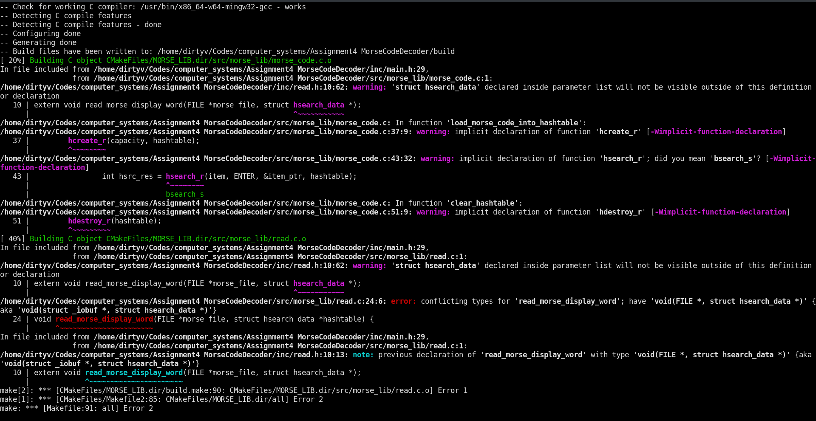

GCC Compilation for Ubuntu-Linux
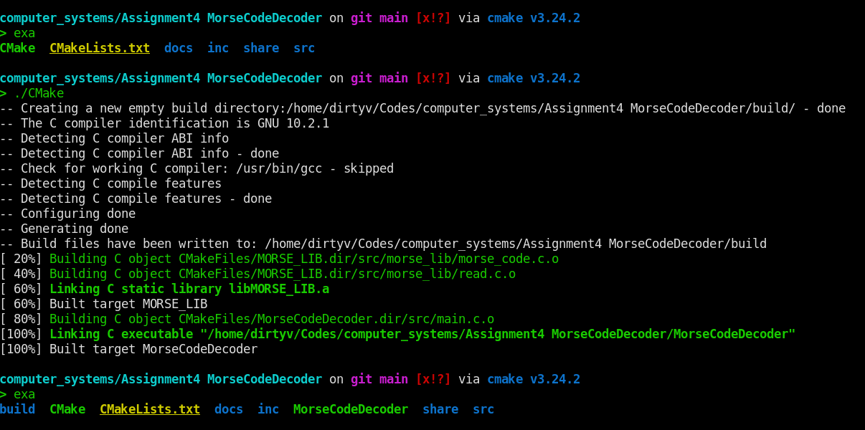
Morse Decoder is the executable that it is produced after compilation. The program compiles easily on Unix Systems but you need to put effort to compile it on Windows. The program will not work for windows if you do not know how to cross compile for Linux from Windows.

PASS/FAIL: The test was successful the solution builds with GCC but does not build with minGW. I prefer to use the compiler that is native to my machine. There is no restriction on the course saying a program should be written for only windows operating system or support cross compilation. Only restriction was that it should be a program written in C.

Test 2: Missing file name test

Purpose: This test checks for missing input file

Configuration: The program is built on Linux and the Linux CLI is used to pass the file names. The name of the executable module, MorseCodeDecoder, should be entered after the prompt, followed by <Enter>.

Expected results: The program should display a message and an assertion error. The following string is outputted “MorseCodeDecoder: /home/dirtyv/Codes/computer_systems/Assignment4 MorseCodeDecoder/src/main.c:4: main: Assertion `"Missing file paths as input. Program requires files to operate" && argc > 1' failed.”, and terminates.

Actual results: In a Linux CLI the program, the missing file name error was produced if a file was not passed. After producing the error message the program terminates.

The results of search_arctic module in a CLI:
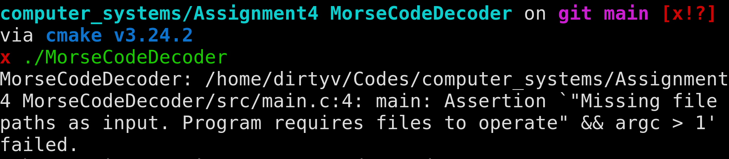

PASS/FAIL: The test was successful.

TEST 3: Input file does not exist

Purpose: A file name is supplied, but the file does not exist.

Configuration: The test can be only run in a CLI and requires the tester to supply a name of a file that does not exist in the directory.

Expected Result: The program will print the name of the file name and an error message by <assert.h> header.

Actual Result:
The results of search_arctic module in a CLI:
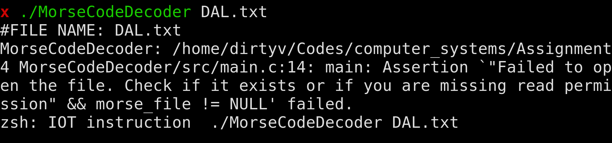

PASS/FAIL: The test was successful.

TEST 4: One input file

Purpose: Test if the program is capable of detecting matches for morse code and print them as words.

Test Configuration: A test file, morse_code_1.txt, containing the following record is used:
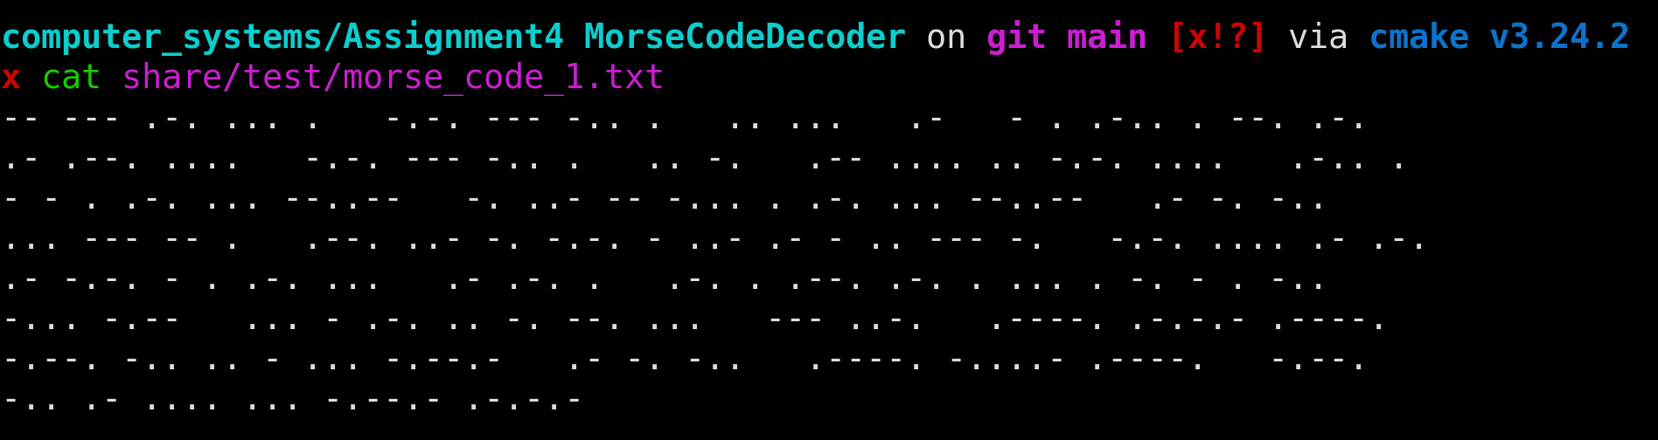
Expected Result: The program prints the output and waits for a <enter> to terminate.
The expected output is:
#FILE NAME: share/test/morse_code_1.txt
MORSE CODE IS A TELEGRAPH CODE IN WHICH LETTERS, NUMBERS, AND SOME PUNCTUATION CHARACTERS ARE REPRESENTED BY STRINGS OF '.' (DITS) AND '-' (DAHS).

Actual Result: The output is from the above input shown in the test configuration.
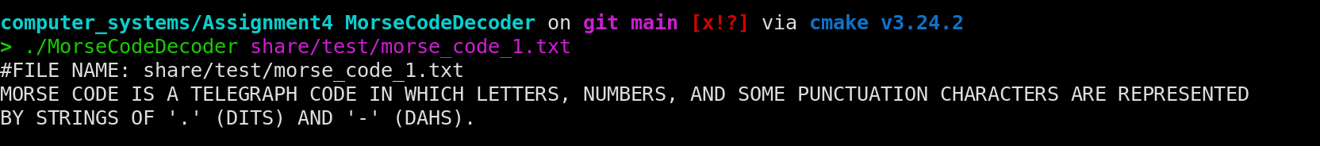

PASS/FAIL: The test was successful.

Test 5: More than one file as inputs

Purpose: To check if the program can handle more than one input file.

Test Configuration: Same type of files will be passed as last test. The file contents are share below in the image:
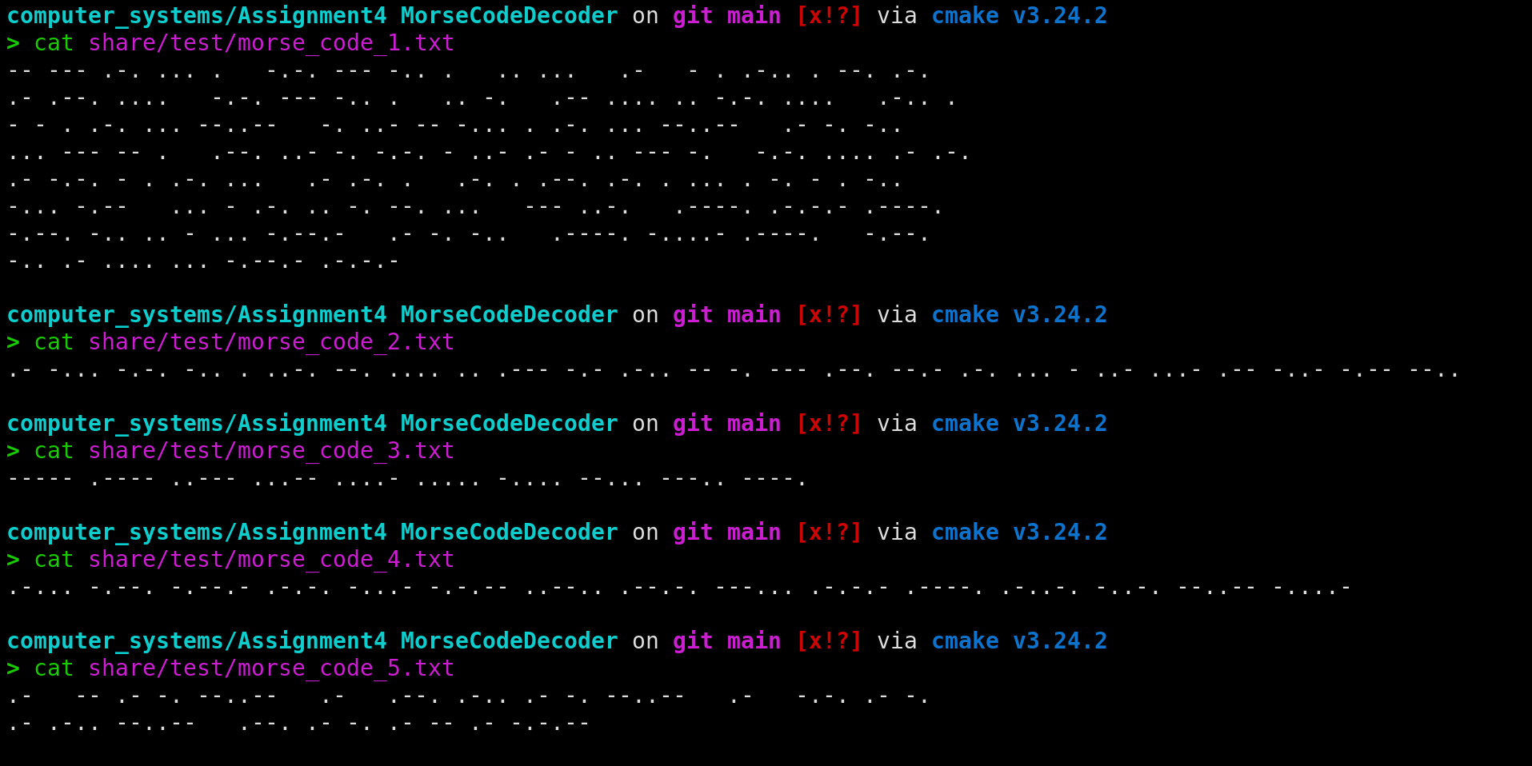
Expected Result: The program take all files and prints out the results. The expected results are shown below:
#FILE NAME: share/test/morse_code_1.txt
MORSE CODE IS A TELEGRAPH CODE IN WHICH LETTERS, NUMBERS, AND SOME PUNCTUATION CHARACTERS ARE REPRESENTED
BY STRINGS OF '.' (DITS) AND '-' (DAHS).
#FILE NAME: share/test/morse_code_2.txt
ABCDEFGHIJKLMNOPQRSTUVWXYZ
#FILE NAME: share/test/morse_code_3.txt
0123456789
#FILE NAME: share/test/morse_code_4.txt
&()+=!?@:.'"/,-
#FILE NAME: share/test/morse_code_5.txt
A MAN, A PLAN, A CANAL, PANAMA!

Actual Results:
The output is the same as the expected results.

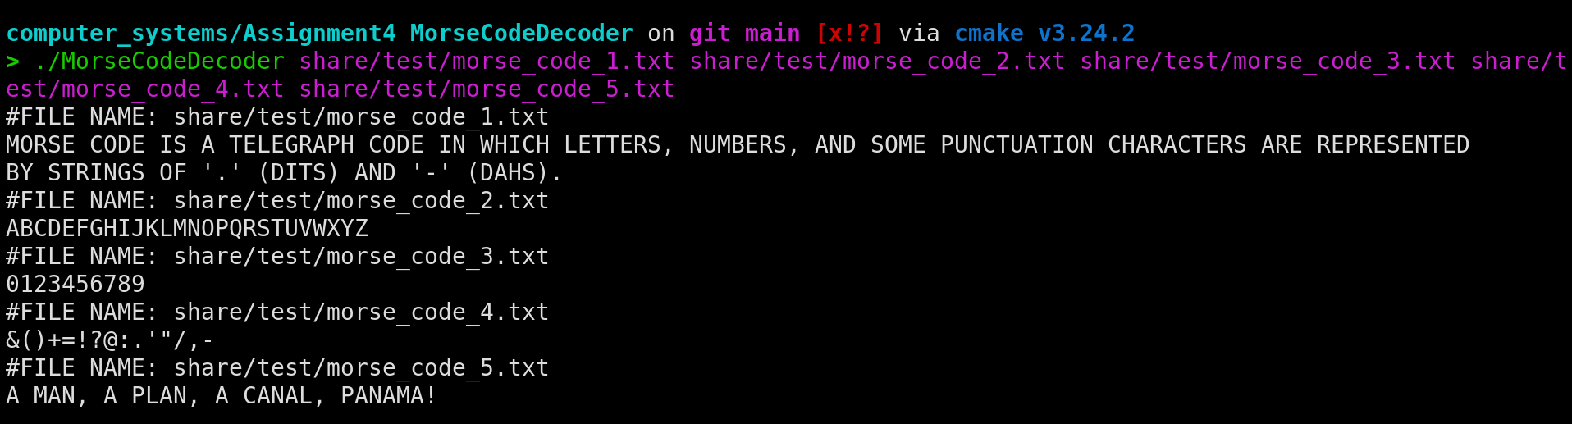

PASS/FAIL: The test was successful.

Test 6: More than one file as inputs and 1 file that does not exist

Purpose: To check if the program can handle more than one input file and can also handle if one of those files does not actually exist.

Test Configuration: Same type of files will be passed as last test. The file contents are the same. But 1 new file will be passed that does not exist.

Expected Result: The program will print the name of the file that does not exist and will terminate but any correct files before that will show outputs.

Actual Result:
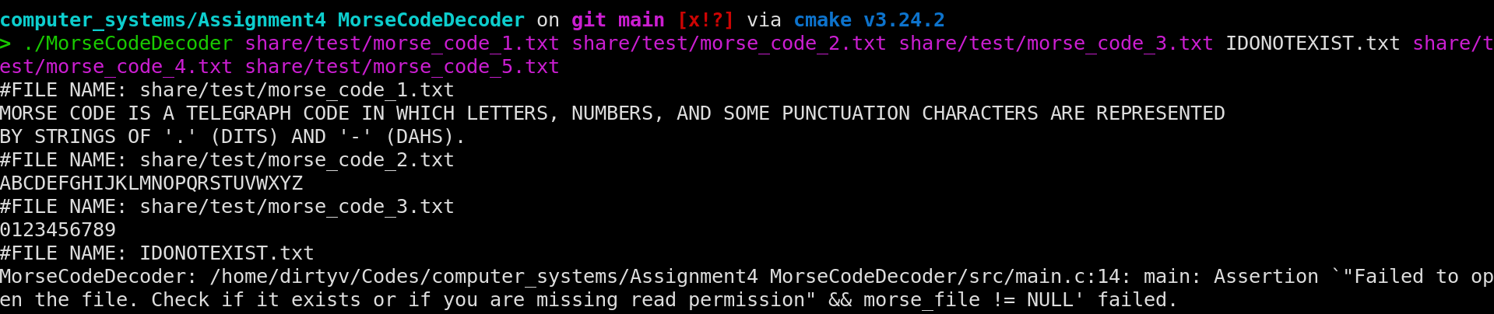
PASS/FAIL: The test was successful.

