Test 1: Test compiler.
Purpose: This checks if the solution builds with a specific compiler, which is MINGW32.
Configuration: The test is done by attempting compile folder software with cmake.
Expected results: It compiles with the Windows gcc compiler MINGW32.

Actual results:

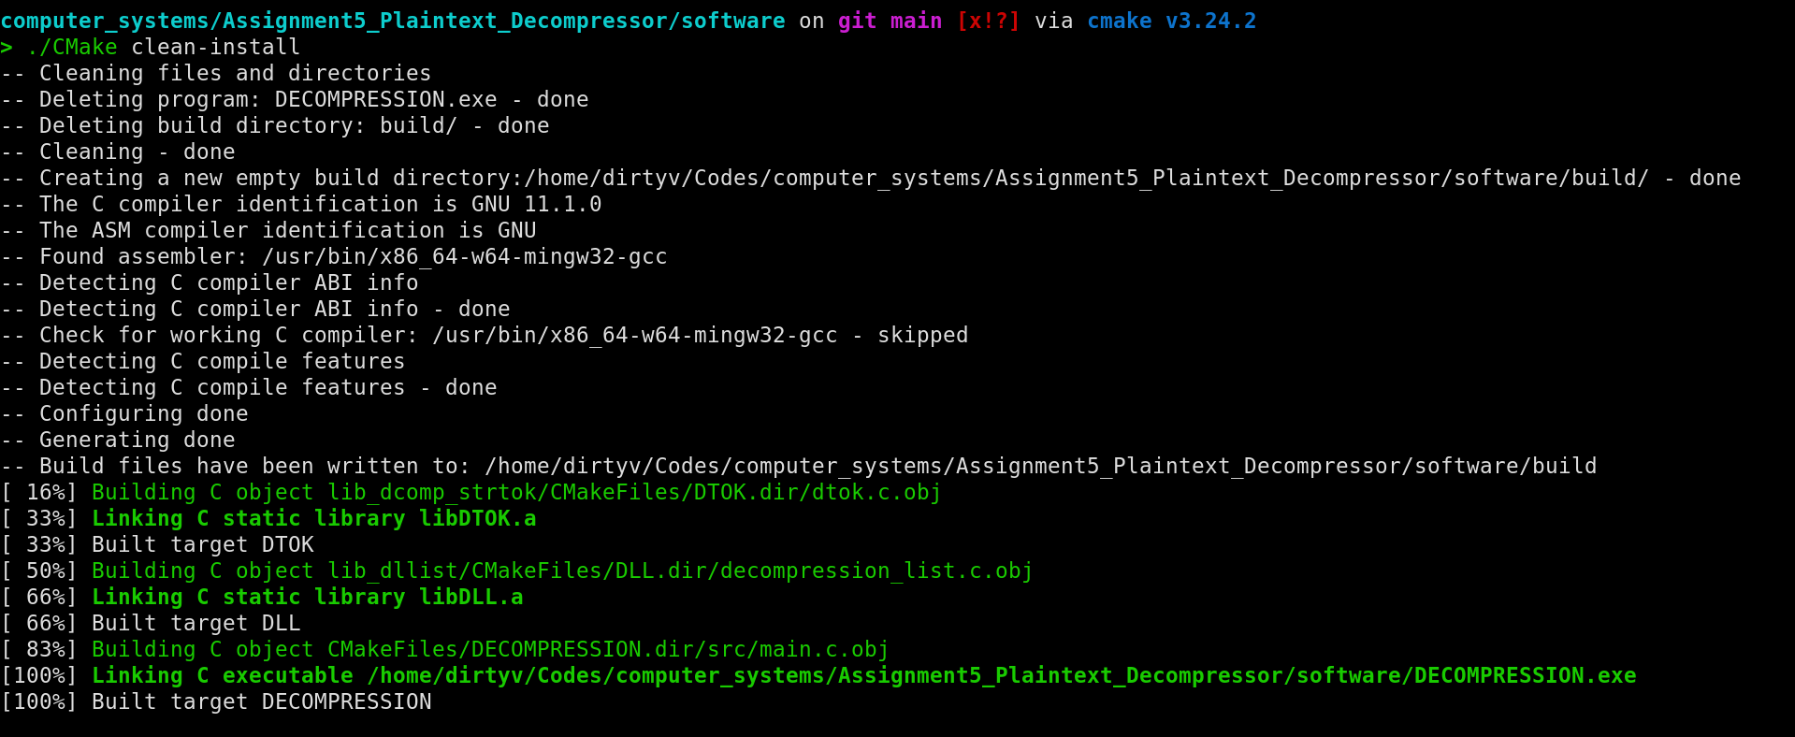
You can see the name of the compiler which is x86_64-w64-mingw32-gcc and you can see that the compiled program is DECOMPRESSION.exe

PASS/FAIL: The test was successful proving it will work on Windows.

Test 2: Missing file name and more than one input file test
Purpose: This test checks for missing input file and program’s behaviour on more than one input file.
Configuration: The name of the executable module, DECOMPRESSION.exe, should be entered after the prompt, followed by <Enter> and then the name of the executable module should be entered again with more than one file name.
Expected results: The program should display a message which is “In file software/src/main.c:5, Error: Program only operates with -->one input file<--”
Actual results:
The actual result is shown below:

PASS/FAIL: The test was successful.

TEST 3: Input file does not exist
Purpose: A file name is supplied, but the file does not exist.
Configuration: The test can be only run in a CLI and requires the tester to supply a name of a file that does not exist in the directory.
Expected Result: The program is print an error message, which is “In file software/src/main.c:10, Error: Failed to open the input file -->possibly missing<--”

Actual Result:
The results of search_arctic module in a CLI:

PASS/FAIL: The test was successful.

TEST 4: One input file

Purpose: Test if the program can decompress the plain text.

Test Configuration: A test file, dcomp.txt, containing the following record is used:

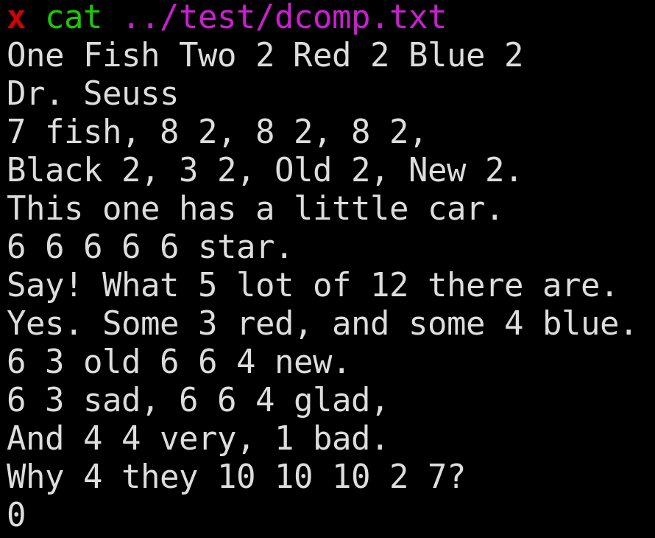

Expected Result: The program prints the output and waits for a <enter> to terminate.
The expected output is:
One Fish Two Fish Red Fish Blue Fish
Dr. Seuss
One fish, Two fish, Red fish, Blue fish,
Black fish, Blue fish, Old fish, New fish.
This one has a little car.
This one has a little star.
Say! What a lot of fish there are.
Yes. Some are red, and some are blue.
Some are old and some are new.
Some are sad, and some are glad,
And some are very, very bad.
Why are they sad and glad and bad?

Actual Result: The output is from the above input shown in the test configuration.

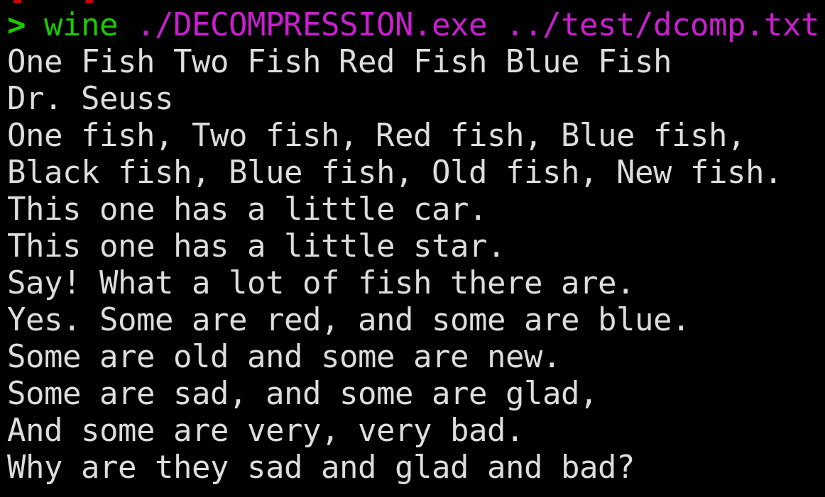
PASS/FAIL: The test was successful.

Test5: Check if the program ends without the terminating character.

Purpose: Test if the program can decompress plain text from a file if the file does not contain terminating character.
Test Configuration: A test file, dcomp0.txt, containing the following record is used:

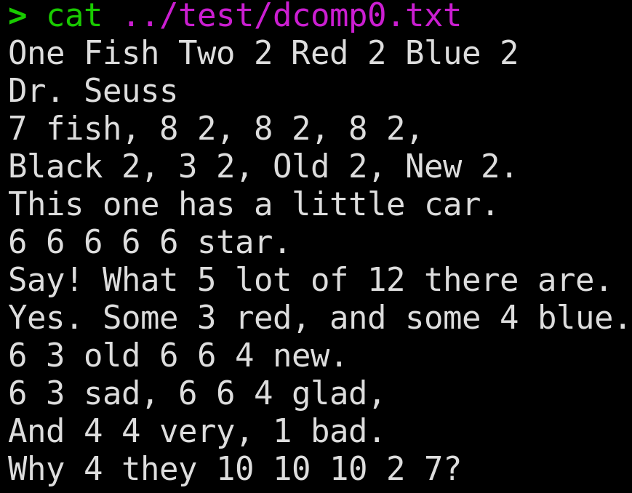

Expected Result: The program prints the output and waits for a <enter> to terminate.
The expected output is:
One Fish Two Fish Red Fish Blue Fish
Dr. Seuss
One fish, Two fish, Red fish, Blue fish,
Black fish, Blue fish, Old fish, New fish.
This one has a little car.
This one has a little star.
Say! What a lot of fish there are.
Yes. Some are red, and some are blue.
Some are old and some are new.
Some are sad, and some are glad,
And some are very, very bad.
Why are they sad and glad and bad?

Actual Result: The output is from the above input shown in the test configuration.

PASS/FAIL: The test was successful.

