SQL 1

Create Statements for all tables 1

Common Queries used in program 1

Windows 1

Homepage 2

Design 2

XAML 2

C# 3

Register page 3

Design 3

XAML 3

C# 3

Reset password 3

Design 3

XAML 3

C# 4

Login page 4

Design 4

XAML 4

C# 5

Resources and Assets 5

Assets used + Sources 5

References 5

# SQL

## Create Statements for all tables

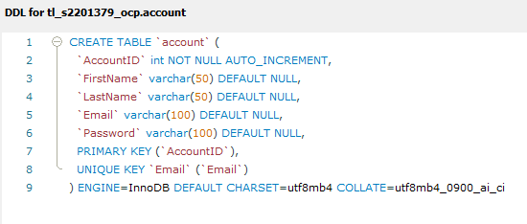

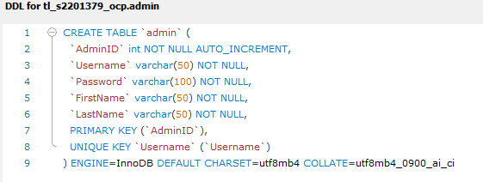

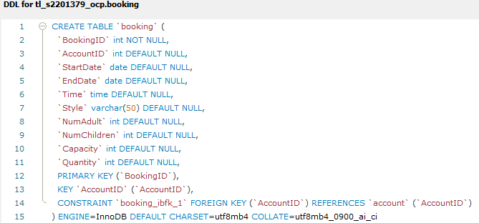

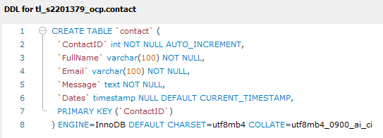

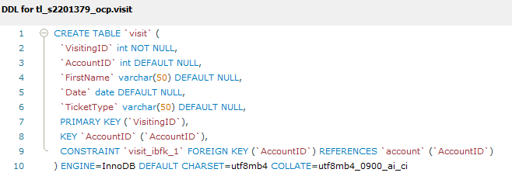

## Common Queries used in program

# Windows

## Homepage:

### Design

The main window is the first thing you see when starting an application in a Windows system, acting as the user's main interface for interaction. I have chosen to creat a simplistic and minimalist design for the home page, this is to not over stilmulate the user and detaer users from using the aplication. It contains different components, such as:

* **Account, login, Register**: I have chosen to display these subheadings to make it easier fot the user to access detail and amend them to there disgretion.
* **Booking, Discount, visiting**: A collection of the application that are what I espect to atract consumers/users’ attention and I have chosen to incorperate this into my page to create efficeny but to grab users’ attention prom the moment they open the application.
* **Map, information, about us**: these headins are found on the page to aid users that may need help or require Knowledge about RZA, I have chosen to put these headins on the home page for the betterment of the overal user expirance.
* **Contact us, policy, term and conditons**: the reason I have included these interface into the design of this page is so that if users want to contact oor read aout legistation and what we do with there data, this creates tranpaciy but also an open relation for b2c operations.

V1

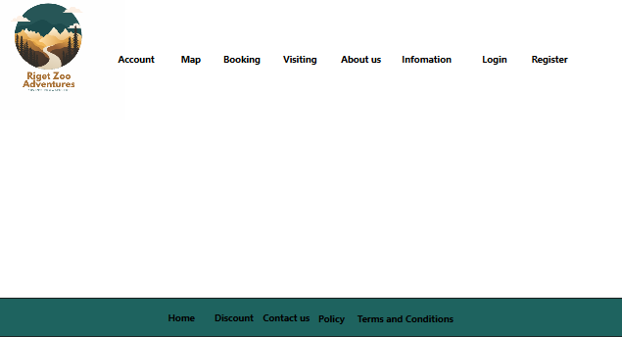

V2

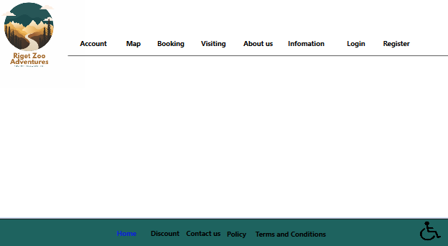

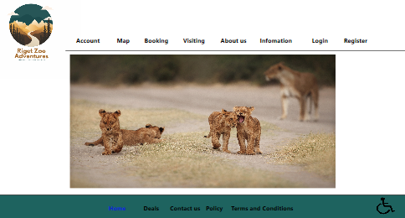

### XAML

### C#

## Register page:

### Design

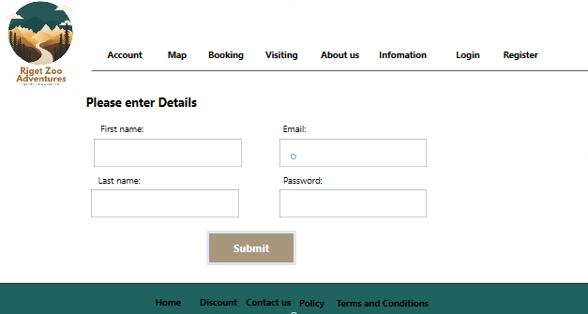

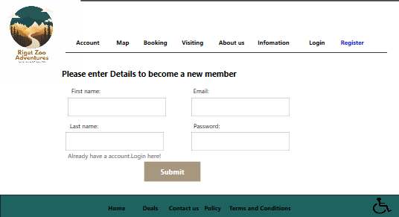

### XAML

### C#

### C#

## Login page:

### Design

, the design of the login page is clean and easy to use. The use of colour and styling makes it clear what actions the user can take, and the centred layout of the page makes it easy to find and use. The zoo-themed image adds a personal touch to the page, making it feel more welcoming and engaging.

This login page has several features to make it user-friendly, including:

* Clear labelling of the page fields.
* A password box to protect the user's password from being seen by others.
* A wheelchair icon button to indicate the page's accessibility.
* Hyperlink buttons for forgotten password and register options.
* A visually distinct primary action button.
* A visually distinct colour scheme for the main menu buttons.
* A visually distinct colour scheme for the hyperlink buttons.

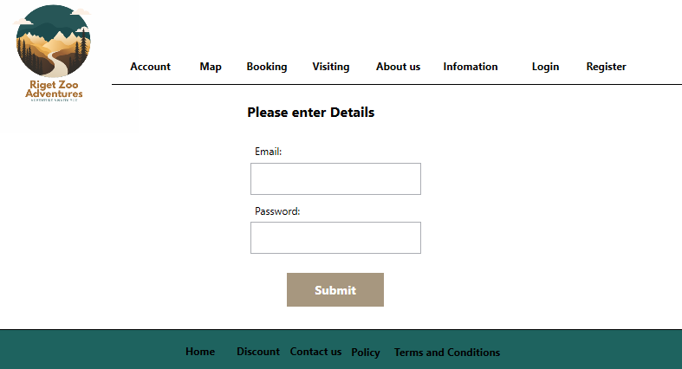

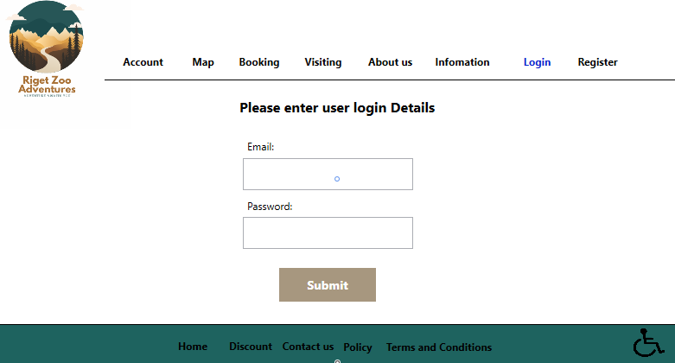

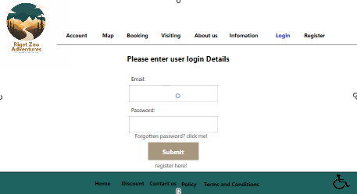

### XAML

## Reset password:

### Design

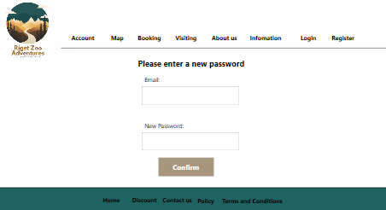

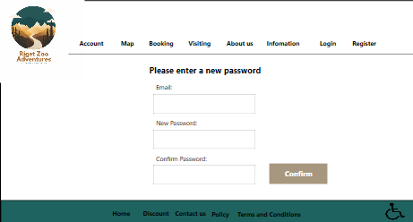

### XAML

### C#

## Account:

### Design

### XAML

### C#

## Map:

### Design

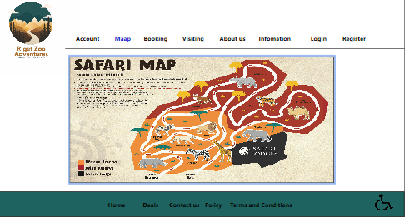

### XAML

### C#

## Booking:

### Design

### XAML

### C#

## Visiting:

### Design

### XAML

### C#

## About us:

### Design

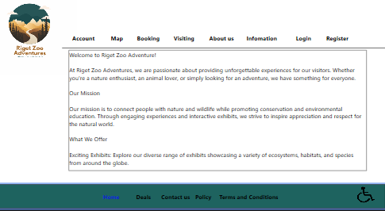

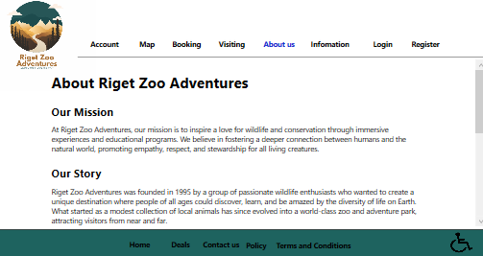

### XAML

### C#

## Information:

### Design

### XAML

### C#

## Discount:

### Design

### XAML

### C#

## Policy:

### Design

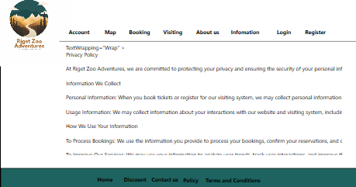

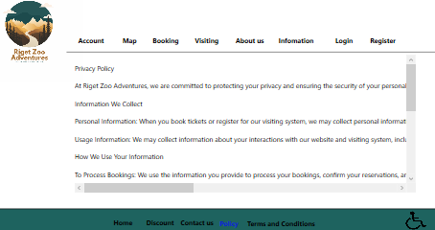

### XAML

### C#

## Term and conditions:

### Design

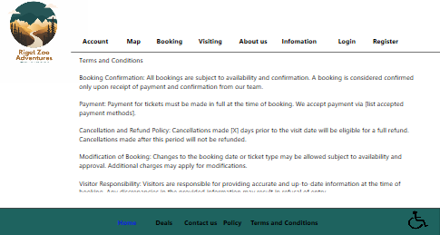

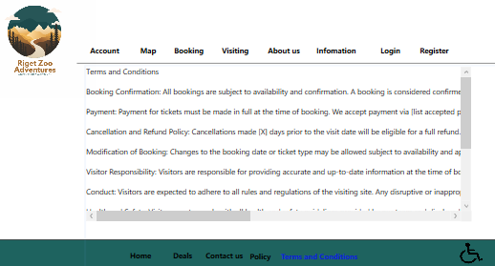

### XAML

### C#

# Resources and Assets

## Assets used + Sources

(Any images used and links to where you found them)

## References

(Links to any sources of information you used e.g., GitHub / stack overflow)