SQL 1

Create Statements for all tables 1

Common Queries used in program 1

Windows 1

Homepage 2

Design 2

XAML 2

C# 3

Register page 3

Design 3

XAML 3

C# 3

Reset password 3

Design 3

XAML 3

C# 4

Login page 4

Design 4

XAML 4

C# 5

Resources and Assets 5

Assets used + Sources 5

References 5

# SQL

## Create Statements for all tables

## Common Queries used in program

# Windows

## Homepage:

### Design

V1

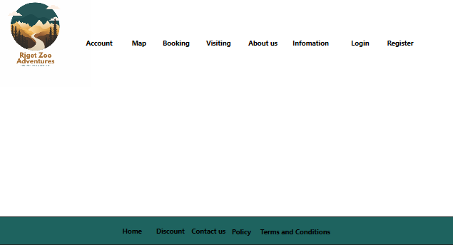

The main window is the first thing you see when starting an application in a Windows system, acting as the user's main interface for interaction. I have chosen to creat a simplistic and minimalist design for the home page, this is to not over stilmulate the user and detaer users from using the aplication. It contains different components, such as:

* **Account, login, Register**: I have chosen to display these subheadings to make it easier fot the user to access detail and amend them to there disgretion.
* **Booking, Discount, visiting**: A collection of the application that are what I espect to atract consumers/users’ attention and I have chosen to incorperate this into my home page to create efficeny but to grab users’ attention prom the moment they open the application.
* **Map, information, about us**: these headins are found on the home page to aid users that may need help or require Knowledge about RZA ,I have chosen to put these headins on the home page for the betterment of the overal user expirance.
* **Close Button**: C

V2

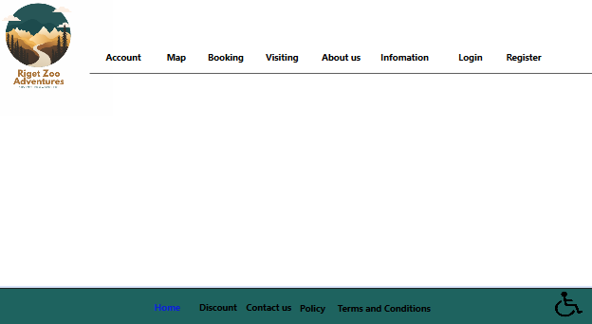

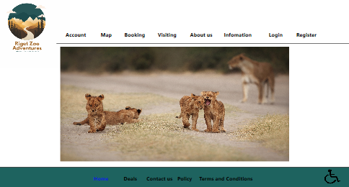

### XAML

### C#

## Register page:

### Design

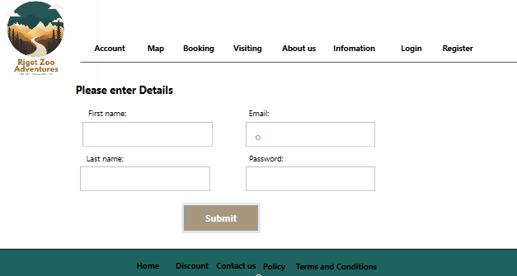

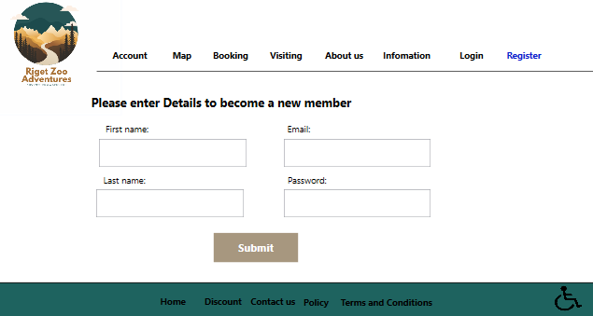

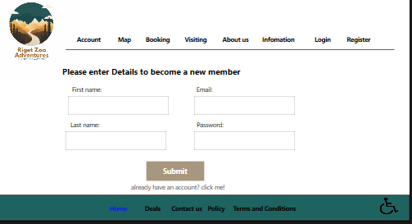

### XAML

### C#

### C#

## Login page:

### Design

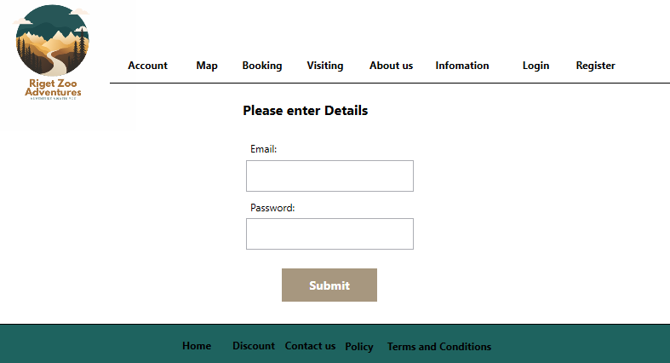

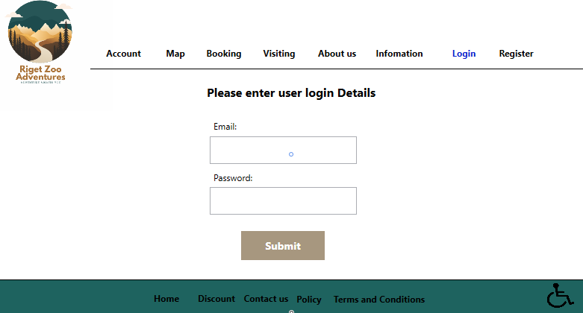

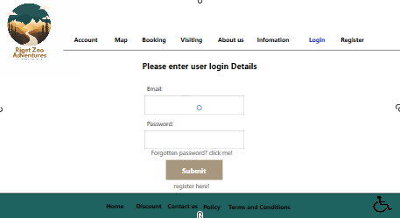

### XAML

## Reset password:

### Design

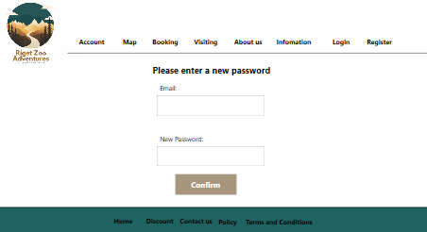

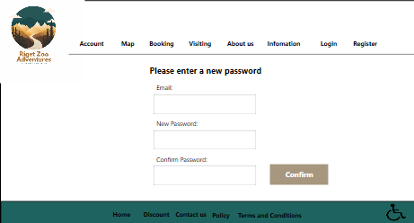

### XAML

### C#

## Account:

### Design

### XAML

### C#

## Map:

### Design

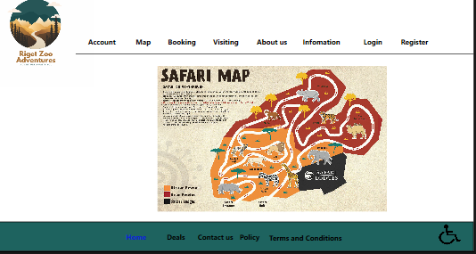

### XAML

### C#

## Booking:

### Design

### XAML

### C#

## Visiting:

### Design

### XAML

### C#

## About us:

### Design

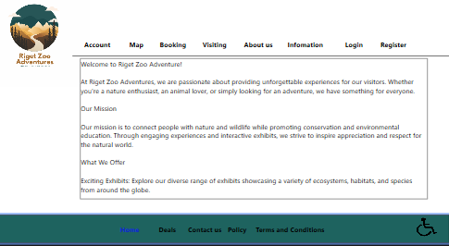

### XAML

### C#

## Information:

### Design

### XAML

### C#

## Discount:

### Design

### XAML

### C#

## Policy:

### Design

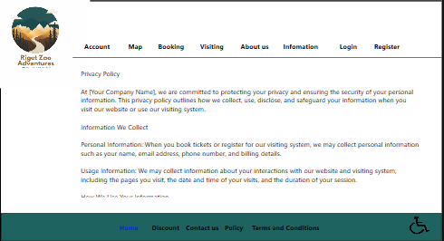

### XAML

### C#

## Term and conditions:

### Design

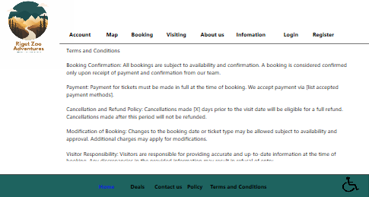

### XAML

### C#

# Resources and Assets

## Assets used + Sources

(Any images used and links to where you found them)

## References

(Links to any sources of information you used e.g., GitHub / stack overflow)