ATTENDEASE
ONLINE ATTENDANCE MANAGEMENT SYSTEM
Project Report
Smart Attendance, Smarter Access

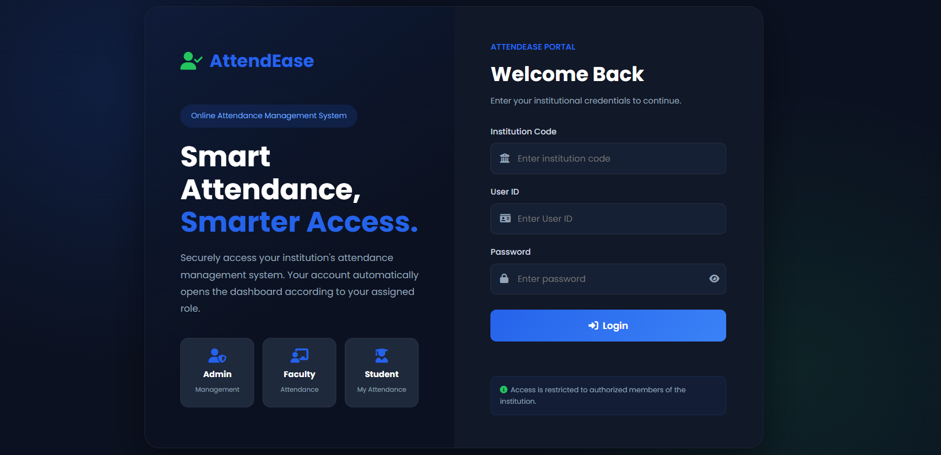
Figure 1. AttendEase landing/login interface.
Live Project: https://sanehasharam.github.io/AttendEase/
FEE-II Project Evaluation • 2026

PRELIMINARY

Certificate
This is to certify that the project report entitled “AttendEase — Online Attendance Management System” represents the project work prepared for the FEE-II project evaluation. The report documents the project concept, interface design, role-based dashboards, responsive design, frontend implementation, testing approach, limitations and future scope.

Project Information | Details
Project Title | AttendEase — Online Attendance Management System
Project Type | Web-based frontend project
Primary Focus | Attendance management through role-specific dashboards
Roles | Admin, Faculty, Student
Deployment | GitHub Pages
Project Link | https://sanehasharam.github.io/AttendEase/
Evaluation | FEE-II

Place: ______________________________
Date: _______________________________
Faculty Signature: ____________________

PRELIMINARY

Declaration
I hereby declare that the project titled “AttendEase — Online Attendance Management System” has been prepared as an academic project for the FEE-II evaluation. This report describes the implemented interface and functionality represented by the project files and presentation material.
The report focuses on the frontend experience of AttendEase, including the login interface, role-based navigation, Admin dashboard, Faculty attendance workflow, Student attendance visibility, responsive behavior, and the HTML/CSS design approach.
Scope note: The report does not claim a separate server-side backend or production database where the supplied project materials describe browser-based temporary data storage.

PRELIMINARY

Acknowledgement
I would like to express my sincere gratitude to the faculty members and mentors who provided guidance and evaluation feedback during the development of AttendEase.
I am also thankful for the opportunity to work on a project that combines HTML, CSS and JavaScript concepts with a practical educational use case. The project helped me understand how frontend structure, visual design, responsive layouts and role-based workflows can be brought together into a single web interface.
Finally, I acknowledge the importance of iterative testing and refinement. The project interface was reviewed across desktop and mobile layouts so that the same attendance workflow remains understandable at different viewport sizes.

CHAPTER 1

Abstract
AttendEase is a web-based attendance management system designed around three distinct user roles: Admin, Faculty and Student. The project provides a common login entry point and then presents a role-specific dashboard experience. The Admin side focuses on institution-level management, Faculty focuses on attendance operations, and Student focuses on personal attendance visibility.
The project emphasizes a structured and visually consistent frontend. The interface uses a dark professional theme, dashboard cards, clear navigation, attendance statistics, forms, tables and responsive layouts. The Admin dashboard includes student and faculty management, academic/class management, attendance monitoring, reports and settings. The Faculty workflow is centered on selecting an academic context, accessing the student roster, marking attendance and saving attendance records. The Student experience is limited to personal attendance information.
The supplied Admin implementation uses browser localStorage as a temporary dataset, and reports can be generated as CSV files. The project is deployed through GitHub Pages and is accessible through the project URL.
Keywords: Attendance Management, HTML, CSS, JavaScript, Responsive Web Design, Role-Based Dashboard, GitHub Pages, Frontend Development

PRELIMINARY

Table of Contents
1. Introduction
2. Problem Statement and Motivation
3. Objectives
4. Scope of the Project
5. Requirements Analysis
6. Technology Stack
7. System Architecture
8. User Roles and Access Control
9. Login and Landing Page
10. Admin Dashboard
11. Faculty Dashboard
12. Student Dashboard
13. Attendance Lifecycle
14. Academic and Class Management
15. Responsive Design
16. HTML and CSS Implementation
17. JavaScript and Data Handling
18. Testing and Validation
19. Limitations and Future Scope
20. Conclusion and References

CHAPTER 1

Introduction
Attendance is a recurring academic activity involving students, faculty, classes and institutional records. AttendEase approaches this activity as a connected web interface rather than as an isolated attendance form.
The project begins with an institutional login screen. The login page collects Institution Code, User ID and Password and communicates that access is restricted to authorized institutional members. The assigned role determines the dashboard experience shown after login.
The three roles create a clear separation of responsibilities. The Admin is responsible for institution-level management and monitoring. Faculty operates the attendance workflow within an academic/class context. Student access is limited to personal attendance information.
Role | Primary responsibility | Typical information
Admin | Manage institution and monitor attendance | Students, Faculty, Academics, Attendance, Reports, Settings
Faculty | Record attendance | Class context, student roster, attendance status, records
Student | View personal attendance | Dashboard, attendance percentage, personal records

Overall flow: Login → Role Identification → Role Dashboard → Attendance Activities → Attendance Visibility.

CHAPTER 2

Problem Statement and Motivation
A useful attendance interface must support more than the act of marking a student present or absent. It must also provide the surrounding academic structure, user management, record visibility and reporting required by different stakeholders.
AttendEase addresses this through role-specific experiences. Instead of giving every user the same set of controls, the project separates administrative management from faculty attendance operations and student visibility.
OBJECTIVES

Objectives of AttendEase
- Create a clear and accessible online attendance interface.
- Provide a common login entry point with role-based dashboard experiences.
- Give administrators centralized controls for students, faculty, academics, attendance and reports.
- Provide faculty with a focused attendance workflow using class context and student rosters.
- Allow students to access and review their own attendance information.
- Maintain consistent visual design across desktop and mobile layouts.
- Demonstrate practical use of HTML, CSS and JavaScript in a complete frontend project.

CHAPTER 3

Scope of the Project
The scope of AttendEase is centered on the frontend representation of an attendance management environment. The project includes the interface structures required to demonstrate the major user roles and their activities.
Included in scope | Description
Authentication entry interface | Institution Code, User ID, Password and Login presentation.
Admin experience | Student, faculty, academic, attendance, report and settings sections.
Faculty experience | Academic context, student roster, attendance marking and record workflow.
Student experience | Personal dashboard and attendance visibility.
Responsive interface | Desktop and mobile layout adaptation.
Data interaction | Temporary browser-side dataset behavior in the supplied Admin implementation.
Reporting | CSV report generation for student, faculty and attendance data in Admin.
Deployment | Browser-accessible GitHub Pages deployment.

OUT OF SCOPE

Boundaries
- A separate production server and permanent database are not described in the supplied implementation.
- The project should not be presented as a full enterprise security system.
- The report does not assume external APIs or services beyond the libraries/resources visibly referenced by the supplied frontend.

CHAPTER 4

Requirements Analysis
FUNCTIONAL REQUIREMENTS

Functional Requirements
- The system should provide a login interface with institution code, user ID and password.
- The system should distinguish Admin, Faculty and Student experiences.
- Admin should be able to view and manage student accounts.
- Admin should be able to view and manage faculty accounts.
- Admin should be able to create and manage classes and subjects.
- Admin should be able to monitor attendance records.
- Admin should be able to generate student, faculty and attendance CSV reports.
- Faculty should work with an academic/class context and student roster.
- Faculty should record Present/Absent attendance status.
- Students should be able to access their personal attendance information.
NON-FUNCTIONAL REQUIREMENTS

Non-Functional Requirements
- Readable and consistent user interface.
- Responsive layout for desktop and mobile screens.
- Clear visual hierarchy and navigation.
- Fast client-side interaction for the demonstrated dataset.
- Maintainable separation of page sections, styling and JavaScript behavior.

CHAPTER 5

Technology Stack
Technology / resource | Purpose in the project
HTML5 | Defines the structure of pages, forms, navigation, dashboard sections, tables and content.
CSS3 | Controls the dark theme, layout, spacing, typography, cards, buttons and responsive behavior.
JavaScript | Controls interaction, dashboard rendering, forms, data updates, navigation and report generation.
localStorage | Used by the supplied Admin implementation for temporary browser-side dataset storage.
Font Awesome | Provides interface icons used in navigation and dashboard components.
Poppins | Used as the primary interface font in the supplied Admin implementation.
GitHub Pages | Deployment platform used to make the project browser-accessible.

FRONTEND DESIGN APPROACH

Design Approach
- Use reusable visual patterns such as cards, buttons, badges, tables and panels.
- Use color accents to distinguish primary actions and role-related information.
- Use consistent spacing and rounded components to create a unified interface.
- Use responsive breakpoints to reorganize dashboard content on smaller screens.

CHAPTER 6

System Architecture
AttendEase is organized around role-based access. The shared entry point is the login interface, after which the user reaches the dashboard associated with the current role.
Stage | Description
1. Login | User enters Institution Code, User ID and Password.
2. Role identification | The account role determines which dashboard experience is presented.
3. Role dashboard | Admin, Faculty or Student interface is loaded.
4. Attendance activity | Faculty records attendance; Admin monitors it; Student views personal information.
5. Visibility / reporting | Attendance becomes visible through the appropriate dashboard and Admin reporting functions.

ARCHITECTURE DIAGRAM

Logical Flow
ADMIN | FACULTY | STUDENT
Setup students / faculty / classes | Select academic context | Login
Monitor attendance | Access roster | Open personal dashboard
Reports and settings | Mark Present / Absent | View personal attendance
Institution-level visibility | Save attendance record | Review information

Connected workflow: Setup → Attendance Entry → Stored Records → Reporting & Personal Visibility.

CHAPTER 7

Login and Landing Page
Figure 2. AttendEase login/landing page captured from the project.
The landing page is the primary entry point of AttendEase. The left side establishes product identity through the AttendEase brand, a short description and three role cards. The right side contains the institutional login form.
- Institution Code field establishes the institution context.
- User ID field identifies the individual account.
- Password field protects the credential entry.
- Login button provides the primary action.
- Role cards communicate the responsibilities of Admin, Faculty and Student.
- The access notice communicates that the interface is intended for authorized institutional users.

CHAPTER 8

Admin Dashboard
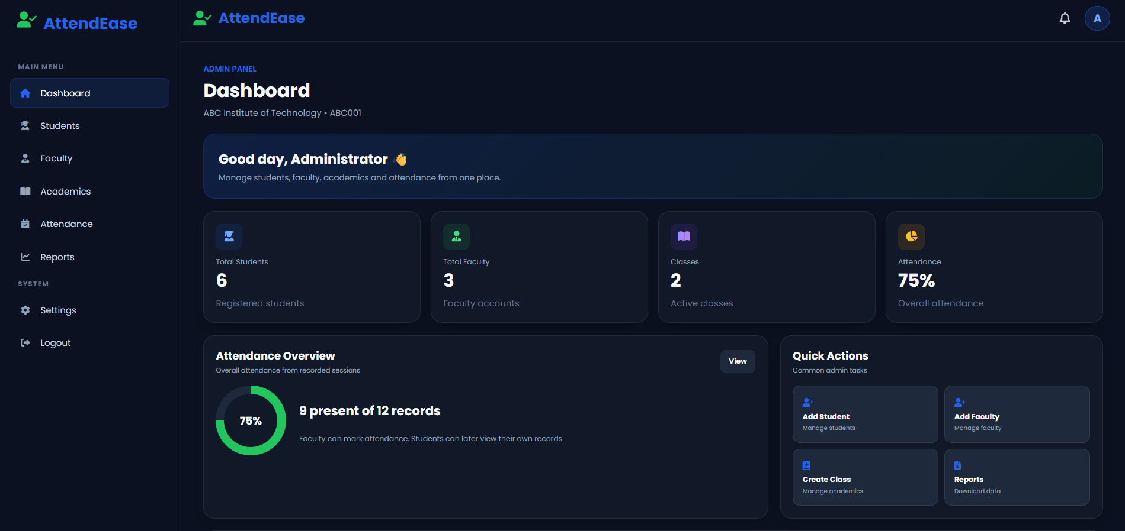
Figure 3. AttendEase Admin dashboard — desktop view.
The Admin dashboard is the central management interface. The supplied implementation includes a top bar, fixed sidebar navigation, dashboard statistics, attendance overview, quick actions and recent activity.
Area | Purpose
Dashboard | Institution-level overview and quick access.
Students | Search, filter, add, edit and delete student accounts.
Faculty | Search, add, edit and delete faculty accounts.
Academics | Manage classes, sections, subjects and faculty assignments.
Attendance | Monitor recorded attendance with filters and status.
Reports | Generate CSV reports for students, faculty and attendance.
Settings | View institution/session details and reset temporary changes.
Logout | End the Admin session.

Dashboard snapshot shown in the supplied presentation: 6 students, 3 faculty, 2 classes and 75% overall attendance.

CHAPTER 9

Admin Features in Detail
DASHBOARD STATISTICS

Dashboard Overview
The Admin dashboard calculates and displays total students, total faculty, class count and overall attendance. The attendance percentage is derived from recorded attendance entries; the supplied code counts Present records against total attendance records.
STUDENT MANAGEMENT

Student Management
- Search by student name, username or class.
- Filter students by class.
- Add a new student with name, username, password and class.
- Edit student information.
- Delete a student and remove related attendance/faculty-linked records where implemented.
FACULTY AND ACADEMIC MANAGEMENT

Faculty & Academics
- Faculty accounts can be searched, added, edited and deleted.
- Classes can be created with class name, section and optional class teacher.
- Subjects can be created with subject name, code, class and faculty assignment.
- Classes and subjects can be edited or deleted.
ATTENDANCE AND REPORTS

Attendance & Reports
- Attendance can be searched by student and filtered by class/status.
- Attendance records show date, student, class, subject, faculty and status.
- Student, faculty and attendance reports can be downloaded as CSV files.

CHAPTER 10

Faculty Dashboard
The Faculty role is the operational bridge between academic structure, student records and attendance data. Its main task is not institution-wide administration; it is the accurate recording of attendance within the relevant class context.
Step | Faculty workflow
1 | Select the relevant academic/class context.
2 | Access the student roster associated with that class.
3 | Mark each student's attendance status as Present or Absent.
4 | Save the attendance information as a record.
5 | The recorded information contributes to later attendance visibility.

Role boundary: Faculty is focused on attendance operations, while institution-wide management remains with Admin.

The supplied project presentation describes this workflow as Class → Roster → Mark → Save → Visible.

CHAPTER 11

Student Dashboard
The Student experience is deliberately focused on personal attendance. The student uses the same institutional login entry point, but after authentication receives a student-specific interface rather than administrative controls.
- Access the student dashboard after login.
- Open the My Attendance area.
- View personal attendance information.
- Review attendance records and understand current attendance status.
- Avoid institution-wide controls that are not required by the student's role.
ROLE BOUNDARY

Student Access Boundary
The student does not manage institutional records. This separation reduces unnecessary interface complexity and keeps the student experience centered on personal attendance visibility.
Personal visibility: Faculty records attendance → the system stores the information → the student reviews personal attendance → Admin retains institution-level visibility.

CHAPTER 12

Attendance Lifecycle
Stage | Responsible role | Result
Academic setup | Admin | Classes, students, subjects and faculty relationships are structured.
Attendance entry | Faculty | Attendance is recorded against the relevant class/student context.
Data storage | System / browser dataset | Attendance records become part of the current project data.
Monitoring | Admin | Institution-level attendance can be reviewed.
Personal visibility | Student | Student can review their own attendance information.
Reporting | Admin | Student, faculty and attendance CSV reports can be generated.

The project therefore treats attendance as a lifecycle rather than as a single button. Academic structure supports attendance entry; attendance records support monitoring and personal visibility.
ROLE CONNECTION

How the Dashboards Connect
- Admin creates the environment in which classes, students and faculty are organized.
- Faculty performs the attendance operation.
- The stored attendance information supports Admin monitoring and Student personal visibility.

CHAPTER 13

Academic and Class Management
Attendance becomes easier to organize when academic information is structured first. AttendEase represents this relationship through the Admin Academics section.
Entity | Purpose
Institution | Provides the organizational context for users and records.
Class | Groups students and attendance activity into an academic context.
Section | Identifies the specific section of a class.
Student | Belongs to a class and contributes attendance records.
Subject | Connects an academic subject to a class and faculty member.
Faculty | Can be associated with subjects/classes for attendance operations.

The Admin implementation provides interfaces for creating and editing classes and subjects. A class can have a class teacher, while a subject can be associated with a class and faculty member.
Design principle: Set up the academic structure first, then record attendance against it.

CHAPTER 14

Responsive Design
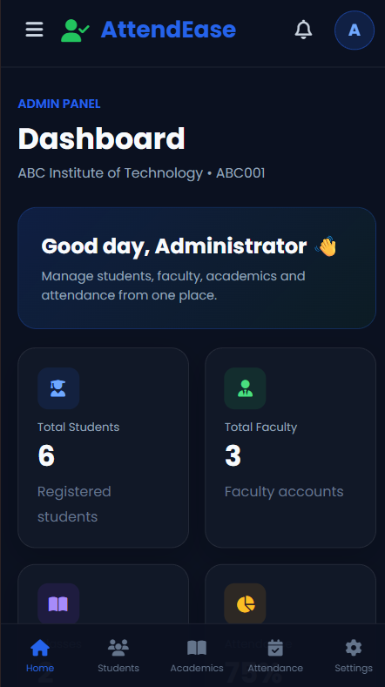
Figure 4. AttendEase Admin dashboard — mobile view.
The project is designed to adapt the dashboard to smaller screens. The desktop interface uses a persistent sidebar and multi-column dashboard layout. The mobile interface reorganizes navigation and content to fit a narrow viewport.
Desktop | Mobile
Fixed left sidebar | Compact mobile menu / navigation
Four-column statistics row | Two-column statistics arrangement
Two-column overview area | Single-column stacking
Full horizontal workspace | Reduced horizontal padding and reflow
Sidebar navigation | Bottom navigation remains available for key sections

The responsive approach is important for an FEE-II frontend evaluation because it demonstrates that CSS is being used not only for visual styling but also for layout adaptation.
Responsive principle: The mobile layout should reorganize content rather than simply shrink the desktop interface.

CHAPTER 15

HTML and CSS Implementation
HTML STRUCTURE

HTML Responsibilities
- The supplied Admin page declares HTML5 document structure and a responsive viewport meta tag.
- The page uses header, aside, main, section and nav elements to organize the dashboard.
- Buttons carry data-page attributes for navigation and data-action attributes for quick actions.
- Tables are used for students, faculty, classes, subjects and attendance records.
- Forms are generated for adding/editing users, classes and subjects.
CSS STRUCTURE

CSS Responsibilities
- CSS custom properties define the primary blue, green secondary, dark background, cards, text, muted text, border, danger and warning colors.
- box-sizing is standardized across elements.
- CSS Grid is used for statistics, quick actions, report cards and responsive layouts.
- Flexbox is used for top navigation, panel headers and horizontal information groups.
- Rounded borders, shadows and consistent padding create the dashboard card system.
- A media query at 900px changes the layout for smaller screens.
Viva concept | AttendEase example
Box model | Cards and panels use padding, border and rounded corners.
Flexbox | Topbar and panel header alignment.
Grid | Stats and quick-action layouts.
Media query | Desktop/mobile layout transformation.
Class selector | Reusable .panel, .btn, .stat and .side-link styling.
Pseudo-class | Hover styling for buttons and sidebar links.

CHAPTER 16

JavaScript and Data Handling
The Admin implementation combines the HTML/CSS interface with JavaScript for dynamic rendering and interaction. The project code checks the current session and redirects to the login page when an Admin session is not available.
DYNAMIC DASHBOARD

Dashboard Rendering
- The renderAll() function calculates student count, faculty count and class count.
- Attendance percentage is calculated from the number of Present records divided by total attendance records.
- The attendance ring is updated through a conic-gradient based on the calculated percentage.
- Student, faculty, class, subject, attendance and activity sections are rendered from the current dataset.
DATA STORAGE

Temporary Browser Dataset
The supplied Admin implementation uses localStorage to save users, classes, subjects, attendanceRecords and activityLog. This means the demonstrated data is stored in the browser rather than in a separate permanent database.
REPORTS

CSV Generation
The Reports section creates CSV content in the browser and triggers a download. The available report types are Student Report, Faculty Report and Attendance Report.
Implementation note: For a future production version, the browser-side temporary dataset could be replaced with a secure backend and persistent database.

CHAPTER 17

Testing and Validation
Testing for AttendEase should verify both visible interface behavior and the logical flow between user roles and dashboard sections.
Test case | Expected result | Status
Open landing page | Login interface and role cards are visible. | Pass
Open Admin dashboard | Admin dashboard loads with navigation and statistics. | Pass
Sidebar navigation | Dashboard sections switch without leaving the Admin page. | Pass / verify after latest navigation fix
Mobile menu | Compact menu opens and closes on narrow viewport. | Pass / verify after latest responsive fix
Students search/filter | Student table responds to search/filter controls. | Pass
Add student | New student is added to the current browser dataset. | Pass
Create class | New class appears in Academics. | Pass
Add subject | Subject appears with class/faculty association. | Pass
Attendance filtering | Attendance list can be filtered by class/status. | Pass
CSV report | Browser downloads selected report as CSV. | Pass
Reset changes | Temporary dataset returns to original state after confirmation. | Pass
Responsive layout | Dashboard reorganizes for mobile viewport. | Pass

The latest Admin source also includes a mobile overlay and menu behavior, while the dashboard uses a bottom navigation bar on small screens. The final deployed version should be tested in the browser after replacing the older dashboard file with the corrected version.

CHAPTER 18

Limitations and Future Scope
CURRENT LIMITATIONS

Limitations
- The supplied Admin implementation explicitly describes data storage as a temporary browser dataset using localStorage.
- The project is primarily a frontend demonstration rather than a production-grade multi-user server system.
- A real institution would require persistent database storage and server-side validation.
- Authentication and authorization would require stronger security controls for production use.
- The report focuses on the functionality represented in the supplied project materials and does not assume additional backend services.
FUTURE ENHANCEMENTS

Future Scope
- Add a secure backend and persistent database.
- Introduce server-side authentication and role-based authorization.
- Add institution-wide cloud synchronization.
- Provide richer attendance analytics and visual reports.
- Add export formats beyond CSV where required.
- Add stronger validation, audit trails and error handling.
- Add notification features for attendance thresholds or important events.
- Improve accessibility testing and cross-browser validation.

CHAPTER 19

Conclusion
AttendEase demonstrates how a practical attendance management problem can be translated into a structured frontend application. Its most important design decision is the separation of responsibilities among Admin, Faculty and Student.
The Admin dashboard provides institution-level management and monitoring, the Faculty experience supports attendance operations, and the Student dashboard provides personal attendance visibility. The project also demonstrates responsive frontend design through desktop and mobile layouts.
From an FEE-II perspective, AttendEase provides clear opportunities to demonstrate HTML structure, CSS layout, responsive media queries, reusable components, JavaScript interaction and client-side data handling.
Final takeaway: One portal → Three roles → One connected attendance workflow.

REFERENCES

Project References
- AttendEase live project: https://sanehasharam.github.io/AttendEase/
- AttendEase project presentation supplied for the evaluation.
- admin-dashboard(7).html — supplied Admin dashboard source.
- admin-dashboard-FIXED.html — corrected Admin dashboard source produced during the project refinement.
End of Report

