**Docker-Compose**

* Install Docker
* Install Docker-compose

1. Follow below steps to make files and run

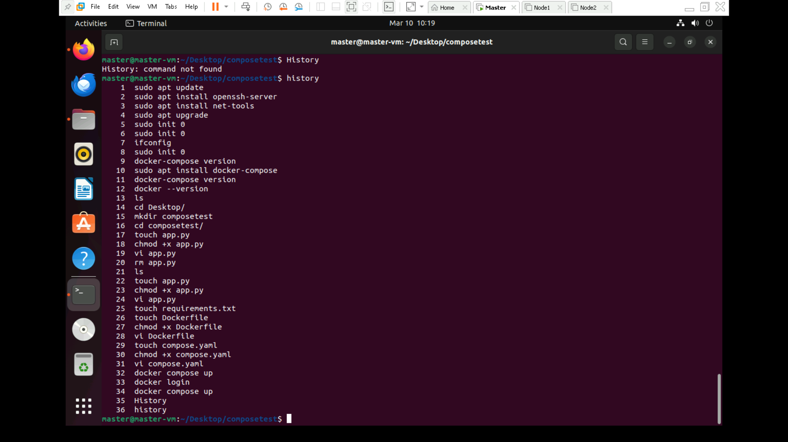

1. Terminal Output

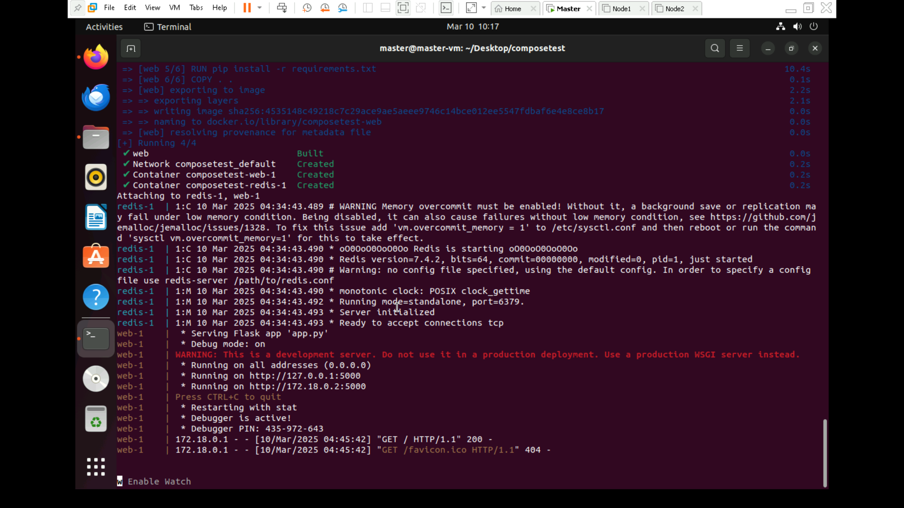

1. OUTPUT

