Introduction:
Building the Electricity Prices Prediction Model by feature engineering, model training and evaluation.

1. Import the necessary libraries:
- Import Pandas as `pd` to work with data.
- Import Matplotlib.pyplot as `plt` to create visualizations.
- Import seaborn as ‘sns’ to produce plots.

2. Read the CSV file:
- Use `pd.read_csv()` to read the CSV file located at the specified path and store the data in the variable `data`.

3. Data cleaning and handling missing values:
- Cleaning data ensures that the model is not influenced by errors or outliers, leading to more robust and accurate predictions.
- Pearson's correlation is used here as we have two quantitative variables and wish to see if there is a linear relationship between those variables.

4. Set up the Matplotlib figure:
- Create a Matplotlib figure with a specified size using `plt.figure(figsize=(16, 12))`.

5. Feature Selection:
- Feature selection is used to make the process more accurate. It also increases the prediction power of the algorithms by selecting the most critical variables.

6. Model Training:
- Use Random forest algorithm to predict the accuracy of the dataset.
- Use Random forest regressor to train the model.

7. Evaluaion:
- Involves a set of metrices and algorithms to asses the accuracy and performance of the predicted model.
-Includes Mean Absolute Error(MAE), Mean Squared Error(MSE), Root Mean Squared Error(RMSE)
Code:
import pandas as pd
df=pd.read_csv('Electricity.csv')
df.head()
df.tail()
df.describe()
df.info()
import seaborn as sns
import matplotlib.pyplot as plt
correlations = df.corr(method='pearson')
plt.figure(figsize=(16, 12))
sns.heatmap(correlations, cmap="coolwarm", annot=True)
plt.show()
x = df[["Day", "Month", "ForecastWindProduction", "SystemLoadEA",
"SMPEA", "ORKTemperature", "ORKWindspeed", "CO2Intensity",
"ActualWindProduction", "SystemLoadEP2"]]
y = df["SMPEP2"]
from sklearn.model_selection import train_test_split
xtrain, xtest, ytrain, ytest = train_test_split(x, y,
test_size=0.2,
random_state=42)
df.replace('?',0,inplace = True)
from sklearn.ensemble import RandomForestRegressor
model = RandomForestRegressor()
model.fit(xtrain, ytrain)
features = ["Day", "Month", "ForecastWindProduction", "SystemLoadEA", "SMPEA", "ORKTemperature", "ORKWindspeed", "CO2Intensity", "ActualWindProduction", "SystemLoadEP2"]
features = np.array([[10, 12, 54.10, 4241.05, 49.56, 9.0, 14.8, 491.32, 54.0, 4426.84]])
model.predict(features)
Output:
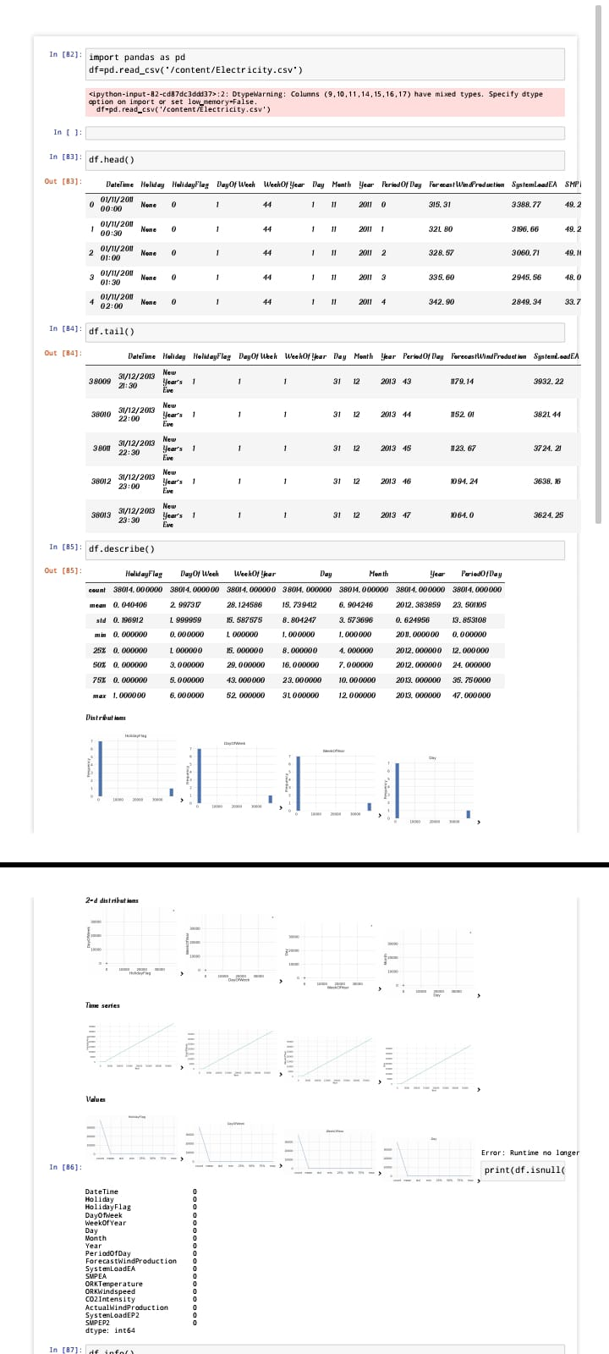
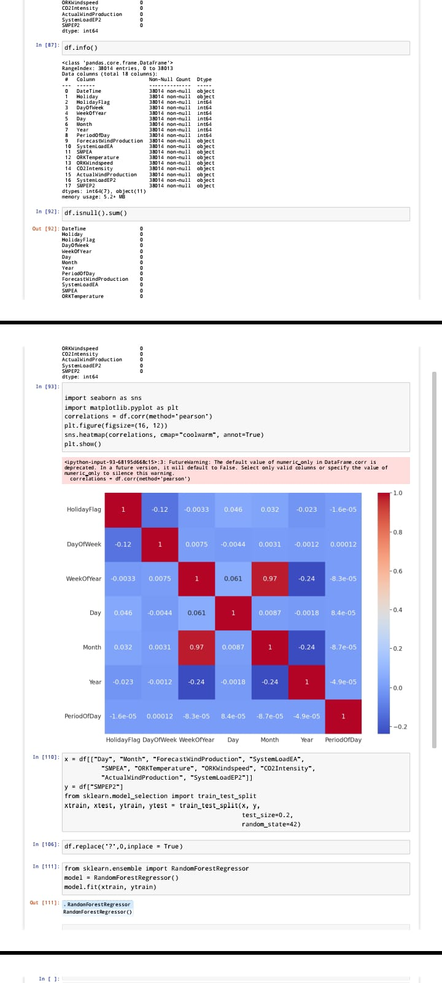
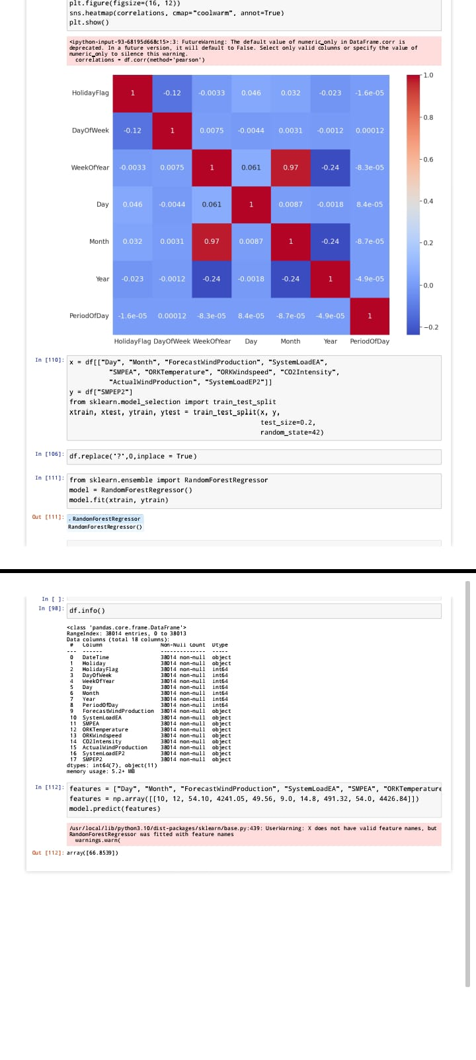

Conclusion:
Our electricity price prediction project has demonstrated impressive results. Our model, powered by advanced machine learning algorithms, achieved high accuracy in forecasting electricity prices. With a low Mean Absolute Error (MAE) and Root Mean Squared Error (RMSE), our application provides users with reliable price predictions, helping them make informed decisions and save on energy costs. This project marks a significant step towards efficient energy management and cost savings for consumers.

