**Design documentation**

**General info:**

Name of program:

-StarHopper

Users:

-For my eyes only + whoever is looking

Background, needs, purpose:

A graphics prototype for a space strategy game, also used by me to learn Java’s JDBC API. The program should show a rotatable 3-dimensional view of a collection of stars and spaceships that can be made to move between the stars. The program should also be able to create, read, update and delete something in/to a database.

**User-stories:**

1. I make the game create a collection of stars that I decide to store for later, so I click a save or export button that stores the stars into a preconfigured database.
2. I come back to the game after shutting it down for some time and click on a load or import button to retrieve the stored stars from the database.
3. Since the galaxy is stored in a database, it is possible to modify it or create a completely custom galaxy manually. This might subvert any logical safeguards on star creation, so there should be functionality that modifies the imported custom data to work properly.
4. Since deleting is required, let’s push a button that deletes the last star by ID



How it works:

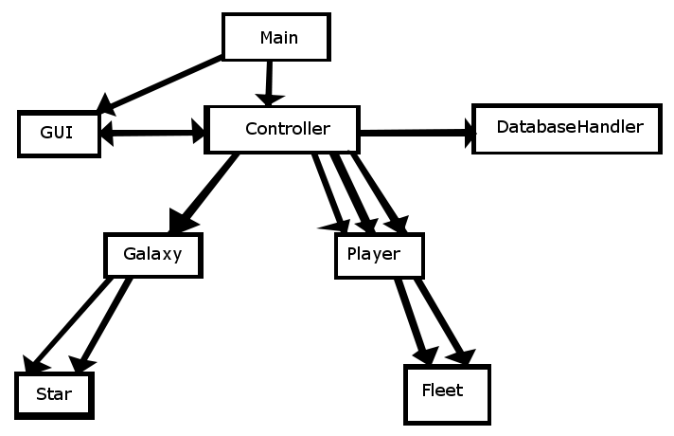

**Database implementation:**

This is for storing Stars:



create table if not exists stars (

id int(10) not null,

x int(10) not null,

y int(10) not null,

z int(10) not null,

type int(10) not null,

size int(10) not null,

name varchar(20) not null,

primary key (id)

);