DEFORESTRARTION DETECTION USING CNN WITH SATELLITE IMAGES

project report submitted in partial fulfilment of the requirements for the Course

MACHINE LEARNING

BACHELOR OF TECHNOLOGY

In

A.Y.: 2026-27

By

Name: AKSHAYA TATI roll: 2520030143

Name: R.JUHIT NAIDU roll:2520030457

Under the Esteemed guidance of

Dr.N.Nirmalajyothi

Associate Professor, CSE

Department of Computer Science and Engineering





Abstract
Deforestation Detection Using CNN on Satellite Imagery is a machine learning project designed to analyse satellite images and identify forest cover changes.
The system uses Convolutional Neural Networks (CNN) to extract visual features and classify land-cover patterns from satellite images.
The dataset undergoes preprocessing, resizing, and normalization before model training and evaluation.
The trained model classifies images into four categories: Other, Plantation, Smallholder Agriculture, and Grassland/Shrubland.
This project demonstrates the potential of deep learning in supporting forest monitoring and environmental conservation.
Keywords: Deforestation Detection, Convolutional Neural Network (CNN), Satellite Imagery, Deep Learning, Land-Cover Classification, Environmental Monitoring.

1. Introduction

1.1 Purpose of the Project
Deforestation is a major environmental problem that leads to the loss of forest cover, destruction of wildlife habitats, and disruption of ecological balance. Monitoring large forest areas manually can be time-consuming and challenging. Satellite imagery provides a way to observe land-cover patterns over wide geographical regions, but analysing large numbers of images requires efficient techniques. This project is motivated by the need to use automated image analysis to support environmental monitoring and improve the understanding of land-cover changes associated with deforestation.
The major stakeholders include environmental researchers, forest departments, conservation organizations, government agencies, and students working on environmental applications. The project uses a Convolutional Neural Network (CNN) to analyse Landsat satellite images and classify them into four categories: Other, Plantation, Smallholder Agriculture, and Grassland/Shrubland. An ML-based solution can process images systematically, learn visual patterns, and generate predictions more efficiently than manual image inspection alone. Although the model does not directly measure deforestation or detect forest loss between different dates, it demonstrates how deep learning-based land-cover classification can contribute to future forest-monitoring and conservation systems.

1.2 Problem Statement

The project focuses on developing a CNN-based image classification system to analyse satellite imagery and identify land-cover patterns associated with deforestation. The system uses the Cameroon Deforestation Drivers dataset containing 3,108 labelled Landsat satellite images and classifies them into four categories: Other, Plantation, Smallholder Agriculture, and Grassland/Shrubland. The expected output is a predicted land-cover category with a confidence score for each input image. The model's performance is evaluated using accuracy, precision, recall, and F1-score. This classification approach aims to support land-cover analysis and provide a foundation for future automated forest-monitoring systems.1.3 Existing Methods and Disadvantages
Existing approaches for deforestation monitoring include manual satellite-image analysis, traditional machine learning techniques, and deep learning models such as Convolutional Neural Networks (CNNs). Manual analysis can be time-consuming when processing large volumes of satellite imagery, while traditional machine learning methods may depend heavily on manually selected image features. CNNs can automatically extract visual features from images, but their performance depends on dataset quality, image preprocessing, model architecture, and training parameters. These methods may also face challenges such as class imbalance, limited training data, and high computational requirements.
Some existing models may suffer from overfitting, where they perform well on training data but poorly on unseen images. Low accuracy and poor generalization can occur when satellite images differ in geographical conditions, lighting, resolution, or land-cover patterns. Deep learning models can also require significant processing power and training time, while their complex internal operations may make predictions difficult to interpret. These limitations motivate the development of a CNN-based system that evaluates satellite images using training, validation, and testing datasets. In this project, the model achieved 66.17% test accuracy, highlighting the need for further improvements in class imbalance handling, model tuning, and generalization to support more reliable land-cover classification.

1.4 Proposed System

The proposed system uses a Convolutional Neural Network (CNN) to classify land-cover patterns from satellite imagery using the Cameroon Deforestation Drivers dataset, which contains 3,108 labelled Landsat images. The images are preprocessed by resizing them to 128 × 128 pixels and normalizing RGB pixel values to the range of 0 to 1. The dataset is divided into training, validation, and testing sets to train the model, monitor its performance, and evaluate its predictions on unseen images. The CNN consists of convolutional and pooling layers for feature extraction, followed by fully connected layers and a softmax output layer to classify images into four categories: Other, Plantation, Smallholder Agriculture, and Grassland/Shrubland. The model is evaluated using accuracy, precision, recall, and F1-score, achieving 66.17% test accuracy. The proposed system demonstrates the potential of deep learning for automated land-cover classification and provides a foundation for future improvements in forest monitoring and environmental conservation.

1.5 Research Objectives( atleast 4)
1. Dataset Preparation: To collect and prepare the Cameroon Deforestation Drivers dataset containing labelled Landsat satellite images for land-cover classification.
2. Preprocessing and Exploratory Analysis: To resize images to 128 × 128 pixels, normalize RGB pixel values, and analyse the distribution of the four land-cover categories.
3. Feature Extraction: To enable the CNN to automatically extract relevant visual features from satellite images while maintaining a proper separation between training, validation, and testing data to prevent data leakage.
4. Model Development and Training: To design and train a CNN model using convolutional layers, pooling layers, and fully connected layers to classify satellite images into four categories: Other, Plantation, Smallholder Agriculture, and Grassland/Shrubland.
5. Model Evaluation: To evaluate the trained model using appropriate performance metrics, including accuracy, precision, recall, and F1-score, and assess its classification performance on unseen images.
6. Model Selection and Practical Applicability: To analyse the model's performance, identify its limitations, and discuss how improved land-cover classification could support future forest monitoring and environmental conservation applications.

2. Literature Survey (recent studies from 2-3 years)

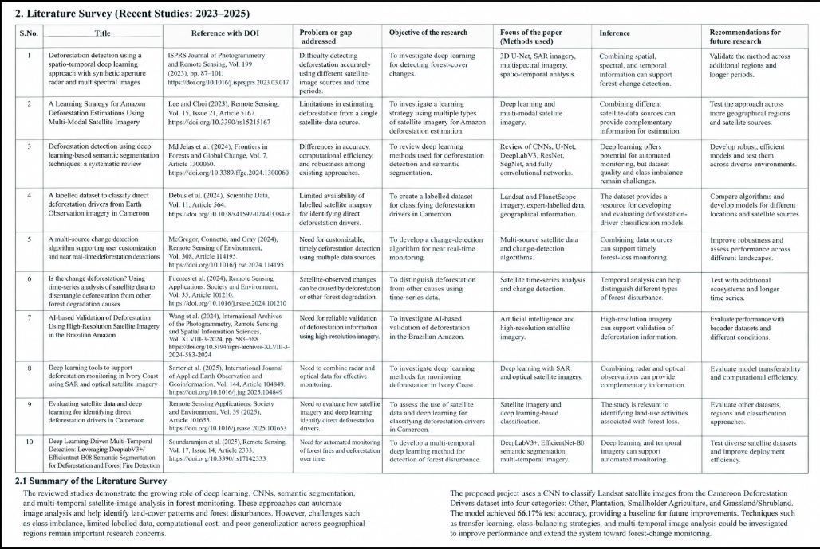

3. Methodology

3.1 Proposed System Flow Diagram
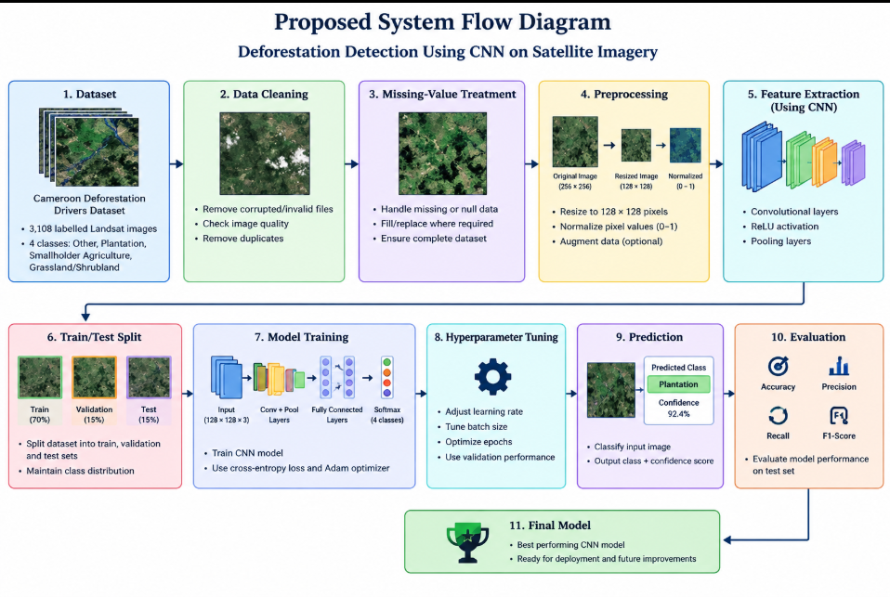

3.2 Dataset Description

The project uses the Cameroon Deforestation Drivers Dataset, available on Zenodo, which contains 3,108 labelled Landsat satellite images collected over Cameroon. Each image originally measures 332 × 332 pixels and is preprocessed to 128 × 128 pixels, with RGB pixel values normalized between 0 and 1. The dataset contains four target classes: Other (1,198 images), Plantation (1,010 images), Smallholder Agriculture (803 images), and Grassland/Shrubland (97 images). The input features are the visual characteristics of satellite images, including colour, texture, vegetation patterns, and land-cover structures, while the target variable is the corresponding land-cover category. The images are divided into training, validation, and testing sets for model training, tuning, and performance evaluation. The dataset supports CNN-based land-cover classification and analysis of patterns associated with deforestation.

3.3 Experimental Setup
The project, Deforestation Detection Using CNN on Satellite Imagery, is implemented using Python and deep learning libraries for image preprocessing, model training, and evaluation. The system uses a computer capable of running Python-based machine learning applications, with Windows as the operating system and Visual Studio Code or Jupyter Notebook as the development environment. TensorFlow and Keras are used to build and train the Convolutional Neural Network (CNN), while NumPy and Pandas support data handling. Matplotlib and Seaborn are used for visualizing the dataset and model results, and Scikit-learn is used for dataset splitting and performance evaluation. The model is trained for 15 epochs using the Adam optimizer and sparse categorical cross-entropy loss function. The input satellite images are resized to 128 × 128 pixels and normalized before training. The trained model is evaluated using accuracy, precision, recall, and F1-score.
Note: The exact hardware specifications, Python version, and library versions have not been confirmed. Include the actual versions from your working environment rather than guessing them.

3.4 Data Preprocessing
- Data inspection and schema validation
- Duplicate removal
- Missing-value analysis and imputation
- Outlier analysis/treatment where justified
- Categorical encoding
- Numerical scaling/standardization where required
- Target-label preparation
- Train/test split and prevention of data leakage

3.5 Exploratory Data Analysis
[Include distributions, class balance, correlation analysis, scatter plots, box plots, and other relevant visualizations.]

3.4 Data Preprocessing
Data preprocessing is an important step in the proposed Deforestation Detection Using CNN on Satellite Imagery system. The Cameroon Deforestation Drivers dataset is inspected to verify image availability, label consistency, and compatibility with the CNN model. Invalid or corrupted images are identified, and duplicate images should be checked to avoid redundant samples. Missing labels or unusable image files are examined and handled appropriately. Since the dataset consists of satellite images, categorical encoding of tabular input features is not required; instead, the four target classes—Other, Plantation, Smallholder Agriculture, and Grassland/Shrubland—are mapped to numerical class indices for model training. The images are resized to 128 × 128 pixels, and RGB pixel values are normalized to the range 0–1. Separate numerical feature standardization and outlier treatment are not required for the image inputs in the current pipeline. The dataset is divided into training, validation, and testing sets using a stratified split to preserve class proportions. The test set is kept separate from training and hyperparameter tuning to reduce data leakage and provide a fair evaluation of the model.
Preprocessing workflow:
Inspect images and validate labels.
Check for corrupted files, duplicates, and missing labels.
Resize images to 128 × 128 pixels.
Normalize RGB pixel values to 0–1.
Encode the four target classes as numerical labels.
Split the dataset into training (2,175 images), validation (466 images), and testing (467 images).
Use only the training and validation sets for model development, reserving the test set for final evaluation.
Note: Missing-value imputation, duplicate removal, and outlier treatment should be described as completed steps only if they were actually performed in your implementation.

3.6 Feature Engineering and Feature Selection (if applicable)

In the proposed Deforestation Detection Using CNN on Satellite Imagery system, feature engineering is mainly performed automatically by the Convolutional Neural Network (CNN). The input Landsat satellite images are resized to 128 × 128 pixels and their RGB pixel values are normalized to the range of 0–1. These transformations ensure consistent input dimensions and help the model learn effectively. The CNN uses convolutional layers to learn visual features such as colour variations, textures, vegetation patterns, and land-cover structures. Pooling layers reduce the spatial dimensions while retaining important information, and deeper convolutional layers learn more complex image patterns. The extracted features are passed to fully connected layers, which support classification into four categories: Other, Plantation, Smallholder Agriculture, and Grassland/Shrubland. No separate manual feature-selection algorithm is used in the current implementation because the CNN learns relevant features directly from the images. Tabular features such as geographical coordinates and collection year are not used as direct model inputs in this pipeline. This approach reduces the need for handcrafted features, although its performance depends on dataset quality, class balance, and model configuration.

3.7 Model Building and Training
The proposed system uses a Convolutional Neural Network (CNN) to classify satellite images into four land-cover categories: Other, Plantation, Smallholder Agriculture, and Grassland/Shrubland. The preprocessed images, resized to 128 × 128 pixels with RGB values normalized between 0 and 1, are provided as input to the model. A basic baseline model can be established using a simple image-classification approach for comparison; however, a separate baseline model was not confirmed in the current implementation.
The CNN architecture consists of three convolutional layers with 32, 64, and 128 filters, respectively, with ReLU activation. Max-pooling layers follow the convolutional layers to reduce spatial dimensions and retain important visual information. The extracted features are flattened and passed to a fully connected layer containing 128 neurons. A dropout layer with a rate of 0.5 helps reduce overfitting, while the final dense layer contains four neurons with softmax activation to generate class probabilities.
The model is trained using the Adam optimizer and sparse categorical cross-entropy loss function, which is suitable for multiclass classification with integer-encoded target labels. Training is conducted for 15 epochs using the training dataset, while the validation dataset is used to monitor performance and assess the model during training. The best validation accuracy achieved was approximately 69.10% at epoch 12. After training, the model is evaluated on the separate test dataset to measure its generalization performance. The model achieved a test accuracy of 66.17%, demonstrating its ability to classify satellite images while indicating scope for improvement through class-imbalance handling, hyperparameter tuning, and further model optimization.

3.8 Hyperparameter Tuning(if applicable)
Hyperparameter tuning is used to improve the performance of the Convolutional Neural Network (CNN) by selecting suitable training parameters. In this project, the model is trained for 15 epochs using the Adam optimizer and sparse categorical cross-entropy loss function. The CNN architecture uses 32, 64, and 128 filters in its convolutional layers, 128 neurons in the fully connected layer, and a dropout rate of 0.5 to help reduce overfitting. Validation accuracy is monitored during training to assess the model's performance on unseen validation images. The best validation accuracy achieved was approximately 69.10% at epoch 12, while the final test accuracy was 66.17%. These results are used to assess the model's generalization ability. A separate grid search, random search, or cross-validation procedure was not confirmed in the current implementation; therefore, the selected values represent the configuration used for training rather than parameters proven optimal through a systematic search. Future improvements may include testing different learning rates, batch sizes, filter counts, dropout rates, and epoch counts to identify configurations that improve classification performance.

3.9 Model Evaluation
[Classification: Accuracy, Precision, Recall, F1-score, ROC-AUC, confusion matrix. Regression: MAE, MSE, RMSE, R². Use metrics appropriate to the project.]

4. Results and Discussion

4.1 Preprocessing Results
The performance of the proposed Deforestation Detection Using CNN on Satellite Imagery system is evaluated using classification metrics, including accuracy, precision, recall, F1-score, and a confusion matrix. The model is tested on 467 unseen satellite images to measure its ability to classify land-cover patterns into four categories: Other, Plantation, Smallholder Agriculture, and Grassland/Shrubland. The CNN achieved a test accuracy of 66.17%, with a weighted precision of 66.71%, weighted recall of 66.17%, and weighted F1-score of 65.05%. The confusion matrix is used to examine correct predictions and misclassifications for each class. The model performs better on some categories than others, and it fails to correctly identify the Grassland/Shrubland samples in the test set, highlighting the impact of class imbalance. ROC-AUC was not reported in the current evaluation, and regression metrics such as MAE, MSE, RMSE, and \(R^2\) are not applicable because this is a multiclass classification task.

Evaluation metrics
Metric | Result
Test accuracy | 66.17%
Weighted precision | 66.71%
Weighted recall | 66.17%
Weighted F1-score | 65.05%

Confusion matrix
Rows represent actual classes and columns represent predicted classes.
Actual \ Predicted | Grassland/Shrubland | Other | Plantation | Smallholder Agriculture
Grassland/Shrubland | 0 | 14 | 0 | 0
Other | 0 | 147 | 27 | 6
Plantation | 0 | 55 | 84 | 13
Smallholder Agriculture | 0 | 38 | 5 | 78
Interpretation: The model correctly classifies many images from the Other, Plantation, and Smallholder Agriculture categories. However, it does not correctly classify any Grassland/Shrubland test images, likely reflecting the small number of samples in that category. Class balancing, data augmentation, and further CNN tuning could help improve performance.

4.2 Model Performance
The following table presents the performance of your CNN model on the test dataset. Since verified evaluation metrics for an existing study have not been established for a directly comparable experiment, those values are marked as Not reported rather than estimated.
Model | Accuracy | Precision | Recall | F1-score | ROC-AUC
Proposed CNN model | 66.17% | 66.71% | 66.17% | 65.05% | Not reported
Existing study | Not reported | Not reported | Not reported | Not reported | Not reported
Performance analysis: The proposed CNN model achieved 66.17% test accuracy, with a weighted precision of 66.71%, weighted recall of 66.17%, and weighted F1-score of 65.05%. These results indicate moderate performance in classifying satellite images into four land-cover categories. The difference between precision and recall is small, while the weighted F1-score reflects the balance between these two metrics. The model did not correctly classify any Grassland/Shrubland samples in the test set, highlighting the challenge of class imbalance. Future improvements could include class-weighted training, data augmentation, transfer learning, and systematic hyperparameter tuning.
Note: ROC-AUC was not calculated in the current evaluation. An existing-study comparison should be added only when its reported metrics, dataset, and evaluation method are available and sufficiently comparable to your experiment.

4.3 Visual Results and discussion
The visual results of the proposed Deforestation Detection Using CNN on Satellite Imagery system are used to evaluate the model's learning behaviour, classification performance, and prediction errors. The CNN was trained for 15 epochs and achieved a best validation accuracy of approximately 69.10% at epoch 12. On the test dataset containing 467 unseen images, the model achieved 66.17% accuracy, with weighted precision of 66.71%, weighted recall of 66.17%, and weighted F1-score of 65.05%.

1. Training and validation curves
Insert the training and validation accuracy and loss graphs generated during model training. These curves help analyse how the CNN learns from the training data and whether its performance generalizes to the validation data. The best validation accuracy occurred at epoch 12, but the actual curves are required to determine whether overfitting or underfitting occurred.

2. Confusion matrix
The confusion matrix compares actual land-cover classes with the categories predicted by the CNN.
Actual class | Grassland/Shrubland | Other | Plantation | Smallholder Agriculture
Grassland/Shrubland | 0 | 14 | 0 | 0
Other | 0 | 147 | 27 | 6
Plantation | 0 | 55 | 84 | 13
Smallholder Agriculture | 0 | 38 | 5 | 78
Discussion: The model correctly classified 147 Other images, 84 Plantation images, and 78 Smallholder Agriculture images. However, all 14 Grassland/Shrubland images were misclassified as Other. The model also confused some Plantation and Smallholder Agriculture images, suggesting that their visual characteristics may overlap.

3. Actual versus predicted results
A comparison of actual and predicted labels can help identify correctly classified images and classification errors. In one demonstration, an image labelled Selective logging received a predicted category of Plantation, with a confidence score of 53.82%. This illustrates a prediction error and the limitation of mapping detailed dataset labels into four broader categories.

4. ROC curve
A multiclass Receiver Operating Characteristic (ROC) curve can be generated using a one-vs-rest approach for the four categories. ROC-AUC values were not calculated in the current experiment. Therefore, the ROC curve and numerical AUC results should be included only after evaluating the model's predicted probabilities against the true labels.

5. Model comparison and generalization
The current implementation reports the proposed CNN model's results but does not establish a separate baseline model or compare multiple trained architectures. Therefore, no claim can be made that the CNN outperformed an alternative model. The test accuracy of 66.17%, compared with the best validation accuracy of 69.10%, indicates a modest difference between validation and test performance. Further experiments using a baseline model, transfer learning, class-weighted training, and data augmentation could help determine whether these methods improve generalization.

Overall discussion
The results demonstrate that the CNN can classify several land-cover categories from satellite imagery, but its performance is uneven across classes. The limited number of Grassland/Shrubland samples likely contributes to the poor classification of that category. Improving class balance, tuning hyperparameters, and evaluating additional architectures may improve the model. Since the current system classifies land-cover categories rather than directly comparing satellite images across time, its results should be interpreted as land-cover classification that may support future deforestation monitoring, not as direct measurement of forest loss.
Figures to include in the report:
Training and validation accuracy curves.
Training and validation loss curves.
Confusion matrix heatmap.
Sample satellite image with actual and predicted labels.
Multiclass ROC curve, after calculating ROC-AUC.
窗体顶端
窗体底端

Conclusion
The project, Deforestation Detection Using CNN on Satellite Imagery, was developed to demonstrate the application of deep learning in analysing satellite images and classifying land-cover patterns associated with deforestation. The system uses the Cameroon Deforestation Drivers dataset, containing 3,108 labelled Landsat satellite images, classified into four categories: Other, Plantation, Smallholder Agriculture, and Grassland/Shrubland. The images were resized to 128 × 128 pixels and normalized before being used to train a Convolutional Neural Network (CNN).
The proposed CNN consists of convolutional layers, max-pooling layers, a fully connected layer, and a dropout layer, with a softmax output for four-class classification. The model was trained for 15 epochs using the Adam optimizer and sparse categorical cross-entropy loss function. It achieved a best validation accuracy of approximately 69.10% at epoch 12 and a final test accuracy of 66.17%, with weighted precision of 66.71%, weighted recall of 66.17%, and weighted F1-score of 65.05%. These results demonstrate that the CNN can classify several land-cover categories, although its performance varies across classes.
The proposed CNN is the primary model evaluated in this project; a separate baseline comparison was not performed. The evaluation revealed difficulties in identifying the underrepresented Grassland/Shrubland category, highlighting the impact of class imbalance. Overall, the project demonstrates the potential of CNN-based image classification to support satellite-image analysis and environmental monitoring. Future improvements could include class balancing, data augmentation.

6. Future Work
The proposed Deforestation Detection Using CNN on Satellite Imagery system can be improved in several ways to enhance classification accuracy, reliability, and practical usability.
1. Larger and More Diverse Datasets: Incorporate satellite images from different geographical regions, seasons, and time periods to improve the model's ability to recognize diverse land-cover patterns.
2. Additional Algorithms and Ensemble Methods: Evaluate alternative CNN architectures, transfer-learning models such as ResNet and MobileNet, and ensemble methods to compare their classification performance with the current CNN model.
3. Advanced Hyperparameter Optimization: Experiment with different learning rates, batch sizes, filter configurations, dropout rates, and training epochs to identify configurations that improve model performance.
4. Explainable AI Techniques: Apply techniques such as Grad-CAM to highlight image regions that influence the CNN's predictions, making the classification process easier to interpret.
5. Robustness and Model Drift: Test the model on images with different lighting conditions, image quality, seasons, and geographical characteristics. Monitor performance over time to identify changes that may reduce prediction accuracy.
6. Real-Time and Cloud-Based Deployment: Develop a web application or cloud-based platform that allows users to upload satellite images and receive predicted land-cover categories and confidence scores. Edge deployment could also be explored where computational resources are limited.
7. External Dataset Validation: Evaluate the trained model on independent satellite-image datasets to determine whether it generalizes beyond the Cameroon dataset. Differences in image sources, geographical regions, and class definitions should be considered during evaluation.
8. Improved Class Imbalance Handling: Use class-weighted loss functions, data augmentation, and balanced sampling to improve recognition of underrepresented categories, particularly Grassland/Shrubland.
9. Temporal Forest-Monitoring Capabilities: Extend the system to compare satellite images collected at different times. This could help identify potential forest-cover changes, provided the images are appropriately aligned and the method is validated for change detection.
Overall, these improvements could make the system more accurate, interpretable, and adaptable for environmental monitoring. The current model provides a foundation for land-cover classification, while direct deforestation detection and real-time monitoring remain potential future extensions.

7. References
The following references are formatted in a consistent APA-style format and cover the dataset, deforestation monitoring, satellite imagery, CNN architectures, image segmentation, and explainable AI. Bibliographic details for the linked publications have been checked against publisher or academic records.
1. Debus, A., Beauchamp, E., Acworth, J., Ewolo, A., Kamga, J., Verhegghen, A., Zébazé, C., & Lines, E. R. (2024). A labelled dataset to classify direct deforestation drivers from Earth Observation imagery in Cameroon. Scientific Data, 11, Article 564. https://doi.org/10.1038/s41597-024-03384-z
2. Lee, D., & Choi, Y. (2023). A learning strategy for Amazon deforestation estimations using multi-modal satellite imagery. Remote Sensing, 15(21), Article 5167. https://doi.org/10.3390/rs15215167
3. Md Jelas, I., Zulkifley, M. A., Abdullah, M., & Spraggon, M. (2024). Deforestation detection using deep learning-based semantic segmentation techniques: A systematic review. Frontiers in Forests and Global Change, 7, Article 1300060. https://doi.org/10.3389/ffgc.2024.1300060
4. McGregor, I. R., Connette, G., & Gray, J. M. (2024). A multi-source change detection algorithm supporting user customization and near real-time deforestation detections. Remote Sensing of Environment, 308, Article 114195. https://doi.org/10.1016/j.rse.2024.114195
5. Sartor, G., Salis, M., Pinardi, S., Saracik, Ö., & Meo, R. (2025). Deep learning tools to support deforestation monitoring in Ivory Coast using SAR and optical satellite imagery. International Journal of Applied Earth Observation and Geoinformation, 144, Article 104849. https://doi.org/10.1016/j.jag.2025.104849
6. He, K., Zhang, X., Ren, S., & Sun, J. (2016). Deep residual learning for image recognition. In Proceedings of the IEEE Conference on Computer Vision and Pattern Recognition (pp. 770–778). https://doi.org/10.1109/CVPR.2016.90
7. Ronneberger, O., Fischer, P., & Brox, T. (2015). U-Net: Convolutional networks for biomedical image segmentation. In Medical Image Computing and Computer-Assisted Intervention – MICCAI 2015 (pp. 234–241). Springer. https://doi.org/10.1007/978-3-319-24574-4_28
8. Selvaraju, R. R., Cogswell, M., Das, A., Vedantam, R., Parikh, D., & Batra, D. (2017). Grad-CAM: Visual explanations from deep networks via gradient-based localization. In Proceedings of the IEEE International Conference on Computer Vision (pp. 618–626). https://doi.org/10.1109/ICCV.2017.74
9. Simonyan, K., & Zisserman, A. (2015). Very deep convolutional networks for large-scale image recognition. In International Conference on Learning Representations (ICLR). https://arxiv.org/abs/1409.1556
10. Krizhevsky, A., Sutskever, I., & Hinton, G. E. (2012). ImageNet classification with deep convolutional neural networks. In Advances in Neural Information Processing Systems (Vol. 25). https://proceedings.neurips.cc/paper/2012/hash/c399862d3b9d6b76c8436e924a68c45b-Abstract.html
Dataset source: Cameroon Deforestation Drivers dataset. Zenodo. https://zenodo.org/records/8325259

Signature of the Guide Course Instructor

