Digital Image Processing
Term Project #1 Report

Team 15
50251566 데니스 고레츠키
20206224 이주환



Contents
Outline of Program 2
Purpose 2
Functionality Overview 2
Design of Program 2
High-Level Design 2
Flow Diagram 2
Implementation Notes 3
How to execute 3
Time spent 4
Process of Project and Record of Project Meetings 5
Meeting 1 – Project Kickoff 5
Meeting 2 – Review & Integration 5
Records 5
GitHub records 6
Member's Thoughts on This Project 6
Lessons Learned 6
Future Improvements 6

Outline of Program

Purpose
The program is designed to perform basic image compositing operations, specifically addition and subtraction of images, while handling potential overflow and underflow in pixel values. This allows simple image blending and manipulation for educational purposes.

Functionality Overview
- Load input images using CxImage library
- Perform composite operations:
  - Pixel-wise addition of two images
  - Pixel-wise subtraction of one image from another
- Clamp pixel values to valid range (0–255 for 8-bit images)
- Display the resulting image

Design of Program

High-Level Design
- Input Module: Handles loading of images from disk
- Composite Module: Implements the addition and subtraction logic. Key steps include:
- Looping over each pixel of the input images
- Performing the addition or subtraction
- Clamping the result to avoid underflow/overflow
- Output Module: Displays the final image

Flow Diagram

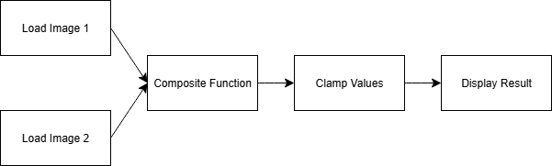

Implementation Notes
- The Composite function is implemented in a single method using simple loops over image pixels
- The program is modular, allowing easy extension for additional composite operations in the future

How to execute
- Run the source code ‘ImageProcessing.cpp’
- After the code is executed, the program runs, and a window opens
- Choose the ‘File’ option in the menu bar of the program as shown below
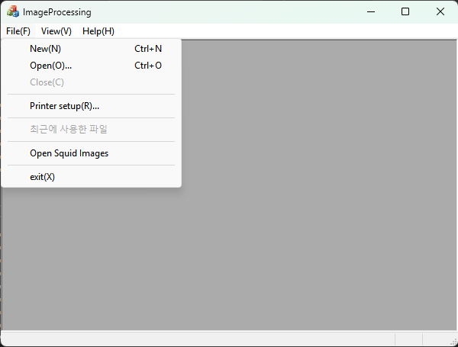
- Open all the images(‘squid_head.png’, ‘squid_body.png’ and ‘squid_points.png’ that can found in the same directory as the ImageProcessing.cpp in folder ‘Term_Project_01_Sample Images’) one after another
(Automatic way: open all the images by choosing ‘Open Squid Images option’)
- All three pictures now are opened as shown below
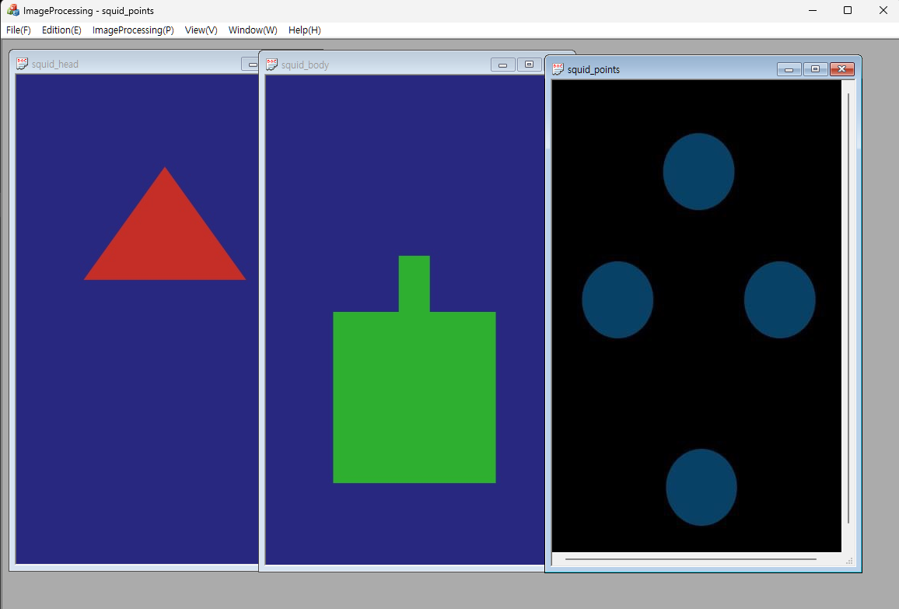
- Click ‘ImageProcessing’ tab and choose ‘Composite’. You can choose the second image and the operation:
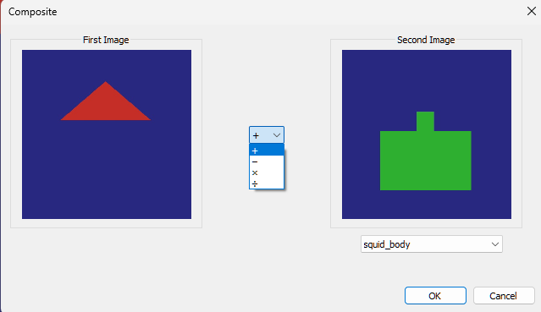
- Add ‘squid_body’, to ‘squid_head’, then subtract ‘squid_points’ from the result of this addition
(Automatic way: choose ‘Auto Composite Squid Images’ option)
- Result is shown below
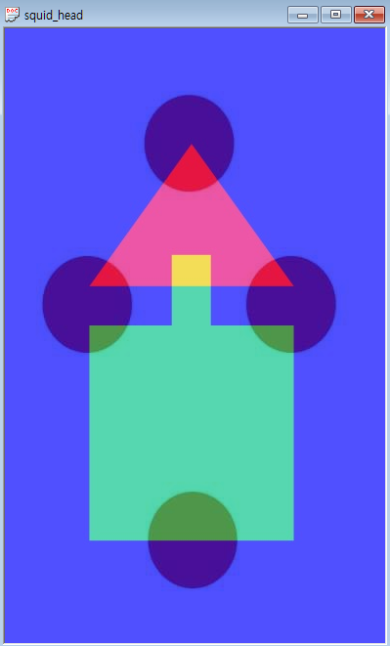

Time spent
Planning & Design: ~30 minutes
Implementation of Composite Function: ~45 minutes
Testing & Debugging: ~30 minutes
Meetings & Collaboration: ~1 hour
Total Estimated Time: ~2.5 hours

Process of Project and Record of Project Meetings

Meeting 1 – Project Kickoff
- Discussed project requirements
- Assigned tasks: one team member focused on the composite function, the other one on the clamping
- Duration: ~30 minutes

Meeting 2 – Review & Integration
- Shared individual implementations
- Tested composite function with sample images
- Adjusted clamping logic to handle edge cases
- Duration: ~30 minutes

Records
- Adjusting schedule

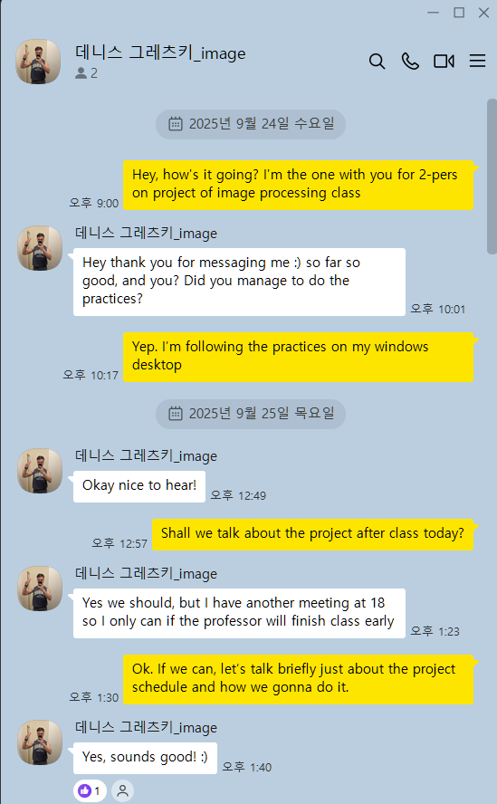

- Discussing how to share the code
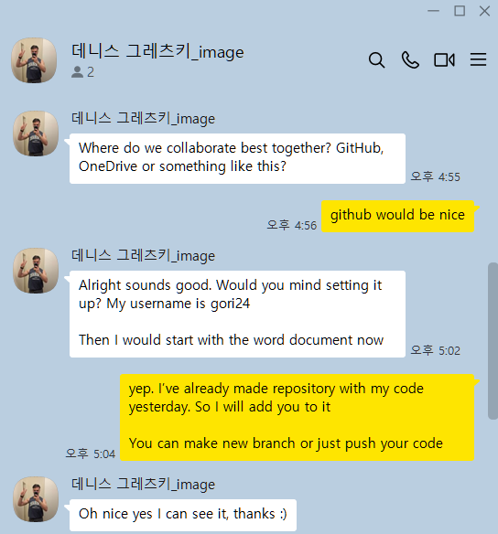
- Cross check for executing
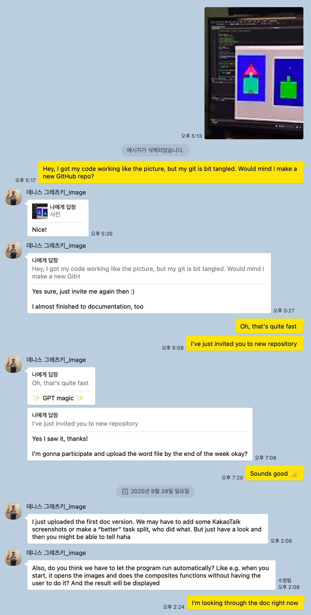

- Additional process for automatic process
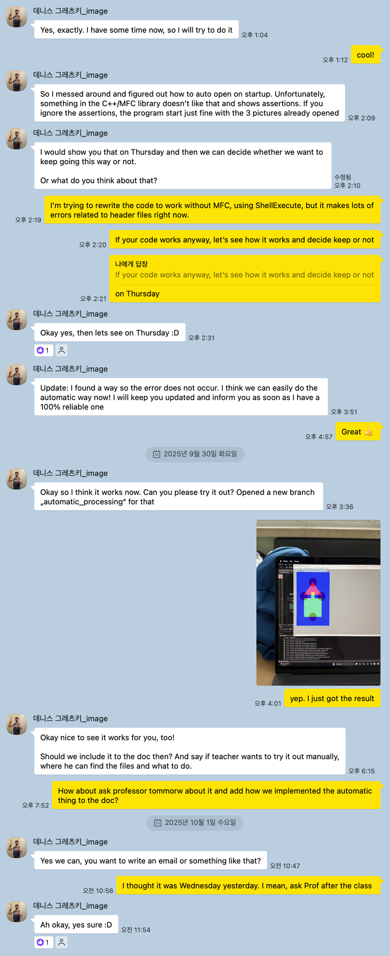


GitHub records
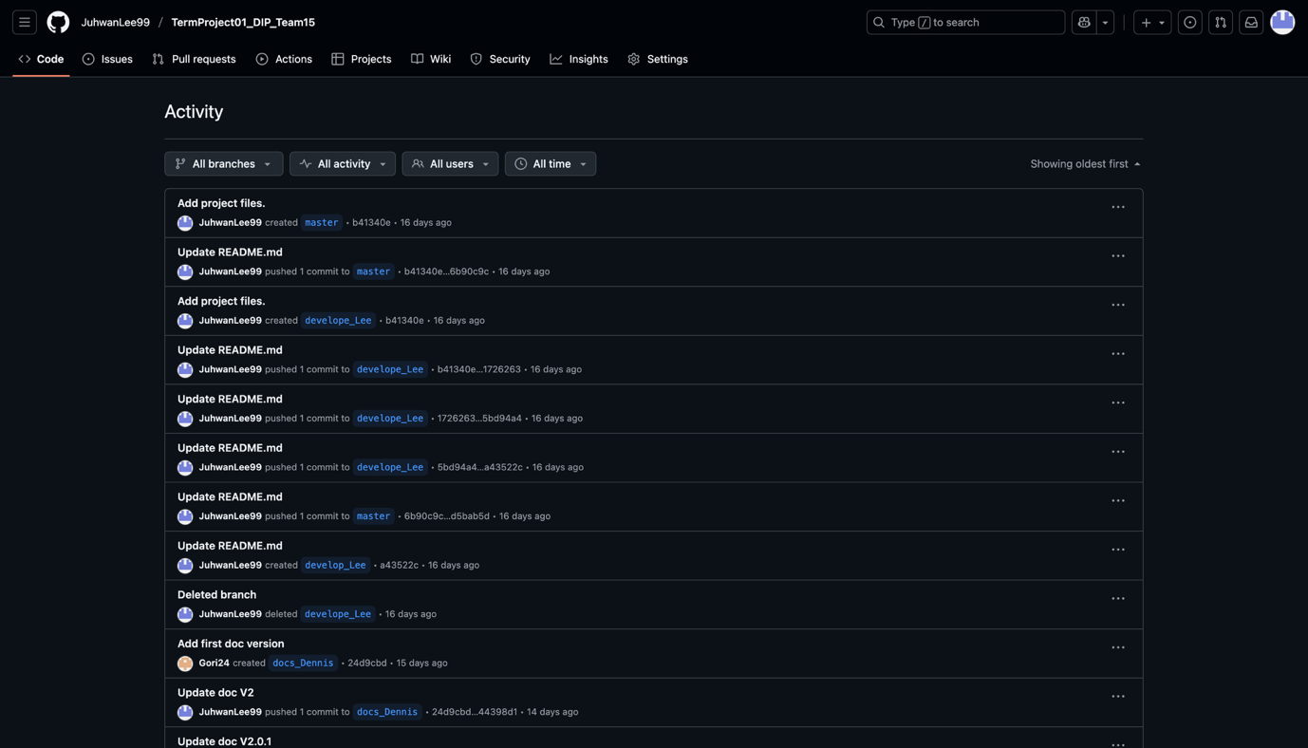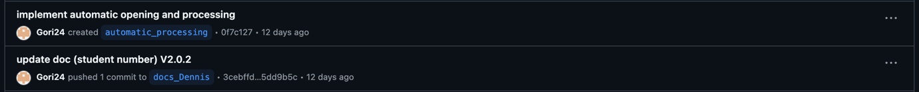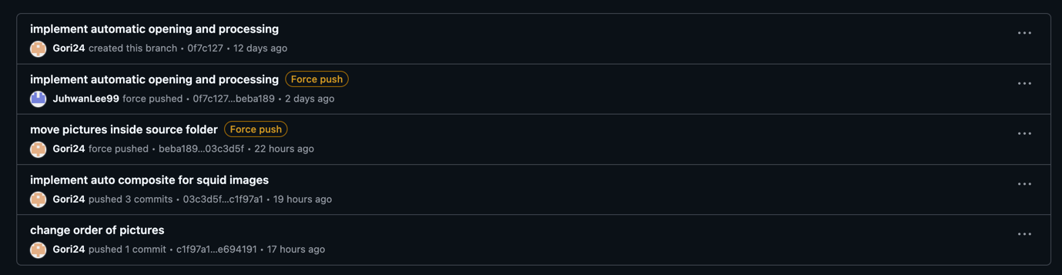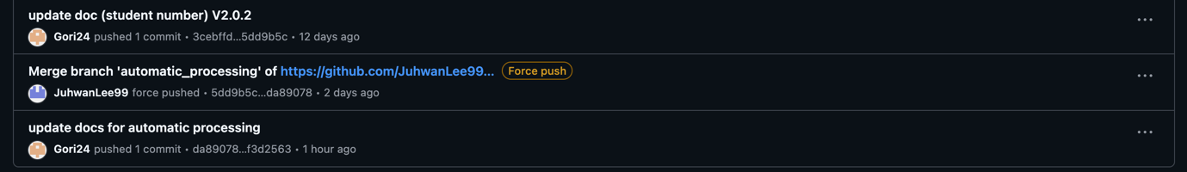

Member's Thoughts on This Project

Lessons Learned
- Even small programs benefit from modular design
- Pixel-level operations require attention to overflow/underflow
- Collaboration and code review help catch subtle mistakes

Future Improvements
- Support for blending with weights (alpha blending)
- Adding more composite modes (multiply, divide, etc.)

